In the Appellate Court of Illinois, First District

Docket Number: 1-18-0572

GMAC Mortgage, LLC, ) Appeal from the Circuit Court of Cook County, IL
Plaintiffs, ) County Department, Law Division
vs. )
) Trial Court No: 07CR29738
Gordon Wayne Watts, et. al., ) (Transfer into Law Division from Chancery)
Defendants. )
___________________________________ ) Trial Judge: Hon. James P. Flannery (#1505)
Gordon Wayne Watts, ) Date of Notice of Appeal: March 16, 2018
Appellant/Counter-Plaintiff, ) Date of Judgment: March 01, 2018
vs. ) Date of Post-judgment Motion: None
) Order: #6
Joseph Younes, Hon. Diane M. Shelley, )
Hon. James P. Flannery, et al., ) Supreme Court Rule(s) which confer(s) jurisdiction
Counter-Defendants. ) upon the reviewing court: Ill.Sup.Ct. R.301, 303

Docketing Statement and Notice of Appearance of Counsel for Appellant
(Civil)

Appellant-Defendant, Gordon Wayne Watts, acting solely in his capacity pro se, and pursuant to Supreme Court Rule 312, submits the following for his Docketing Statement in this appeal within 14 days after filing the notice of appeal. Pursuant to Illinois Appellate Court, First District, local court Rule 9, this Docketing Statement shall also serve as the appearance of the undersigned as counsel, pro se, for the Appellant.

1. Is this a cross-appeal, separate appeal, joining in a prior appeal, or related to another appeal which is currently pending or which has been disposed of by this court? __YES__
If so, state the docket number(s) of the other appeal(s):

* NO. 1-14-2751 (Trial Court No.: 2007-CH-29738 – Chancery Division) GMAC v. Daniggelis
* NO. 1-15-0662 (Trial Court No.: 2014-M1-701473 – Civil Division) Younes v. Daniggelis
* NO. 1-18-0091 (Trial Court No.: 2007-CH-29738 – Law Division) GMAC v. Watts / Watts v. Younes, Shelley, and Flannery, Counter-Defendants
* NO. 1-18-0538 (Art. VI, Sec. 6, Original Jurisdiction Writ) Watts v. Shelley and Flannery

[Administrative Note: Petitions, such as 1-18-0538, are typically heard in the IL Supreme Court, and actually, this is the 1st known Mandamus Petition ever placed before This Honourable Court, however, it is permitted under Art. VI, Sec. 6 of the IL Constitution, and it behooves us greatly to solve our own problems and not bother the Supreme Court over trivial matters, when their case-load is already too high, so this Writ, after one clerical misstep, was properly placed.]

Page 1 of 27 - Docketing Statement: Gordon Wayne Watts, Docket Number: 1-18-0572
Page 2 of 27 - Docketing Statement: Gordon Wayne Watts, Docket Number: 1-18-0572

As this court recalls, Daniggelis was the elderly victim of documented mortgage fraud, as outlined in GMAC, a Chancery case which was appealed to this court; however, this court never reached the merits, chiefly because Atty. Andjelko Galic, the attorney for Richard Daniggelis, the elderly victim, who was temporarily made homeless & living in his rental van, as a result of the theft of his house/land, was negligent and never filed his merits brief; and, as a result, Galic was chewed out royally by This Honourable Court in its last substantive order. (See: Order of this court, date June 16, 2016, in Docket number: 1-14-2751, supra.) This Court was permitted – but not required – to accept my Amicus Curiae (aka: “Friend of the Court”) briefs; and, while this court didn't break any laws in rejecting my amicus briefs in these appeals, above, it was an unwise refusal to 'make use' of proximal judicial help offered, since amici are permitted to be a “friend” to the court –and aide its appellate jurisdiction when, as in this case, counsel for both sides overlooked stuff and/or are/were negligent—and, no disrespect meant, kicking the can down the road has resulted in continued headaches for all parties, but I shall attempt to simplify things, and help This Noble Court complete its mission, & thereby reduce the headache factor.

Kinkel v. Cingular Wireless, L.L.C., 223 Ill. 2D 1; 857 N.E.2d 250; 306 Ill.Dec. 157 (Jan. 11, 2006), holds that an Amicus needs merely offer helpful information that the parties have overlooked—which I clearly do insofar as I use several legal arguments that no lawyers on either side have used. [This holding is analogous to Rule 37.1 of the U.S. Supreme Court, which states: “1. An amicus curiae brief that brings to the attention of the Court relevant matter not already brought to its attention by the parties may be of considerable help to the Court.” (Emphasis added in bold-faced underline for clarity; not in original)] Illinois Courts also adopt a 7th Cir. Federal Court standard in which ((#1)) a party is not represented at all; ((#2)) the 'direct interest' test; or, ((#3)) the same test as above: Helpful info overlooked by the parties. NOTE: The 7th Circuit test uses the key operator “or,” meaning that any one “or” the other of the three tests need apply. See e.g., NOW, et al. v. Scheidler, et al., (Nos. 99-3076, 99-3336, 99-3891 & 99-3892, 7th. Cir., Opinion July 31, 2000): http://media.ca7.uscourts.gov/cgi-bin/rssExec.pl?Submit=Display&Path=Y2000/D07-31/C:99-3076:J:_:aut:T:op:N:0:S:0

- ** VERY IMPORTANT ADMINISTRATIVE NOTE: This Court violated a direct command of the Illinois Supreme Court, here recently, in a related case:

[Web-Post Date: 5/6/2015 aka “March 25, 2015”] No. 118434 - GMAC Mortgage, LLC, et al., respondents, v. Richard Daniggelis, petitioner. Leave to appeal, Appellate Court, First District. (1-14-2751)
Petition for leave to appeal denied.
In the exercise of this Court's supervisory authority, the Appellate Court, First District, is directed to vacate its order in GMAC Mortgage, LLC v. Daniggelis, case No. 1-14-2751 (09/24/14),
Page 2 of 27 - Docketing Statement: Gordon Wayne Watts, Docket Number: 1-18-0572
Page 3 of 27 - Docketing Statement: Gordon Wayne Watts, Docket Number: 1-18-0572

denying Richard Daniggelis leave to file a late notice of appeal. The appellate court is instructed to allow Richard Daniggelis to file a late notice of appeal and hear the case. (27 N.E.3d 610 (2015))

Let's looks again at the ORDER rendered here: Notice that it doesn't say “hear” the case only if Atty. Galic files his merits briefs. Notice, please, it says to “hear the case.” Period. Now, no one will hold it against the appellate court judges for being human and getting side-tracked.
(Movant is human, and asks for forgiveness for a late motion in 1-18-0091, no?) However, when this case inevitably wends it way to the Supreme Court again (no matter the outcome, some party will lose, and will be an unhappy camper, and appeal, OK?), the Supreme Court will remember that this reviewing court disobeyed it's last standing order to fully-and-completely review this case on the merits, hear it, and render a decision (which it did not do).
The trial court (and the other litigants) do not care if This Court is embarrassed or misses an opportunity to correct an honest, and human, mistake. However, even tho Movant admits that he sometimes disagrees with this court's rulings, in the past, refusing to give Daniggelis justice, and even tho Movant is also human (and makes mistakes), Movant, Watts, will make a Herculean effort to move heaven & earth, in order to grant This Court a “Second Chance” to finish the job given to it by the Illinois Supreme Court. To be clear, if This Court does not obey The Supreme Court's last order to hear the merits, five (5) parties will suffer harm:

- (1) This Court will risk censure, embarrassment, & failure to obey the IL Supreme Court.
- (2) Mr. Daniggelis, who is elderly (about 79 or 80, as I write), and was made homeless, & living in his rental van, is still suffering loss of his house, land, and hundreds of thousands of dollars of equity, which I documented in prior filings.
- (3) Oh, and as I am owed monies for much work done, only about 10% which was documented in my Intervention motion, since many new costs have accrued, I wouldn't get paid, in this Intervention, which is, legally, similar to a Mechanic's Lien, but without the lien filing fee. [I filed Intervention vs. Lien, in order to save paying said fee.]
- (4) I would suffer “double” harm, because Daniggelis is like a grandfather to me.
- (5) The Rule of Law would suffer, and who else would get denied a fair hearing, simply because he's a poor, out-of-state nonLawyer?

Therefore, I ask This Court to pay close attention to what follows, as I shall (to the best of my human ability) give a “road map” so we all escape unharmed in this legal maze and trek. THEREFORE – I move This Court to:
((A)) Extend Time for filing the Record on Appeal three (3) months, to June 12, 2018. But, at the same time, EXPEDITE PROCEEDINGS for the elderly & all parties.
((B)) Issue a Writ of Mandamus compelling the trial court to grant intervention (see Exhibit “A”), and grant fee waiver (see Exhibits “B”, “C”, and “D” which cite to statutory law).
((C)) If preparation of the entire record seems unfeasible (remember: Trial Court got burned on this in the past), I'd recommend This Court issue a MANDAMUS Writ compelling trial court to prepare 'selected' record items, only: ONLY filings by Movant, responsive filings, & selected “representative” filings by Galic & opposing attorneys, for the Record on Appeal.
Page 3 of 27 - Docketing Statement: Gordon Wayne Watts, Docket Number: 1-18-0572
Page 4 of 27 - Docketing Statement: Gordon Wayne Watts, Docket Number: 1-18-0572

((D)) Since “less than 100%” of the Record on Appeal would be prepared (for the sake of time /&/ brevity), Due Process would require that This Court give Joseph Younes & other defendants “one last chance” to make their case for innocence or ask that selected items be added to the Record. (A “Writ of Show Cause” might play into the mix.)
((E)) Then, unless you disagree with my legal arguments (you should not), I ask that you give Daniggelis' house back to him, and order repayment for damages to those aggrieved, including myself. After ((D)) above, Summary Judgment would be appropriate. Please do so.

Playing the Devil's Advocate

Before we come down too hard on Judge Flannery for his refusal to comply with the law (regarding refusal to Grant Fee Waiver, Acknowledge Intervention rights, and Prepare the Record on Appeal—the subject of the instant appeal), let's look at mitigating circumstances: His court, previously, prepared a huge record in a related case, which Atty. Galic (Daniggelis' attorney), and his court “got burned” badly, insofar as the preparation of the huge record was a wasted effort, when This Court (see Exhibit “H”) dismissed the case for Galic's repeated refusals to prosecute the case. (See the IL Supreme Court's “Supervisory Order” next page to verify, & see Movant's Docketing Statement for details.) Sadly, this was before “electronic” record standards, and trials court's efforts were not preserved.
So, while Judge Flannery is in open disobedience to the the law, his tacit concerns are genuine (and appellant's motion, here, will offer a compromise to get around the risk of a repeated mistake here).

2. Is any party a corporation or association ? If so, please identify any affiliate, subsidiary, or parent group: __NO__

3.(A) Full name and complete address of appellant(s) filing this statement:

Mr. Gordon Wayne Watts, pro se
821 Alicia Road, Lakeland, FL 33801-2113
PH: (863) 688-9880 [home] or (863) 409-2109 [cell]
Web: http://www.GordonWatts.com / http://www.GordonWayneWatts.com
Email: Gww1210@aol.com / Gww1210@gmail.com

3.(B) Full name and complete address of appellee(s): (Use additional page for multiple appellees.) See the attached Service List, which includes all known parties – and their attorneys.

3.(C) Counsel on Appeal for appellee(s): (Use additional page for multiple appellees.)
See the attached Service List, which includes all known parties – and their attorneys.

4. Court reporting personnel: (If more space is needed, use other side.)
As I became a “party proper” to this case after its inception (and not merely a prospective

Page 4 of 27 - Docketing Statement: Gordon Wayne Watts, Docket Number: 1-18-0572
Page 5 of 27 - Docketing Statement: Gordon Wayne Watts, Docket Number: 1-18-0572

Amicus Curiae, as I had initially sought), I do not rightly know, but I can tell you that I have heard a report from Mr. Daniggelis, who is my friend, who has told me that Andjelko Galic, his attorney, has hired a court reporter and has purchased records. If you want to know about any court reporting personnel, you may ask the attorneys involved in this case and/or the Civil Appeals Division of the trial court below.

5.(A) Approximate Duration of trial court proceedings to be transcribed: Unknown

5.(B) Can this appeal be accelerated? Yes—on motion of the court or any party: R.311(b).

While not mandatory (e.g., as in domestic or child rearing issues), the victim of this mortgage fraud is elderly, I'm guessing about 79 or 80 years old, as I speak, and it would not serve the appellate jurisdiction of this court were it to purposely let all the elderly victims die of old age (or stress- from being made homeless) before the merits of this case could be reached. Therefore, this court would have my gratitude if it could fast track the case, review it on the merits (based solely on what I filed, which should be enough to justify summary judgment), and then render summary judgment in favour of Daniggelis, giving him back his house & land, with costs assessed for pain & suffering ; damages to his house by Joseph Younes (as further described in City of Chicago v. 1720 Sedgwick, Younes, et. al., 2017-M1-400775, a Code Violation case in the Civil Division of Cook County, IL trial courts) ; monies lost due to having to find another place to live and/or store belongings ; award for attorneys fees to his attorney, Andjelko Galic, –and award for monetary losses to Watts and More, who suffered various losses as a result of financial distress inflicted upon Daniggelis –such ruling which would moot Daniggelis' otherwise valid 'non-suit' motion to the trial court, which precipitated this appeal to this court, and with remand to the Circuit Court for further proceedings consistent with this order:

Rule 311. Accelerated Docket
(b) Discretionary Acceleration of Other Appeals. Any time after the docketing statement is filed in the reviewing court, the court, on its own motion, or on the motion of any party, for good cause shown, may place the case on an accelerated docket. The motion shall be supported by an affidavit stating reasons why the appeal should be expedited. If warranted by the circumstances, the court may enter an order accepting a supporting record prepared pursuant to Rule 328, consisting of those lower court pleadings, reports of proceedings or other materials that will fully present the issues. In its discretion the court may accept memoranda in lieu of formal briefs. The court may then enter an order setting forth an expedited schedule for the disposition of the appeal.

6. Is this appeal from a final order in a matter involving child custody or allocation of parental responsibility pursuant to Illinois Supreme Court Rule 311(a) which

Page 5 of 27 - Docketing Statement: Gordon Wayne Watts, Docket Number: 1-18-0572
Page 6 of 27 - Docketing Statement: Gordon Wayne Watts, Docket Number: 1-18-0572

requires Mandatory Accelerated Disposition(*) of Child Custody or Allocation of Parental Responsibilities Appeals? ___NO___
(*) If yes, this docketing statement, briefs and all other notices, motions and pleadings filed by any party shall include the following statement in bold type on the top of the front page: THIS APPEAL INVOLVES A MATTER SUBJECT TO EXPEDITED DISPOSITION UNDER RULE 311(a).

7.(A) State the supreme court rule, or the law, which confers jurisdiction upon the reviewing court: Ill.Sup.Ct. Rules 301 and 303 confer jurisdiction as of right for this appeal. While I was a prospective amicus, when previously filing in this court, I later asserted intervention in the Law Division case; and, as my name appears on docket, in the court below, this is proof of my status as a party, the court below having neither denied my motion nor given any reason to deny intervention as of right. City of Chicago v. John Hancock Mutual Life Ins. Co., 127 Ill.App.3d 140, 144 (1st Dist. 1984). I satisfy all 3 requirements, giving me a right to intervene under 735 ILCS 5/2-408(a)(3). Also, as I'm a food stamp recipient, I qualify for few waiver in this court –and the court below, subject to mandamus proceedings, should it balk or refuse my rights to both sue and defend in forma pauperis, as my prior docketing statement (in 1-18-0091) had predicted that my gut feeling said it may attempt—and which prediction came true.

7.(B) State the facts of the case, which bring it within this rule or other law; and, the date that the order being appealed was entered:
The order being appealed was on March 01, 2018. I have 30 days to appeal, so my appeal dated March 16, is timely. My docketing statement is due 14-days later, e.g., by Fri. 03-30-2018.

7.(C) State any other facts which are necessary to demonstrate that the appeal is timely:
Rule 373 allows the time-stamp of the post office or a 3rd-party carrier, such as UPS or FedEx, to count as the time of filing. [Note: This wasn't needed in the instant appeal, 1-18-0572, but it was a “close call” in 1-18-0091, so I invoked Rule 373 there—with apparent success.]

8. Nature of the Case: (if several apply, check all) Mortgage Fraud / Foreclosure
Administrative Review Contract Estates Personal Injury
Juvenile Domestic Relations Child Custody or Support
Product Liability Forcible Entry Detainer (FED) Tort

9. Briefly describe the (A) nature of the case, and (B) the result in the trial court, and set forth (C) any reasons for an expedited schedule:

9. [A] Nature of the Case: Administrative review of Judge Flannery's Order

Actually, due to Judge Flannery's refusal to comply with statutory and case law, this case is “bifurcated” and there are “2-in-1” – there are two (2) answers here: Administrative (this case: 1-18-0572) and “on the merits” (the underlying case: 1-18-0091). Let's take things one at a time:

Page 6 of 27 - Docketing Statement: Gordon Wayne Watts, Docket Number: 1-18-0572
Page 7 of 27 - Docketing Statement: Gordon Wayne Watts, Docket Number: 1-18-0572

First off, my Amicus Curiae briefs, as you vividly recall, DOCUMENTED beyond any reasonable doubt, that there was indeed provable “mortgage fraud” which ensued when Daniggelis attempted to merely get 'basic' help with refinancing and/or investors, via a photocopy forgery, a felony forgery fraud, and this, combined with lack of consideration (payment), especially in light of the fact that known 'mortgage fraud' artist, Paul Shelton (who lost a law license over this) aided Atty. Joseph Younes, gave damning proof of mortgage fraud.

However, there is the matter of Presiding Law Division Judge, Hon. James P. Flannery (#1505) violating three (3) areas of statutory and case law: [[#1]] First off, he denied Fee Waiver, which is the subject on the instant appeal in this—the case at bar. [[#2]] Secondly, he used, as his excuse, the alleged refusal of Trial Judge, Hon. Diane M. Shelley (#1925), to grant Intervention. [This is a disputed matter of fact and law, but if Judge Flannery is correct, then trial judge, Diane Shelley, violated This Court's holdings on Intervention; if, however, Judge Flannery is incorrect, and the docket's claim of “Defendant” and party status is a true fact, then Judge Flannery violated the law in his refusal to grant Intervention and, of course, his refusal to permit the preparation of the Record on Appeal, which, since it is VERY lengthy, can not be paid for by an indigent appellant, who is on food stamps, and barely able to crank out printing and mailing costs for the huge service list (which the attorneys in the court below have illegally refused to serve). [[#3]] Of course, since appellant's qualification for Fee Waiver was met, the refusal to grant the request for preparation of the Record on Appeal was clearly manifest error.

NOTE: There are legitimate Mandamus Proceedings occurring in 1-18-0538, one of the sister cases, because appellant, Watts, was told by Patricia A. O'Brien, the Deputy Chief of the Civil Appeals Division (Cook County, IL Circuit Court) that this appeal court not proceed without the preparation of the Record on Appeal, but then the preparation of the Record on Appeal can not proceed without appellant, Watts, winning this appeal. That is a “classic catch-22,” meaning, there is no solution, and thus Due Process is denied in the instant case at bar, 1-18-0572.
So, if This Court refuses to hear the instant appeal (as appellant represents to This Court that Ms. O'Brien has told him in phone conversation), then Mandamus is the only remedy.
If, however, This Court will review the merits of Judge Flannery's illegal order, without requiring the huge & lengthy 'Record on Appeal' in the court below, then this appeal can proceed on the merits. [Since what is being appealed in 1-18-0572 is merely Judge Flannery's roadblock ruling, and not the merits of the elderly Richard Daniggelis being made homeless via documented Mortgage Fraud, as documented further in 1-18-0091, then, perhaps Ms. O'Brien's assessment, while certainly well-meaning, could be incorrect, and we proceed as planned.]

9. [C] Reasons for an Expedited Schedule
Before I go any further, let me remind you that the victim is elderly, and this, alone, is reasons enough for an expedited schedule [an R.311(b) Accelerated Docket], phone conferencing for myself (as I'm in Florida), and a summary Judgment, speedily rendering justice. This elderly man was made homeless, and was sleeping in his rental van for a spell, and this is verified by my statement herein, but if you doubt, you may ask Daniggelis, himself. He continues to suffer

Page 7 of 27 - Docketing Statement: Gordon Wayne Watts, Docket Number: 1-18-0572
Page 8 of 27 - Docketing Statement: Gordon Wayne Watts, Docket Number: 1-18-0572

financial hardship as a result of having to find replacement housing for both himself and his belongings, which, necessarily, must be in storage somewhere, and thus not cost a small price.

9. [A] Nature of the Case: provable 'Mortgage Fraud' (continued)
However, since I last filed in your court, I discovered the most unusual thing in all of mankind's history: Judge Michael F. Otto (see: Exhibit “F”), the judge who forcibly stripped Daniggelis' house from him, entered an Order dated March 08, 2013 (Exhibit “F”), in which he basically admitted fraud, and made my case stronger. Direct link for convenience (but check with trial court to verify – or see e.g., Exhibit “F” below)
* http://GordonWatts.com/MortgageFraudCourtDocs/3-8-2013-MOTION-DENIED.pdf
or:
* http://GordonWayneWatts.com/MortgageFraudCourtDocs/3-8-2013-MOTION-DENIED.pdf

1. Judge Otto admits (Order, p.4) that the July 9, 2006 warranty deed "is in most respects identical" to the May 9, 2006 warranty deed that Daniggelis signed (except, of course, for the word 'July' being hand-written in), which supports Daniggelis claims that there was a photocopy forgery of his signature, which forgery -all by itself -would void the entire illegal transfer of title.
2. Judge Otto (Order, p.3) acknowledges (admits) that 'Exhibit L' existed, a side-agreement to limit the title transfer only for the purpose of paying the “mortgage arrearage.” Judge Otto claims that this document was not properly signed, but apparently, Otto did not see the exhibits filed in Daniggelis' July 30, 2008 answer (see pages 38 and 40 of the 96-page PDF file of a public records request at this link, provided by my personal repository and online docket: http://GordonWayneWatts.com/MortgageFraudCourtDocs/07ch29738-07242015.pdf or
http://GordonWatts.com/MortgageFraudCourtDocs/07ch29738-07242015.pdf where both Shelton and Rhone sign on to such statements, and Daniggelis also signs them: These contracts place limits on both the time and purpose of the POA). So, this conclusively proves the POA to be fraudulently used, which fraud -all by itself -would void the entire illegal transfer of title. If you can't access my website, please see contact the trial court for official records, here.
3. There's no material disagreement with repeated assertions, by multiple parties, that Richard Daniggelis never got paid, which is a key proof of fraud that's being alleged by multiple parties. (Daniggelis would not simply give away the farm, for free. Moreover, even had he done so, Watts' case law shows that a sale is void ab initio if it lacks consideration.) My filings have repeatedly accused the other parties of failing to pay Daniggelis any consideration, and no one has contested this claim. Per 735 ILCS 5/15-1506(a), that which the other parties to this case don't deny is admitted, and, as such, it's plain that Daniggelis didn't get paid for his house, which is documented to have had hundreds of thousands of dollars equity, and which equity (and house and land) were taken without any consideration (payment), thus voiding any purported sale. But even if you think my case law, here, is “outdated,” the fact Daniggelis didn't get paid shows he had NO motive to give away—for free—the house and all its equity, thus the transfer of title was not authorised by Daniggelis, and is therefore NOT legal or valid. At all. Period.
4. On page 7 of Judge Otto's ORDER, he claims that the 'difficulty' for Daniggelis is that,

Page 8 of 27 - Docketing Statement: Gordon Wayne Watts, Docket Number: 1-18-0572
Page 9 of 27 - Docketing Statement: Gordon Wayne Watts, Docket Number: 1-18-0572

even assuming the signature to be altered (forgery by photocopy), Otto claims that Daniggelis “provides no factual or legal basis support for his assertion that, assuming the signature to have been altered, the Bank therefore “knew or should have known that the deed … was no longer valid when the closing occurred.” This argument by Judge Otto is totally ridiculous:
Let's say, for example, that a group of thieves steal Daniggelis' vehicle, and then sell it on the Black Market to a Bank (or take a loan out on it, using as collateral for a mortgage). When the police finally catch the thieves, do you really think, for one second, that the Bank will be allowed to keep the hot (stolen) property, simply because they didn't have “notice” that the property was stolen? Certainly not, and may God forbid! If Otto's logic seems crazy when we use a stolen vehicle, then it's just as crazy with the stolen house. Otto's claim that the bank needed 'notice' is ridiculous on its face, and invites the federal courts to investigate him for civil rights violations, under the color of law. However, the bank certainly did get notice: Daniggelis recording a statement of forgery in the recorder's office: Indeed, Otto admits (Order, p.4) that: "In April 2007, Daniggelis filed a Notice of Forgery with the Recorder of Deeds, stating that the deed filed in August 2006 [i.e., the one dated "July 9, 2006"] was a forgery." Moreover, the Bank was also notified of this fraud by voluminous and lengthy litigation which ensued. [Thus, Otto's claim that the bank wasn't notified is contradicted by himself, no less.] However, more-important than the fact Otto's claims were in contradiction to himself is the fact his ridiculous argument is in direct contradiction to absolute truth and common sense, and that this trial court judge used said 'nonsense' argument as an excuse to “rubber stamp” plain & obvious fraud. Otto further admits (Order, p.4) that: "Daniggelis contends that the deed he signed in May 2006 was intended to take effect only if the property was sold on or before May 31, 2006. He claims that the July 2006 closing took place without his awareness or consent," and the Record on Appeal clearly supports Daniggelis' valid claim, which Otto acknowledges, but thereafter ignores.
Judge Otto's 'arguments' (particularly, #4, supra) are totally ridiculous.

Because numerous courts & judges repeatedly continue to ignore Jospeh Younes' clear fraud, he's been allowed to gut, damage, & destroy Daniggelis' house, as explicated in City of Chicago v. 1720 N. Sedgwick, Joseph Younes, et. al., case number 2017-M1-400775, in the Civil Division, a case, overseen by Judge Patrice Ball-Reed, and which case has been featured numerous times in DNAinfo, my blog, The Register, and more recently, ChicagoCityScape: https://blog.ChicagoCityScape.com/landmarks-commission-still-threatening-fines-if-house-in-historic-district-isnt-worked-on-once-390f052a2ab2

9. (B) The Result in the Trial Court(s)
[[#1—First]] In the underlying Chancery Division case, which stretched on for almost a decade, numerous judges kept ignoring the clear fraud which I've documented above (and in both my filings, and the exhibits to said filings, which reference documentary evidence from the record). [[#2—Secondly]] Then, based on the illegal transfer of title, which was permitted by the ruling in Chancery, the Civil Division, in a FED (Forcible Entry Detainer aka eviction) case, kicked Daniggelis out of his own home. [[#3—Third]] Also, I affirm, by means of this filing,

Page 9 of 27 - Docketing Statement: Gordon Wayne Watts, Docket Number: 1-18-0572
Page 10 of 27 - Docketing Statement: Gordon Wayne Watts, Docket Number: 1-18-0572

that Daniggelis told me, on one occasion, that when all seemed lost, he jumped up in court, in Chancery, before Judge Otto, and exclaimed that if he weren't right as a matter of law, then why would Stewart Title have settled for a large sum of monies, at which time, he reported to me that Judge Otto suddenly, and unexpectedly, responded by directing that this case must be transferred to the Law Division, from which it is presently being appealed by the undersigned appellant. [Note: The Law Division transfer, in #3, may have happened before the Civil Division conclusion, in #2, above, but the Law division case is, indeed, the last –and only remaining– case – based on the underlying mortgage fraud/foreclosure issues, common to all three (3) cases.]
[[#4—Lastly]] Initially, there were questions about whether the Law Division case could over-rule the various Orders issued in the Chancery case, handing title to Younes, and, many legal scholars, even the famous Wikipedia – https://en.wikipedia.org/wiki/Circuit_Court_of_Cook_County#Law_Division – insisted that the Law Division could only do A-B-and-C, but no mention of vacating or over-ruling a bad Chancery ruling.
However, in spite of numerous “urban legends” that claim that the Law Division is unable to do anything other than limited monetary torts, the undersigned appellant did diligent research into this matter: See the “9/11/2017” motion by Defendant, Gordon Wayne Watts, filed before Hon. DIANE M. SHELLEY, in the Law Division case sub judice, documenting that the local rules of the Cook County circuit courts, specifically GENERAL ORDER NO. 1.2,2.1 - County Department, place no limitations or restriction prohibiting a Law Division judge (particularly, a senior or circuit judge, such as Judge Shelley) from reversing an incorrect title-transfer ruling by a Chancery Division judge (such as junior or Associate Judge Michael F. Otto, who entered the erroneous order in question on May 15, 2014, thereby proving Watts' claim that The IL Supreme Court is correct when it states that Circuit Judges, such as Judge Shelley, “can hear any circuit court case.” (Emphasis added for clarify) http://www.IllinoisCourts.gov/CircuitCourt/CCInfoDefault.asp
Source:
http://www.CookCountyCourt.org/Manage/DivisionOrders/ViewDivisionOrder/tabid/298/ArticleId/188/GENERAL-ORDER-NO-1-2-2-1-County-Department.aspx
Defendant-Appellant, Watts, showed Judge Shelley (viz Watts' “9/11/2017” motion) that she had the authority to vacate the incorrect Chancery rulings, but Judge Shelley, presiding over this Law Division case being appealed, chose not to, for reasons known only to her and The Almighty. For that reason, the undersigned now appeals to this reviewing court.

[[#5—Overtime]] Since Judge Shelley's court refused an opportunity to vacate an illegal ruling arising out of Chancery (Judge Michael F. Otto's order, stripping title from Daniggelis, without him being paid a dime, and taking house, land, and hundreds of thousands of dollars of equity, without any payment to Daniggelis), the matter was appealed. However, Judge Flannery refused to comply with statutory and case law in regards to Intervention, Fee Waiver, and Preparation of the Record on appeal, necessitating the instant appeal in 1-18-0572.

This five (5) prong summary, is the “result in the Trial Court” in this matter.

Page 10 of 27 - Docketing Statement: Gordon Wayne Watts, Docket Number: 1-18-0572
Page 11 of 27 - Docketing Statement: Gordon Wayne Watts, Docket Number: 1-18-0572

10 . Briefly state the general issues proposed to be raised (failure to include an issue in this statement will not result in the waiver of the issue on appeal):

* In the instant appeal (1-18-0572), I shall raise the following issues:

1. Mixed Issues of Fact and Law: Whether, the facts in the court below, justify Watts' timely Motion for Intervention:

Looking at the exhibits, we see Exhibit “A”, a proper motion to Intervene, and plaintiff documents in excruciating detail a mere fraction of his interests, which are not being represented by defendant, Daniggelis, whose attorney has gotten This Court very angry at him for failure to prosecute this case the last time it came before you, as documented by the June 16, 2016 ORDER, in case number 1-14-2751, by this court, royally chewing out Galic, the attorney for Daniggelis (see Exhibit “H”). Since Galic isn't doing his job, therefore, Watts' interests weren't being represented, thereby justifying intervention.

If trial court's claim is true, then this is an admission by the trial court that it refused to comply with This Court's holding on Intervention: Where intervention as of right is asserted, “the trial court’s jurisdiction is limited to determining timeliness, inadequacy of representation and sufficiency of interest; once these threshold requirements have been met, the plain meaning of the statute directs that the petition be granted.” City of Chicago v. John Hancock Mutual Life Ins. Co., 127 Ill.App.3d 140, 144 (1st Dist. 1984). [See Exhibit “A”, documentation to Intervene as of right] Petitioner satisfies all 3 requirements, giving Watts the right to intervene under 735 ILCS 5/2-408(a)(3). Trial court's refusal to comply with its ministerial duty and This Court's holdings re Intervention is also subject to a MANDAMUS WRIT to force trial court to obey the law: See again, e.g., Exhibit “A”, which gives documentation to support the claim.

2. Issue of Law: Whether the trial court (Judge Flannery) was legally justified in denying Fee Waiver.

3. Issue of Law: Whether the trial court erred in its refusal to remove its self-imposed roadblock Order, which was a roadblock to the Preparation of the Record on Appeal. [Note: While quite illegal, there may have been genuine concerns about wasted man-hours in the preparation of this Record, which is unusually large, and, per the “Playing the Devil's Advocate,” discussion, supra, I give the benefit of the doubt to the trial court's actions, and impute pure motives. Additionally, since Judge Flannery's possible motive was a genuine and legitimate concern of the Circuit Court, I shall –per my Motion to Extend Time in 1-18-0091, the sister case, suggest that a much smaller, limited “Record” is all that is necessary, and specifically enumerate only those filings which are necessary for This Court to successfully complete review on the merits.] Commentary: Some of the issue at law (next page) are so complex that either an 'en banc' sitting of This Court and/or certification of selected “questions of law” to the IL Supreme Court might be needed to properly complete review of these matters.

Page 11 of 27 - Docketing Statement: Gordon Wayne Watts, Docket Number: 1-18-0572
Page 12 of 27 - Docketing Statement: Gordon Wayne Watts, Docket Number: 1-18-0572

* In the underlying “sister case” (1-18-0091), I shall raise the following issues:

1. Issue of Law: Whether, as a matter of law, the CIRCUIT COURT'S Law Division is permitted plenary authority to rule on or vacate 'all' orders arising from the Chancery Division, as was argued in the 9-11-2017 motion, and summarised above. (Standard of Review: de novo, as this court has just as good a grasp on the law as the trial courts)

2. Whether it's finally clear that Daniggelis is the victim of mortgage fraud, which even Judge Otto's March 08, 2013 Order admits:
A. Issue of Fact as raised regarding Otto's false claims that documents weren't signed, even tho the record says otherwise. The standard of review here “Clearly Erroneous” (aka: Plain Error aka Manifest Error).
B. Issues of Law (which are reviewed de novo, as this court has as good a grasp on law as trial courts), regarding forgery & fraud. Here, the courts below again made “clear error,” “plain error,” “manifest error,” or even “plainly nonsense,” depending on your verbiage.

3.(A) Issue of Law: Whether the ILLINOIS RULES OF PROFESSIONAL CONDUCT definition of a lawyer, as an officer of the court, is sufficient to sustain an “ineffective counsel” argument, in “civil appeal” cases, such as how Galic is documented to have continually failed Daniggelis. (Since Illinois recognises attorneys as 'Officers of the Court', and not merely private citizens, then Galic's failure is legally equivalent to a failure of the Judicial Branch, and thus Daniggelis' Due Process was denied, and no further legal argument is needed to advance an 'Ineffective Counsel' defense... or is it? This court reviews my legal claim de novo.)

ARTICLE VIII. ILLINOIS RULES OF PROFESSIONAL CONDUCT OF 2010, Preamble: a Lawyer’s Responsibilities reads: “[1] A lawyer, as a member of the legal profession, is a representative of clients, an officer of the legal system and a public citizen having special responsibility for the quality of justice.”
Cite: http://www.IllinoisCourts.gov/supremecourt/rules/art_viii/artviii_new.htm

3.(B) Issue of Law—Constitutionality & other standards: Whether this court will refuse to hear the merits of this case and deny Daniggelis Due Process because of ineffective counsel. This may not be illegal (yet... see 3.A., above) but it certainly runs afoul of the other three major standards:
I. Unconstitutionally denying Daniggelis his Federal Due Process rights to have a fair day in court—as codified in Rule 10-100(a) (Illinois Supreme Court Commission on Access to Justice), which states: “The Illinois Supreme Court Commission on Access to Justice is established to promote, facilitate, and enhance equal access to justice with an emphasis on access to the Illinois civil courts and administrative agencies for all people, particularly the poor and vulnerable.” Cite: http://www.IllinoisCourts.gov/SupremeCourt/Rules/Art_X/Art_X.htm
II. Immoral, as his house was stolen, and he wasn't paid a dime, and was made

Page 12 of 27 - Docketing Statement: Gordon Wayne Watts, Docket Number: 1-18-0572
Page 13 of 27 - Docketing Statement: Gordon Wayne Watts, Docket Number: 1-18-0572

homeless, sleeping in his rental van, there for a spell, and stressed out, as he is elderly. Do morals matter anymore?
III. Impractical: While this court was not bound by law to accept my amicus curiae briefs, it only delayed the inevitable to refuse to review them with scrutiny: This caused additional delays and headaches for all parties – both the litigants (victims) and the court.

4.(A) Issue of Law: Whether a trial (circuit) court's refusal to rule on a motion (and issue a responsive motion) constitutes a denial of First Amendment Redress and Due Process. – This issue is raised because appellant notices a pattern of silence in the trial courts, particularly touching pro se litigants (which also implicates Equal Protection). Appellant is not suggesting that a trial court must “rule on” all motions, as some motions are clearly erroneous, nor should a clearly vexatious litigant be acknowledged. However, if, as in the appeal, sub judice, a litigant moves to Intervene, and carefully documents the costs and interests—as the July 7, 2017 motion to intervene, by Intervenor, Gordon Wayne Watts, and no explicit ruling issues, this leaves litigants and court officials confused. PROOF: Appellant-Defendant, Watts, represents to This Court that Deputy Chief, Patricia O'Brian, in the Civil Appeals Division, is very intelligent, and also dedicated in answering technical questions about appeals, but even she was negatively influenced by a lack of an explicit ruling on the 7-7-2017 motion supra: She insisted, in a recent phone conversation, that the undersigned defendant, whose name appears on docket, was not a “party” to this case, and not qualified for a Fee Waiver, and that any appeal of that could not proceed without payment of the fee for which the applicant is exempt. (The undersigned is a food stamp recipient, and can **barely** pay printing & mailing costs.)
4.(B) Issue of Law: Whether inability to appeal a denial of Application for Fee Waiver unless fees are paid constitutes a “catch-22” denial of Due Process: can't appeal without paying huge fees, and can't pay huge fees without winning appeal if waiver is denied in circuit court. [Note: If Mandamus is a proper remedy for wrongly denial of fee waiver, as hinted supra, then this issue is a moot question, and may be safely ignored.]
4.(C) Issue of Law: Whether one's name appearing on docket is sufficient indication of party status, as defendant, Watts, alleges, or insufficient, as O'Brian claimed. [Hint: Since a person may bring suit de novo to sue Joseph Younes, and thus make one plaintiff and a party, thus this cross-complaint against Younes is legally indistinguishable, making me a party.] The concern, here, is that trial courts may “abuse their discretion” & prevent a person from being a party in order to slow or stop their appeal of a bad ruling, thus impeding their Due Process.

5. Issue of Law: Whether all parties to a case must be served when making motions to the court. – This seems like a “no brainer,” and a waste of This Court's time; however, even a cursory review of the court below shows that many litigants often serve just 1 or 2 parties, and FAIL to serve all the parties, proper. As this is endemic and common practice, but a clear violation of the most basic professional legal standards, this matter must be addressed already. This Court can clearly see, in my Certificate of Service, that the undersigned is respectful to the other parties, and serves ALL parties ((#1)) hard copies by mail; ((#2)) via e-mail when possible;

Page 13 of 27 - Docketing Statement: Gordon Wayne Watts, Docket Number: 1-18-0572
Page 14 of 27 - Docketing Statement: Gordon Wayne Watts, Docket Number: 1-18-0572

((#3)) by e-File, when it became available; and, lastly, ((#4)) My online docket, which all may view for free, has not just 'docket entries,' but the filings themselves, for download/viewing.

6.((A)) Issue of Law: Whether the trial court's repeated delays in preparing the Record on Appeal, in at least 1 of the 2 prior related appeals, implicates Due Process. While it is without dispute that Galic, as attorney for Daniggelis, was negligent in moving for “extension of time” in such cases, the court (and not the parties) prepares the Record on Appeal. (And, now with new electronic standards, the court also transmits the Record to the Reviewing Court—instead of having the appellant do so, as in the the recent past.)
6.((B)) Issue of Law: Whether this reviewing court can consider the merits of the 2 other related cases (even though those appeals have expired), which are the **same** issues raised in the case at bar being appealed, here – e.g., this case sub judice. [Hint: Since the merits were never reached, there wouldn't be violation of Res Adjudicata, nor would any issues be collaterally estopped. I will argue that this reviewing court can consider the case sub judice, rule on it, and dispose of all issued raised in the 2 related cases.]

7. Issue of Law: Whether the trial courts, below, committed Manifest Error in applying the “Burden of Proof” backwards regarding ownership of 1720 N. Sedgwick (house & property, which has hundreds of thousands of dollars of equity, as many of us have documented in our past filings, below). [Daniggelis was forced to prove that his house was his, beyond all reasonable doubt, even though the circuit court should clearly have demanded that Younes and Shelton be the ones to meet this threshold before just snatching house, land, & equity.]

8. Issue of Law: Whether ((a)) Younes' admission of a conspiracy (see infra), from which he later profits & benefits; or ((b)) Judge Otto's admission of facts supporting & documenting fraud claims (see supra); or, ((c)) Younes' repeated attempts to gut, demolish, and destroy Daniggelis' house (see recent DNAinfo stories, as cited in various filings by Appellant, or see the City of Chicago v. Younes, et. al. case in Civil: 2014-M1-400775) are individually or collectively sufficient for this court to make a referral to the IARDC for discipline against Younes, for unprofessional conduct, not unlike the recent IARDC action against Younes' former law partner, Paul Shelton, who lost both his broker's license, and then his law license.
* Documentation that Shelton was Younes' former law partner: March 21, 2011 complaint against Atty. Paul L. Shelton, by the IARDC Administrator, Commission No. 09-CH-58: http://www.iardc.org/rd_database/rulesdecisions.html (Look up case by entering 'Younes')
* Documentation that Younes admitted conspiracy, and then benefited from it, thus implicating himself: EXHIBIT-Exhibit-D(2.) “Younes complaints to OAG about Linda Green conspiracy: Feb 06, 2013” – an exhibit in the “04/21/2017” motion filed by “pro se” (e.g., appellant, Gordon Wayne Watts), which is a Public Records document that the Office of Attorney General released, showing a complaint that Younes had made against DocX, U.S. BanCorp, Nationwide Title Clearing, and Bank of America, N.A., regarding the infamous “Linda Green” fraud assignments.

Page 14 of 27 - Docketing Statement: Gordon Wayne Watts, Docket Number: 1-18-0572
Page 15 of 27 - Docketing Statement: Gordon Wayne Watts, Docket Number: 1-18-0572

9. Issue of Law: Whether appellant has to document all of his 'interests' under Intervention case law (and 735 ILCS 5/2-408(a)(3)) to make a full claim, or whether some (which is hard to document) can safely be estimated, CoC v. Hancock Mutual, 127 Ill.App.3d 140, 144 (1st Dist. 1984), which This Court decided regarding Intervention.

10. Issue of Law: Whether the Application for Fee Waiver in this appellate court must be served upon all parties; or, rather, can it be served ex parte, as the Circuit Court's “approved form” allows? This is a matter of Equal Protection (litigants in this court have a higher standard), as well as Due Process (financially indigent litigants—like the undersigned appellant—are struggling to just print and mail the service copies in question). If Due Process is not offended by the court below allowing a Fee Waiver application to be served ex parte, on the court alone, then why must indigent applicants, to this court, serve all the parties extra paperwork that costs to print and mail? And—which paperwork the other litigants probably don't care to read? [[Side-note: While this appellant is not ashamed to release his financial statements or admit financial poverty, some litigants may feel this is 'private' information, not appropriate to share with other parties in a case. However, if a Fee Waiver application is served on all parties at the same time as the Docketing Statement, as the rules require, then the extra costs would probably add little—if any—costs to postage, and only require printing of additional paperwork, which could be double-sided to save paper.]]

Miscellaneous Court issues implicating Due Process
11.(A) Issue of Law: Did Judge Sanjay T. Tailor's January 17, 2017 order, in the case sub judice, offend Due Process when the judge threatened to dismiss the case (punish the victim, Mr. Daniggelis) for the failure of the Sheriff's Department to serve a party a subpoena (a “body attachment,” as the order describes)?
11.(B) Issue of Law: Is issue 11.(A), supra, a moot point, in light of the fact that Daniggelis had a compelling case for summary judgment, and did not need to issue a subpoena? [Hint: The July 24, 2012 Order, by then-Judge Mathias W. DeLort, now a member of This Honourable Court, royally chews out Daniggelis' attorney, Andjelko Galic, for focusing too much on invalidating the actual underlying foreclosure suit by questioning ownership based on the infamous "Linda Green" assignment fraud issues –instead of focusing on the actual mortgage fraud in question, which, of course, was the illegal transfer of title from Daniggelis to Younes, without any payment to Daniggelis, and by clear & obvious used of a "photocopy forgery-fraud" signature, and for purposes other than the mere refinancing for which Daniggelis initial sought help—which we now know is even documented and supported by a 2013 ruling by Judge Otto.]
11.(C) Issue of Law: Does it offend Due Process for the trial court to enter a ruling, but refuse to provide the litigant with a copy of the ruling, making it impossible to appeal said ruling? Clarification: I know this seems “trivial,” and, really, it is (in most cases), but a **very** common practice of the circuit court (Chancery, Law, and Civil Divisions, at the least) is to usually no provide a copy (either mailed or electronic, e.g., a scanned image from the

Page 15 of 27 - Docketing Statement: Gordon Wayne Watts, Docket Number: 1-18-0572
Page 16 of 27 - Docketing Statement: Gordon Wayne Watts, Docket Number: 1-18-0572

docket) to a litigant whose motion is denied. In those cases where the litigant can not afford to make a “Public Records” request, and lives too far from the courthouse to physically pick up a copy, he/she is prevented from appealing any order (Due Process issue) is the court doesn't (at the least) email him/her a scanned image (and they usually don't). Again, apologies, for a possibly “de minimus” waste of the precious time of the reviewing court justices, but, as some litigants (including the undersigned) occasionally find themselves in this situation, I would argue that the court must provide the litigants or movants with copies of orders (as most courts do), even if only via email of an image. STANDARD OF REVIEW: Constitutional issues – This is de novo, as I'm sure no one has ever asked this question before, but I am, as it affects a lot of litigants too “weak” to ask for themselves (as the undersigned is asking in the case at bar).

Certification of Appellant

As ___ attorney for the appellant __-X-__ Pro Se appellant, I hereby certify that on Monday, the _8th_ day of _January_, 2018, I asked / made a written request to the clerk of the circuit court to prepare the record on appeal, and on _NO_ day of _any month_, 2018, did I make a written request to the court reporting personnel to prepare the transcript(s). – See “Exhibit K,” below –

/s/ Gordon Wayne Watts
(Electronic Signature)
_______________ ___________________________ ______________________________
Date Appellant’s Attorney Pro Se Appellant,
Gordon Wayne Watts

In lieu of court reporting personnel’s signature I have attached the written request to the circuit court below (Civil Appeals Division) to prepare any “Reports of Proceedings prepared in accordance with Illinois Supreme Court Rule 323” – by checking the appropriate box in my “Request for Preparation of Record on Appeal.” – See “Exhibit K,” below –

/s/ Gordon Wayne Watts
(Electronic Signature)
_______________ ___________________________ ______________________________
Date Appellant’s Attorney Pro Se Appellant,
Gordon Wayne Watts

I hereby acknowledge receipt of an order for the preparation of a report of the proceedings.

_______________ ___________________________
Date Court Reporter or Supervisor

Page 16 of 27 - Docketing Statement: Gordon Wayne Watts, Docket Number: 1-18-0572
Page 17 of 27 - Docketing Statement: Gordon Wayne Watts, Docket Number: 1-18-0572

Verification by Certification

I, Gordon Wayne Watts, the undersigned Movant, under penalties as provided by law pursuant to 735 ILCS 5/1-109, Section 1-109 of the ILLINOIS Code of Civil Procedure, hereby certify that the statements set forth in this instrument are true and correct, except as to matters therein stated to be on information and belief, and, as to such matters, the undersigned certifies as aforesaid that he verily believes the same to be true: “Any pleading, affidavit or other document certified in accordance with this Section may be used in the same manner and with the same force and effect as though subscribed and sworn to under oath.” Source: 735 ILCS 5/1-109:
http://www.ILGA.gov/legislation/ilcs/documents/073500050K1-109.htm

Nonetheless, This Court has on record several of my sworn, witnessed, and notarised affidavit, just to remove any and all doubt hereto.

Date: Sunday, 25 March 2018 /s/Gordon Wayne Watts
Gordon Wayne Watts

Page 17 of 27 - Docketing Statement: Gordon Wayne Watts, Docket Number: 1-18-0572
Page 18 of 27 - Docketing Statement: Gordon Wayne Watts, Docket Number: 1-18-0572

INDEX TO THE EXHIBITS

Instrument Docket/Tab#

** Motion for Intervention (in 2 file formats: Exhibit “A”
Court-Stamped Image & text-searchable)

** Fee Waiver ORDER (Granted by This Court) Exhibit “B”

** Fee Waiver application (to trial court) with Exhibit “C”
verified request to prepare the Record on Appeal

** Fee Waiver ORDER (Denied by Trial Court) Exhibit “D”

** Returned Mail & web-tracking (to document Exhibit “E”
updated addresses & Service of filings)

** Judge OTTO's 3-8-2013 ORDER Exhibit “F”

*** Docketing Statement (bundled with Court-Stamped Fee Waiver app) Exhibit “G”

** June 16, 2016 ORDER by this court in 1-14-2751, chewing Exhibit “H”
out Galic, the attorney for Daniggelis, to verify Watts' interests
were not being represented by Galic, thus justifying Intervention

** Email from Odyssey eFileIL (Tyler Host), e.g., clerical error of clerk Exhibit “I”
mistakenly returning filing when she overlooked Art. VI, Sec. 6, of the
ILLINOIS Constitution giving your appeals court original jurisdiction

** Tracking Receipts For 03-16-2018 filings Exhibit “J”

** Verified request to Circuit Court for Exhibit “K”
Preparation of the Record on Appeal

Page 18 of 27 - Docketing Statement: Gordon Wayne Watts, Docket Number: 1-18-0572
In the Appellate Court of Illinois, First District

Docket Number: 1-18-0572

GMAC Mortgage, LLC, ) Appeal from the Circuit Court of Cook County, IL
Plaintiffs, ) County Department, Law Division
vs. )
) Trial Court No: 07CR29738
Gordon Wayne Watts, et. al., ) (Transfer into Law Division from Chancery)
Defendants. )
___________________________________ ) Trial Judge: Hon. James P. Flannery (#1505)
Gordon Wayne Watts, ) Date of Notice of Appeal: March 16, 2018
Appellant/Counter-Plaintiff, ) Date of Judgment: March 01, 2018
vs. ) Date of Post-judgment Motion: None
) Order: #6
Joseph Younes, Hon. Diane M. Shelley, )
Hon. James P. Flannery, et al., ) Supreme Court Rule(s) which confer(s) jurisdiction
Counter-Defendants. ) upon the reviewing court: Ill.Sup.Ct. R.301, 303

NOTICE OF FILING

To: See attached Service List

PLEASE TAKE NOTICE that today, Sunday, 25 March 2018, I am causing to be filed with the ILLINOIS 1st Appellate Court my Docketing Statement and Notice of Appearance of Counsel for Appellant ; Certification of Appellant ; Verification by Certification ; INDEX TO THE EXHIBITS ; NOTICE OF FILING ; an Updated/Corrected SERVICE LIST ; Certificate of Service ; and , all the Exhibits referenced herein, copies of which are attached hereto and are (or were) herewith served upon you. [You were previously served hard copies of all the exhibits, A—H, in the 03/16/2018 Motion to Extend time in 1-18-0091, and got electronic service of Exhibits I and J, because the Mandamus petition, 1-18-0538, had to be refiled due to clerical error; consequently, Exhibits I, J, and K appear below.]

Respectfully submitted,
______________________________ /s/ Gordon Wayne Watts
(Actual Signature, if served upon clerk) (Electronic Signature)
Gordon Wayne Watts Gordon Wayne Watts

Gordon Wayne Watts, pro se [Code: '99500' = Non-Lawer, pro se]
821 Alicia Road, Lakeland, FL 33801-2113
PH: (863) 688-9880 [home] or (863) 409-2109 [cell]
Web: http://www.GordonWatts.com / http://www.GordonWayneWatts.com
Email: Gww1210@aol.com / Gww1210@gmail.com

Page 19 of 27 - Docketing Statement: Gordon Wayne Watts, Docket Number: 1-18-0572
Page 20 of 27 - Docketing Statement: Gordon Wayne Watts, Docket Number: 1-18-0572

SERVICE LIST

* 1st District Appellate Court, Clerk's Office, 160 North LaSalle St., Chicago, IL 60601
(312) 793-5484 , Office Hours: 8:30a.m.-4:30p.m., Mon-Fri, Excl. Holidays [served by eFiling only, since this The Court no longer accepts paper filings]

* CIVIL APPEALS DIVISION: Richard J. Daley Center, 50 West Washington St., Room 801
Chicago, IL 60602 – (312) 603-5406, Hours: 8:30a.m.-4:30p.m., Mon-Fri, Excl. Holidays
Attention: Deputy Chief, Patricia O'Brian, PAOBrien@CookCountyCourt.com [served by all means, as Rule 326 requires for Motions for Extension of Time]

*Hon. Timothy C. Evans, Chief Judge (Ph 312-603-6000, 4299, 4259 TTY: 6673) Circuit Court of Cook County, 50 W. Washington St., Room 2600, Richard J. Daley Center Chicago, IL 60602
Courtesy copy via: Timothy.Evans@CookCountyIL.gov [served by email / electronic service only, as a courtesy, since this is an appeal]

* Hon. James P. Flannery, Jr., Circuit Judge–Presiding Judge, Law Division 50 W. Washington St., Room 2005, Chicago, IL 60602, Ph:312-603-6343, Courtesy copy via: James.Flannery@CookCountyIL.gov [served by email / electronic service only, as a courtesy, since this is an appeal]

* Law Division and Hon. Diane M. Shelley, Circuit Judge, [served by email / electronic service only, as a courtesy, since this is an appeal] Law@CookCountyCourt.com ; ccc.LawCalendarW@CookcountyIL.gov ; Diane.Shelley@CookCountyIL.gov

* Richard B. Daniggelis [true owner of 1720] 312-774-4742, c/o John Daniggelis 773-327-7198
2150 North Lincoln Park West, Apartment #603, Chicago, IL 60614-4652

* Richard B. Daniggelis (who receives mail, via USPS mail-forwarding at his old address)
1720 North Sedgwick St., Chicago, IL 60614-5722

* Andjelko Galic (Atty#:33013) Cell:312-217-5433, Fax:312-986-1810, Phone:312-986-1510
845 Sherwood Road, LaGrange Park, IL 60526-1547 (Please take note of Mr. Galic's new address) Email: AndjelkoGalic@Hotmail.com ; AGForeclosureDefense@Gmail.com

* Robert J. More ( Anselm45@Gmail.com ) [Note: More's name is misspelled on docket as: “MOORE ROBERT”] P.O. Box 6926, Chicago, IL, 60680-6926, PH: (708) 317-8812

* Associated Bank, N.A., 200 North Adam Street, Green Bay, WI 54301-5142

Page 20 of 27 - Docketing Statement: Gordon Wayne Watts, Docket Number: 1-18-0572
Page 21 of 27 - Docketing Statement: Gordon Wayne Watts, Docket Number: 1-18-0572

SERVICE LIST (continued from above)

MERS (Mortgage Electronic Registration Systems, Inc.) https://www.MersInc.org/about-us/about-us a nominee for HLB Mortgage, (703) 761-0694 / (800)-646-MERS (6377) / 888-679-MERS (6377) ATTN: Sharon McGann Horstkamp, Esq., Corporate Counsel, Mortgagee: https://www.MersInc.org/component/content/article/8-about-us/401-sharon-horstkamp Senior Vice President, Chief Legal and Legislative Officer, and Corporate Secretary for MERSCORP Holdings, Inc. – Telephone No.: (703) 761-1270, Facsimile No.: (703) 748-0183, SharonH@MersInc.org ; SharonH@MersCorp.com Cc: Janis Smith, 703-738-0230, VP, Corp. Comm. is no longer with MersCorp, and Amy Moses (AmyM@MersCorp.com ; AmyM@MersInc.org) has replaced her as an email contact; Sandra Troutman 703-761-1274, E: SandraT@MersInc.org ; SandraT@MersCorp.com) Dir, Corporate Communications, Karmela Lejarde, Communications Manager, Tel~ 703-761-1274, Mobile: 703-772-7156, Email: KarmelaL@MersInc.org ; KarmelaL@MersCorp.com C/o: MERS (Mortgage Electronic Registration Systems, Inc.), 1901 East Vorhees Street, Suite 'C', Danville, IL 61834-4512

* COHON RAIZES®AL LLP (90192) (Atty for STEWART TITLE ILLINOIS)
Attn: Carrie A. Dolan, 208 S LASALLE#1860, CHICAGO IL, 60604 [ph:(312) 726-2252]

* Stewart Title, Attn: Leigh Curry
http://www.Stewart.com/en/stc/chicago/contact-us/contact-us.html
2055 W. Army Trail Rd., STE 110, Addison, IL 60101 [ph:(630) 889-4050]

* Richard Indyke, Esq. Atty. No. 20584, (312-332-2828 Atty for LaSalle Bank Natl. Assn.), Email: RIndyke@SBCGlobal.net ; 221 N. LaSalle St. STE 1200, Chicago, IL 60601-1305

* Peter King (Atty. for Joseph Younes) (Atty. No.: 48761)
(312) 780-7302 / (312) 724-8218 / Direct: (312) 724-8221
http://www.KingHolloway.com/contact.htm ; Attn: Peter M. King, Esq. PKing@khl-law.com
or: PKing@KingHolloway.com ; One North LaSalle Street, Suite 3040, Chicago, IL 60602

* Joe Younes: 2625 West Farewell Avenue, Chicago, IL 60645-4522 JoeYounes@SbcGlobal.net

* Joseph Younes (Atty#:55351) Law Offices / http://ChicagoAccidentAttorney.net
312-635-5716, per website 166 West WASHINGTON ST, Ste. 600, Chicago, IL 60602-3596
Phone: 312-372-1122 ; 312-802-1122 ; Fax: 312-372-1408. Email: RoJoe69@yahoo.com

* Paul L. Shelton, Pro Se, (Atty. #15323, disbarred per IARDC)
E-mail: PMSA136@Gmail.com ; PLShelton@SBCGlobal.net
3 Grant Square, SUITE #363, Hinsdale, IL 60521-3351

* Erika R. Rhone [ph:(773) 788-3711], 22711 Southbrook Dr., Sauk Village, IL 60411-4291

Page 21 of 27 - Docketing Statement: Gordon Wayne Watts, Docket Number: 1-18-0572
In the Appellate Court of Illinois, First District

Docket Number: 1-18-0572

GMAC Mortgage, LLC, ) Appeal from the Circuit Court of Cook County, IL
Plaintiffs, ) County Department, Law Division
vs. ) Trial Court No: 07CR29738
Gordon Wayne Watts, et. al., ) (Transfer into Law Division from Chancery)
Defendants. ) Trial Judge: Hon. James P. Flannery (#1505)
Gordon Wayne Watts, ) Date of Notice of Appeal: March 16, 2018
Appellant/Counter-Plaintiff, ) Date of Judgment: March 01, 2018
vs. ) Date of Post-judgment Motion: None
Joseph Younes, Hon. Diane M. Shelley, ) Order: #6
Hon. James P. Flannery, et al., ) Supreme Court Rule(s) which confer(s) jurisdiction
Counter-Defendants. ) upon the reviewing court: Ill.Sup.Ct. R.301, 303

CERTIFICATE AND AFFIDAVIT OF DELIVERY (aka: Certificate of Service)

* The undersigned Defendant-Appellant, Gordon Wayne Watts, hereby certifies under penalties of perjury as provided by law pursuant to 735 ILCS 5/1-109, that the above Docketing Statement and Notice of Appearance of Counsel for Appellant ; Certification of Appellant ; Verification by Certification ; INDEX TO THE EXHIBITS ; NOTICE OF FILING ; an Updated/Corrected SERVICE LIST ; Certificate of Service ; and, all the Exhibits referenced herein, copies of which are attached hereto and are herewith served upon you—and upon the parties listed in the attached Service List, above – this Sunday, 25 March 2018, via the Odyssey eFileIL (TylerHost.net) Electronic Filing system if they're e-file registered.
* I'm concurrently serving all parties via First Class U.S. Postal Mail –except The Appeals Court (which only accepts eFiling), or as otherwise indicted in the Service List—or here:You were previously served hard copies of all the exhibits, A—H, in the 03/16/2018 Motion to Extend time in 1-18-0091, and got electronic service of Exhibits I and J, because the Mandamus petition, 1-18-0538, had to be refiled due to clerical error; consequently, Exhibits I, J, and K appear below.
* Additionally, I shall, when practically possible, post a TRUE COPY of this filing –and related filings –online at my official websites, infra –linked at the “Mortgage Fraud” story, dated Fri. 14 April 2017.
* Lastly, I may, later, cc all parties via e-mail, if I am able. Respectfully submitted,
______________________________ /s/ Gordon Wayne Watts
(Actual Signature, if served upon clerk) (Electronic Signature)
Gordon Wayne Watts Gordon Wayne Watts

Gordon Wayne Watts, pro se [Code: '99500' = Non-Lawer, pro se]
821 Alicia Road, Lakeland, FL 33801-2113
PH: (863) 688-9880 [home] or (863) 409-2109 [cell]
Web: http://www.GordonWatts.com / http://www.GordonWayneWatts.com
Email: Gww1210@aol.com / Gww1210@gmail.com
Page 22 of 27 - Docketing Statement: Gordon Wayne Watts, Docket Number: 1-18-0572
Page 23 of 27 - Docketing Statement: Gordon Wayne Watts, Docket Number: 1-18-0572

Email from Odyssey re Clerical Error, since corrected – Exhibit “I”
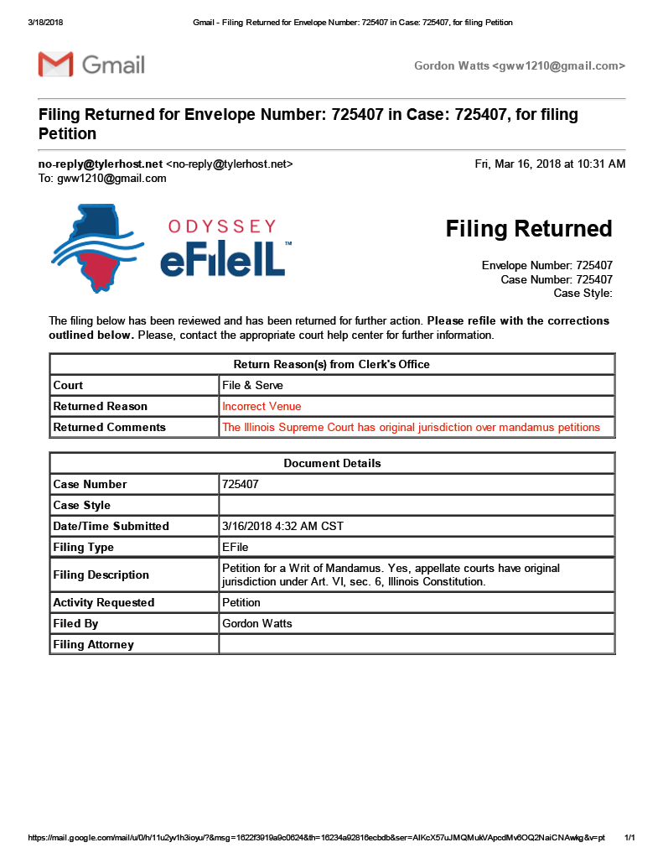
Page 23 of 27 - Docketing Statement: Gordon Wayne Watts, Docket Number: 1-18-0572
Page 24 of 27 - Docketing Statement: Gordon Wayne Watts, Docket Number: 1-18-0572

EXHIBIT-J – Tracking Receipts For 03-16-2018 filings

Here are the tracking receipts for all three (3) of the Friday, 16 March 2018 filings, which I filed on that day. (I put all 3 filings in the same envelope, to save postage.)
- My notice of appeal of the denial of the fee waiver in GMAC v. Watts, et. al., case number 1-18-0091, before the ILLINOIS 1st Appellate Court. (The trial court denied fee waiver, not the appeals court.)
- My motion to extend time, & concurrent motions in GMAC v. Watts, et. al., case number 1-18-0091.
- My petition for a Writ of Mandamus to compel the circuit court to comply with their ministerial duties to grant intervention, grant fee waiver, & prepare the Record on Appeal, matters where they have no discretion per statutory & case law. See Art. VI, Sec. 6, IL Const. which gives appellate courts original jurisdiction.
Notice, if you would, that I found the post office closed near the end of the business day, so the delivery rolled over til the next business day, Saturday, 03-17-2018.
Via FedEx Office, 3rd-Party Commercial carrier:
- Tracking number: 7801-3137-1157 for the Notice of appeal paperwork sent to the Civil Appeals Division of Cook County, IL circuit court.
- Tracking number: 7801-3139-7363 for the Mandamus filing I sent to Judge Jamees P. Flannery, presiding judge, Law Division, which is required of me to serve him as a defendant party to this action.
Via USPS, the United States Postal Service:
- Richard Daniggelis c/o John Daniggelis
- Paul Shelton & Erika Rhone
- Richard Daniggelis via his old street address (the house/property that was stolen via mortgage fraud), which should get to him, as I understand he has mail forwarding ; Atty. Galic ; Robert J. More ; Associated Bank ; M.E.R.S. ; COHON/RAIZES ; Stewart Title ; Atty. Indyke ; Atty. Peter King ; and,
- Joseph Younes (home) ; Joseph Younes (work)
See below.
Gordon Wayne Watts
(http://GordonWatts.com / http://GordonWayneWatts.com)

Page 24 of 27 - Docketing Statement: Gordon Wayne Watts, Docket Number: 1-18-0572
Page 25 of 27 - Docketing Statement: Gordon Wayne Watts, Docket Number: 1-18-0572
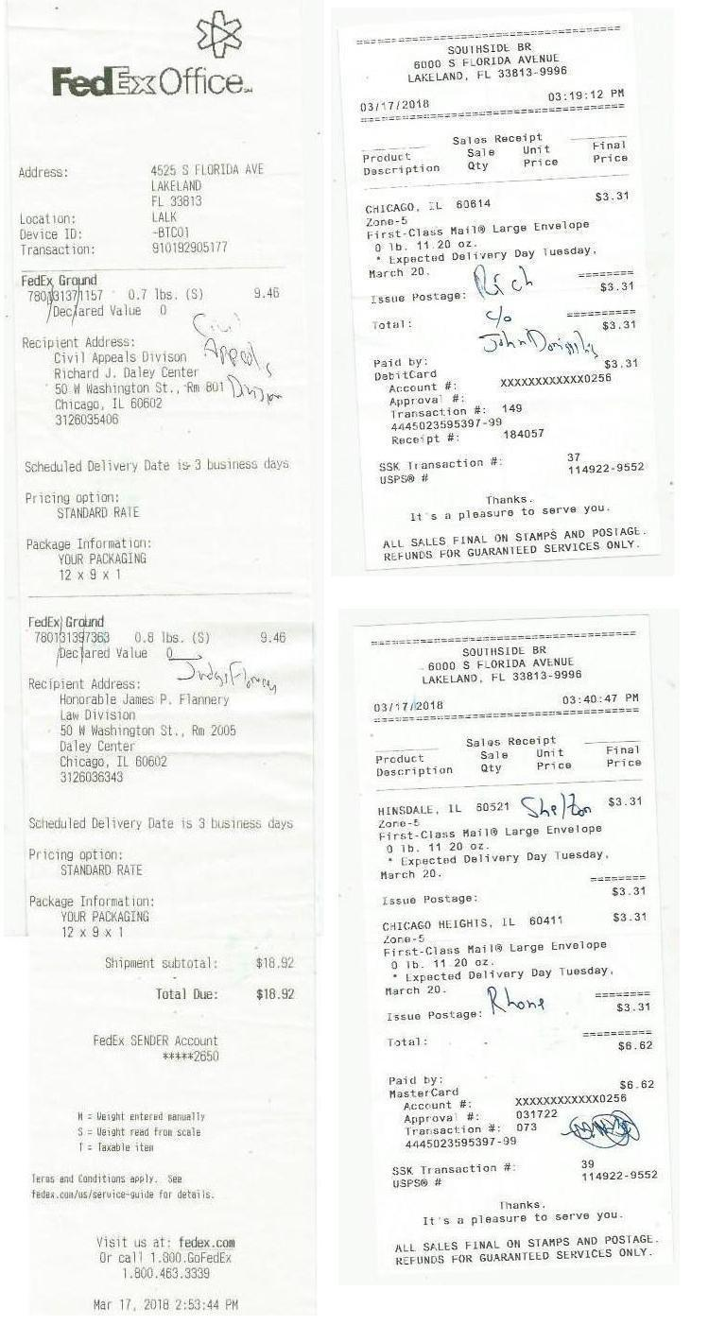
Page 25 of 27 - Docketing Statement: Gordon Wayne Watts, Docket Number: 1-18-0572
Page 26 of 27 - Docketing Statement: Gordon Wayne Watts, Docket Number: 1-18-0572
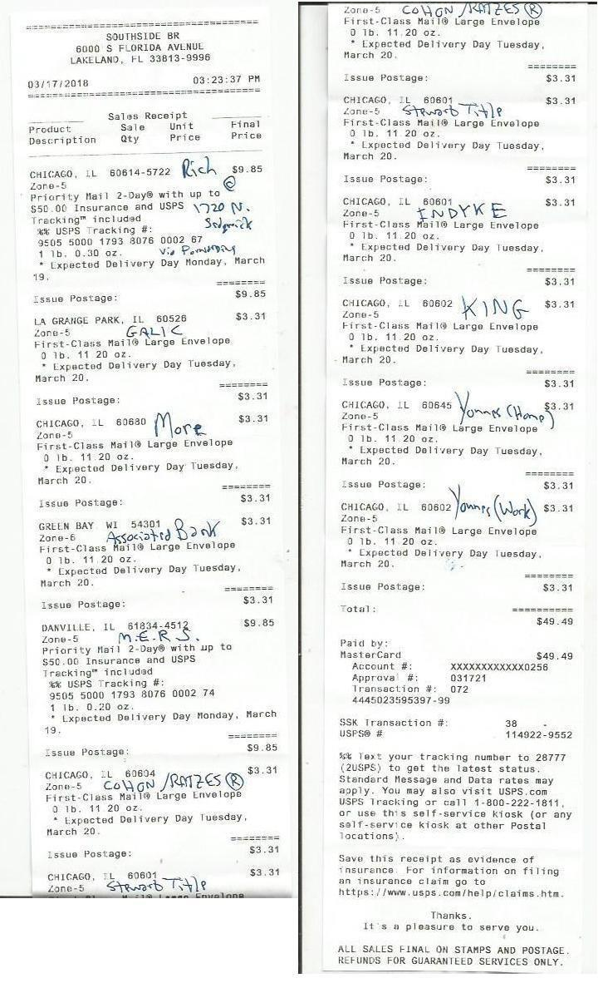
Page 26 of 27 - Docketing Statement: Gordon Wayne Watts, Docket Number: 1-18-0572
Page 27 of 27 - Docketing Statement: Gordon Wayne Watts, Docket Number: 1-18-0572
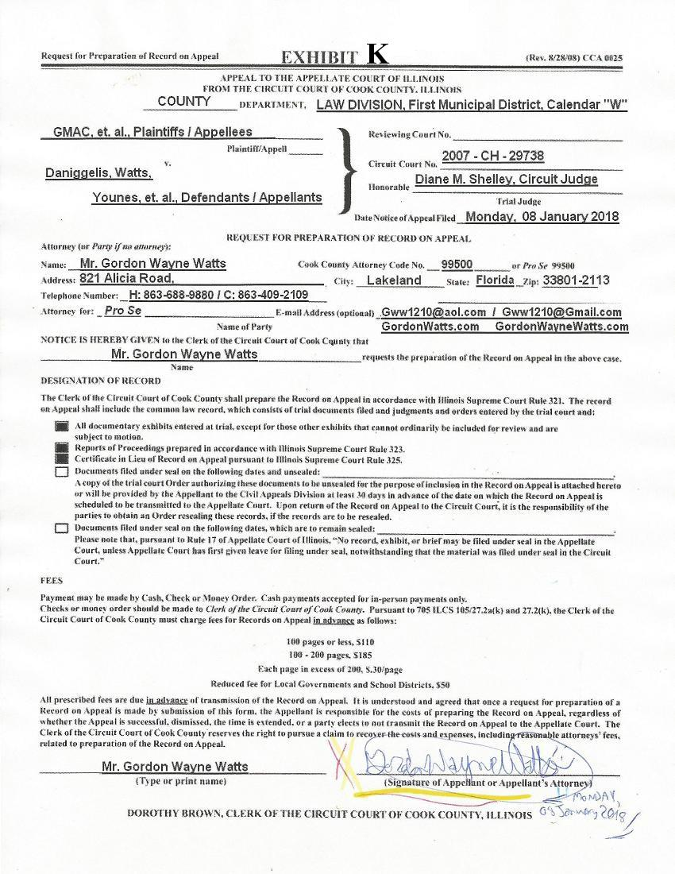
Page 27 of 27 - Docketing Statement: Gordon Wayne Watts, Docket Number: 1-18-0572

