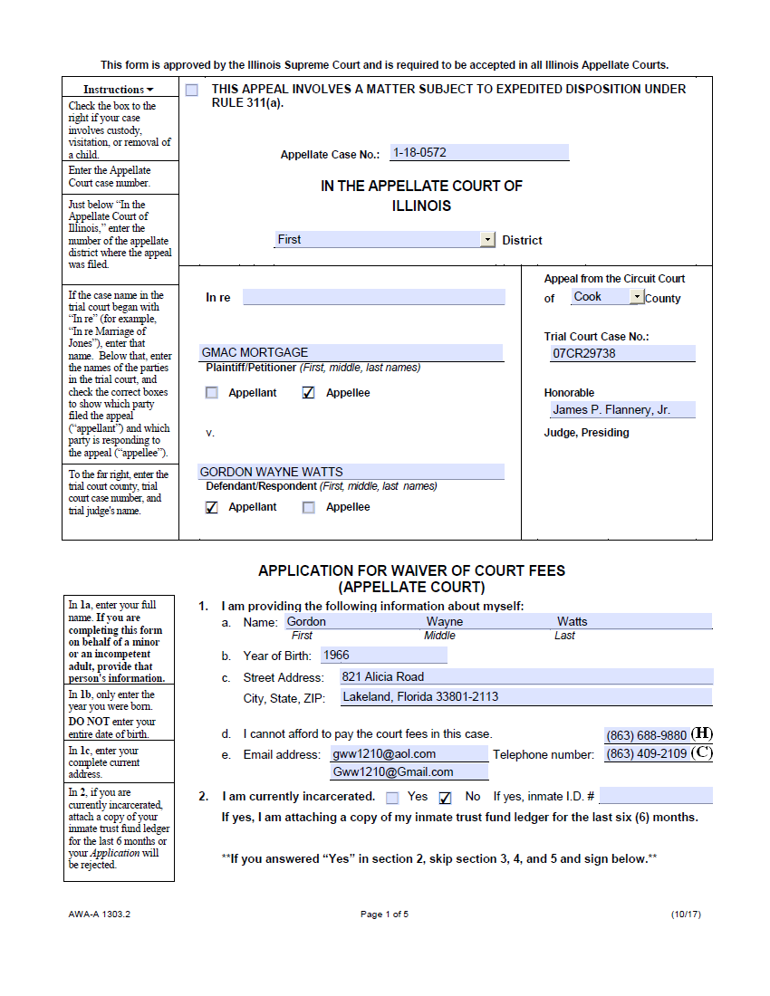
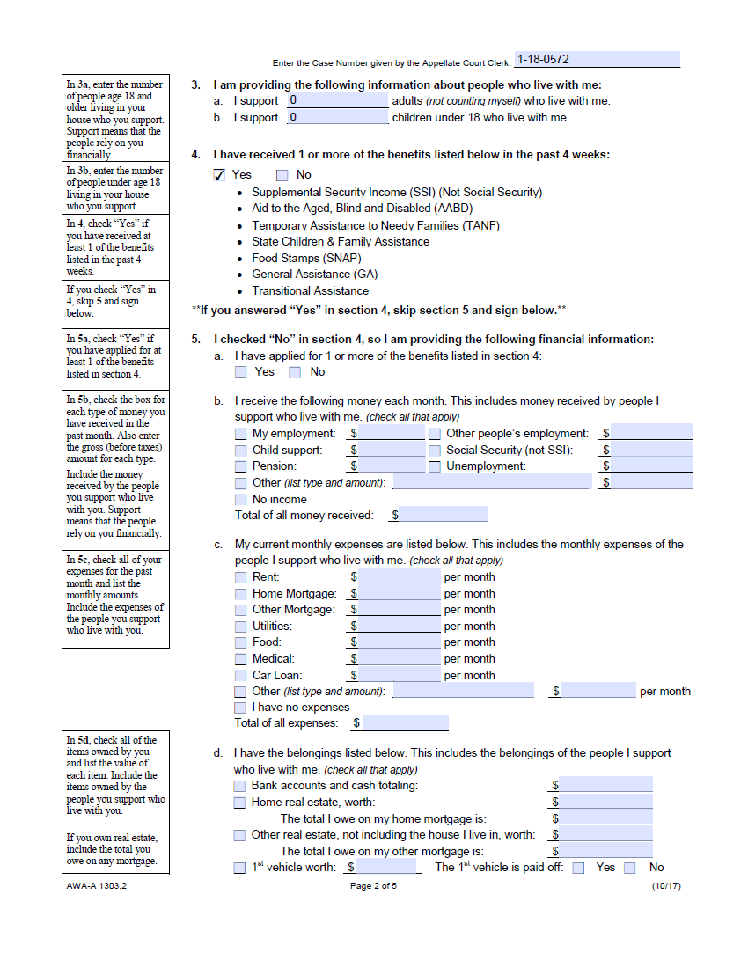
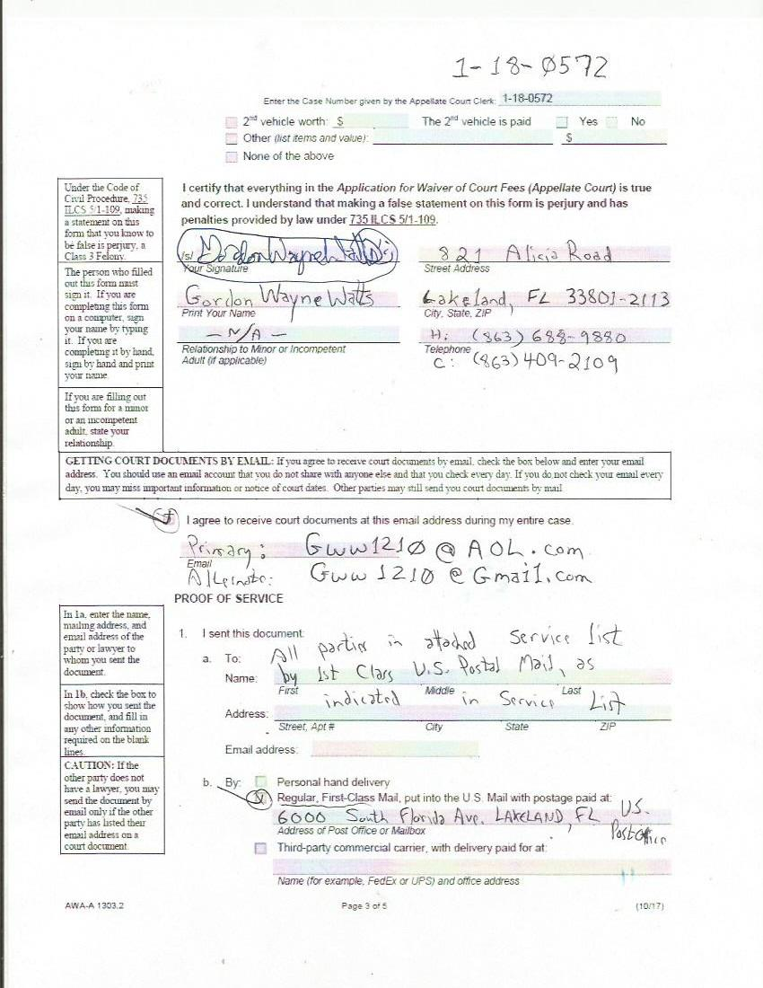
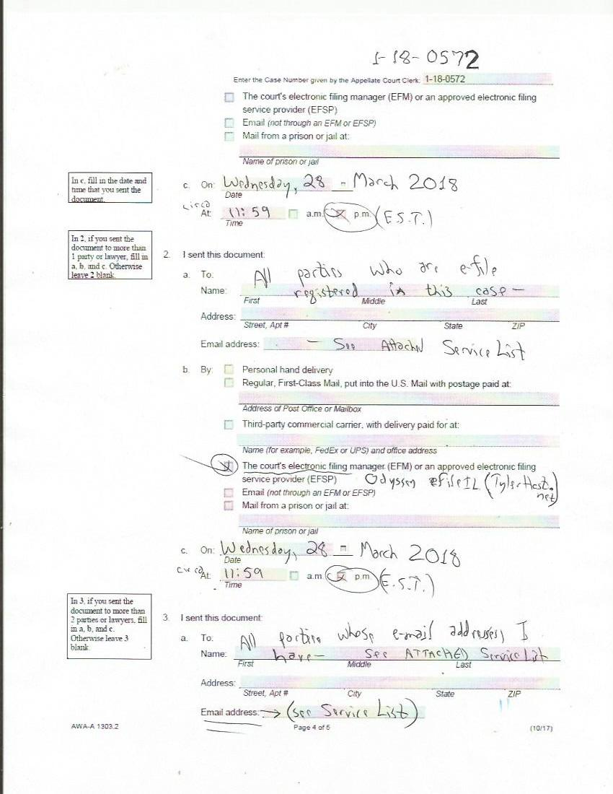
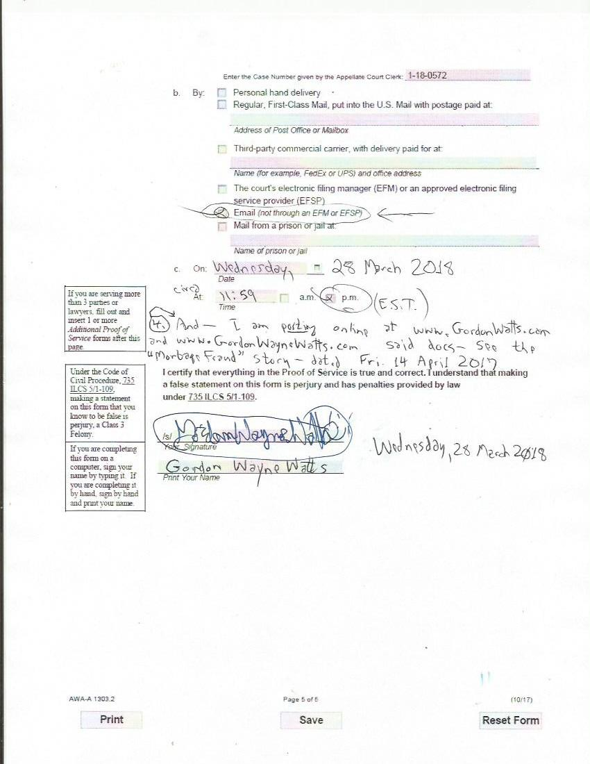
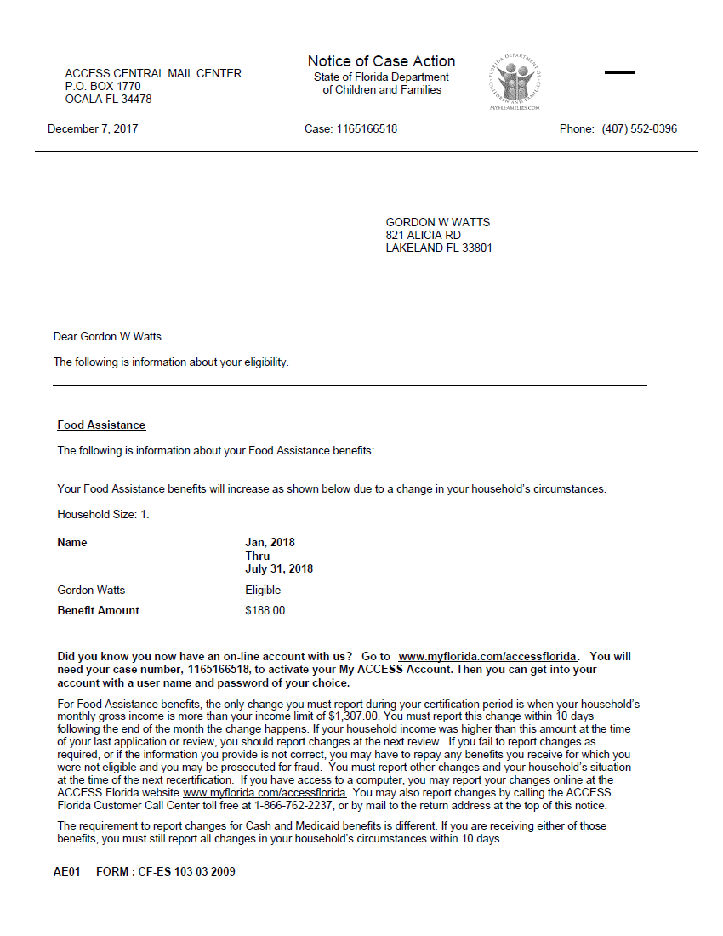
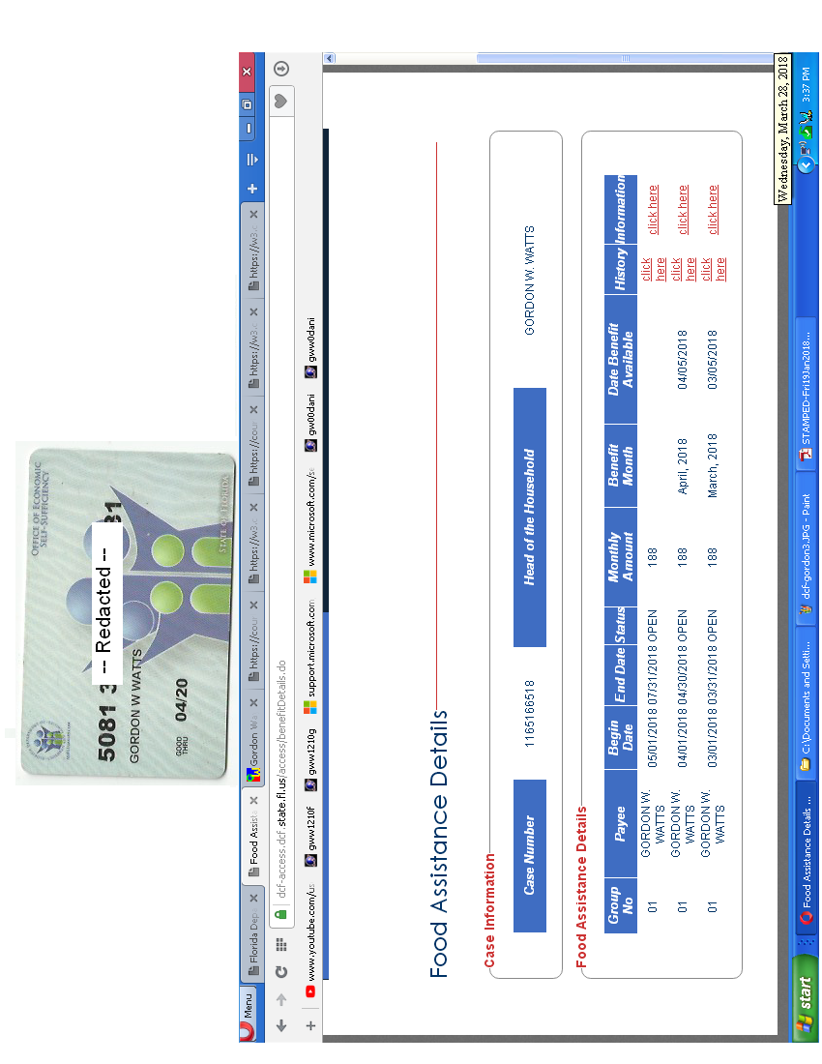
Source: Page 20 of 27-Docketing Statement: Gordon Wayne Watts, Docket No.: 1-18-0572

SERVICE LIST

* 1st District Appellate Court, Clerk's Office, 160 North LaSalle St., Chicago, IL 60601
(312) 793-5484 , Office Hours: 8:30a.m.-4:30p.m., Mon-Fri, Excl. Holidays [served by eFiling only, since this The Court no longer accepts paper filings]

* CIVIL APPEALS DIVISION: Richard J. Daley Center, 50 West Washington St., Room 801
Chicago, IL 60602 – (312) 603-5406, Hours: 8:30a.m.-4:30p.m., Mon-Fri, Excl. Holidays
Attention: Deputy Chief, Patricia O'Brian, PAOBrien@CookCountyCourt.com [served by all means, as Rule 326 requires for Motions for Extension of Time]

*Hon. Timothy C. Evans, Chief Judge (Ph 312-603-6000, 4299, 4259 TTY: 6673) Circuit Court of Cook County, 50 W. Washington St., Room 2600, Richard J. Daley Center Chicago, IL 60602
Courtesy copy via: Timothy.Evans@CookCountyIL.gov [served by email / electronic service only, as a courtesy, since this is an appeal]

* Hon. James P. Flannery, Jr., Circuit Judge–Presiding Judge, Law Division 50 W. Washington St., Room 2005, Chicago, IL 60602, Ph:312-603-6343, Courtesy copy via: James.Flannery@CookCountyIL.gov [served by email / electronic service only, as a courtesy, since this is an appeal]

* Law Division and Hon. Diane M. Shelley, Circuit Judge, [served by email / electronic service only, as a courtesy, since this is an appeal] Law@CookCountyCourt.com ; ccc.LawCalendarW@CookcountyIL.gov ; Diane.Shelley@CookCountyIL.gov

* Richard B. Daniggelis [true owner of 1720] 312-774-4742, c/o John Daniggelis 773-327-7198
2150 North Lincoln Park West, Apartment #603, Chicago, IL 60614-4652

* Richard B. Daniggelis (who receives mail, via USPS mail-forwarding at his old address)
1720 North Sedgwick St., Chicago, IL 60614-5722

* Andjelko Galic (Atty#:33013) Cell:312-217-5433, Fax:312-986-1810, Phone:312-986-1510
845 Sherwood Road, LaGrange Park, IL 60526-1547 (Please take note of Mr. Galic's new address) Email: AndjelkoGalic@Hotmail.com ; AGForeclosureDefense@Gmail.com

* Robert J. More ( Anselm45@Gmail.com ) [Note: More's name is misspelled on docket as: “MOORE ROBERT”] P.O. Box 6926, Chicago, IL, 60680-6926, PH: (708) 317-8812

* Associated Bank, N.A., 200 North Adam Street, Green Bay, WI 54301-5142

Source: Page 20 of 27-Docketing Statement: Gordon Wayne Watts, Docket No.: 1-18-0572
Source: Page 21 of 27-Docketing Statement: Gordon Wayne Watts, Docket No.: 1-18-0572

SERVICE LIST (continued from above)

MERS (Mortgage Electronic Registration Systems, Inc.) https://www.MersInc.org/about-us/about-us a nominee for HLB Mortgage, (703) 761-0694 / (800)-646-MERS (6377) / 888-679-MERS (6377) ATTN: Sharon McGann Horstkamp, Esq., Corporate Counsel, Mortgagee: https://www.MersInc.org/component/content/article/8-about-us/401-sharon-horstkamp Senior Vice President, Chief Legal and Legislative Officer, and Corporate Secretary for MERSCORP Holdings, Inc. – Telephone No.: (703) 761-1270, Facsimile No.: (703) 748-0183, SharonH@MersInc.org ; SharonH@MersCorp.com Cc: Janis Smith, 703-738-0230, VP, Corp. Comm. is no longer with MersCorp, and Amy Moses (AmyM@MersCorp.com ; AmyM@MersInc.org) has replaced her as an email contact; Sandra Troutman 703-761-1274, E: SandraT@MersInc.org ; SandraT@MersCorp.com) Dir, Corporate Communications, Karmela Lejarde, Communications Manager, Tel~ 703-761-1274, Mobile: 703-772-7156, Email: KarmelaL@MersInc.org ; KarmelaL@MersCorp.com C/o: MERS (Mortgage Electronic Registration Systems, Inc.), 1901 East Vorhees Street, Suite 'C', Danville, IL 61834-4512

* COHON RAIZES®AL LLP (90192) (Atty for STEWART TITLE ILLINOIS)
Attn: Carrie A. Dolan, 208 S LASALLE#1860, CHICAGO IL, 60604 [ph:(312) 726-2252]

* Stewart Title, Attn: Leigh Curry
http://www.Stewart.com/en/stc/chicago/contact-us/contact-us.html
2055 W. Army Trail Rd., STE 110, Addison, IL 60101 [ph:(630) 889-4050]

* Richard Indyke, Esq. Atty. No. 20584, (312-332-2828 Atty for LaSalle Bank Natl. Assn.), Email: RIndyke@SBCGlobal.net ; 221 N. LaSalle St. STE 1200, Chicago, IL 60601-1305

* Peter King (Atty. for Joseph Younes) (Atty. No.: 48761)
(312) 780-7302 / (312) 724-8218 / Direct: (312) 724-8221
http://www.KingHolloway.com/contact.htm ; Attn: Peter M. King, Esq. PKing@khl-law.com
or: PKing@KingHolloway.com ; One North LaSalle Street, Suite 3040, Chicago, IL 60602

* Joe Younes: 2625 West Farewell Avenue, Chicago, IL 60645-4522 JoeYounes@SbcGlobal.net

* Joseph Younes (Atty#:55351) Law Offices / http://ChicagoAccidentAttorney.net
312-635-5716, per website 166 West WASHINGTON ST, Ste. 600, Chicago, IL 60602-3596
Phone: 312-372-1122 ; 312-802-1122 ; Fax: 312-372-1408. Email: RoJoe69@yahoo.com

* Paul L. Shelton, Pro Se, (Atty. #15323, disbarred per IARDC)
E-mail: PMSA136@Gmail.com ; PLShelton@SBCGlobal.net
3 Grant Square, SUITE #363, Hinsdale, IL 60521-3351

* Erika R. Rhone [ph:(773) 788-3711], 22711 Southbrook Dr., Sauk Village, IL 60411-4291

Source: Page 21 of 27-Docketing Statement: Gordon Wayne Watts, Docket No.: 1-18-0572
