IN THE CIRCUIT COURT OF COOK COUNTY, ILLINOIS
Municipal Department – District 1 - Housing Section

CITY OF CHICAGO )
Plaintiff, ) Case No.: 2017-M1-400775
)
vs. ) Before: Hon. PATRICE MUNZEL
) BALL-REED, Associate Judge
1720 N SEDGWICK ST, ASSOCIATED BANK NA, ) Case Type: HOUSING
NON-RECORD CLAIMANTS, UNKNOWN OWNERS, ) District: First Municipal
Atty. Joseph Younes, Esq., et al. )
Defendants, and ) TIME-SENSITIVE: to be heard
) in Court Room:1105, by 07/13/2017
Gordon Wayne Watts, ) Court Time: 11:00am (CST)
Proposed Intervening Defendant. )

Notice of Motion

To: This Honourable Court and all parties being served (see attached service list, below)
From: Mr. Gordon Wayne Watts, LAKELAND, Fla. (full contact data, below)

Notice Proper: Pursuant to Local Rule 2.1 [“Notice of Hearing of Motions”], the undersigned movant is hereby giving this honourable court and all parties proper notice of the “MOTION TO INTERVENE BY INTERVENOR, GORDON WAYNE WATTS,” filed on 05/17/2017, and docketed on 05/18/2017, as “MOTION FILED,” by “Attorney: PRO SE.” Due to unfamiliarity with this very uncommon “local rule,” movant did not give proper “notice” of the motion, via the “notice of motion,” in accordance with said local rule, which is peculiar to this court alone.

Moreover: As This Court can see, the FedEx priority overnight package containing the filing was promised / scheduled to be delivered to This Court by 10:30am (Exhibit-A), this past Thursday, 05/18/2017, in order to be available for the judge to review it by the 11:00am court time, in courtroom 1105. However, due to unforeseen circumstances outside the control of (and thus through no fault of) this undersigned litigant (reported to be snow storms in one of the FedEx stations), the package did not arrive until 12:50pm (CST) that day. (See generally Exhibit-A and Exhibit-B) Thus, it is impossible for This Court to have ruled on the matter (as it did not have, before it, said filing). But, it is reported that most or all other litigants got their service copies by court time (at least the electronically-served copied via email), and it is also reported that this matter was superficially discussed in open court that day (and possibly 'struck' for lack of “notice of motion” and/or physical in propia persona appearance—although it's not known how it could be ruled on if it had not yet arrived). Therefore, pursuant to R.2.1, proper notice is being given of the above-mentioned motion.
* Details: Normally, a notice of motion contains a promise for the movant to appear as such-and-such time in such-and-such courtroom to present the motion: “Please take notice that on (certain date) and at (certain time), I shall appear before (named judge) – or any other judge, as may be holding court, in his/her absence – in (certain courtroom) to present (certain motion), which is attached hereto.”

The undersigned Movant understands the value and importance of in propia persona physical appearance (to be available, for example, to answer any questions in real time, as well as connect name & face). However, physical appearance (as is normally done) is mathematically impossible, and yet Due Process requires that This Court consider the matter on the merits, so notice is given – with arguments for an alternative.

Problem: Movant lives in a far, distant locale called “Lakeland, Florida” (which is squarely between Tampa

Page 1 of 4, Notice of Motion, by Intervenor, Gordon Wayne Watts
and Orlando, Fla.), and has neither a local attorney retained (to appear on his behalf), nor resources to glibly travel at the drop-of-a-hat whim to Chicago, Illinois (to appear for himself), due to oppressive and ever-present financial constraints.

Proposed Solution: This motion should be considered on its merits via written submission to This Court. In the alternative, This Court may also (if it so chooses) invoke Art. II, Rule 185 (Telephone Conferences), R.Civ. Proceedings in the Trial Court, and/or Rule 206(h)(Remote Electronic Means Depositions), etc., by calling movant at either of his two phone numbers of record: 863-688-9880 (home) and/or 863-409-2109 (cell)

Arguments Whereof: It is very common legal precedent for motions to be considered in written form only. (In fact, this is probably the most common form, or at least a close second, if not first-place.) Here are but a few examples:

(1) Intervenor, Gordon Wayne Watts, filed direct intervention as “next friend” in the Florida Supreme Court on behalf of the late Theresa Marie “Terri” Schindler-Schiavo (see e.g., Exhibit-C). While the court eventually ruled against him in a razor-thing 4-3 split decision (garnering almost 43% of his panel), Mr. Watts' motions, nonetheless, were considered on the merits before the full Supreme Court of his home state, in this high-profile case, and, in fact, his intervention got even farther than that of former Florida Governor, John Ellis “Jeb” Bush, who filed similar intervention on behalf of Ms. Schiavo (Bush lost 7-0), or even Schiavo's blood family (who got only about 33% of their panel in Federal Court).

Watts lost 4-3 on rehearing. Bush lost 7-0 on rehearing – before the same panel, and on the same issue. (Apparently, the court liked Watts' “food/water” arguments better than the similar, but inferiour “feeding tube” arguments presented by both Gov. Jeb Bush and Schiavo's parents.) Although Watts occasionally visited The Florida Supreme Court in person while he was a student at The Florida State University (in Tallahassee, Fla.), he never appeared in person to present the his motions for intervention in the infamous “Terri Schiavo” case, and yet The Court still considered the matter on the merits. (See Exhibit-C)

(2) Subsequently, Mr. Watts decided to file an Amicus Curiae (a friend of the court brief) in one of the recent “Gay Marriage” cases pending before the Federal Appeals court in his circuit. In fact, he even went as far as to ask The Court for leave to amend 'out of time' (a rare procedure to allow a litigant to amend a brief, even though filing deadlines have passed, to correct errors and/or to add additional materiel, facts, arguments, etc.). It is believed that Watts was the only non-Lawyer litigant allowed participation in this case. (In fact, Watts was permitted to amend his initial brief, out of time, even though another pro se non-Lawyer was denied: Ex-D) In any event, although Mr. Watts did not present, “in person,” his motion for leave to file an amicus brief, nor the amicus brief itself, by traveling to The U.S. 11th Circuit FEDERAL Court of Appeals, in Atlanta, GA, nonetheless, the court considered his brief and all related motions on the merits. (See, e.g., Exhibit-D)

(3) Let us also consider the case of an imprisoned Illinois prisoner – in some state or county jail: many a “jailhouse lawyer” exists in our correctional institution's incarcerated population. They file all kinds of frivolous lawsuits, motions, and torts! While most of them end up in “file-13” of that great wastebasket of the Judicial System, nonetheless, state and federal Due Process requires these motions be considered on the merits. While the undersigned litigant has no “expert” knowledge of The State of Illinois court system, it goes without saying that not all prisoners are carted “back and forth” to the court for numerous frivolous motions (for very obvious cost-restraint reasons—in fact, Illinois is currently facing a financial crisis!). These prisoners, many of whom do not appear in person to present their motions, nonetheless, get “their day in court”: They don't appear in person, and yet their motions are still considered on the merits!

(4) Perhaps, the best argument for consideration of a motion, where the litigant can't travel to The Court in person to present it, comes from This Court itself! (And would, thus, be legally-binding case-law precedent.)

Page 2 of 4, Notice of Motion, by Intervenor, Gordon Wayne Watts
Looking at GMAC MORTGAGE LLC, et al. v. RICHARD DANIGGELIS, et al. (case number: 2007-CH-29738), which was heard before the Chancery Division of the Cook County, IL circuit court (not to be confused with a case heard in the Law Division, and by the same style and case number, which was subsequently transferred from Chancery to Law), we see a spirited fight put up for justice in this case, by no less than Mr. Watts, himself: As but one example of a motion considered without litigant appearing in person, we find from the docket in the above-mentioned case, on 11/30/2015, Watts moved for rehearing (without appearing in person), and on 12/07/2015, The Court (Hon. Michael F. Otto, associate judge, presiding in this case) ruled, in courtroom 2804, in a ruling titled: “MISCELLANEOUS MOTION – ALLOWED.” While Judge Otto commits a tort of slander on page 3 of his Dec. 07, 2015 ruling¹, nonetheless, he does rule on the merits of Watts request to Supplement the Record on Appeal (in the appeal that was pending at that time).

Although the undersigned movant would argue that rulings made by Hon. Judge Michael F. Otto (Associate Judge, #2605) were exceptionally incorrect (as a matter of case law, statutory law, and State & Federal constitutional rights), as applied to the facts of that case, nonetheless, Judge Otto finally (after much prodding and begging) considered the motions on the merits—and issued a ruling (right or wrong), not just once, but several times. (Judge Otto should be commended for an “A+” performance of granting “Procedural Due Process,” even if “Substantive Due Process” was trampled upon by what movant argues were “unjust” rulings.)

Therefore, even This Court's own legally-binding precedent confirms that State and Federal Due Process require all redresses, grievances, suits at law, and related motions to be heard on the merits—whether or not litigants seeking redress can physically travel to The Court in propia persona: The Court does not discriminate nor deny due process to litigants simply for being “too poor” to afford to hire a lawyer to appear—or to travel to appear themselves. Discrimination is wrong—in any of its forms or manifestations.

Prayer for Relief: Therefore, please review and rule on my motion for intervention, filed by overnight FedEx on 05/17/2017 and docketed on 05/18/2017, according to This Court's docket. This Court may also (if it so chooses) invoke Art. II, Rule 185 (Telephone Conferences), R.Civ. Proceedings in the Trial Court, and/or Rule 206(h)(Remote Electronic Means Depositions), etc., by calling movant at either of his two phone numbers of record: 863-688-9880 (home) and/or 863-409-2109 (cell).

Dated: This Thursday, July 06, 2017
_______________________

CERTIFICATE AND AFFIDAVIT OF DELIVERY (aka: Certificate of Service)
The undersigned Movant, Gordon Wayne Watts, hereby certifies under penalties of perjury as provided by law pursuant to 735 ILCS 5/1-109, that the above “Notice of Motion,” and its exhibits were delivered to the following parties as indicated – this Thursday, the 6th day of July 2017:

* CIVIL DIVISION: Richard J. Daley Center, 50 West Washington St., Room 601, Ph: (312) 603-5116, (312) 603-5122, (312)603-5252, Chicago, IL 60602, Hours: 8:30a.m.-4:30p.m., Mon-Fri, Excl. Holidays

* Hon. Patrice Munzel Ball-Reed, Associate Judge, Civil Division, District 1 - Housing Section, Daley Center, 50 W. Washington St., Rm. 1105, Chicago, Illinois 60602, Ph: (312) 603-4535 The number listed on Judge's page, ends in '4536': http://www.CookCountyCourt.org/JudgesPages/BallReedPatrice.aspx but clerk says that this is wrong number & goes to room 1107. [Note: I'm attempting to send both Judge Ball-Reed's
_______________________
¹ Falsely claiming that Watts is arguing that vexatious litigants practices are 'OK'—direct quote: “The argument that all strangers to a case should be allowed to engage in the tactics of a vexatious litigant is so unpersuasive as to require no further discussion.”—Watts **never** said such things within the “4 Corners” of any of his briefs, arguing only that if vexatious litigants be given a fair hearing, then he should be heard & treated fairly too.
Page 3 of 4, Notice of Motion, by Intervenor, Gordon Wayne Watts
courtesy copy and the Clerk's official copy to Emma J. Burse, Mail Room Manager (312-603-3117, EJBurse@CookCountyCourt.com), for her to deliver, since previously, Priority mail to the judge got delayed.]

* City of Chicago, CORPORATION COUNSEL, 30 N LASALLE 900, CHICAGO IL, 60602,
Phone: (312) 742-0200; (312) 744-7764, Attn: Greg Janes (312-744-9555) and Glenn Angel (312-744-4033) GJanes@CityOfChicago.org, Greg.Janes@cityofchicago.org, GAngel@CityOfChicago.org, Glenn.Angel@CityOfChicago.org, Benna.Solomon@CityOfChicago.org, Edward.Siskel@CityOfChicago.org

* Joseph Younes Law Offices / http://ChicagoAccidentAttorney.net (312)635-5716, per website: 166 W WASHINGTON ST, Ste. 600, Chicago, IL 60602; Phone: (312) 372-1122 ; Fax: (312) 372-1408. Email is (or was?) RoJoe69@yahoo.com per http://www.ZoomInfo.com/p/JosephYounes/599467626 Note: Mr. Younes recently refused service of his copy of a filing I filed via FedEx [see e.g., EXHIBIT-E in the instant filing], so all he gets this time is “standard postal mail” or otherwise 'standard' service (not expensive signature confirmation), but I certify he is being served. If This Court doubts, it may effect service (e.g., “Postcard” Mr. Younes & other litigants), and send me a nominal bill for said service, but, I doubt anyone would question me on this. In fact, Younes will have to get his service copy from his attorney, Hugh Howard, who uses the same mailing address: Younes' attorney Hugh Howard, c/o: Law Offices of Hugh D. Howard, 166 W Washington St, Suite 600, Chicago, Il 60602, Phone | 312-781-1002, Email | Hugh@HughDHowardLaw.com, per: http://www.HughDHowardLaw.com

* Heavner Beyers Mihlar LLC, 111 E Main St #200, Decatur Il, 62523, (217) 422-1719, (312)-999-9110 [Mailing Address: P.O. Box 740, Decatur, IL 62525, per http://www.HSBattys.com/page/about-us/] RickHeavner@hsbattys.com, JulieBeyers@hsbattys.com, FaiqMihlar@hsbattys.com, MeredithPitts@hsbattys.com

* CR Realty Advisors, LLC, which has been appointed by the court as a temporary receiver on the property: 325 W. Huron, Suite 708, Chicago, IL 60654, P: 312.332.7100, F: 312.332.7102, E: info@cr-ra.com, per: http://www.cr-ra.com/contact/ —and— Attention: Josh Nadolna and David J. Mitidiero via:
JoshN@cr-ra.com and DaveM@cr-ra.com

I, Gordon Wayne Watts, the undersigned, hereby certify under penalties of perjury as provided by
law pursuant to 735 ILCS 5/1-109, that the above “Motion to Intervene by Intervenor, Gordon Wayne Watts,” and its exhibits, were served upon all parties listed above, this __6th__ day of ___July___, 2017 by the following methods:
• United State Postal Service: I am serving the parties proper via my city's local post office on the date listed – and with proper postage and/or by FedEx 3rd-party commercial carrier (whichever proves more convenient). I hope to obtain certification of delivery with return receipt and signature confirmation on as many packages as I can afford.
• E-mail: I may, later, serve all the parties listed above via email, in such cases as I have their e-mail address—as a courtesy. Or, then again, I may not (as it is not required), but if I serve any party electronically (via email), then I will serve all parties, so as to keep everybody in the loop.
• Internet: I shall, when practically possible, post a TRUE COPY of this filing – and related filings – online at my official websites, infra-- linked at the “Mortgage Fraud” story, dated. Fri. 14 Apr. 2017.

Signature: _______________________________ Date: _____________________
Gordon Wayne Watts, Intervenor, pro se
821 Alicia Road, Lakeland, FL 33801-2113
PH: (863) 688-9880 [home] or (863) 409-2109 [cell]
Web: www.GordonWatts.com / www.GordonWayneWatts.com
Email: Gww1210@aol.com / Gww1210@gmail.com
Date: Thursday, 06 July 2017
Page 4 of 4, Notice of Motion, by Intervenor, Gordon Wayne Watts
INDEX TO THE EXHIBITS

Instrument Docket/Tab#

FedEx tracking, promising delivery by 10:30 am (CST) Exhibit-A

FedEx proof of delivery, documenting delivery at 12:50 pm (CST) Exhibit-B

Case law citations to the “Terri Schiavo”
(aka: the Florida 'feeding tube girl') case Exhibit-C

Court ruling & docketing information in the recent
“Gay Marriage” case, heard before the U.S. 11th Circuit
FEDERAL Court of Appeals, in Atlanta, Georgia Exhibit-D

FedEx package refused by Atty. Joseph Younes Exhibit-E
E-1 (FedEx proof of Service to Defendant, Joseph Younes, Esq.: April 18, 2017)
E-2 (AOL email dated April 21, 2017 from FedEx showing Defendant, Younes, refused court service)
E-3 (Returned FedEx service copy of briefs to Atty. Joseph Younes, Esq., dated April 21, 2017)

FedEx tracking, promising delivery by 10:30 am (CST) Exhibit-A

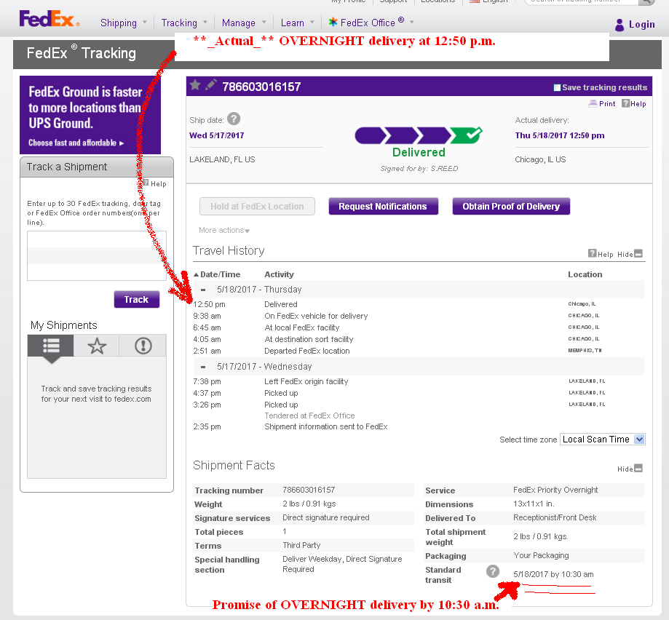

FedEx proof of delivery, documenting delivery at 12:50 pm (CST) Exhibit-B

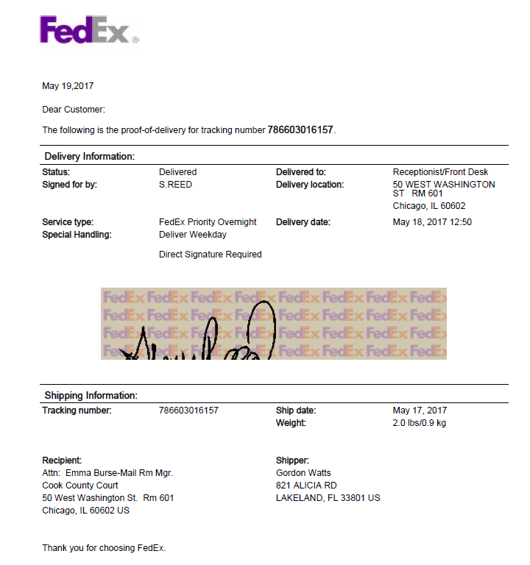

Case law citations to the “Terri Schiavo”
(aka: the Florida 'feeding tube girl') case Exhibit-C

* In Re: GORDON WAYNE WATTS (as next friend of THERESA MARIE 'TERRI' SCHIAVO),
No. SC03-2420 (Fla. Feb.23, 2005), denied 4-3 on rehearing. (Watts got 42.7% of his panel) http://www.FloridaSupremeCourt.org/clerk/dispositions/2005/2/03-2420reh.pdf

* In Re: JEB BUSH, GOVERNOR OF FLORIDA, ET AL. v. MICHAEL SCHIAVO,
GUARDIAN: THERESA SCHIAVO, No. SC04-925 (Fla. Oct.21, 2004), denied 7-0 on rehearing.
(Bush got 0.0% of his panel before the same court)
http://www.FloridaSupremeCourt.org/clerk/dispositions/2004/10/04-925reh.pdf

* Schiavo ex rel. Schindler v. Schiavo ex rel. Schiavo, 403 F.3d 1223, 2005 WL 648897 (11th
Cir. Mar.23, 2005), denied 2-1 on appeal. (Terri Schiavo's own blood family only got 33.3% of
their panel on the Federal Appeals level)
http://Media.ca11.UsCourts.gov/opinions/pub/files/200511556.pdf

Court ruling & docketing information in the recent “Gay Marriage” case, heard before
the U.S. 11th Circuit FEDERAL Court of Appeals, in Atlanta, Georgia Exhibit-D (1st of 3 pages)

[January 06, 2015 Order of Hon. Beverly B. Martin, Federal Cir. Judge granting Mr. Gordon Wayne Watts' (Pro Se) motion for leave to file an amended Amicus Curiae brief and denying Mr. Anthony Clare Citro's (Pro Se) motions for leave to file out of time and for leave to file as Amicus Curiae]

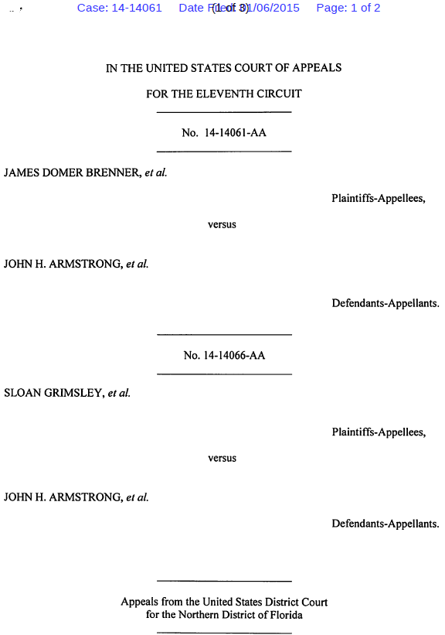
Exhibit-D (2nd of 3 pages) (continued from above)

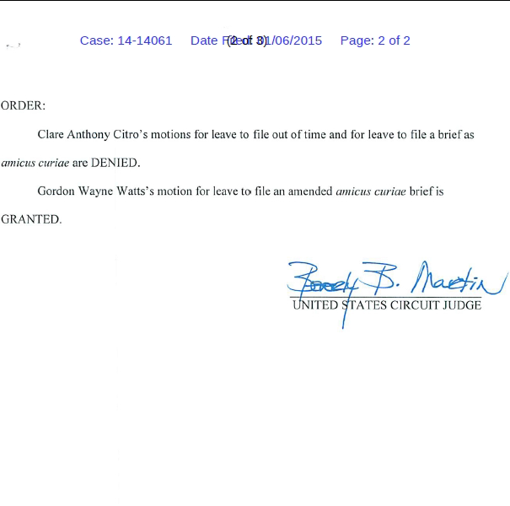

Exhibit-D (3rd f 3 pages) (continued from above)

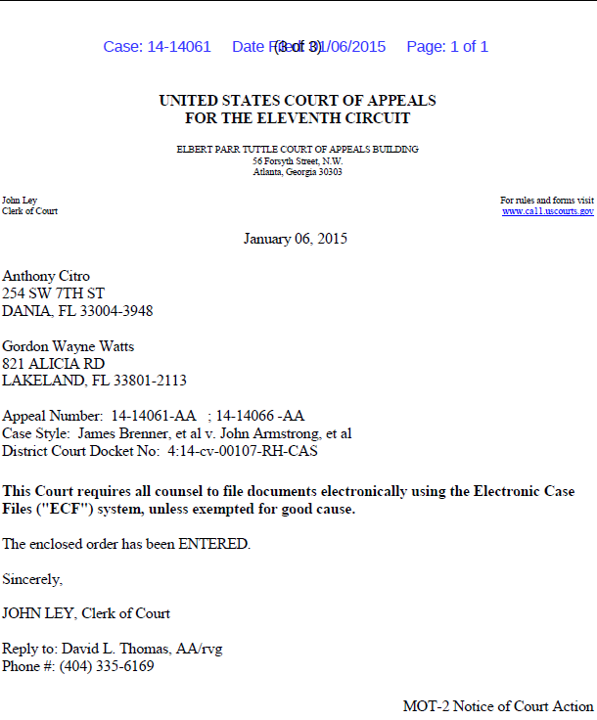

FedEx package refused by Atty. Joseph Younes Exhibit-E
E-1 (FedEx proof of Service to Defendant, Joseph Younes, Esq.: April 18, 2017)

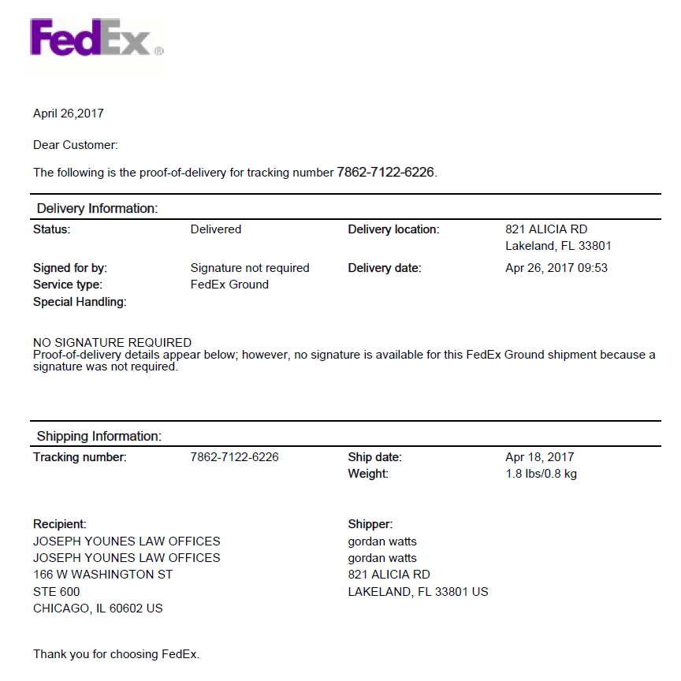

FedEx package refused by Atty. Joseph Younes Exhibit-E
E-2 (AOL email dated April 21, 2017 from FedEx showing Defendant, Younes, refused court service)

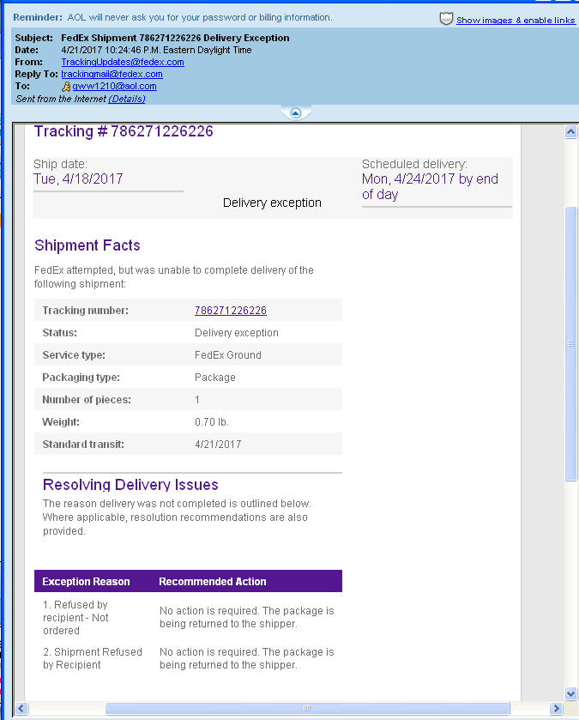
FedEx package refused by Atty. Joseph Younes Exhibit-E
E-3 (Returned FedEx service copy of briefs to Atty. Joseph Younes, Esq., dated April 21, 2017)

