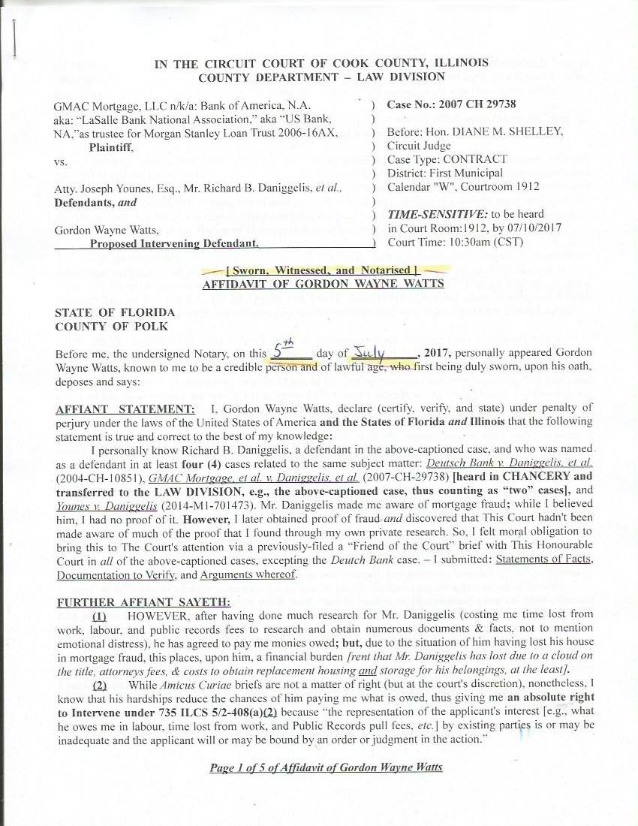
IN THE CIRCUIT COURT OF COOK COUNTY, ILLINOIS
COUNTY DEPARTMENT – LAW DIVISION

GMAC Mortgage, LLC n/k/a: Bank of America, N.A. ) Case No.: 2007 CH 29738
aka: “LaSalle Bank National Association,” aka “US Bank, )
NA,”as trustee for Morgan Stanley Loan Trust 2006-16AX, ) Before: Hon. DIANE M. SHELLEY,
Plaintiff, ) Circuit Judge
vs. ) Case Type: CONTRACT
) District: First Municipal
Atty. Joseph Younes, Esq., Mr. Richard B. Daniggelis, et al., ) Calendar "W", Courtroom 1912
Defendants, and )
) TIME-SENSITIVE: to be heard
Gordon Wayne Watts, ) in Court Room:1912, by 07/10/2017
Proposed Intervening Defendant. ) Court Time: 10:30am (CST)

[ Sworn, Witnessed, and Notarised ]
AFFIDAVIT OF GORDON WAYNE WATTS

STATE OF FLORIDA
COUNTY OF POLK

Before me, the undersigned Notary, on this _______ day of ___________, 2017, personally appeared Gordon Wayne Watts, known to me to be a credible person and of lawful age, who first being duly sworn, upon his oath, deposes and says:

AFFIANT STATEMENT: I, Gordon Wayne Watts, declare (certify, verify, and state) under penalty of perjury under the laws of the United States of America and the States of Florida and Illinois that the following statement is true and correct to the best of my knowledge:
I personally know Richard B. Daniggelis, a defendant in the above-captioned case, and who was named as a defendant in at least four (4) cases related to the same subject matter: Deutsch Bank v. Daniggelis, et al. (2004-CH-10851), GMAC Mortgage, et al. v. Daniggelis, et al. (2007-CH-29738) [heard in CHANCERY and transferred to the LAW DIVISION, e.g., the above-captioned case, thus counting as “two” cases], and Younes v. Daniggelis (2014-M1-701473). Mr. Daniggelis made me aware of mortgage fraud; while I believed him, I had no proof of it. However, I later obtained proof of fraud and discovered that This Court hadn't been made aware of much of the proof that I found through my own private research. So, I felt moral obligation to bring this to The Court's attention via a previously-filed a “Friend of the Court” brief with This Honourable Court in all of the above-captioned cases, excepting the Deutch Bank case. – I submitted: Statements of Facts, Documentation to Verify, and Arguments whereof.

FURTHER AFFIANT SAYETH:
(1) HOWEVER, after having done much research for Mr. Daniggelis (costing me time lost from work, labour, and public records fees to research and obtain numerous documents & facts, not to mention emotional distress), he has agreed to pay me monies owed; but, due to the situation of him having lost his house in mortgage fraud, this places, upon him, a financial burden [rent that Mr. Daniggelis has lost due to a cloud on the title, attorneys fees, & costs to obtain replacement housing and storage for his belongings, at the least].
(2) While Amicus Curiae briefs are not a matter of right (but at the court's discretion), nonetheless, I know that his hardships reduce the chances of him paying me what is owed, thus giving me an absolute right to Intervene under 735 ILCS 5/2-408(a)(2) because “the representation of the applicant's interest [e.g., what he owes me in labour, time lost from work, and Public Records pull fees, etc.] by existing parties is or may be inadequate and the applicant will or may be bound by an order or judgment in the action.”

Page 1 of 5 of Affidavit of Gordon Wayne Watts
(3) Moreover, I state, for the record, that I have the right to intervene under 735 ILCS 5/2-408(a)(3) because “the applicant [the undersigned Affiant] is so situated as to be adversely affected by a distribution or other disposition of property in the custody or subject to the control or disposition of the court or a court officer.”

(4) I am the sole author of this affidavit, the accompanying proposed “Motion to Intervene,” and the related “notice of motion,” as required by the rules of your court.

(5) Although I have previously submitted a sworn & notarised Affidavit in both the Chancery case (on 8/10/2015) and the above-captioned case (on 9/14/2015), as well as legal arguments, supporting documentation, and statements of fact (in my prior briefs), there have been several new developments (as well as overlooked facts & legal arguments) that compel me to take my valuable & limited time to carefully write up (hopefully) this last & final Affidavit (and related filings) to help shepherd Mr. Daniggelis' case through the court—and, of course, to avail myself of my Rights of Intervention, as proscribed by ILLINOIS statutory and case law:

My intervention as of right is asserted, and “the trial court’s jurisdiction is limited to determining timeliness, inadequacy of representation and sufficiency of interest; once these threshold requirements have been met, the plain meaning of the statute directs that the petition be granted.” City of Chicago v. John Hancock Mutual Life Ins. Co., 127 Ill.App.3d 140, 144 (1st Dist. 1984). [Emphasis added in underline & bold; not in original] I satisfy all three requirements, giving me rights to intervene under 735 ILCS 5/2-408(a)(3).

NEW DEVELOPMENTS: Very recently, I got an unexpected email response from (disbarred) Atty. Paul L. Shelton (the former law partner of Joseph Younes, and who conspired with Younes to defraud Daniggelis out of his house, title, and land), in response to me serving him his “service copies” of my filings, via email. (See attached.) Mr. Shelton has been very helpful, to me, in comparing notes and candidly discussing this case, and a few of his observations are worth bringing to This Court's attention: As we all recall, Shelton was not only stripped of his broker's license by the IDFPR, but subsequently, he was disbarred, and thus stripped of his IL law license, by the IARDC—and, in both instances, for mortgage fraud, as the publicly-accessible IL Records clearly show. (Both of Shelton's disbarments, above, made me suspect Younes, since both law partners were named defendants in numerous of Daniggelis' cases—also involving mortgage fraud.)

Mr. Shelton told me in his May 16, 2017 reply (see attachments) that: “This is personal and confidential and I'm trusting that none of what I say here is used against me.” For that reason [and because the 3 emails comprise fourteen (14) pages, which is a bit lengthy for the court's review], I'm hesitant to include his replies. HOWEVER, after reviewing his replies, nothing, in my opinion would do him any harm or injury. (His loss of law license means it can't get any worse, other than criminal charges, and nothing he said makes his case any worse. In fact, I have hopes that if he “turns state's evidence” & helps The Court by testifying, he can get some form of leniency or partial reinstatement.) MOREOVER, This Court need not read through the minutiae of our email exchange, but I must include, in relevant part, key portions, “in context,” of our exchange to verify & demonstrate genuine authenticity, e.g., that it was Mr. Shelton (not myself) who wrote his reply.
The key thing that Shelton tells me is that: “But in reality, he [Daniggelis] gave her [Erika Rhone] POA and she had [legal] right to alter deed, even date, "forge" it or sign properly as attorney in fact. That is the judges point.” [Comments in bracket to clarify; not in Shelton's original reply.] While this may seem irrelevant to the casual reader (what 2 non-Lawyers are discussing), I include this “new development” because I believe sitting judges may accept this wrong view of statutory and case law: As This Court can see in my “Thu, May 18, 2017 at 6:56 AM” reply to Atty. Shelton, he's incorrect, & I cite several sources to verify, including LeagleBeagle.com, Caring.com, LegalZoom.com, StandardLegal.com, and NationalNotary.org, all which all clearly state that you can not “forge” another persona's signature, even if you are their POA (Power of Attorney), and moreover, you must make it clear that you are signing *as* the POA for the principal. In fact, StandardLegal clearly states that: “When signing on behalf of a Grantor as Attorney-in-Fact, you should always sign YOUR OWN NAME, followed by the words “Power of Attorney“.

Page 2 of 5 of Affidavit of Gordon Wayne Watts
Do NOT sign the Grantor’s name — EVER!

By signing your own name with the words “Power of Attorney” after your name to any contract or other legal document, the person receiving the documents signed by you on behalf of the person who granted you the Power of Attorney understands exactly what is being provided.” http://www.StandardLegal.com/blog/if-i-have-power-ofattorney-how-do-i-sign-legal-documents-on-behalf-of-my-grantor

Shelton goes on to say (see email exchanges) how he was trying to help Daniggelis and now regrets it, and he implores me to not waste my time with him. Shelton also answered legal questions about whether one needed their own money at closing, and the difference between a mere notice of deposition and an official & binding subpoena. Finally, Shelton goes on to say:

“Alot of your legal arguments are very valid...but you are fighting for a liar and scammer. I firmly believe that. Your resources are being wasted in the eyes of God.” [In his 5/16/2017 11:14:43 P.M. Eastern Daylight Time reply] and: “Good luck but please leave me alone if possible.” [In his 5/16/2017 6:49:24 A.M. Eastern Daylight Time reply, that morning].

I agree with Shelton on some of what he says (about the strength of my legal arguments), but disagree that it is a waste of time, and I'm hoping that This Court does not prove him right on this point. He asks me to leave him out of it “if possible,” but since he's a material witness in the criminal Grand Theft of a house and land, by means of clear & obvious forgery, he can't be “out” of it except by leave of This Court, and even that (if the court issued such an order) would be contrary to loads of case law & statutes regarding witnesses, crimes, etc.

* Relevant Legal Arguments which came up in newly-discovered email exchanges with SHELTON *

But, in short, I include our email exchange because I believe his claims that the judges may have used this (incorrect) legal standard, namely, falsely assuming that a POA could legally forge the signature of the principal. (And, I school him on the terms of the contract, showing that even assuming the POA existed, it was a “limited” POA, limited both by scope and time, and both made it illegal to transfer title, as it was for a sale, not a quit claim, and no sale ensued as there was no payment to Daniggelis—and his signature was clearly forged.

* Overlooked Legal Arguments & Statements of Fact that DANIGGELIS has desired to be included *

Richard Daniggelis has told me, on numerous occasions, of his desire to include both certain legal arguments and certain recollections of which his attorney, Andjelko Galic, did not include in his filings. As I'm intervening as a matter of right, I have a right to include said “orphaned” legal arguments and statements of fact:

- Richard has repeatedly asked me why Younes didn't evict him right away, after having gotten “legal” title to the house, from Judge Otto's ruling and/or Judge Diana Rosario's order in the Civil Court. Mr. Daniggelis clearly told me that he felt Younes was afraid of being found out for mortgage fraud, or else he would've evicted him sooner.
- Mr. Daniggelis also told me that Judge George F. Scully, Jr., who apparently was assigned the civil division case, at one point, said (in open court, I think) that he had had lunch with Judge Michael F. Otto (who was a Chancery judge for Daniggelis' case at one point). Daniggelis then said that shortly thereafter, Judge Scully adjured & warned Younes to “be careful for what you ask for—you just might get it” or words to that effect. While I'm not sure of what legal significance this might have, Daniggelis said that he felt that Scully & Otto had discussed the matter privately at lunch, and I include it in my statements, in order that the record not be lacking. (As this is probably the last chance to include relevant filings—I want to give The Court all the tools it needs to do its job.)
- As further clarified in “Exhibit-D” of my 04/17/2017 filing to This Court, Richard asked me to

Page 3 of 5 of Affidavit of Gordon Wayne Watts
search for & locate documentation which would support his theory that Younes' complaints to the Office of the Attorney General (OAG) intimidated the banks & title companies, thereby blackmailing them into colluding to commit R.I.C.O. Crimes—and intimidated into giving him a “sweetheart” loan modification. [While it's harder to prove collusion or intent, it's a matter of record that the bank did, in fact, reduce both the interest and principal of Younes' loan by huge amounts—as I clearly document.]
- When discussing this matter with one mutual friend, has asked me if the original signature (you know, the one I'm alleging is forged) could be produced by the banks and/or Atty. Joseph Younes. My friend was implying that since Daniggelis' signature was forged (he's a mutual friend of Daniggelis and myself, and believes Daniggelis' claims], no original existed: It was a photocopy, e.g., felony forgery fraud. Since my friend's observation is good, I include it in my overlooked legal arguments, here.
- This Court is fully aware of the fact that John LaRoque has continued to (illegally) evade deposition by Daniggelis' attorney, Andjelko Galic. While I don't know what Galic might ask him (nor do I know what LaRoque is trying to hide), it's painfully obvious—even to any blind person—that John LaRoque is trying to hide something, and I think that “something” is further proof/details of the forgery fraud.
- Richard repeatedly told me that when people hear he signed the POA & the first Warranty Deed (where his signature wasn't forged), they automatically think that this is proof that he just “gave away” the house. Because of that, Richard has been trying (in vain, I might add) to somehow convey to This Court that this isn't true—and offer a sound legal explanation. Since Richard is unable (and his attorney is either unable and/or unwilling), I shall do so—since it represents my interests in Intervention: Richard told me (repeatedly) that other attorneys had previously had him sign Warranty Deeds (like he did here) to help them in their negotiations to discuss refinancing, part-ownership shares, or other matters—and that, in no instance did any attorney try to take title. Because of this, when Younes & Shelton asked Daniggelis, in like-manner, to sign a warranty deed & POA, he believed it was necessary for the transaction—and that it was not his intent to simply “give away” the house—based on past attorney interactions—and based on what Younes & Shelton told him—in their official capacity as attorney at law.
- Daniggelis has said (or implied) numerous times that people view him as helpless & pushover because of his advanced age (I think he is 78 year-old or so, at this time), and that they think it would be “unwise” to allow him to hold title. But, since Daniggelis has said that he thinks he can get a reverse mortgage and/or sell shares to Investors, and/or rent out rooms, therefore these arguments (about his age and alleged inability to manage the house/land) must be rebutted and resisted. Here, I am so doing.
- Daniggelis has said that, at one court hearing (I think, while waiting for court to convene) that Younes said that he wanted to “wash his hands” of 1720 N. Sedgwick, since it was becoming more trouble than it was worth. While I'm not sure of any “direct” legal relevance, here, this recollection (and others above) that Daniggelis made might be useful in helping understand the issues. So, since Daniggelis can't enter them into the record—and since I have legal rights of intervening, I shall do so, here.

- Oh, and perhaps the most interesting (and possibly useful) recollection that I must add is this one: When Judge Michael F. Otto, the Chancery Division judge for GMAC v. Daniggelis (the case that was transferred to the Law Division, the above-captioned case) entered his 5/15/2014 order snatching title from Daniggelis—and giving it to Younes—Mr. Daniggelis tells me that he jumped up in court and blurted out to the effect of: “Hey, if I were not the true owner of 1720 N. Sedgwick, then why was there a huge monetary judgment settlement by Stewart Title to me, for such-and-such amount!?” Mr. Daniggelis tells me that Judge Otto was startled & possibly frightened by the fact that he'd just entered an incorrect order, but that he was unwilling to admit any wrongdoing, and—instead—Daniggelis tells me that Judge Otto “passed the buck” and said: “Ah, we're going to have to transfer this case to the Law Division,” or words to that effect. [I would add: 'Passing the Buck' is not good practice, and diminishes the reputation of the court—since, of course, The Buck Stops Here, and the matter should be decided here—and not elsewhere.]

Page 4 of 5 of Affidavit of Gordon Wayne Watts

Closing statement:

I fully know, realise, & understand that This Court has received lots of lengthy written filings from me, and I'm not joyful or happy at the thought that it might be difficult to read (because of the length).

[Just remember, tho: As hard as it may be to read, it was 10X harder for me to write, so please appreciate that.]

I am not trying to make This Court's job harder—or be “vexatious” in any manner—since I know judges, clerks, & staff are all human, like myself. (And, as stated in my opening arguments in my Intervention, I inserted a rare apology for being slightly emotional with certain unnamed clerks. But, as Daniggelis is like a grandfather to me, and his repeated mistreatment—and this court's refusal to grant him justice—is like continually kicking a dog, then I will compare myself with a “dog”and say that while barking is not necessarily right, nonetheless, I beg Forgiveness and Pardon from This Honourable Court for being human: If you keep kicking a dog, it will eventually yelp.

Therefore, I respectfully submit this sworn, witnessed, & notarised Affidavit, which should serve as a legal proxy for the “Statements of the Case & Facts” in my legal briefs.

FURTHER AFFIANT SAYETH NAUGHT.
_________________________________
Gordon Wayne Watts, Affiant
STATE OF FLORIDA
COUNTY OF POLK

The foregoing instrument was acknowledged, subscribed, and sworn before me this _____ day of ___________, 2017, by GORDON WAYNE WATTS, Affiant, who ( is / is not ) personally known to me, who ( did / did not ) produce identification as shown below, and who ( did / did not ) take an oath.

IDENTIFICATION TYPE: ______________________________________________

IDENTIFICATION NUMBER: (*) ___________________________________________

(*) In compliance with Rule 138, ILLINOIS SUPREME COURT RULES, “Personal Identity Information” (b)(2), “driver’s license numbers,” I am not including my full Driver's License Number. However, in accordance with Rule 138 (c)(2), “A redacted filing of personal identity information for the public record is permissible and shall only include: the last four digits of the driver’s license number.” Therefore, I am asking This Notary to use only the last 4 digits.
See: http://www.IllinoisCourts.gov/supremecourt/rules/art_ii/artii.htm

Notary Public: ____________________________________ Date: ________________

(Notary Stamp) My Commission Expires: ______________

Page 5 of 5 of Affidavit of Gordon Wayne Watts
