IN THE CIRCUIT COURT OF COOK COUNTY, ILLINOIS
COUNTY DEPARTMENT – CHANCERY DIVISION
MORTGAGE FORECLOSURE / MECHANICS LIEN SECTION

GMAC Mortgage, LLC aka “US Bank, N.A.,”etc., )
) Case No. 2007-CH-29738
Plaintiff )
) 1720 N. Sedgwick Ave.
vs. ) Chicago, IL
)
Atty. Joseph Younes, Esq., Mr. Richard B. Daniggelis, et al., ) Before:
) Hon. Michael F. Otto #2065
Defendants ) Associate Judge, Chancery

Notice of Motion

To: This Honourable Court and all parties being served (see attached service list, below)
From: Mr. Gordon Wayne Watts, LAKELAND, Fla. (full contact data, below)
Notice Proper: On such day as this court sets – and duly notifies me by email, telephone, and postal mail, I shall[[**]], via Teleconference, as the Supreme Court Rules allow, appear “telephonically” before any judge sitting assigned to this case and present the attached “Motion for Rehearing,” with supporting Exhibits and an Index of said Exhibits. My appearance, if it is required (it may not be required[[***]]) can not be in person, due to the fact that I reside in Lakeland, FL, which is too distant for me to reasonably travel from Lakeland (between Tampa & Orlando) to Cook County, IL.

[[**]] I shall, to the best of my ability, make myself available to This Court by telephone, email, and standard postal mail, and will do so, barring an Act of God or other unpreventable disaster. See: Art. II, Rule 185 (Telephone Conferences), R.Civ. Proceedings in the Trial Court ; Rule 206(h)(Remote Electronic Means Depositions), etc.
[[***]] While I would like to appear “in person,” as is usually done in cases like this, I can not; however, many motions are considered by printed form only, so I trust that my travel handicap should not impair the wheels of justice or frustrate Due Process.

** NOTE ** While This Court allows just any 'yahoo' to appear 'in person' to present motions, etc., I note that the court has denied me my right to appear telephonically, in the past (which seems very unfair, as well as a violation of court rules, supra), & therefore wonder why I'd even need to file a “notice of motion.” But as your court requires “notices of motion,” I'm dutifully attempting to do my part & comply with the rules. Here are my current phone numbers should the court wish to follow the rules: Home: (863) 688-9880 ; Cell: (863) 409-2109.

Signed: Date: Monday, 30 November 2015
X ______________________________
Gordon Wayne Watts, MOVANT
IN THE CIRCUIT COURT OF COOK COUNTY, ILLINOIS
COUNTY DEPARTMENT – CHANCERY DIVISION
MORTGAGE FORECLOSURE / MECHANICS LIEN SECTION

GMAC Mortgage, LLC aka “US Bank, N.A.,”etc., )
) Case No. 2007-CH-29738
Plaintiff )
) 1720 N. Sedgwick Ave.
vs. ) Chicago, IL
)
Atty. Joseph Younes, Esq., Mr. Richard B. Daniggelis, et al., ) Before:
) Hon. Michael F. Otto #2065
Defendants ) Associate Judge, Chancery

MOTION FOR REHEARING

The undersigned is in receipt of the 10/29/2015 Order of This Court (Exhibit-A), Hon. Michael F. Otto, Associate Judge #2065, of the Chancery Division, presiding – striking and/or denying the various motions by the undersigned in the above-captioned case. For the reasons stated below, some of This Court's orders are found to be decided correctly – and other orders are found to be decided incorrectly. To that end, this motion seeks a rehearing of that portion of the court's orders found to be decided incorrectly as a matter of law.

There are two (2) categories of the court's order that bear relevance: Adjudication “on the merits” and a request to “supplement the record” on appeal. Although the trial court decided incorrectly on one portion of this case – and that not after an almost three (3) month delay in this potentially “life-or-death” issue¹, nonetheless, it is freely acknowledged that the trial court judge gave an excellent review of the Mr. Watts' filings, thereby granting “Procedural Due Process,” even if “Substantive Due Process” was egregiously denied movant.
_______________________
¹ As explained in initial filings by the undersigned, defendant, Mr. Daniggelis, is an elderly, 76-year-old gentleman. This alone isn't sufficient justification to find in his favour; however, when he became homeless (read: 'life or death') due solely to a “mortgage fraud rescue scheme” by a known perpetrator –Atty. Paul L. Shelton– who, in 2009, became famous for doing the same thing to Ms. Lessie Towns, another elderly victim, to the point that former Gov. Pat Quinn (D-Ill.) paid Towns a personal visit to sign into law legislation addressing mortgage fraud, this placed the Judiciary in bad light in the public eye –and made an already bad situation even worse: Daniggelis, unlike Towns, wasn't tricked into signing his property away, thus he's even more a victim: he lost it through forgery, as the record shows, yet got no monies in return. That he received no 'consideration' for his 'sale' alone makes this translation illegal, but – and more importantly – it is unthinkable/unreasonable that someone would simply “give away” a lush property with hundreds of thousands of dollars in equity in it-as the trial court apparently claims.

Page 1
Perhaps the best way to explain where the trial court (Chancery Division) erred – and why – a 'fictitious order' from an ideally fair appeals panel can be used. – To that end, see below:

2015 IL App (1st) 123456

FIRST DIVISION
NOVEMBER 30, 2015

1-14-2751

NOTICE: This order is fictitious & views expressed don't necessarily reflect the actual views of the IL 1st Appellate Court –but they should. It is merely being used to illustrate legal points in the limited circumstances allowed under Rules 345 (Amici Curiae) & 329 (omissions in the record).

IN THE
APPELLATE COURT OF ILLINOIS
FIRST JUDICIAL DISTRICT
______________________________________________________________________________

GMAC Mortgage, LLC aka “US Bank, N.A.,”etc., ) Appeal from the
) Circuit Court of
Plaintiff ) Cook County
)
vs. ) No. 07 CH 29738
)
Atty. Joseph Younes, Esq., Mr. Richard B. Daniggelis, et al., ) Honourable
) Michael F. Otto,
Defendants ) Assoc Judge Presiding.

APPEAL from a judgment of the circuit court for Cook County: MICHAEL F. OTTO, Judge. Affirmed in part. Reversed in part. Remanded for proceedings consistent with this opinion.

Before TOM, C.J., DICK, and HARRIET, JJ.

CHIEF JUSTICE TOM delivered the judgment of the court.
JUSTICES DICK and HARRIET concurred in the judgment with respect to the denial of leave to file an Amicus Curiae brief. JUSTICE HARRIET writes a separate dissent with respect to the majority opinion to grant leave to supplement the record on appeal.

¶1 TOM, C.J. Gordon Wayne Watts appeals the decisions of the trial court denying him leave to file an Amicus Curiae brief and leave to supplement the record on appeal. Watts, apparently unfamiliar with the rules of procedure, assumed that his filings would “automatically” get into the record, which was, by that time, already under appeal and being reviewed by our panel (thus, he thought, obviating his need to “supplement the record”). Watts

Page 2
also argues that his proposed Amicus brief sheds new light on the case that the existing attorneys on both sides missed. With respect to his desire to supplement the record, he argues that his filings would have gotten into the record but for a delay that was not his fault. We agree with Watts that his argument on that head is reasonable and the trial court's denial of leave to supplement the record is unconstitutional and unreasonable as applied to him. We therefore reverse that portion of the judgment denying Watts leave to supplement the record on appeal. We, however, uphold the lower tribunal's denial of his motion for leave to file an Amicus Curiae brief, and discuss both issue at length below.

BACKGROUND
¶2 On October 17, 2007, defendant, Daniggelis, was foreclosed on, and, in a strange turn of events, somehow had the title transferred out of his name and into the name of another co-defendant, Atty. Joseph Younes, Esq., who, working with Atty. Paul L. Shelton, Esq., purportedly attempted to help him with his foreclosure distress –in ways that aren't clear (and not relevant to the instant ruling). At some point, Mr. Watts, an acquaintance of Daniggelis and several other parties/participants to this case (Mr. Robert J. More and Daniggelis' attorney, Andjelko Galic, at the least) became aware of Daniggelis' claims of a “mortgage fraud rescue scheme” and attempted to investigate & document or refute Daniggelis' claims.
¶3 As Watts tediously documents in his filings, he made numerous attempts to obtain court documents under IL Public Records law, but was, for reasons not his fault, unsuccessful for well-over a year to obtain any court records in Daniggelis' case. This (he claims) delayed his ability to investigate (and therefore file in) this case. On August 10, 2005, Watts was finally able to file pleadings in both this case (2007-CH-29738, GMAC v. Daniggelis in CHANCERY, which held Daniggelis wasn't the owner of his house & property) and the sister case (2014-M1-701473, Younes v. Daniggelis in CIVIL, a FORCIBLE ENTRY AND DETAINER COMPLAINT case enforcing eviction from his home). On 9/14/2015, Watts also was able to file in the sister case in the LAW Division, a CONTRACT case by the same file number: 2007-CH-29738. However, the trial courts were silent for almost three (3) solid months, not ruling on Watts' pleadings until the October 29, 2015 ruling by Judge Otto, which is presently being appealed before this panel.

TIME-LIMITS FOR REHEARING
¶4 Mr. Watts, not an attorney, waited until the “last minute” to file his request for a rehearing, and, because we feel that there may be some misunderstanding on this head, we address the timeliness issues today: The lower court entered a ruling on 10/29/2015, as reflected by the docket in the screenshot (Exhibit-A) that Watts is providing us today. (There was not a time-stamped date on the ruling he received, which is questionable activity of the lower court, but probably not necessarily a fatal flaw, and certainly reasonable given the heavy workload that the trial court has.) 735 ILCS 5/2-1203 gives Watts 30 days to file a motion for rehearing:

(735 ILCS 5/2-1203) (from Ch. 110, par. 2-1203)
Sec. 2-1203. Motions after judgment in non-jury cases.
(a) In all cases tried without a jury, any party may, within 30 days after the entry of the judgment or within any further time the court may allow within the 30 days or any extensions thereof, file a motion for a rehearing, or a retrial, or modification of the judgment or to vacate the judgment or for other relief.
Page 3
Since 5 ILCS 70/1.11 states that “The time within which any act provided by law is to be done shall be computed by excluding the first day and including the last...,” this would normally allow Watts until Saturday, 11/28/2015. However, since IL Code of Civil Procedure precludes Saturdays, Sundays, and holidays, then the law tolls (suspends) the time-limit and allows Watts until the following Monday, 11/30/2015 to file his motion for rehearing:

(5 ILCS 70/1.11) (from Ch. 1, par. 1012)
Sec. 1.11. The time within which any act provided by law is to be done shall be computed by excluding the first day and including the last, unless the last day is Saturday or Sunday or is a holiday as defined or fixed in any statute now or hereafter in force in this State, and then it shall also be excluded. If the day succeeding such Saturday, Sunday or holiday is also a holiday or a Saturday or Sunday then such succeeding day shall also be excluded.
(Source: Laws 1968, p. 155.)

However, this doesn't address mailing delays, which the Illinois Supreme Court Rules does:

Rule 373. Date of Filing Papers in Reviewing Court; Certificate or Affidavit of Mailing
Unless received after the due date, the time of filing records, briefs or other papers required to be filed within a specified time will be the date on which they are actually received by the clerk of the reviewing court. If received after the due date, the time of mailing, or the time of delivery to a third-party commercial carrier for delivery to the clerk within three business days, shall be deemed the time of filing. Proof of mailing or delivery to a third-party commercial carrier shall be as provided in Rule 12(b)(3). This rule also applies to a motion directed against the judgment and to the notice of appeal filed in the trial court.

Rule 12. Proof of Service in the Trial and Reviewing Courts; Effective Date of Service
(b) Manner of Proof. Service is proved:(1) by written acknowledgment signed by the person served;
(3) in case of service by mail or by delivery to a third-party commercial carrier, by certificate of the attorney, or affidavit of a person other than the attorney, who deposited the document in the mail or delivered the document to a third-party commercial carrier, stating the time and place of mailing or delivery, the complete address which appeared on the envelope or package, and the fact that proper postage or the delivery charge was prepaid; or...

Rule 373 states, in relevant part, that this standard also applies to a motion directed against a judgment in the trial court – which is the case here, in Watts' motions above, referenced in this fictitious order of the appeals court. Originally, this rule provided that the time of mailing might be evidenced by the post mark affixed by a US Post Office. Because of problems with legibility of post marks, the rule was amended in 1981 to provide for the use of Rule 12 affidavits.
Page 4
So, Watts has an obligation, under the rules of this court, to complete, mail, and certify his motion for rehearing by 11:59:59 P.M. this Monday the 30th of November 2015. (However, given all the troubles Watts has had in getting as fair review of his motions, affidavits, and other filings, the portion of 735 ILCS 5/2-1203 which reads “or within any further time the court may allow within the 30 days or any extensions thereof” should be considered – and applied – if reasonably needed, to extend time, effect justice, and otherwise “level the playing field.”)

Motion for Leave to file an Amicus Curiae brief

¶5 We now turn to Watts' request for leave to file an Amicus Curiae brief in this case (and the related cases). As all parties have agreed, the “merits” of case are presently being appealed before our court in case number 1-14-2751, and the lower court has lost subject matter jurisdiction. However, Watts, when initially filing Amici briefs in the various trial courts below, either did not notice that the case was on appeal and/or did not know that the trial court had lost jurisdiction to entertain a motion for leave to file an Amicus brief. The trial court, even if it wanted to, could not grant such a motion, and for that reason alone, we must affirm the lower tribunal's holding on this head.
¶6 We therefore commend the trial court for attempting to address this point, in light of the 'mootness' of the arguments/facts –and its obvious inability to take any judicial action. That the trial court judge even attempted to offer legal analysis was clear evidence that he'd reviewed all the pleadings, and therefore, granted substantive proof of PDP (Procedural Due Process)². However, we write to clear up gross misunderstandings of issues surrounding the request for leave to file an Amicus. While not as legally relevant as the above, meeting the Amicus standard would impact the supplement/record issue somewhat, so we address that below.

Motion to Supplement

¶7 Next, we turn to Watts' request to supplement the record on appeal. The trial court, on page 2 of its order (Exhibit-A), claims that: “Mr. Watts cites no authority, nor has the court's own research uncovered any, which would permit a stranger to supplement the record.” The claim that Watts failed to cite legal authority is absurd, in light of a clear reading of Watts' filings: Mr. Watts clearly lays out the Rule 329 authority and arguments in the pleadings in the trial court's possession – and available in multiple places online:
http://GordonWatts.com/MortgageFraudCourtDocs/2007-CH-29738-Aug16-2015-MotionToSupp-GordonWayneWatts.pdf
mirror:
http://GordonWayneWatts.com/MortgageFraudCourtDocs/2007-CH-29738-Aug16-2015-MotionToSupp-GordonWayneWatts.pdf
In his opening statements, Watts cites to Supreme Court Rule 329 (Supplemental Record on Appeal) and clearly lays out how he had attempted to file in the case long before it was

_______________________
² Procedural Due Process (PDP), in both civil and criminal proceedings, is the right to fundamental fairness, which guarantees a party the “right to be heard” in such proceedings, ensures all parties receive “proper notification” throughout the litigation, and requires
Page 5
appealed.

¶8 The relevant fact here is that even had Watts' filings been “chicken scratch,” they would have been dutifully scanned in, docketed, and included in the record on appeal – all ministerial duties of the trial court. It bears mentioning that Mr. Robert J. More, who is a party of record [according to the docket (Exhibit-B1) – which misspells his last name as 'Moore'] is allegedly trespassed off the court's property, and (if you look at his filings) is a 'vexatious litigant' under current sanction (Exhibit-B2). (It is surprising, therefore, that Mr. More can even file at all.) Whether More's legal arguments are valid or not, one gets a headache trying to read them. In fact, Watts reports that More told him that More is a 'restricted filer' in numerous courts, and has been so-restricted in the Chicago trial courts in the past. (If any reader doubts these claims, please take look at More's filings in the trial court (Exhibit-B3) –or Federal Court (Exhibit-B4), and try to read them without getting a headache. We note that More is a named plaintiff in no less than forty (40) cases in the trial court alone (Exhibits-B5, B6, and B7) – 25 Civil, 7 Chancery, and 8 Law cases. A Google and/or LexisNexis search should turn up even more such filings.
¶9 Watts clearly documents that his delay in obtaining public records (a Sine Qua Non prerequisite of any filing) was not his fault, and that he made diligent efforts to obtain said records. If we are to deny Mr. Watts' request to allow a Rule 329 Supplement, and therefore allow his filings into the record, but allow Mr. More's scurrilous and verbose 'nonsense filings' to be included in the official record on appeal (which is currently the state of affairs), then this is an absurd result. As a moral point (yes, morals do count), it is absurd to punish Watts for a fault that is entirely not his. However, we note that Watts' difficulties in obtaining court records on which to base any filings were The Court's fault alone –and prevented him from filing. Otherwise, his various filings would have gone into the trial court – and, of course, the record on appeal. So, by law (Rule 329), these omissions constitute “material omissions in the record.” For that reason alone, we reverse.

Motion for Leave to file an Amicus Curiae brief – REDUX

¶10 We turn back to the Amicus issue – not only because it is – in and of itself in an “absolute sense” – not very well-understood by the trial court, but – as it applies “relevant to Watts' motion” to supplement – legally controlling. We can all agree that if Watts' filings meet the standards for an Amicus, they should meet the other, lower, standards, right? Here is the chart
_______________________
² (continued from previous page) adjudicating courts both be impartial regarding the matter before them, basing their decision a decision resting solely on the law and evidence adduced –as well as have “appropriate jurisdiction” to render judgment, and in some cases retained counsel, if desired, and a statement from the adjudicator of reasons for the decision and evidence relied on. PDP is violated when a government harms a person without first following the exact course of the law, thus denying their legal rights under the law. Substantive Due Process (SDP), on the other hand, is a well-established case law standard for courts to enforce limits on legislative and executive powers & authority [e.g., failures on the part of “the more politically accountable branches of government.”]. SDP prohibits both Federal and State governments from depriving any person of so-called “unnamed rights” guaranteed under the 9TH AMENDMENT to the U.S. Constitution, such as the right to “life,” “property,” and various other “liberties.”
Page 6
to clarify:

Standard #1 – Can be filed in the trial court: This is the lowest standard, and many a vexatious litigant has succeeded in filing things that are duly scanned in & docketed in the trial courts. (The 'ministerial duty' of the clerks.) Mr. More, even though he seems – by Mr. Watts' description (see Watts' filings) – to be a legal 'genius' or 'savant' (“a virtual walking case-law Encyclopædia, a savant on the order of “Rain man,” the famous 1988 movie starring American actor, Dustin Hoffman,” Page 4 of 6 of Affidavit of Gordon Wayne Watts, filed in the trial court in Chancery), Mr. More's filings are incomprehensible by most objective observers. Yet, he finds his filings appearing on docket anyhow. See, e.g., 'Activity Date: 6/21/2013 INCOMING CORRESPONDANCE FILED' by 'Participant: MOORE ROBERT,' – in the case-at-bar – an obvious misspelling of his last name. (Exhibit-B1)

Standard #2 – Courts grant leave to supplement the record on appeal: This is an intermediate standard. All that is required here is to show that the filings should have been included in the trial courts – and, for reasons not the filer's fault – were not (see Rule 329).

Standard #3 – Courts grant leave for an Amicus Curiae brief: The trial court judge clearly lays out the correct standards, referring to Kinkel v. Cingular Wireless, L.L.C., 223 Ill. 2d 1; 857 N.E.2d 250; 306 Ill.Dec. 157 (Jan. 11, 2006), basically stating that an Amicus needs to offer helpful information that the parties have overlooked. Illinois Courts also adopt a 7th Cir. Federal Court standard in which ((#1)) a party is not represented at all; ((#2)) the 'direct interest' test; or, ((#3)) the same test as above: Helpful info overlooked by the parties. NOTE: The 7th Circuit test uses the key operator “or,” meaning that any one “or” the other of the three tests need apply. (Contrary to the trial court's implications, the inclusion of the extra options of the 7th Cir. Test make the standard lower and easier, not higher, to meet: one need only meet one 'or' the other test.)

Standard #4 – The highest standard: would the brief be 'determinative' to the outcome of the case (i.e., change the outcome) – and not merely “helpful,” as in #3 above? If 'yes,' then the brief or filing meets the gold standard.

¶11 We now look back at the trial courts findings (Exhibit-A). On the top of page 2, the court admits that: “Mr. Watts' submissions contend, essentially, that the case was decided incorrectly because neither of the two attorneys who represented Mr. Daniggelis during the seven-year litigation raised certain arguments [that] Mr. Watt (sic) believes would have carried the day.” The trial court is correct in how it represents Watts' claims on this head; however, the trial court's recollection of what Watts actually filed initially and/or assertion of facts is woefully incorrect: Two arguments, at least, raised by Watts [proof of a photocopied signature, Arg.IV.A, and the fact that 2 versions of the POA (Power of Attorney) exist, Arg.IV.G., suggesting it was notarised after the fact] were not – to this panel's review – ever mentioned by any of Daniggelis' attorneys. Unless Shelton had a photocopy machine right handy at the Starbuck's where the signature took place, there is no way a version without a notary seal could have made it into the court's record. This fact, added to Daniggelis' claims that Shelton was not present when he signed

Page 7
on POA, add to the already strong criminal case against Shelton and Younes.
Also, since the trial court found in favour of Younes, this implies that the trial court was alleging that both Warranty Deeds were valid. But, since no mere mortal can sign his/her name exactly the same twice in a row, then this means that the latter Warranty Deed was an obvious photocopy forgery, thus annulling any claim Younes might have to the subject property, and making Watts' submissions 'determinative' to the outcome of the case. {{In fact, even without Watts' legal arguments, we don't see how any reasonable reader could conclude that Daniggelis would just sign away his property to Younes 'for free,' e.g., “give away the farm” and lose hundreds of thousands of dollars of equity in the house and property without any consideration (payment) whatsoever.}}
Watts, on page 6 of his proposed Amicus, states that: 'One does not need to be a “handwriting expert” [to see the obvious forgery on Daniggelis' signature].' Because this may be a sticky point, we write to address this point: If, for example, one was comparing two different handwriting samples, and trying to determine whether they were written by the same person, then, yes, a “handwriting expert” would clearly be needed. However, we see two signatures on two (2) different Warranty Deeds, but they are, clearly, identical: obviously the latter one is a photocopy of the former, thus making the latter Warranty Deed null and void ab initio.
The attorneys for Daniggelis alleged that the signature was a forgery and offered scant “white-out” arguments, but neither the court itself, nor attorneys for either side, addressed the “identical signature” issue Watts raises, and, for that reason alone, we would grant his motion for leave to file as Amicus Curiae in the case at bar—were we to take up the issue. But today, we merely reverse, in our appellate capacity, the trial court's denial of Watts' Rule 329 motion for leave to supplement the record.

¶12 We note a careful review of Watts' personal websites –in particular, these 2 links:

http://GordonWatts.com/MortgageFraud-Court-Filings/Mon03Aug2015-FedEx-and-USPS-Tracking/
and:

http://GordonWayneWatts.com/MortgageFraud-Court-Filings/Mon03Aug2015-FedEx-and-USPS-Tracking/

With respect to these links, it is apparent that Watts is very displeased (and possibly a little frightened) by our court system, and, in response, is tying to “work the media,” not unlike as was done in the Lessie Towns case. (And, in his mind, this is justified – because the life or health of his elderly friend –Mr. Daniggelis –is being threatened –through criminally fraudulent means –or at the least, the court and parties are simply “waiting for him to die,” and then take his house/property –as he is quite old.) We doubt that a poor, non-lawyer from out-of-state, such as Watts, can successfully embarrass or harm our courts with 'bad press' (and, for the record, our decisions should not be based on public opinion, but rather on the legal and moral standards of justice), but, as a 'practical' matter, our jobs are harder when there is the perception (true or false) that we are contributing to the ill health or death (as in making an elderly man homeless by failure to rule against a “mortgage rescue scheme”). For that reason, alone, we must try to be

Page 8
“honest and just” judges, even in the face of peer pressure to the contrary.
Mr. Watts may be almost as 'annoying' as the infamous Mr. Robert J. More; however, Watts is merely attempting to help this court sort through a notoriously-difficult case. (And help save his friend's life, even at high cost to print and mail copious pleadings with little or no hope of reimbursement.) Must we rebuff a 'Good Samaritan' as we have continued to do up until now? Oh, really?.. Why did we become judges if not to afford justice to the oppressed and weak?
Yet rather than comply with our own court's rules, and apply reason and common sense, the Court regularly looks the other way as yet another Trial Court Judge casts aside state laws without making any effort to preserve justice or equity. This acquiescence may well be seen as a signal of the Court’s intended resolution to turn a blind eye to justice if the litigant is not “rich and connected.” This is not the proper way to discharge our Article III responsibilities. And, it is indecorous for this Court to pretend that it is.

¶13 It is clear that Watts' submissions should have made it onto the trial court's docket –and, therefore, into the official record on appeal – and lacked only due to the trial court's own blatant and continued failure to comply with the applicable Public Records laws. This is not an affront or insult to the trial court: This Court is fully aware that the trial court clerks are often short-staffed and yet they do their best to treat every citizen with respect, but sometimes being slack or slow to grant such records requests due to their heavy workload. But failure is failure, and punishing Watts for the court's own failure is inconsistent with This Court's standards of justice: Had Watts been given the records when he requested them, his pleadings en toto would, no doubt, have found their way into the record on appeal, in a timely fashion – as he is requesting of us today. Watts has rights under Due Process (a means to supplement the record) Equal Protection (is he not as equally-protected as Mr. More – whose filings are indisputably less deserving of inclusion in the record?) – and Redress (the 'forgotten' First Amendment Right). Justice Harriet (dissent at ¶16) is therefore wrong, as a matter of law, when she would deny that Watts' Constitutional Rights were implicated (and, in the instant case, denied). Justice Harriet in her dissent at ¶17 disdains the precedent of other courts. And yes, Stare Decisis (the practice to 'stand by' past precedent) is not a hard-and-fast rule. But when numerous (in fact, most) courts permit Amici to participate on nearly equal ground, are we not depriving ourselves of a “benefit be had” – and “falling behind” our sister courts?

¶14 In fact, Mr. Watts was permitted to participate by a Federal Appeals Court – and, apparently, was the only non-lawyer permitted to proceed Pro Se and file Amici briefs. (Exhibit-C1.) This in addition to the fact he nearly won as 'next friend' of Terri Schiavo – all by himself. (Exhibit-C2) Contrary to come claims, Watts' filings in the internationally-famous 'Terri Schiavo' case were reviewed on the merits: his request for a rehearing got past the clerk (who would have stricken it had it not met technical requirements) and was reviewed on the merits by the full Florida Supreme Court, eventually denying his request in a 4-3 split decision, which was better than all other parties on the losing side – combined. Thus, while Watts is (by his own admission) not a lawyer, the trial court judge's comments (on the bottom of page 2, in the footnote) are an understatement and incorrectly assess the legal potential for Watts' filings to assist this court.
Even assuming arguendo that Watts was a “legal dummy,” this would not necessarily mean that he was 'helpless' to help This Court in legal matters – an important fact which our

Page 9
colleague, Justice Harriet, seems to overlook in her dissent. (Dissent at ¶17) Take, for example, a citizen calling in to an 'Anonymous Tip Line' for the local Police Department (or perhaps the State's attorney general fraud line, which many states have). Suppose, further, that Watts knew of some fact or legal angle that was overlooked. Would you expect the police to say “shut up: you're not a cop” or “you're not a lawyer: what would you know?” – Of course not! The police would check out any and all leads – as would the fraud line – and follow-up on it as needed. Are we any less professional or more proud than our colleagues in the police and fraud units?
God forbid, and certainly not! But that is what we end up doing when we tell Watts (and countless other prospective Amici Curiae) to 'shut up and go away' in response to his providing us with key insight to solve a potentially life-threatening legal mystery.
Lastly, we must address our colleague's dissent respecting the apparent 'mercy killing' of this case: Justice Harriet claims that Daniggelis “would doubtless lose his house anyway.” (Dissent at ¶18) This is factually incorrect: In fact, Watts has stated (and is formally stating, for the record, in this motion for rehearing) that he knew of plans for Daniggelis to obtain investors and/or renters, and had some lined up when his dog got sick, and he had to cancel the appointment. Watts' filings clearly lay out how Shelton and Younes 'stepped in' to replace the previous investors, and – had Shelton/Younes not been dishonest – Daniggelis would have likely worked up a deal to save the house. (But, even assuming arguendo Daniggelis was negligent and was going to lose the house anyhow, this is not legal grounds to steal it from him: Two wrongs don't make a right, and fraud is still fraud.)
¶15 As an aside, we note that The 'COMPLAINT TO FORECLOSE MORTGAGE' filed on 10/17/2007, by Plaintiff, GMAC MORTGAGE LLC, states, in point 4. of its complaint, that Plaintiff acknowledges the existence of other unknown own interested parties, and hereby includes them in its lawsuit, naming them as defendants. Quoting GMAC, they admit as follows:
“4. Plaintiff alleges that in addition to persons designated by name herein and the Unknown Defendants referred to above, there are other persons, and/or non-record claimants who are interested in this action and who have or claim some right, title, interest or lien in, to or upon the real estate, or some part thereof, in this Complaint described, including but not limited to the following:

UNKNOWN OWNERS AND NON RECORD CLAIMANTS, IF ANY.

That the name of each of such persons is unknown to the plaintiff and on diligent inquiry cannot be ascertained, and all such persons are therefore made party defendants to this action by name and description of UNKNOWN OWNERS and NON RECORD CLAIMANTS.”

For this reason alone, Watts does not need to seek leave to file an Amicus brief: he is already a named party – a defendant – (should he so desire to exercise this right). The trial court, therefore, erred in denying him this right of participation.
For the foregoing reasons, we conclude that the trial court's refusal to grant leave to supplement the record on appeal is unconstitutional as applied to Watts. (The trial court is being petty and nit-picky: Watts' request is not unreasonable or over-burdensome.) We therefore
Page 10
reverse that portion of the judgment denying leave to supplement the record, we uphold the trial court's refusal to grant leave to file an an Amicus Curiae brief, and we remand to the lower tribunal for proceedings consistent with this order.

—Judgment affirmed in part, reversed in part, and remanded. Recommended for publication in the official reports.

¶16 HARRIET, J., dissenting. Mr. Watts asks our court to reverse the trial court's denial of a grant for leave to supplement the record – and to reverse the decision to deny leave to file an Amicus brief. For the reasons stated by my colleague in the majority opinion, I concur with the denial of leave for an Amicus. But I would uphold the lower court's decision to deny leave to supplement the record, and I write to clarify:
Watts has no “Constitutional rights” (Majority opinion at ¶1, ¶13, and ¶15) to participate in a case in which he is not a named party, much less supplement the record out of time. [That his delay in obtaining records was not his fault is not our concern: perhaps, this litigant should hire a lawyer to “work the [news] media” (Majority opinion at ¶12, par.1) to embarrass us with 'bad press' – and/or be “rich and connected” (Majority opinion at ¶12, last paragraph) – should he desire to more-speedily summon desired records.]
¶17 Moreover, if the attorneys of record feel that they have the case “under control,” then perhaps they do. In sum, the rights to participate in “cases not your own” are de minimus and can be ignored at the discretion of the court. That the Supreme Court of the United States (and numerous other courts) regularly entertain Amici is of no import to us: we will follow our own legal dictates – and not be swayed by other courts (or public opinion), even if such is great and vocal: Watts is not a lawyer, and thus unqualified and helpless to aid our court.
¶18 Lastly, we are doing Mr. Daniggelis a favour: he is obviously struggling with his mortgage – and would doubtless lose his house anyway. By ruling in favour of Atty. Younes, who began as a co-defendant in this case, we are “putting Daniggelis out of his misery,” an act of mercy.
For those reasons, I would uphold the trials court's decision to deny leave to supplement the record.

Prayer for relief – of Gordon Wayne Watts: Please rule consistent with the fictitious majority opinion supra, and please specifically grant the Rule 329 motion for leave to supplement the record on appeal with all of what was filed by the undersigned, Gordon Wayne Watts.

CERTIFICATE AND AFFIDAVIT OF DELIVERY (aka: Certificate of Service)
The undersigned, hereby certifies under penalties of perjury as provided by law pursuant to 735
ILCS 5/1-109, that the above motion and all attached pleadings were delivered to the following
parties as indicated – this Monday, the 30th day of November 2015:

Clerk of the Circuit Court: CHANCERY DIVISION PH: 312-603-5031 (5133: Chancery / 5116: Civil), Chief Dep Clerk, Cynthia Eddington; Asst Chief Dep Clerk, Gerald Jones
50 West Washington Street, Room 802, Chicago , IL 60602

Page 11
Hon. Michael F. Otto, Associate, Judge, Chancery, (312) 603-3893 Chancery Div.
Daley Center, 50 W. Washington St., Room 2804, Chicago, Illinois 60602

Andjelko Galic, Esq. (atty for Defendant, Daniggelis) (Atty No.: 33013)
(Cell: 312-217-5433, FAX: 312-986-1810, PH: 312-986-1510)
Email: AndjelkoGalic@Hotmail.com ; AGForeclosureDefense@Gmail.com ;
134 N. LaSalle St., STE 1810, CHICAGO IL, 60602

Richard Indyke, Esq. (312-332-2828 Atty for LaSalle Bank Natl Assn),
221 N. LaSalle St. STE 1200, Chicago, IL 60601-1305

Mr. Robert J. More (Anselm45@Gmail.com) I represent to the court that Mr. More has consented to email service and prefers this method exclusively.

Peter King (Atty. for Joseph Younes) (Atty. No.: 48761)
(312) 780-7302 / (312) 724-8218 / Direct: (312) 724-8221
http://www.KingHolloway.com/contact.htm ;
Attn: Peter M. King, Esq. PKing@khl-law.com
c/o: King Holloway LLC, 101 N. Wacker Dr., STE 2010, Chicago, IL 60606
I represent to the court that Mr. King has graciously consented to email service, but, just to be safe, I shall attempt to effect service in all standard methods.

Paul L. Shelton, Esq.
E-mail: PMSA136@aol.com; PLShelton@SBCGlobal.net As the court has seen fit to deem Shelton a non-party and not in need of service (see comments in the orders in question, and the service list of same), I'm not serving Mr. Shelton a hard copy, just electronic copies.

Page 12

Joseph Younes Law Offices / http://ChicagoAccidentAttorney.net
166 W WASHINGTON ST, Ste. 600, Chicago, IL 60602;
Phone: (312) 372-1122 ; Fax: (312) 372-1408
Email is: RoJoe69@yahoo.com per http://www.ZoomInfo.com/p/JosephYounes/599467626

MERS (Mortgage Electronic Registration Systems, Inc.)
https://www.mersinc.org/about-us/about-us
a nominee for HLB Mortgage, Janis Smith – (703) 738-0230 – Email: JanisS@mersinc.org
Vice President, Corporate Communications, Sandra Troutman – (703) 761-1274 – Email:
SandraT@mersinc.org – Director, Corporate Communications
Note: MERS is only being served electronically per above.

I, Gordon Wayne Watts, the undersigned, hereby certify under penalties of perjury as provided by
law pursuant to 735 ILCS 5/1-109, that the above motion and all attached pleadings (Motion for Rehearing and the Notice of Motion) were served upon all parties listed above, this __30th__ day of ___November___, 2015 by the following methods:
• United State Postal Service: I am serving the parties proper via my city's local post office on the date listed – and with proper postage. I hope to obtain certification of delivery with return receipt and signature confirmation on as many packages as I can afford. (NOTE: Only those parties whose street addresses are listed above are being served hard copies by US Postal Mail.)
• E-mail: I am contemporaneously serving all the parties listed above via email, in such cases as I have their e-mail address.
• Internet: I shall, when practically possible, post a TRUE COPY of this filing – and
related filings – online at my official websites, infra.

Signature: _______________________________ Date: _____________________
Gordon Wayne Watts, Amicus Curiae*
821 Alicia Road
Lakeland, FL 33801-2113
PH: (863) 688-9880
Web: www.GordonWatts.com / www.GordonWayneWatts.com
Email: Gww1210@aol.com / Gww1210@gmail.com
Date: Monday, 30 November 2015
* Watts, acting counsel of record, is not a lawyer. Per Local Rule 2.1, “Notice
of Hearing of Motions,” Watts, appearing pro se, is giving notice of his motion

Page 13
INDEX TO THE EXHIBITS

Instrument Docket/Tab#

Order of This Court, which is being appealed-via Motion for Rehearing (Group 'A')

10/29/2015 Order of Hon. Michael F. Otto in this case Exhibit-A

Various filings of Mr. Robert J. More (Group 'B')

06/21/2013 Docket entry for Mr. Robert J. Moore [sic: 'More'] in this case Exhibit-B1

04/16/2012 (APR 17 2012) Order of Hon. Eileen O'Neill-Burke, imposing
sanctions upon Mr. More in More v. City of Chicago (No.: 2011-M1-12530) Exhibit-B2

6/1/11 Intentional Tort complaint of Robert J. More – a sample filing
in STATE COURT: (case number 2011-M1-013782, More v. Jack) Exhibit-B3

Mar 03, 2008 Notice of Appeal filed by Robert J. More – a sample filing in
FEDERAL COURT: (case number 04-cv-3214, E.D. NY, More v. Monex) Exhibit-B4

Twenty-Five (25) cases in which Robert J. More has filed as plaintiff
in the CIVIL DIVISION of the Cook County, IL trial courts Exhibit-B5

Seven (7) cases in which Robert J. More has filed as plaintiff in
the CHANCERY DIVISION of the Cook County, IL trial courts Exhibit-B6

Eight (8) cases in which Robert J. More has filed as plaintiff
in the LAW DIVISION of the Cook County, IL trial courts Exhibit-B7

Various orders relating to Mr. Gordon Wayne Watts (Group 'C')

January 06, 2015 Order of Hon. Beverly B. Martin, Federal Cir. Judge
granting Mr. Gordon Wayne Watts' (Pro Se) motion for leave to file an
amended Amicus Curiae brief and denying Mr. Anthony Clare Citro's (Pro Se)
motions for leave to file out of time and for leave to file as Amicus Curiae Exhibit-C1

Comparative case-law holdings w/ citations in the internationally-famous 'Terri
Schiavo' case: Mr. Watts ; former Fla. Gov. Jeb Bush ; Schiavo's blood family Exhibit-C2
10/29/2015 Order of Hon. Michael F. Otto in this case Exhibit-A
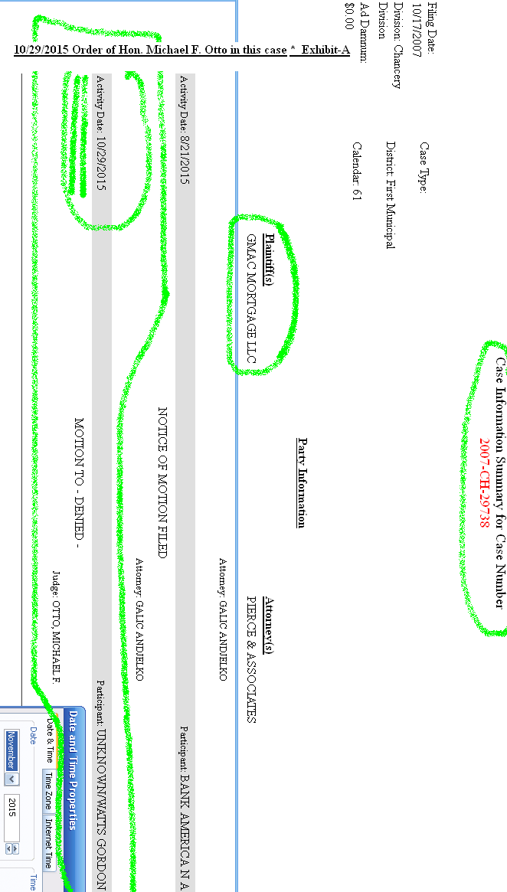
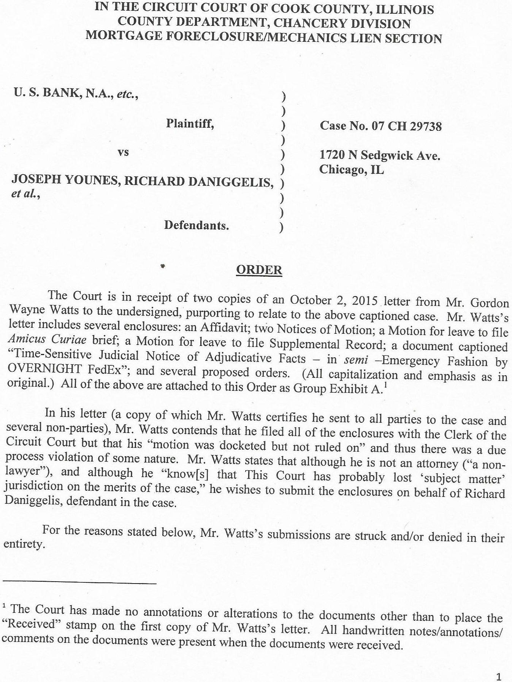
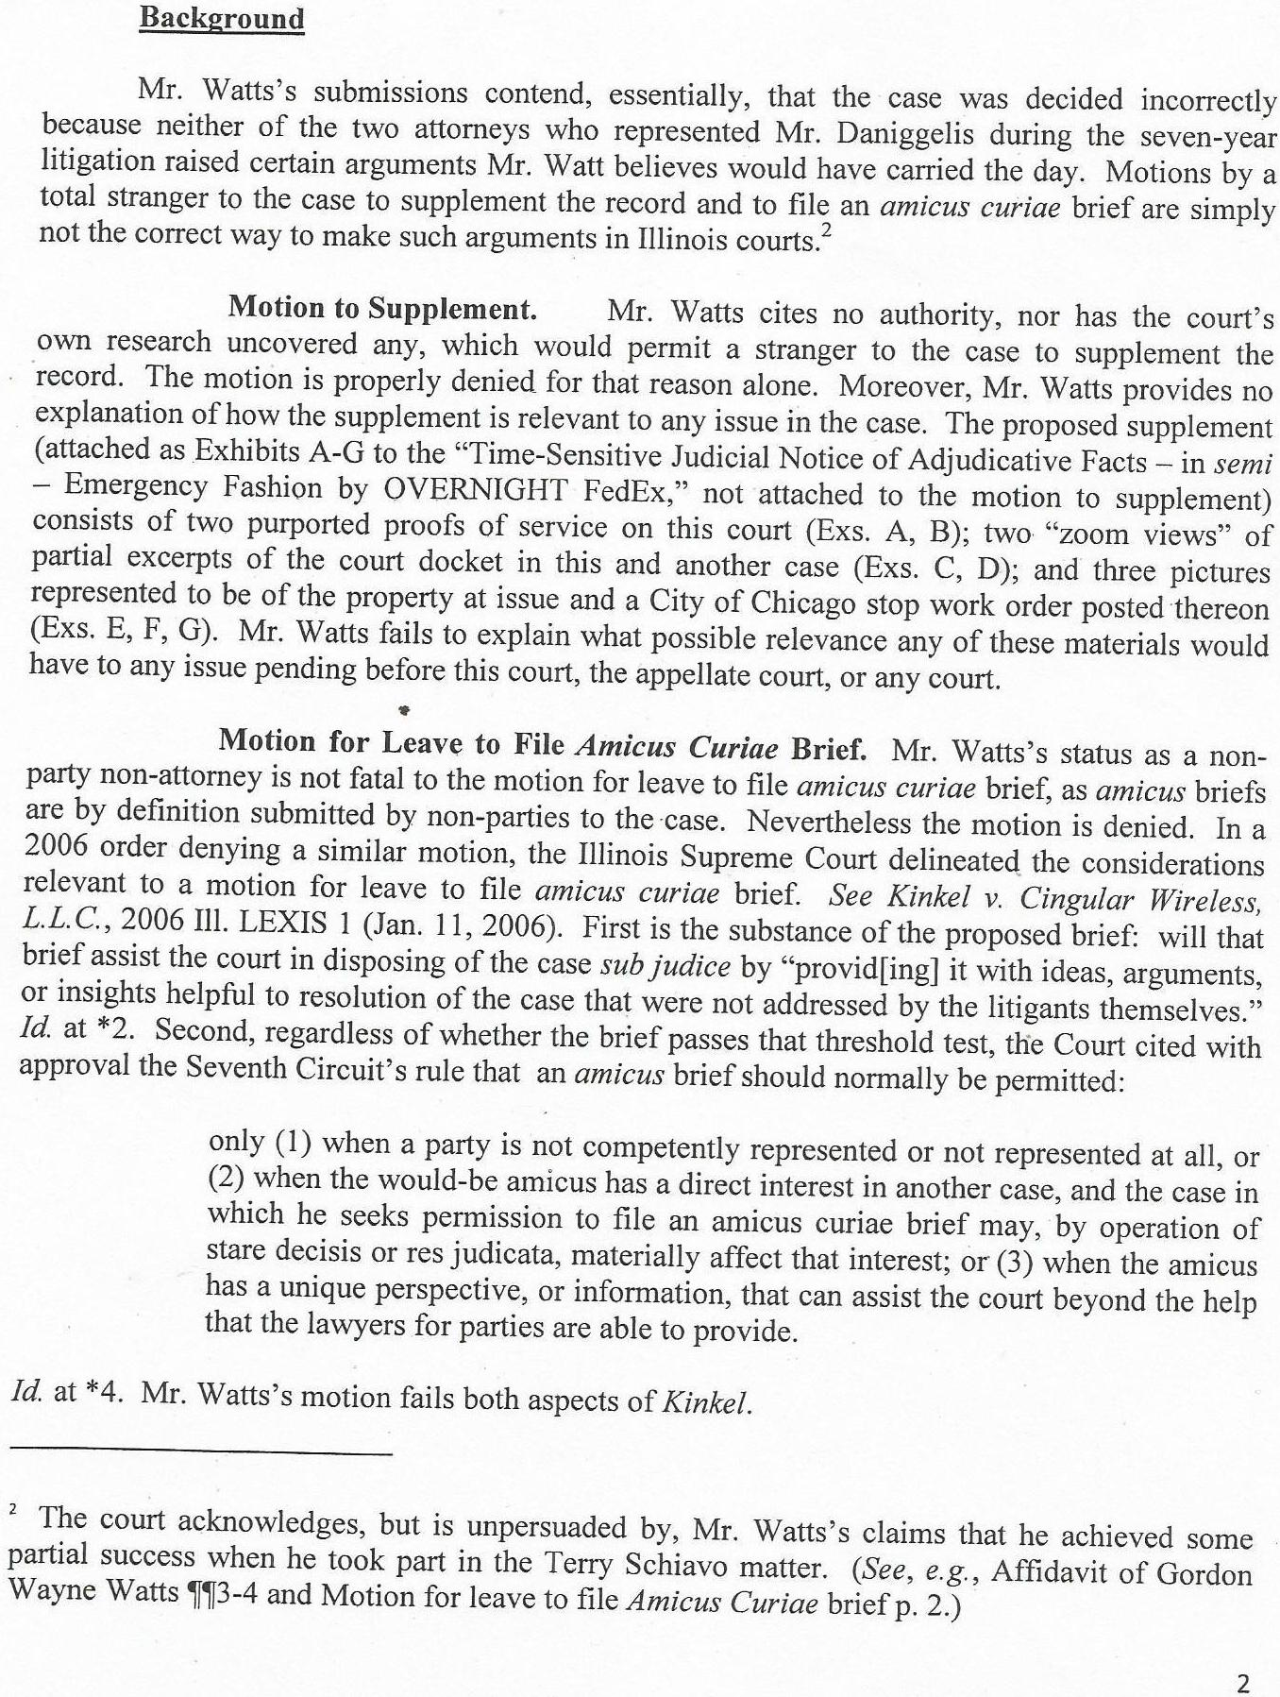
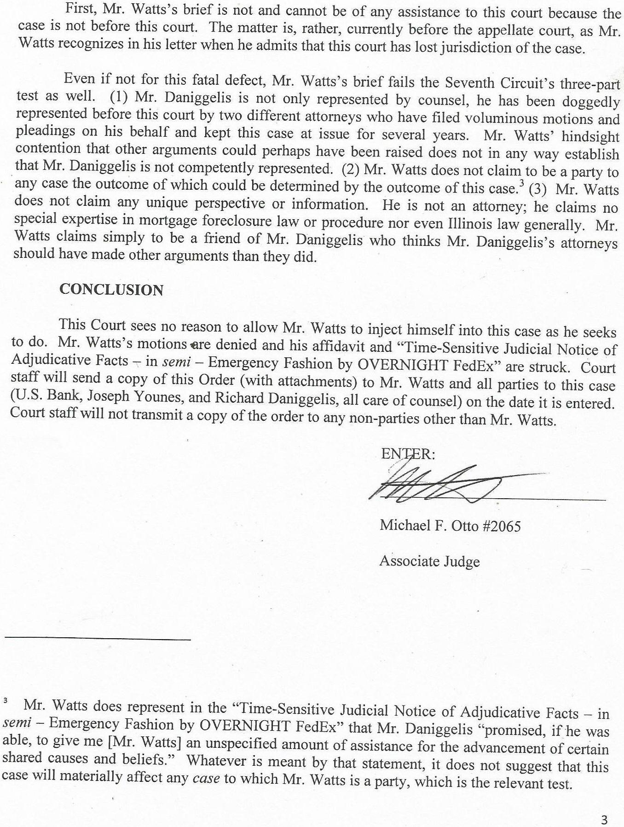
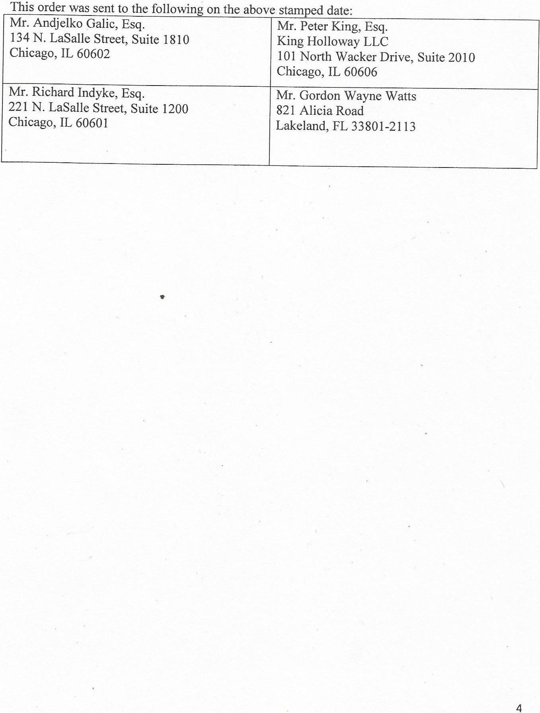
06/21/2013 Docket entry for Mr. Robert J. Moore [sic: 'More'] in this case Exhibit-B1
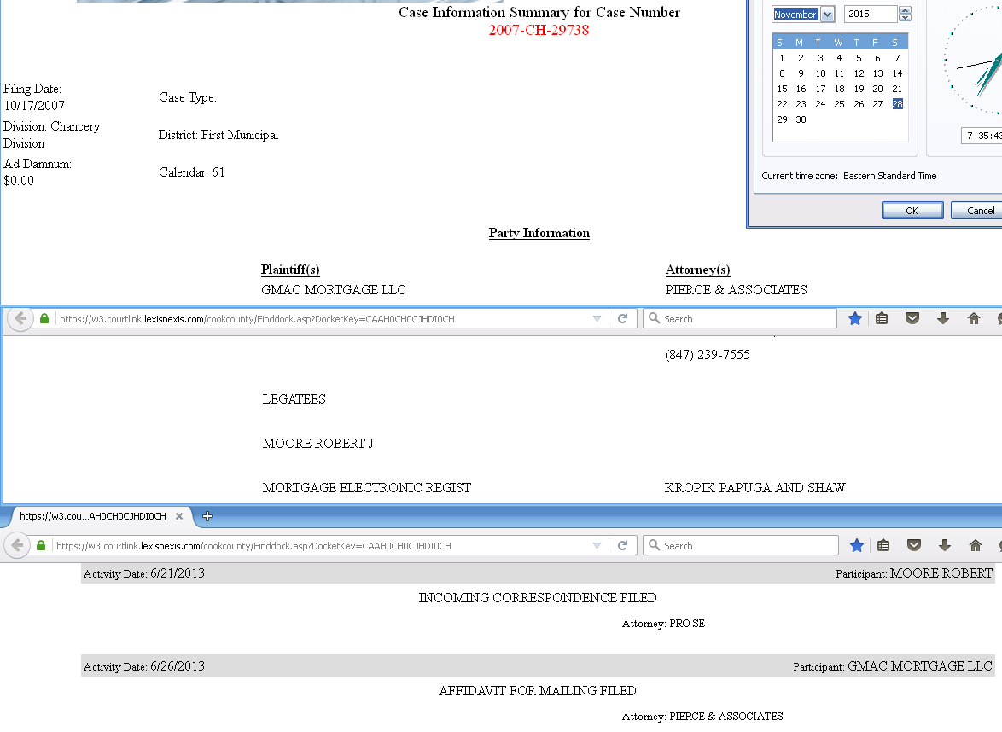
04/16/2012 (APR 17 2012) Order of Hon. Eileen O'Neill-Burke, imposing sanctions upon Mr. More in More v. City of Chicago (2011-M1-12530) Exhibit-B2 (Part 1: order proper)
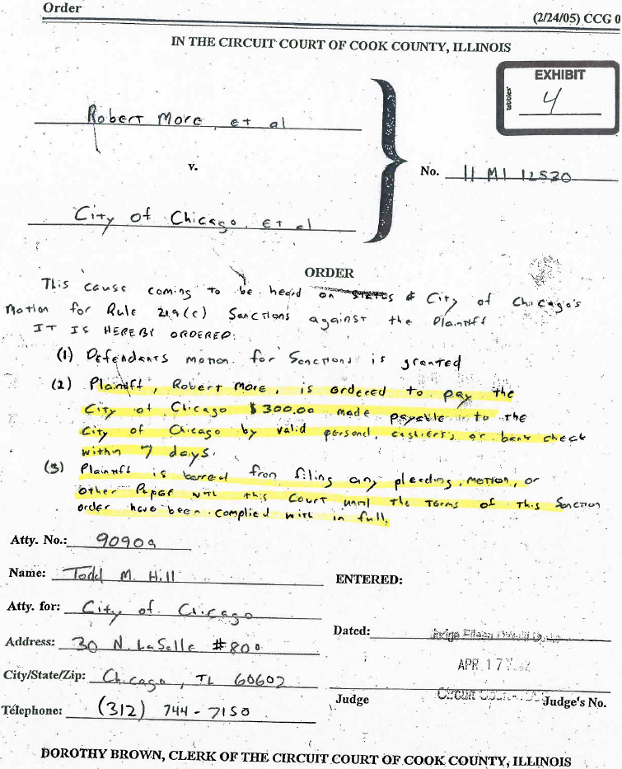
04/16/2012 (APR 17 2012) Order of Hon. Eileen O'Neill-Burke, imposing sanctions upon Mr. More in More v. City of Chicago (2011-M1-12530) Exhibit-B2 (Part 2: City letter)
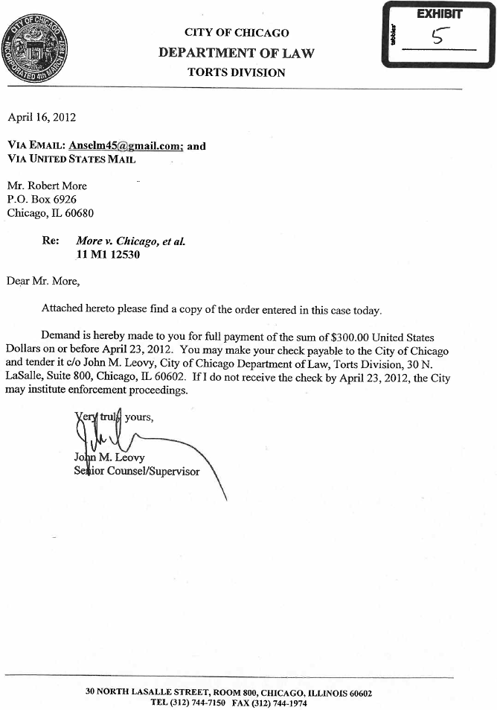
6/1/11 Intentional Tort complaint of Robert J. More – a sample filing
in STATE COURT: (case number 2011-M1-013782, More v. Jack) Exhibit-B3
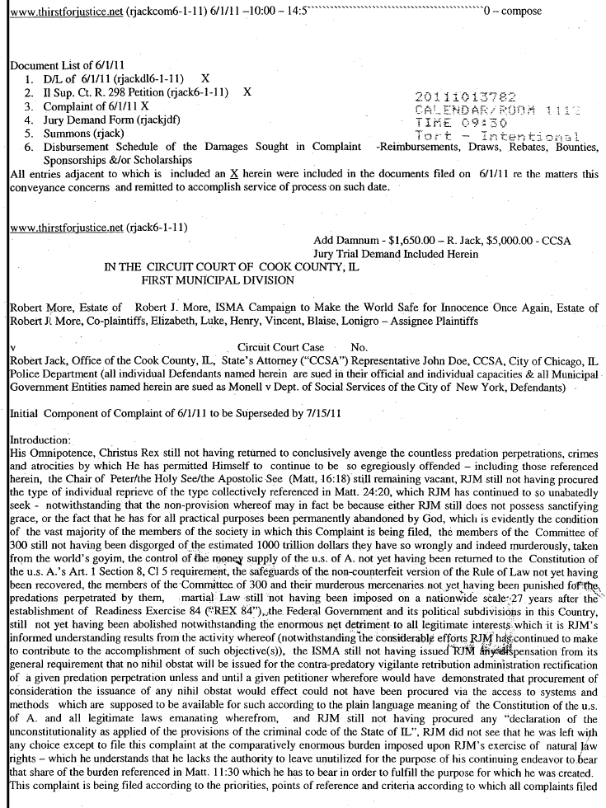
Mar 03, 2008 Notice of Appeal filed by Robert J. More – a sample filing in
FEDERAL COURT: (case number 04-cv-3214, E.D. NY, More v. Monex) Exhibit-B4

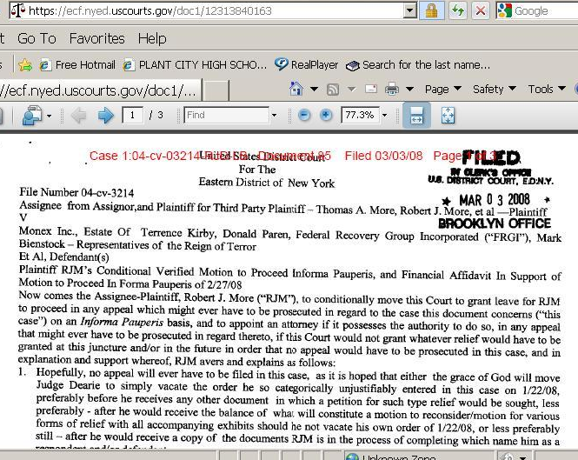

Twenty-Five (25) cases in which Robert J. More has filed as plaintiff
in the CIVIL DIVISION of the Cook County, IL trial courts Exhibit-B5
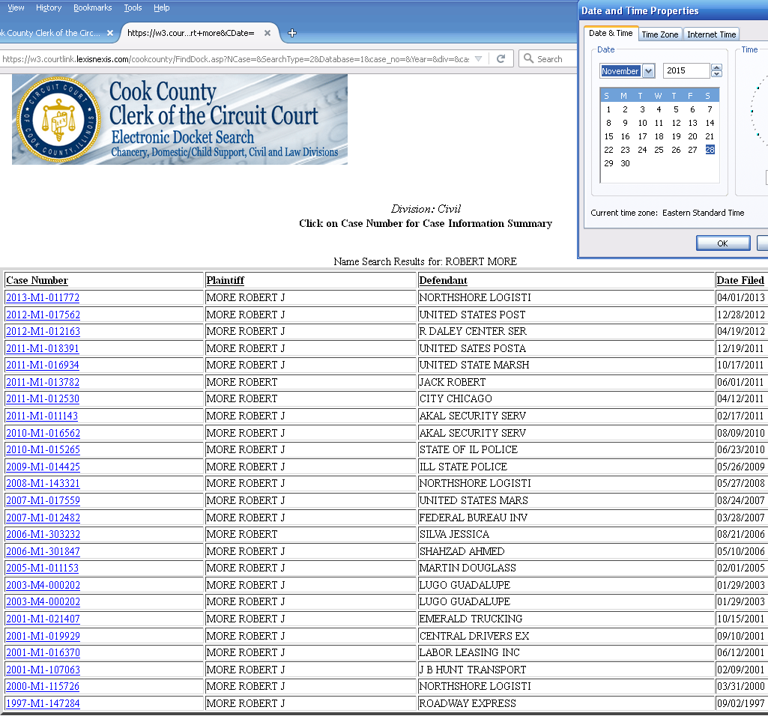
Seven (7) cases in which Robert J. More has filed as plaintiff in
the CHANCERY DIVISION of the Cook County, IL trial courts Exhibit-B6

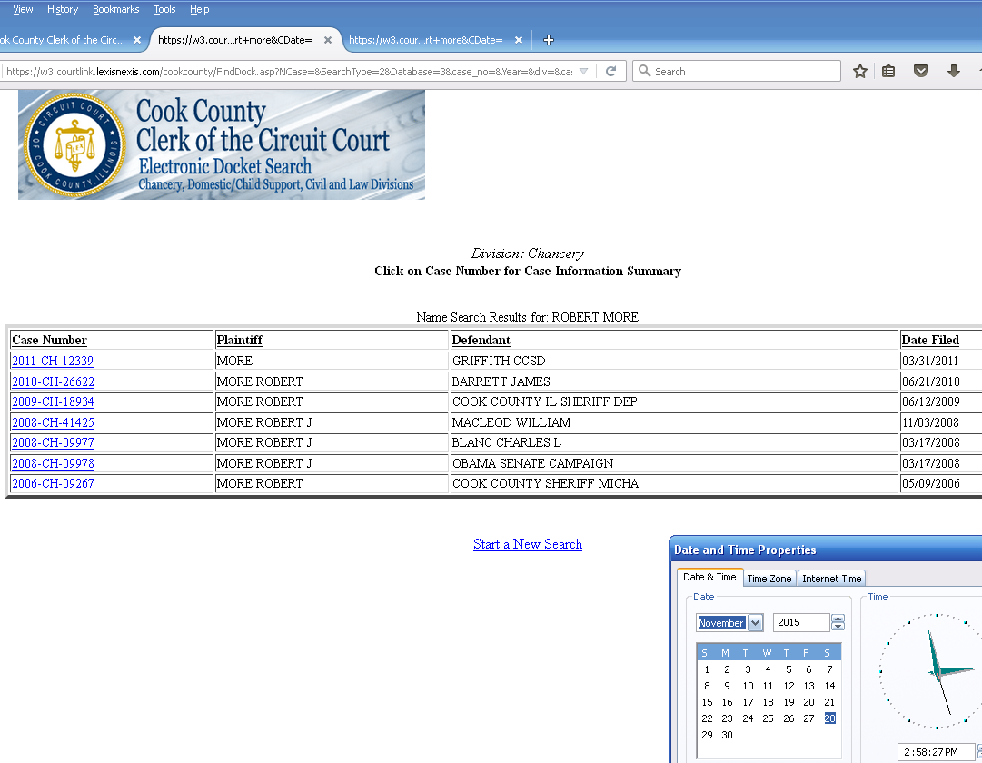
Eight (8) cases in which Robert J. More has filed as plaintiff
in the LAW DIVISION of the Cook County, IL trial courts Exhibit-B7

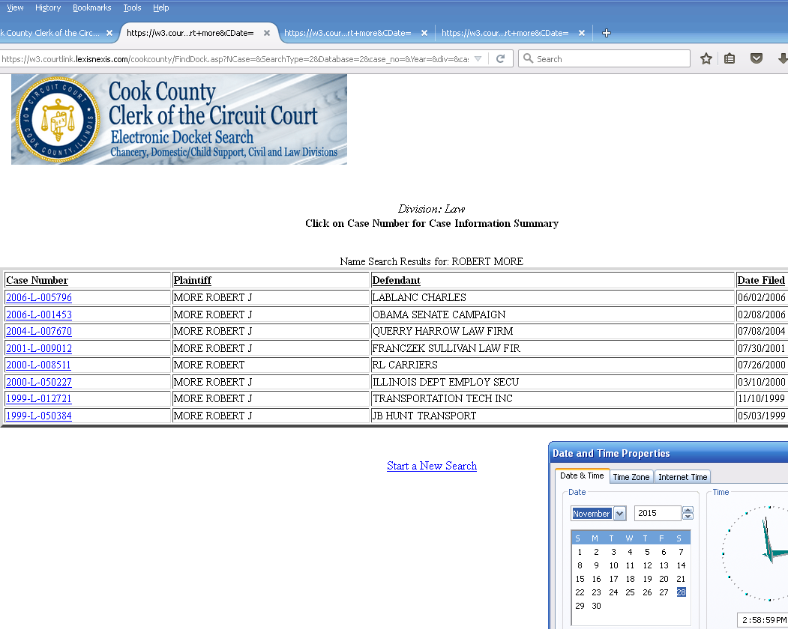
January 06, 2015 Order of Hon. Beverly B. Martin, Federal Cir. Judge
granting Mr. Gordon Wayne Watts' (Pro Se) motion for leave to file an
amended Amicus Curiae brief and denying Mr. Anthony Clare Citro's (Pro Se)
motions for leave to file out of time and for leave to file as Amicus Curiae Exhibit-C1

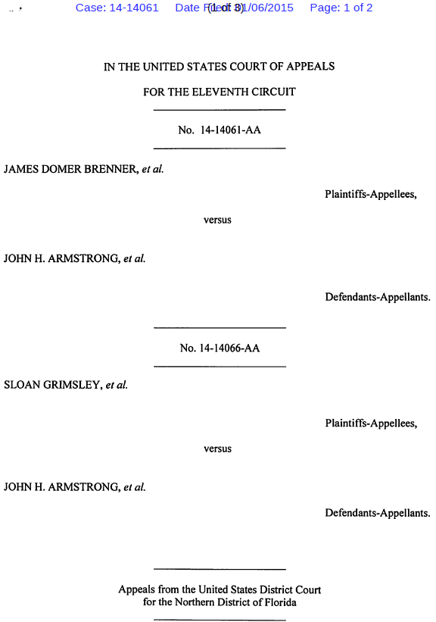
Exhibit-C1 (continued from above)

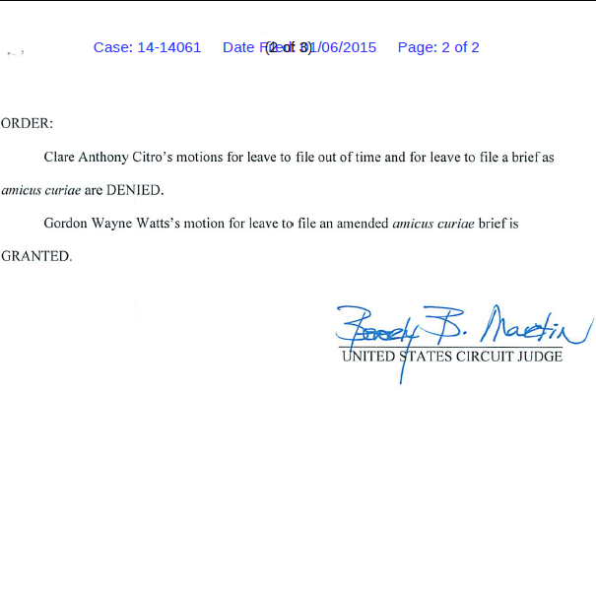
Exhibit-C1 (continued from above)

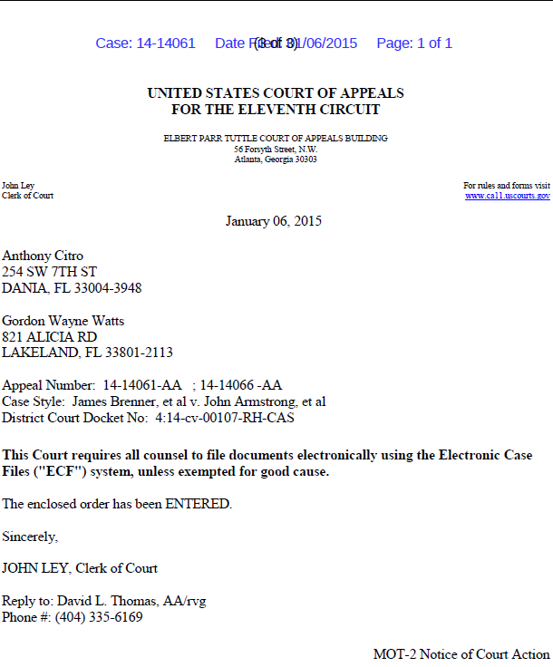

Comparative case-law holdings w/ citations in the internationally-famous 'Terri
Schiavo' case: Mr. Watts ; former Fla. Gov. Jeb Bush ; Schiavo's blood family Exhibit-C2

[1] In Re: GORDON WAYNE WATTS (as next friend of THERESA MARIE 'TERRI' SCHIAVO), No. SC03-2420 (Fla. Feb.23, 2005), denied 4-3 on rehearing. (Watts got 42.7% of his panel) http://www.floridasupremecourt.org/clerk/dispositions/2005/2/03-2420reh.pdf

[2] In Re: JEB BUSH, GOVERNOR OF FLORIDA, ET AL. v. MICHAEL SCHIAVO, GUARDIAN: THERESA SCHIAVO, No. SC04-925 (Fla. Oct.21, 2004), denied 7-0 on rehearing. (Bush got 0.0% of his panel before the same court) http://www.floridasupremecourt.org/clerk/dispositions/2004/10/04-925reh.pdf

[3] Schiavo ex rel. Schindler v. Schiavo ex rel. Schiavo, 403 F.3d 1223, 2005 WL 648897 (11th Cir. Mar.23, 2005), denied 2-1 on appeal. (Terri Schiavo's own blood family only got 33.3% of their panel on the Federal Appeals level) http://media.ca11.uscourts.gov/opinions/pub/files/200511556.pdf

