E-Mail Cover Sheet

From the Desk of: Gordon Wayne Watts
821 Alicia Road – Lakeland, FL 33801-2113
H: (863) 688-9880 – C: (863) 409-2109 – W: (863) 686-3411 or: (863) 687-6141
Email: Gww1210@aol.com / Gww1210@Gmail.com
Web: www.GordonWatts.com / www.GordonWayneWatts.com

To: Atty. Albert S. Krawczyk, Esq., Senior Counsel c/o: Rolanda R. Jones-Golden, Senior Paralegal /Coordinator, for Mr. Krawczyk, Illinois Attorney Registration and Disciplinary Commission, 130 E. Randolph Dr., STE 1500, Chicago, IL 60601-6209 – PH: 312-565-2600 (Switchboard), PH: 312-540-5277 (Mr. Krawczyk), PH: 312-540-5278 (Ms. Golden), E-mails: RGolden@iardc.org, AKrawczyk@iardc.org  Cc: RGreggio@iardc.org (Rita C. Greggio, Esq., Litigation Counsel, PH: 312-540-5209) — Cc's: Information@iardc.org, RBader@iardc.org, EAWelsh@iardc.org, Webmaster@iardc.org | Cc: Peter King (Atty. for Joseph Younes) (Atty. No.: 48761) c/o: King Holloway LLC, www.KingHolloway.com/contact.htm  Attn: Peter M. King, Esq.  One North LaSalle Street, Suite 3040, Chicago, IL 60602, PH: (312) 780-7302 / (312) 724-8218 / Direct: (312) 724-8221, E-mails: PKing@khl-law.com ; PKing@KingHolloway.com  (Not: “101 N. Wacker Dr., STE 2010, Chicago, IL 60606” – Note: Mr. King has informed me that the Wacker Drive address is outdated and that this address is the current service address, and his law office website, listed above, confirms this is correct.) I represent to the IARDC that Mr. King has graciously consented to email service, but, just to be safe, I shall attempt to effect service in all standard methods.
Cc: Joseph Younes Law Offices http://ChicagoAccidentAttorney.net
120 W Madison St Ste 1405, Chicago, IL 60602-4128
PH: 312-372-1122, FAX: 312-372-1408
E-mail is: RoJoe69@yahoo.com per http://www.ZoomInfo.com/p/Joseph-Younes/599467626
Cc: Paul L. Shelton, Esq. Last known cell: (630) 842-0126, per caller ID – E-mail: PMSA136@aol.com,  per: http://www.il-reab.com/agents/26812-paul-l-shelton-shelton-associates-hinsdale-il-60523  E-mail: PLShelton@SBCGlobal.net  per: http://www.zoominfo.com/p/Paul-Shelton/-939241  Note: Mr. Shelton's last known address (10 North Adams Street Hinsdale, IL 60521) has (ironically) gone into foreclosure: “10 North Adams Street, Hinsdale, IL [] House in Hinsdale, Hinsdale, Du Page County, IL, 60521 [] This property was delisted 1 day ago and is no longer available.” Source: http://www.estately.com/listings/info/10-north-adams-street--1  Cf: https://www.redfin.com/IL/Hinsdale/10-N-Adams-St-60521/home/17174116 | Cc: Andjelko Galic, Esq. (Atty. No.: 33013), Atty. for Defendant, Mr. Richard B. Daniggelis, e.g., the elderly victim of the mortgage fraud rescue scheme  134 North LaSalle St., STE 1040, CHICAGO IL, 60602 – (Cell: 312-217-5433, FAX: 312-986-1810, PH: 312-986-1510), E-mail: AndjelkoGalic@Hotmail.com,  and: AGForeclosureDefense@Gmail.com  (Note: The Nov. 16, 2015 proposed order by Mr. Galic in the Law Division case representing Daniggelis, e.g., 2007-CH-29738, GMAC MORTGAGE LLC, et al. v. MR. RICHARD B. DANIGGELIS, et al., suggests that STE 1810 is a old address and that he is now in STE 1040.)
 | Cc: Paul L. Shelton, Pro Se, 3 Grant Square, SUITE #363, Hinsdale, IL 60521-3351
Date: Saturday, 30 April 2016
Subject: Re: Joseph Younes, in relation to Gordon Wayne Watts, case #: 2015-IN-03387
Reply: Dear Atty. Krawczyk: I am in receipt of your postal mail dated Feb. 19, 2016.

Page 1 of 14 -of Gordon Wayne Watts' cross-reply to the IARDC (Sat 30 April 2016)
Thank you for taking time to investigate my complaints & concerns about Atty. Paul Leslie Shelton, Esq. and Atty. Joseph Younes, Esq. Before I reply to your postal letter dated Feb. 19, 2016, I would like to apologize, Big Time – Major League:
As you know, you replied to me over 2 months ago. (And that doesn't even count the time it took for me to write the IARDC –and the time it took for your IARDC Litigation Co-Counsel, Atty. Rita C. Greggio, Esq., to reply before that.)

[[ REASONS for DELAY ]] –Since Mr. Daniggelis (who is now 77-years old, I understand) told me in no uncertain terms that he was homeless & living on the street (and possibly also in a U-Haul-it-type moving vehicle) for at least part of the time subsequent to (and as a direct result of) the “Mortgage Rescue Scheme/Scam,” I had a 'moral' (if not legal) obligation to tarry not: There is no excuse on my end for the untenable delay. But, for the record, I've had to help my elderly, eighty-one (81) year-old father, with his failing business, run household errands, & deal with my own financial problems, and work full-time as the Editor-in-Chief to The Register (which holds many entities responsible for misdeeds, as you may confirm by clicking on said homepage in the Master-head of this reply, immediately above). Additionally, an out-of-town guest needed driving directions when his “smart phone” led him astray; that used up my entire weekend, sitting by Google maps, with him on the phone; I'm exhausted (physically, mentally, & emotionally) , but I have an obligation to you (and Mr. Daniggelis) to reply to your investigatory findings –some of which are incorrect.
Moreover, in spite of the fact that you made several key 'major' screw-ups, I can tell by the diligence you've devoted to your reply, Mr. Krawczyk, that, while imperfect, you're neither dishonest nor lazy: I've done my “Due Diligence” on researching you: You're indeed worthy of the title “Senior counsel,” something that I don't think I can say about the trial court judges overseeing Mr. Daniggelis' case –one of whom never even replied at all to my request to Supplement the Record on Appeal in the Civil Division case –a clear “Procedural Due Process” issue –as it's the initial duty of the trial court (not the appeals court) to address 'Record Supplement' issues for appeals, not even counting the “Sustentative Due Process” issues that became apparent when the trial court simply decided to ignore the clear fraud, when review on the merits was given to both the complaints of Mr. Andjelko Galic (Daniggelis' attorney) and myself.

Again, I tender my deep apologies for my negligence: If anything happens to my friend, Mr. Daniggelis, as a result of my delay, his blood will be on my hands. – Therefore:

Without any further delay, I shall reply to your response, addressing each point—to show proper respect for your Due Diligence:

First, please see below for a copy of your 2-page postal letter to me (albeit marked up with my notes/comments). – Below that, I shall reply to each point – some of which were correct – but some of which were major (tho probably not malicious) screw-ups.

Page 2 of 14 -of Gordon Wayne Watts' cross-reply to the IARDC (Sat 30 April 2016)
IARDC reply to Gordon Wayne Watts, dated Friday, 19 February 2016
Re: Joseph Younes in relation to Gordon Wayne Watts, Case Number: 2015IN03387
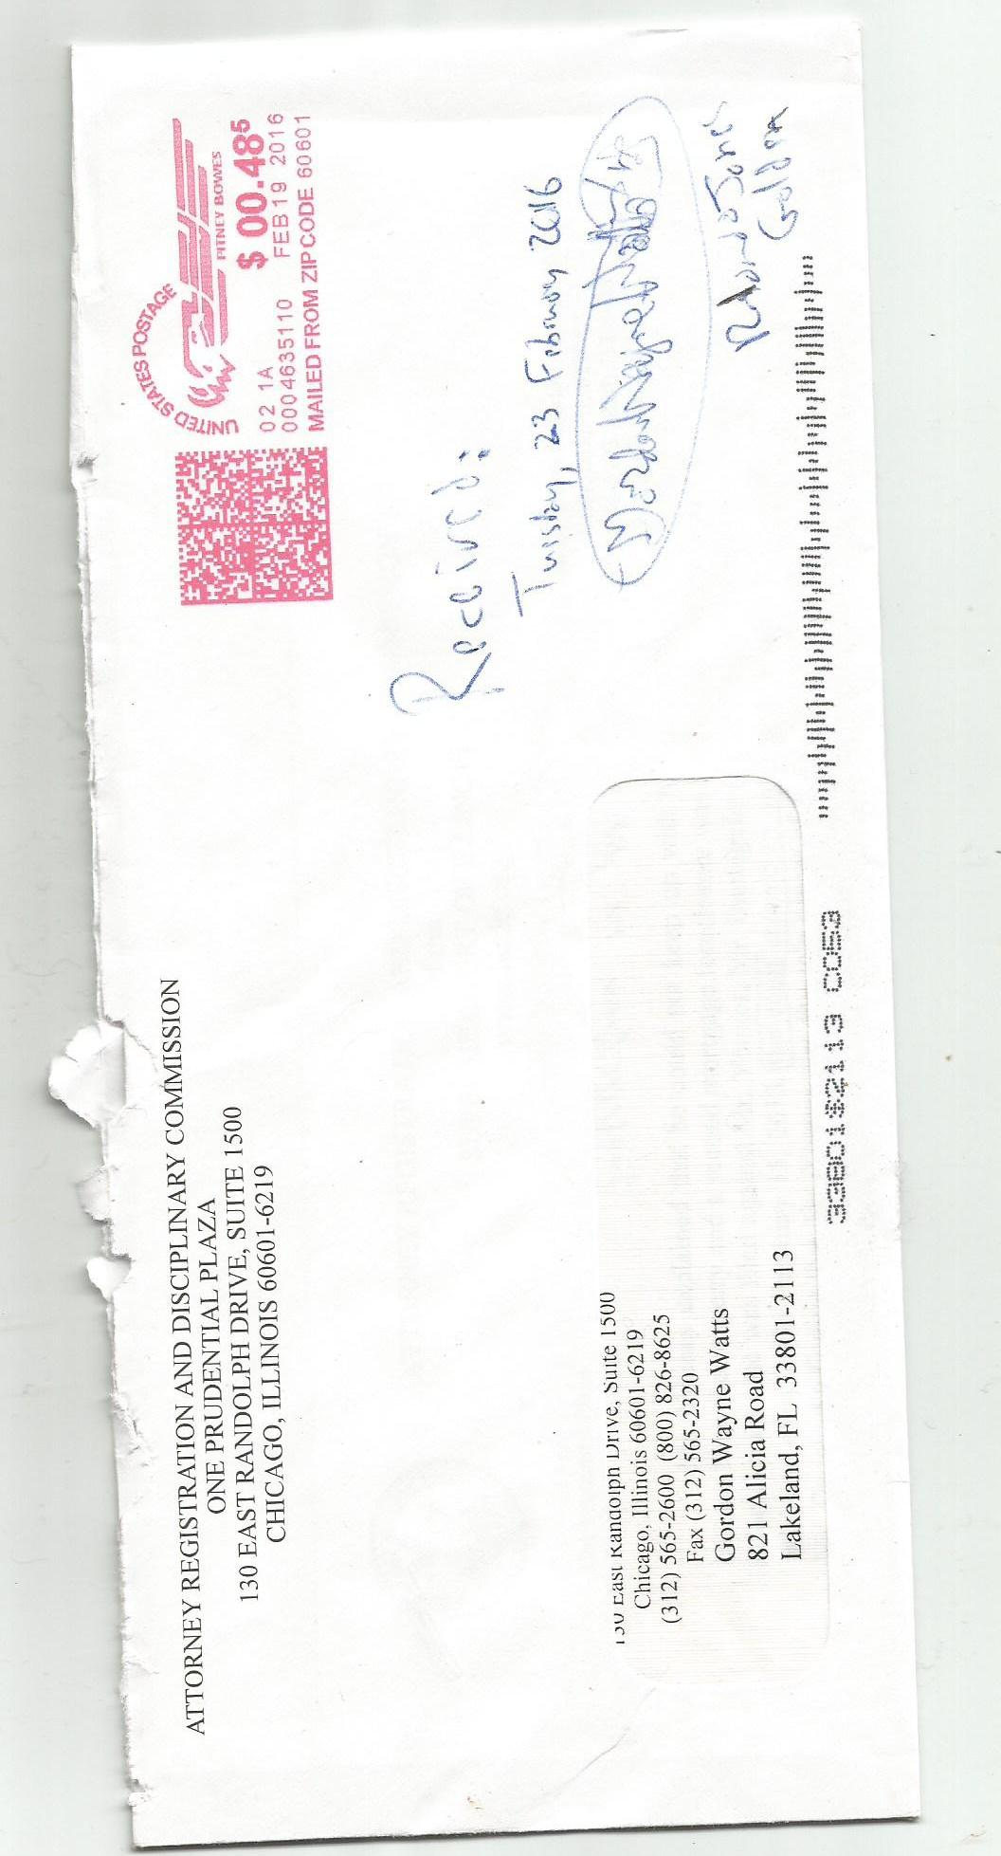
Page 3 of 14 -of Gordon Wayne Watts' cross-reply to the IARDC (Sat 30 April 2016)
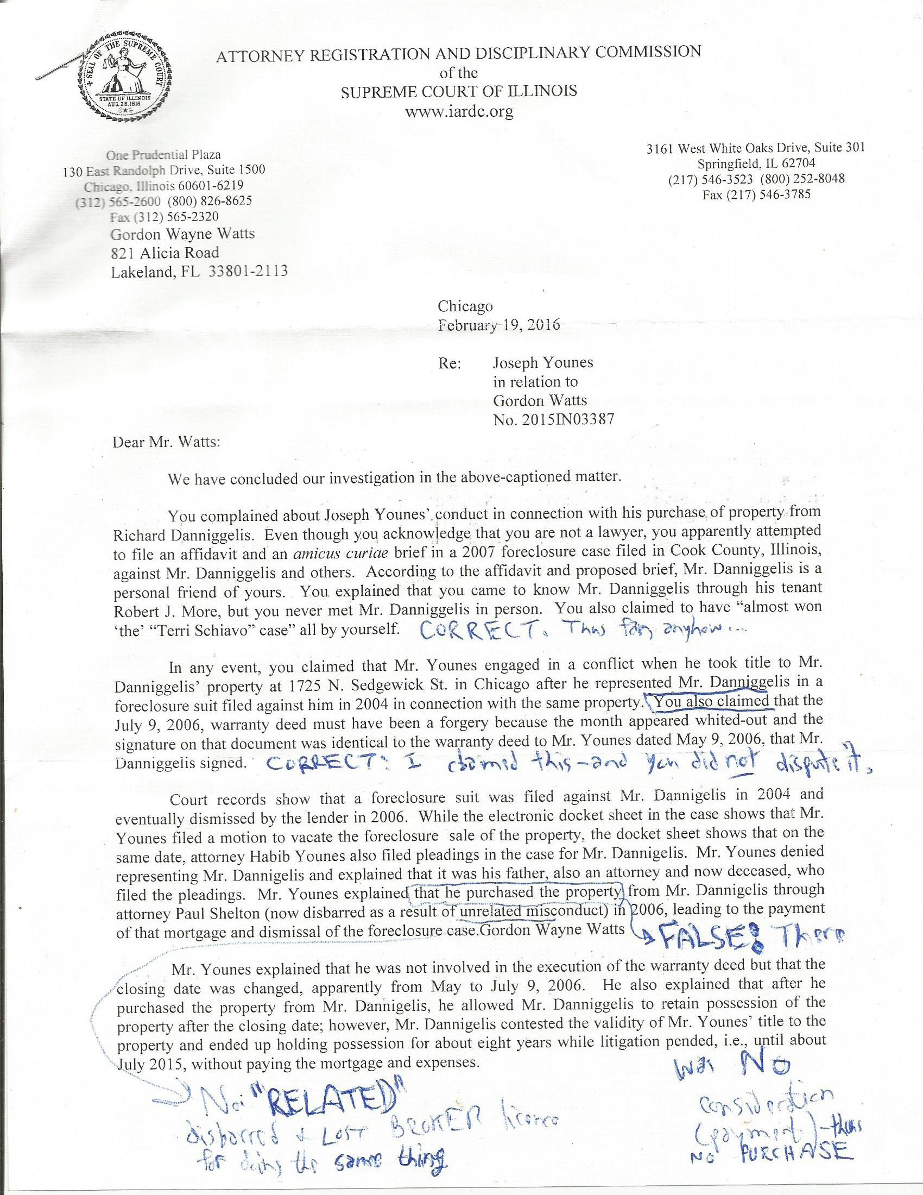
Page 4 of 14 -of Gordon Wayne Watts' cross-reply to the IARDC (Sat 30 April 2016)
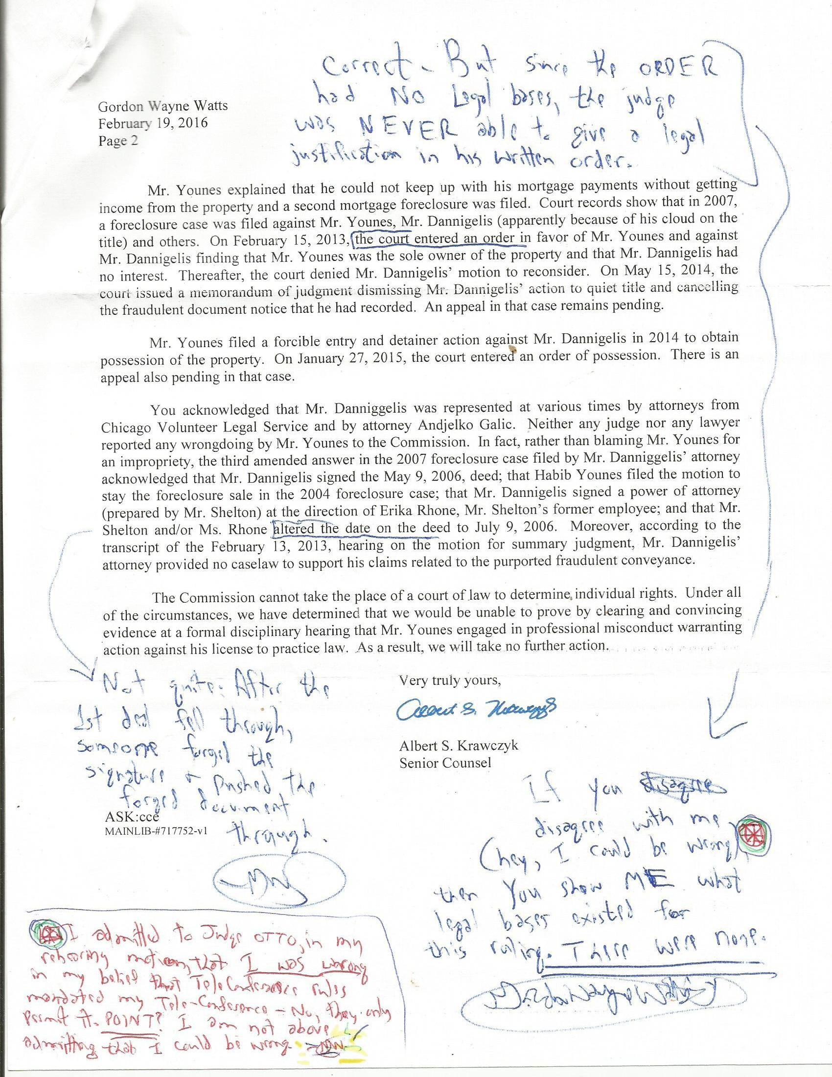
Page 5 of 14 -of Gordon Wayne Watts' cross-reply to the IARDC (Sat 30 April 2016)
Reply proper:

You said: “Dear Mr. Watts: We have concluded our investigation...” Response: Thank you, but you have, for whatever reason, missed some things.

You said: “Even though...you are not a lawyer, you apparently attempted to file an affidavit and an amicus (e.g., friend of the court brief)...” Response: Correct on all points.

You said: “According to the affidavit...Mr. Daniggelis is a personal friend of yours. Response: Correct.

You said: “You explained that you came to know Mr. Daniggelis through...Robert J. More, but that you never met Mr. Daniggelis in person. Response: Correct: We speak by phone on occasion. But, he is still my friend. And, I will add: I know it was the 'real' Richard Daniggelis, not only because of his knowledge of details in the case, which I later verified by numerous 'Records Requests' of the court, but also because of the passion he displayed. Lastly, Mr. More, on occasion, was on 3-way & verified Daniggelis' identity.

You said: “You also claimed to have “almost won 'the' “Terri Schiavo” case” all by yourself.” Response: Correct (as you may confirm by a search of either Lexis/Nexis, the Florida Supreme Court's docket, and/or a good Google search).

* In Re: GORDON WAYNE WATTS (as next friend of THERESA MARIE 'TERRI' SCHIAVO), No. SC03-2420 (Fla. Feb.23, 2005), denied 4-3 on rehearing. (Watts got 42.7% of his panel) http://www.floridasupremecourt.org/clerk/dispositions/2005/2/03-2420reh.pdf
* In Re: JEB BUSH, GOVERNOR OF FLORIDA, ET AL. v. MICHAEL SCHIAVO, GUARDIAN: THERESA SCHIAVO, No. SC04-925 (Fla. Oct.21, 2004), denied 7-0 on rehearing. (Bush got 0.0% of his panel before the same court) http://www.floridasupremecourt.org/clerk/dispositions/2004/10/04-925reh.pdf
* Schiavo ex rel. Schindler v. Schiavo ex rel. Schiavo, 403 F.3d 1223, 2005 WL 648897 (11th Cir. Mar.23, 2005), denied 2-1 on appeal. (Terri Schiavo's own blood family only got 33.3% of their panel on the Federal Appeals level) http://media.ca11.uscourts.gov/opinions/pub/files/200511556.pdf

You know why I mentioned this, right? It was not to 'brag' about myself, but rather to inform / assure you that while I was a “non-lawyer” & “total stranger” (and an imperfect human), that –that, nonetheless, I knew enough about law to not be a “waste of your time.” (I used more solid 'food/water' arguments than Jeb Bush, who focused primarily on the feeding tube, a similar, but distinct, legal issue, and that was probably why my pleading got farther than his: I even picked up several 'liberal' Justice votes in my bitter-sweet 4-3 loss.)

You said: “In any event, you claimed that Mr. Younes engaged in a conflict of interest...” Response: Correct; however, it is possible that I was a 'wee bit' wrong on details, here: The lawyer representing Daniggelis may have been the late Habib Younes, the father of Joseph Younes. Nonetheless, this is a minor point in the grand scheme of things, as conflict of interest still exists for all attorneys at Younes' firm.

Page 6 of 14 -of Gordon Wayne Watts' cross-reply to the IARDC (Sat 30 April 2016)
You said: “You also claimed that the July 9, 2006, warranty deed must have been a forgery because the month appeared whited-out and the signature on that document was identical to the warranty deed to Mr. Younes dated May 9, 2006, that Mr. Daniggelis signed. Response: Correct. I claimed this, and you did not dispute it. Moreover, while I was the only one who raised the issue of the “identical signatures,” in court filings, still – the lack of consideration (payment) alone should have rendered this deal null & void ab initio (e.g., “dead on arrival,” from the very get go). That there was also a white-out only confirmed things. – CAVEAT: While it might require a handwriting expert to compare 2 'different' signatures (to determine if the same person signed them), that was not the case here: These signatures were clearly identical (read: photocopies, forgeries, fraud, felonies).

Mr. Daniggelis was the one who tipped me off to the 'identical signature' forgery (which I eventually confirmed by pulling records from the court), but Daniggelis was unable to inform the court of this, as I have now done: Daniggelis does not know how to file court-type paperwork, and I'm surprised he was able to somehow get a statement (affidavit) into the Recorder's Office that he signature was forged! (He probably had help.)

It is helpful to remember here, Mr. Krawczyk, that while all parties admit that the May 9, 2006 signature was genuine, nonetheless, for whatever reason, the deal fell through, and the closing did not occur within the specified time-frame. (Why else would there even need to be a July 9, 2006 Warranty Deed?) As the closing took place outside the time-window of the only 'real' (read: NOT FORGED) Warranty Deed, it was invalid, and a clear fraud. (Also, Daniggelis, like the very famous Lessie Towns – Google her if you've forgotten – was a victim of a “mortgage rescue scam,” and in both instances, Mr. Paul Leslie Shelton was involved: Shelton is a repeat offender in this regard. Mr. Towns got justice even though she actually did sign away her house: There was coercion and/or misrepresentation. Mr. Daniggelis, unlike Ms. Towns (who was paid a personal visit by then-Gov. Pat Quinn, thereby gaining temporary fame), did not sign anything that failed to have 'safeguards' put in place was to the time of the closing and the purposes, which, of course, were not to simply 'give away' his house, for free! Thus, he is even more deserving of “Justice,” as Mr. More might say –an “inside joke”: I am the webmaster to Mr. More's website, www.ThirstForJustice.net .

You said: “Court records show that a foreclosure suit was filed against Mr. Daniggelis...it was his father, also an attorney and now deceased, who filed the pleadings.” Response: That much seems correct. May his father rest in peace, and I, again, offer my sincere condolences, and respect, to Mr. Younes regarding the passing of his father, Habib.

You said: “Mr. Younes explained that he purchased the property from Mr. Daniggelis...” Response: With all Due Respect to Mr. Younes, that is a bald-face lie: As stated earlier, there is ABSOLUTELY NO record of ANY payment (which would be necessary to claim a 'purchase'). Moreover, remember Younes lied to Rita C. Greggio, as I document in prior

Page 7 of 14 -of Gordon Wayne Watts' cross-reply to the IARDC (Sat 30 April 2016)
communications to the IARDC. Please refer to the Thursday, 08 October 2015 reply to Atty. Rita C. Greggio, your colleague, and the Litigation Counsel initially assigned to this case:

(((A))) First, on page 2 of said reply, I quote Younes, who claims: “In response, I have no idea as to what is being claimed or investigated.” Younes lied to Greggio, as I document: I had filed plenty of litigation in the Chancery and Civil cases by that point, and carefully made Younes sign for his service copies. I showed Greggio the documentation, which can be confirmed as authentic either by clicking on the links to FedEx or by contacting them directly.

Younes knew full-well what my concerns (complaints) were: He lied to the IARDC –and got caught.

(((B))) Secondly, Younes replied to Greggio, and I quoted him where he said: “Apparently Mr. Watts has somehow attempted to embed himself in litigation involving a cloud on the title on a piece of property that I purchased at arm's length from Richard Daniggelis.”

Do you see the problem here, Mr. Krawczyk?

While, yes, I did attempt to 'embed' myself in said litigation, Younes' claim of an “at arm's length” relationship was, legally, false. (See page 6 of that reply for details: (Of course, since Younes –or perhaps his father – entered an appearance for Daniggelis in Deutch Bank v. Daniggelis, 2004-CH-10851, there was both 'control' and a 'special relationship,' thus this was an “Arm in Arm” transaction.

So, let's get clear here: Younes lied to you about his claim that there was a sale (which would necessitate payment, of course), and he lied to Greggio at least twice (maybe more?). Moreover, he & Shelton (a repeat offender who was very famous: Google “Paul Shelton” and “Lessie Towns” and “Pat Quinn” if you didn't get the note) are basically getting a free piece of property and house. Unless you act. Or a miracle occurs.

The claims that Daniggelis got a “free ride” from Younes & Shelton are not only false, but the opposite is quite true: This doesn't even count the huge quantity of rent that Daniggelis lost because no sane renter in his right mind would move in to a place with a cloud hanging over the title; he was lucky to get Mr. More to live with him rent-free!

You said: “Mr. Younes explained that he was not involved in the execution of the warranty deed but that the closing date was changed...” Response: How convenient that he would not remember, but still somehow benefit financially by getting property changed into his name, even in spite of the fact that a whole bank of trial court judges could offer no explanation. (They issued orders of 'what' happened, but nothing to justify 'why.')

Page 8 of 14 -of Gordon Wayne Watts' cross-reply to the IARDC (Sat 30 April 2016)
You said: “...Mr. Daniggelis contested the validity of Mr. Younes' title to the [house and] property...” Response: I am sure that you would too, should someone simply forcibly snatch your house and land without ANY payment WHATSOEVER, simply as a result of the fact of you putting an ad in the paper for help to refinance, seek renters, investment, etc. – and your point?...

But I do acknowledge – again – your (true) claim that Daniggelis didn't pay 'rent' to Younes; yes, this point is moot in light of the theft of both house, land, and ability to rent a place with a cloud over the title (not to mention the various documented frauds that myself and Atty. Andjelko Galic – and Atty. Benji Philips – all three uncovered).

You said: “Mr. Younes explained that he could not keep up with his mortgage payments...” Response: Did you say 'his' mortgage payments? Mr. Younes' that is? Don't you think that your statement is unproved (as even you admit an appeal is ongoing)??

No, of course these were not Younes' payments to make.

However, it is no surprise that Younes was unable to keep up with said payments. He grabbed something that did not belong to him, and he got bit; that is his own fault, and no one else's.

You said: “On February 15, 2013, the court entered an order in favor of Mr. Younes...finding that Mr. Younes was the sole owner...” Response: Correct, but oddly-enough, neither the court nor Mr. Younes offered any explanation as to why in the world this could ever be legal. If you think that I am wrong here, I will listen to your explanation & wisdom, and quietly slink off into the darkness, admitting I am wrong, but if you can offer no explanation for the Feb. 15 ruling, then apparently you overlooked something big –possibly putting Daniggelis' life (or health) at risk, as this both makes him homeless, as well as constituted duress and both emotional and financial stress.

To clarify: Look again at the Feb. 15, 2013 ruling: It states what happened, but offers **no** legal justification. Moreover, reading the various briefs filed by Shelton and Younes, one sees that their only argument is that Daniggelis simply “signed away” his house, in his family for generations, and with hundreds of thousands of dollars of equity – for FREE: There is absolutely NO record of “consideration” (e.g., documented payment to Daniggelis). This causes three (3) problems, Mr. Krawczyk: ((#1)) First, as a “practical” matter, it's unreasonable to assume anyone in their right mind (or even anyone in their 'crazy' mind) would simply “give away” such large quantities of equity (not to mention the sentimental value that was once his grandfather's house). ((#2)) Secondly, as a “moral” issue, theft is wrong. (Are courts & regulatory agencies –such as yours –still guided by mores & morals?) ((#3)) Thirdly, while numerous “legal” problems exist, one “jumps off” the pages of the brief at me (and you too?): Did you not notice that absolutely NO record of 'consideration' (e.g., payment) exists for said house and property?

Page 9 of 14 -of Gordon Wayne Watts' cross-reply to the IARDC (Sat 30 April 2016)
Look again at Argument IV. C. “Lack of consideration (payment),” on page 6 of my Amicus, dated Monday, 03 August 2015, in the underlying Chancery Division case (GMAC v. Daniggelis: Case No.: 2007 CH 29738): It's well-settled case-law that no contract is valid if it lacks consideration: Sometimes consideration is “nominal,” meaning it was stated for form only, such as “for and in consideration of TEN and NO/100ths Dollars ($10.oo) and other good and valuable consideration in hand paid,” (as was done on these Warranty Deeds) –and sometimes used to hide the true amount being paid. But it's also undisputed that Consideration must be of value (at least to the parties), and is exchanged for the performance or promise of performance by the other party. This, alone, voids the so-called “sale”: Stilk v. Myrick, 170 Eng. Rep. 1168, 1168 (1809) (L.R.C.P) (Ellenborough, L) (holding a renegotiated contract void due to lack of consideration).

This case law is old, but undisturbed and valid.

However, more “to the point”: Daniggelis reported to me that he was offered about $1,500.oo dollars, but refused to cash the check, as he never consented to any 'sale.' If you can show me “real” bank records, not just some 'vague' claim by Younes, where he cashed a check for any amount at that time, I'll concede that I'm an idiot & admit wrong... Not.

For the record, in one Chancery filing, which you may have come across, I told Hon. Judge Michael F. Otto, that I had a 'right' to a telephonic hearing, but he showed me where statutory law and case law said differently. –RESULT? I apoligised & admitted that I was wrong: Procedural Due Process didn't even give a right to appear in court (physically or by telephonic conference) for parties to the case, much less myself. –So, I'm open to admitting that I am wrong – IF and ONLY if I'm actually wrong.

You said: “An appeal in that [Chancery Division] case is remains pending...There is also an appeal pending in that [Civil Division] case [the eviction resulting from the Chancery ruling]...” Response: Correct, but whatever may (or may not) happen in either of these cases can not –and will not –(legally) abrogate, annul, or obviate your moral & legal duties to consider my claims that you overlooked key “issues of fact” (resulting in key screw-ups at law, some of which may jeopardise life or health –and set bad precedent, sending the 'wrong message' to bad guys, who, unlike yourself and myself, don't operate with honour or integrity). Translation: This is no excuse to “look the other way.”

You said: “You acknowledge that Mr. Daniggelis was represented at various times by [several] attorneys...” Response: Correct, but this does not somehow give me an excuse to “pass the buck” or “look the other way,” when I see wrongdoing proceed unchecked. And your point?... You said: “Neither any judge nor any lawyer reported any wrongdoing by Mr. Younes to the [Illinois Attorney Registration and Disciplinary] Commission. Response: Correct, but your point?... That is interesting, but not determinative nor conclusive to my complaints.

Page 10 of 14 -of Gordon Wayne Watts' cross-reply to the IARDC (Sat 30 April 2016)
You said: “In fact, rather than blaming Mr. Younes for any impropriety, the third amended answer in the 2007 foreclose case filed by Mr. Daniggelis' attorney acknowledged that Mr. Daniggelis signed the May 9, 2006 deed...and that Mr. Shelton and/or Mr. Rhone altered the date of the deed...” Response: OK, I can't find this particular reply brief in my own online docket[[**]] records (which, I admit, are incomplete due to the cost factor of posting thousands of records online), but as it sounds right, I'll take your word. However...

[[**]] www.GordonWatts.com/MortgageFraudCourtDocs/DOCKET-MortgageFraudCase.html
mirror:
www.GordonWayneWatts.com/MortgageFraudCourtDocs/DOCKET-MortgageFraudCase.html
See also: “(Tue. 01 Dec. 2015, from Staff Reports) Courts * Chicago Courts refuse to help elderly 'Mortgage Rescue Scam' victim; make him homeless:” news item as front-page news on The Register, at www.GordonWatts.com or www.GordonWayneWatts.com

First off, as I've stated before, we all agree that Daniggelis signed the May 9, 2006 deed, but this point is moot: The deal (for whatever reason) feel through, and the closing did NOT take place during the time-frame limited by the POA (Power of Attorney) in this case. Your point?...

Secondly, some attorney admitted that the deed was altered? Your point?... This seems to prove that there was fraud committed. Absent evidence otherwise, I don't see why you have failed to act.

You said: “Moreover, according to the transcript of the February 13, 2013, hearing on the motion for summary judgment, Mr. Daniggelis' attorney provided no caselaw to support his claims related to the purported fraudulent conveyance.” Response: OK, maybe he didn't provide any Oral argument, but you did read his briefs related to the lack of consideration (payment) and some evidence of an altered signature, right? (This begs the question: Why could the court legally just 'give away' a family house with hundreds of thousands of dollars of equity that has, since, been squandered and unaccounted for – without consideration – e.g., payment.) Moreover, so what if his attorney is incompetent? (I don't think he is, but I infer that from your statement.) So what? Since ** I ** provided all the proof necessary of multiple frauds, what is your concern here?

PS: I don't mean to be harsh, Mr. Krawczyk. Again, respectfully, you have done probably more to investigate legitimate complaints at law than all the trail courts **combined** – but, respectfully, your miss the point: Laws were broken. Lots of them.

You said: “The Commission can not take the place of a court of law...” Response: No, but if you are using the courts as an excuse to not do your job, then you mind as well close shop and never investigate any complaint again, and merely “pass the buck.” (But surely you could not have meant that, now could you?)

Page 11 of 14 -of Gordon Wayne Watts' cross-reply to the IARDC (Sat 30 April 2016)
You said: “Under all of the circumstances, we have determined that we would be unable to prove by clear and convincing evidence...that Mr. Younes engaged in professional misconduct...Very truly yours, Albert S. Krawczyk [] Senior Counsel” – Response: Thank you for your efforts so far. – So, your state (Illinois) uses the intermediate standard, eh? That is one of the four (4) 'main' standards for a 'Burden of Proof':

- Reasonable suspicion (A low standard of proof to determine whether a investigation by some government agent –such as yourself –is warranted –or a search by a police officer in a similar setting.)
- Preponderance of the evidence (Aka: “balance of probabilities,” often times “50% plus one” likelihood.)
- Clear and convincing evidence (The intermediate standard you say that you all are using, e.g., between #2 above and #4 below.)
- Beyond reasonable doubt (Not quite the impossible standard of “Beyond the shadow of a doubt,” but certainly the highest standard in Anglo-American jurisprudence & typically only in criminal proceedings, where there's no plausible reason to believe otherwise.)

OK... very well. I think that you and co-counsel Greggio were lied to no less than three (3) times, and that you (being human and busy) overlooked some key evidence and (related) arguments, as evidenced by some of your statements.

Let us also not forget, Mr. Krawczyk, that Under Illinois law, the continued open and visible possession of the home by the scammed homeowners, after being duped by the foreclosure rescue operator, is sufficient to charge those subsequently acquiring title & security interests in the home with notice of the fraud, thereby disqualifying them from bona fide purchaser status. An Illinois appeals court ruling in Life Savings & Loan Association v. Bryant, 125 Ill. App. 3d 1012, 81 Ill. Dec. 577, 467 N.E.2d 277 (1st Dist. 1984) addresses this point: Illinois courts have uniformly held that the actual occupation of land is equivalent to the recording of the instrument under which the occupant claims interest in the property. (Bullard v. Turner (1934), 357 Ill. 279, 192 N.E. 223; Beals v. Cryer (1981), 99 Ill. App. 3d 842, 426 N.E.2d 253).

*** ADMISSION ***

If you can find fault with even one of my assertions (particularly my claim that absolutely NO record of 'consideration' – e.g., payment – exists, thus rendering the 'sale' null and void), then I will admit wrong and withdraw my requests for First Amendment Redress here. Please bear in mind, Mr. Krawczyk, that my lack of 'standing' as a 'party' does not abrogate any regulatory agencies from their duties, as if that is somehow an excuse, and I am heartened and thankful by the fact that you have taken your job seriously, in stark contrast to the court who have used this as an excuse to pass the buck or “look the other way.” BUT: The job is not done, and an injustice remains.

Page 12 of 14 -of Gordon Wayne Watts' cross-reply to the IARDC (Sat 30 April 2016)
I am not – in any way – accusing you of engaging in any of this, as your involvement is a matter of “first impression,” and you – in spite of several key screw-ups – still did a pretty good job as an investigatory agency, here.
But, please be on note that this has gone on long enough, and justice delayed is justice denied: Since I have documented no less than three (3) times where Younes lied to you (not counting the fact that Shelton is a repeat offender, here, in regard to “Lessie Towns” fame: Google him, if you forget), I have about had it with corrupt Illinois courts.
Since I am now going to be involving the local news media, the Attorney General's Office (due to the repeated false statements to your agency, the IARDC), and the Cook County SAO ('State's Attorney Office,' which has previously expressed in telephone calls that the SOL, e.g., 'Statutes of Limitations,' has run out), I have an obligation to show the SAO that it was in legal error in its claims that the SOL have expired and run out. – To that end, I'm appending my complaint with some relevant case law that may – or may not – be relevant to your investigation:

Statutes of Limitations

As you know, on April 20, 2007, Daniggelis executed a “Fraudulent Document Notice” to both the Cook County Recorder's office (doc number: 0711039132, on 4/20/2007) and to the trial court (exhibit 'F' of the July 30, 2008 filing by Atty. Benji Philips, in 2007-CH-29738, in Chancery) that the July 09, 2006 Warranty Deed (doc no: 0622826137 at the Recorder's Office, on 8/16/2006) was a forgery. Since he regularly complained to both the cops and the courts, even putting it “on record,” then the police, sheriff, courts system, state attorney's office, AND the attorney general's office should have had official notice of this and questioned Daniggelis for details so that this felony forgery fraud (by photocopying a signature) could be investigated and prosecuted. That is wasn't investigated in a timely fashion might result in the Statutes of Limitations running out for forgery, perjury, or other such criminal felonies. However, “Delay in the prosecution of a suit is sufficiently excused, where occasioned solely by the official negligence of the referee, without contributory negligence of the plaintiff, especially where no steps were taken by defendant to expedite the case.” Robertson v. Wilson, 51 So. 849, 59 Fla. 400, 138 Am.St.Rep. 128. (Fla. 1910) Moreover, “When facts are to be considered and determined in the administration of statutes, there must be provisions prescribed for due notice to interested parties as to time and place of hearings with appropriate opportunity to be heard in orderly procedure sufficient to afford due process and equal protection of the laws…” Declaration of Rights, §§ 1,12. McRae v. Robbins, 9 So.2d 284, 151 Fla. 109. (Fla. 1942) While this is Florida case law (where I am more familiar), I am sure that any good lawyer could find Illinois state law to support this. – In fact, EEOC v. Indiana Bell, 256 F.3d 516 (2001), allows for excusable delay in filing, prosecution, etc., and as this is a Federal case, the Supremacy Clause would probably control on this point of law, if Illinois State Law is silent. (And, any judge or justice who was truly seeking Due Process and Equal Protection, would find this to be Constitutionally sound case law—and allow Daniggelis to avoid being penalised or lose his house simply because the cops,

Page 13 of 14 -of Gordon Wayne Watts' cross-reply to the IARDC (Sat 30 April 2016)
courts, and state attorney's office kept “passing the buck” back and forth until the clock ran out. Of course, since cops, courts, and SAO refused to act when they could, this is legally equivalent to fraudulent concealment. In addition, there indeed is Illinois state law in favour of equitable tolling for Daniggelis, should he need it: Equitable tolling of a statute of limitations is appropriate if the plaintiff has been prevented from asserting his or her rights in some extraordinary way. (Daniggelis, whose has counter-claims of fraud, would be a plaintiff here, and thus this controls.) Ciers v. O.L. Schmidt Barge Lines, Inc., 285 Ill.App.3d 1046, 1052, 221 Ill.Dec. 303, 675 N.E.2d 210 (1996). Thus, even if Statutes of Limitations is used to bar Daniggelis' claims on this head (and it may not), here is case law to grant justice & prevent his house from outright being stolen in this mortgage fraud.

PS: I am including some supporting documentation in this reply, in order to make it more convenient for you to have access to the key documents in question. – CAVEAT: I am not forging documents, myself, but please do not take my documents to be 'genuine': For 'Official' documents, I refer you to the court, which – I see – you have accessed and reviewed.

Finally, as I've stated before, if I'm wrong, please show me where I'm wrong; if not, please take appropriate action with regard to Younes, Shelton, and the other players.

With kind regards, I am,

Sincerely,

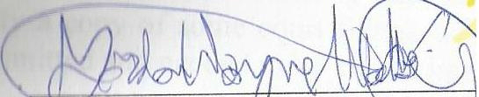
_______________________
Gordon Wayne Watts

Page 14 of 14 -of Gordon Wayne Watts' cross-reply to the IARDC (Sat 30 April 2016)

