APPEAL TO THE ILLINOIS DISTRICT (APPELLATE) COURT, FIRST DISTRICT
FROM THE CIRCUIT COURT OF COOK COUNTY, ILLINOIS
COUNTY DEPARTMENT – LAW DIVISION, First Municipal District, Calendar "W"

GMAC Mortgage, LLC n/k/a: Bank of America, )
N.A., aka: “LaSalle Bank National Association, )
aka: “US Nank, NA,” as trustee for Morgan ) Circuit Court Case No.: 2007-CH-29738
Stanley Loan Trust 2006-16AX, Plaintiff, ) { Transfer into Law Div. from Chancery }
)
vs. ) Trial Judge: Hon. Diane M. Shelley (#1925)
) Date of Notice of Appeal: January 08, 2018
Richard B. Daniggelis, Gordon Wayne Watts, ) Date of Judgment: December 07, 2017
Joseph Younes, Mortgage Electronic Registration ) Date of Post-judgment Motion: None
Systems (MERS), Paul L. Shelton, Erika R. Rhone, ) Order: #5
STEWART TITLE ILLINOIS, John P. LaRocque, )
Robert J. More, LEGATEES, NON-RECORD ) Supreme Court Rule(s) which confer(s)
CLAIMANTS, UNKNOWN, HEIRS, ) jurisdiction upon the reviewing court:
UNKNOWN OWNERS, et. al., Defendants. ) Ill.Sup.Ct. R.301, 303

NOTICE OF APPEAL
Defendant-Appellant, Gordon Wayne Watts, pro se, hereby gives notice, pursuant to Supreme Court Rule 301, that he appeals to the Appellate Court of Illinois for the First District from the order of December 07, 2017, entered in this matter in the Circuit Court of Cook County, Illinois, which ordered the following: (#1) Granting Daniggelis' motion to reconsider, thereby reversing the July 10, 2017 order; (#2) Granting Daniggelis' motion for non-suit aka Voluntary Dismissal with leave to refile; and, (#3) Vacating the 07/10/2017 judgment in favour of Shelton, thereby reinstating Shelton as a defendant. By this appeal, Defendant-Appellant hereby seeks/prays for Summary Judgment in favour of Daniggelis, giving him back his house & land, with costs assessed for pain & suffering ; damages to his house by Joseph Younes (as further described in City of Chicago v. 1720 Sedgwick, Younes, et. al., 2017-M1-400775, a Code Violation case in the Civil Division of Cook County, IL trial courts) ; monies lost due to having to find another place to live and/or store belongings ; award for attorneys fees to his attorney, Andjelko Galic, –and award for monetary losses to Watts and More, who suffered various losses as a result of financial distress inflicted upon Daniggelis –such ruling which would moot Daniggelis' otherwise valid request to the trial court, which precipitated the rulings in question, and with remand to the Circuit Court for further proceedings consistent with this order. Respectfully submitted,
______________________________ /s/ Gordon Wayne Watts
(Actual Signature, if served upon clerk) (Electronic Signature)
Gordon Wayne Watts Gordon Wayne Watts

Gordon Wayne Watts, pro se [Code: '99500' = Non-Lawer, pro se]
821 Alicia Road, Lakeland, FL 33801-2113, PH: (863)688-9880 [home] or (863)409-2109 [cell]
Web: http://www.GordonWatts.com / http://www.GordonWayneWatts.com
Email: Gww1210@aol.com / Gww1210@gmail.com
Page 1 of 15 (08 January 2018, Watts “Notice of Appeal”in 07-CH-29738)
GMAC v Daniggelis, Watts, Younes, et al., 2007-CH-29738 (Notice of Appeal)

APPEAL TO THE ILLINOIS DISTRICT (APPELLATE) COURT, FIRST DISTRICT
FROM THE CIRCUIT COURT OF COOK COUNTY, ILLINOIS
COUNTY DEPARTMENT – LAW DIVISION, First Municipal District, Calendar "W"

GMAC Mortgage, LLC n/k/a: Bank of America, )
N.A., aka: “LaSalle Bank National Association, )
aka: “US Nank, NA,” as trustee for Morgan )
Stanley Loan Trust 2006-16AX, ) Circuit Court Case No.: 2007-CH-29738
Plaintiff, ) { Transfer into Law Div. from Chancery }
vs. )
) Trial Judge: Hon. Diane M. Shelley (#1925)
Richard B. Daniggelis, Gordon Wayne Watts, ) Date of Notice of Appeal: January 08, 2018
Joseph Younes, Mortgage Electronic Registration ) Date of Judgment: December 07, 2017
Systems (MERS), Paul L. Shelton, Erika R. Rhone, ) Date of Post-judgment Motion: None
STEWART TITLE ILLINOIS, John P. LaRocque, ) Order: #5
Robert J. More, LEGATEES, NON-RECORD )
CLAIMANTS, UNKNOWN, HEIRS, ) Supreme Court Rule which confers
UNKNOWN OWNERS, et. al., ) jurisdiction upon the reviewing court:
Defendants. ) Ill.Sup.Ct. R.301, 303

NOTICE OF FILING

To: See attached Service List

PLEASE TAKE NOTICE that today, Monday, 08 January 2018, I am causing to be filed with the Civil Appeals Division of the CIRCUIT COURT OF COOK COUNTY, ILLINOIS, my Notice of Appeal, this Notice of Filing, an Updated and Corrected “Service List” of parties, my Request for Preparation of the Record on Appeal, my “Application for Waiver of Court Fees,” and attached Exhibits, copies of which are attached hereto and herewith served upon you.

Respectfully submitted,

______________________________ /s/ Gordon Wayne Watts
(Actual Signature, if served upon clerk) (Electronic Signature)
Gordon Wayne Watts Gordon Wayne Watts

Gordon Wayne Watts, pro se [Code: '99500' = Non-Lawer, pro se]
821 Alicia Road, Lakeland, FL 33801-2113
PH: (863) 688-9880 [home] or (863) 409-2109 [cell]
Web: http://www.GordonWatts.com / http://www.GordonWayneWatts.com
Email: Gww1210@aol.com / Gww1210@gmail.com

Page 2 of 15 (08 January 2018, Watts “Notice of Appeal”in 07-CH-29738)
GMAC v Daniggelis, Watts, Younes, et al., 2007-CH-29738 (Notice of Appeal)

SERVICE LIST

* CIVIL APPEALS DIVISION: Richard J. Daley Center, 50 West Washington St., Room 801
Chicago, IL 60602 – (312) 603-5406, Hours: 8:30a.m.-4:30p.m., Mon-Fri, Excl. Holidays

*Hon. Timothy C. Evans, Chief Judge (Ph 312-603-6000, 4299, 4259 TTY: 6673) Circuit Court of Cook County, 50 W. Washington St., Room 2600, Richard J. Daley Center Chicago, IL 60602

* Hon. James P. Flannery, Jr., Cir. Judge–Presiding Judge, Law Division [re: “Application for Waiver of Court Fees”] 50 W. Washington St., Room 2005, Chicago, IL 60602, Ph:312-603-6343

* Law Division and Hon. Diane M. Shelley, Circuit Judge, served by email / electronic service only, as a courtesy, since this is an appeal: Law@CookCountyCourt.com ; ccc.LawCalendarW@CookcountyIL.gov ; Diane.Shelley@CookCountyIL.gov

* Richard B. Daniggelis [true owner of 1720] 312-774-4742, c/o John Daniggelis 773-327-7198
2150 North Lincoln Park West, Apartment #603, Chicago, IL 60614-4652

* Unknown Owners/NonRecord Claimants 1720 North Sedgwick St., Chicago, IL 60614-5722

* Andjelko Galic (Atty#:33013) Cell:312-217-5433, Fax:312-986-1810, Phone:312-986-1510
845 Sherwood Road, LaGrange Park, IL 60526-1547 (Please take note of Mr. Galic's new address) Email: AndjelkoGalic@Hotmail.com ; AGForeclosureDefense@Gmail.com

* Robert J. More ( Anselm45@Gmail.com ) [Note: More's name is misspelled on docket as: “MOORE ROBERT”] P.O. Box 6926, Chicago, IL, 60680-6926, PH: (708) 317-8812

* COHON RAIZES®AL LLP (90192) (Atty for STEWART TITLE ILLINOIS)
Attn: Carrie A. Dolan, 208 S LASALLE#1860, CHICAGO IL, 60604 [ph:(312) 726-2252]

* MERS (Mortgage Electronic Registration Systems, Inc.) https://www.mersinc.org/about-us/about-us a nominee for HLB Mortgage; Janis Smith, 703-738-0230, VP, Corp. Comm. is no longer with MersCorp, and Amy Moses (AmyM@MersCorp.com) has replaced her as an email contact; Sandra Troutman 703-761-1274, E: SandraT@mersinc.org Dir, Corporate Communications, 1595 Springhill road, Suite 310, Vienna, VA 22182
(703) 761-0694 / (800)-646-6377

Page 3 of 15 (08 January 2018, Watts “Notice of Appeal”in 07-CH-29738)
GMAC v Daniggelis, Watts, Younes, et al., 2007-CH-29738 (Notice of Appeal)

SERVICE LIST (continued from above)

* Stewart Title, Attn: Leigh Curry
http://www.Stewart.com/en/stc/chicago/contact-us/contact-us.html
2055 W. Army Trail Rd., STE 110, Addison, IL 60101 [ph:(630) 889-4050]

* Associated Bank, N.A., 200 North Adam Street, Green Bay, WI 54301-5142

* Richard Indyke, Esq. Atty. No. 20584, (312-332-2828 Atty for LaSalle Bank Natl. Assn.), Email: RIndyke@SBCGlobal.net ; 221 N. LaSalle St. STE 1200, Chicago, IL 60601-1305

* Peter King (Atty. for Joseph Younes) (Atty. No.: 48761)
(312) 780-7302 / (312) 724-8218 / Direct: (312) 724-8221
http://www.KingHolloway.com/contact.htm ; Attn: Peter M. King, Esq. PKing@khl-law.com
or: PKing@KingHolloway.com ; One North LaSalle Street, Suite 3040, Chicago, IL 60602

* John P. LaRocque, 2 Orchard Place, Hinsdale, IL 60521 [Last known address]

* Paul L. Shelton, (630) 993-9999, (630) 333-4009, (630) 286-5100, / Direct: (630) 842-0126
(Atty. #15323, disbarred per IARDC) E: PMSA136@Gmail.com ; PLShelton@SBCGlobal.net
http://www.il-reab.com/agents/26812-paul-l-shelton-shelton-associates-hinsdale-il-60523
c/o: Shelton Law Group, LLC, https://www.youtube.com/user/PaulSheltonLawGroup
1010 Jorie Blvd. #144, Oak Brook, IL 60523

* Paul L. Shelton, Pro Se, 3 Grant Square, SUITE #363, Hinsdale, IL 60521-3351

* Paul L. Shelton [PH: 630-986-5555], 10 North Adams Street, Hinsdale, IL 60521

* Erika R. Rhone 9948 South Normal, Chicago, IL 60628-1229

* Erika R. Rhone [ph:(773) 788-3711], 22711 Southbrook Dr., Sauk Village, IL 60411-4291

* Joe Younes: 2625 West Farewell Avenue, Chicago, IL 60645-4522 JoeYounes@SbcGlobal.net

* Joseph Younes (Atty#:55351) Law Offices / http://ChicagoAccidentAttorney.net
312-635-5716, per website 166 West WASHINGTON ST, Ste. 600, Chicago, IL 60602-3596
Phone: 312-372-1122 ; 312-802-1122 ; Fax: 312-372-1408. Email: RoJoe69@yahoo.com

Page 4 of 15 (08 January 2018, Watts “Notice of Appeal”in 07-CH-29738)
GMAC v Daniggelis, Watts, Younes, et al., 2007-CH-29738 (Notice of Appeal)

APPEAL TO THE ILLINOIS DISTRICT (APPELLATE) COURT, FIRST DISTRICT
FROM THE CIRCUIT COURT OF COOK COUNTY, ILLINOIS
COUNTY DEPARTMENT – LAW DIVISION, First Municipal District, Calendar "W"

GMAC Mortgage, LLC n/k/a: Bank of America, )
N.A., aka: “LaSalle Bank National Association, )
aka: “US Nank, NA,” as trustee for Morgan )
Stanley Loan Trust 2006-16AX, ) Circuit Court Case No.: 2007-CH-29738
Plaintiff, ) { Transfer into Law Div. from Chancery }
vs. )
) Trial Judge: Hon. Diane M. Shelley (#1925)
Richard B. Daniggelis, Gordon Wayne Watts, ) Date of Notice of Appeal: January 08, 2018
Joseph Younes, Mortgage Electronic Registration ) Date of Judgment: December 07, 2017
Systems (MERS), Paul L. Shelton, Erika R. Rhone, ) Date of Post-judgment Motion: None
STEWART TITLE ILLINOIS, John P. LaRocque, ) Order: #5
Robert J. More, LEGATEES, NON-RECORD )
CLAIMANTS, UNKNOWN, HEIRS, ) Supreme Court Rule which confers
UNKNOWN OWNERS, et. al., ) jurisdiction upon the reviewing court:
Defendants. ) Ill.Sup.Ct. R.301, 303

CERTIFICATE AND AFFIDAVIT OF DELIVERY (aka: Certificate of Service)
* The undersigned Defendant-Appellant, Gordon Wayne Watts, hereby certifies under penalties of perjury as provided by law pursuant to 735 ILCS 5/1-109, that the above Notice of Appeal, this Notice of Filing, an Updated and Corrected “Service List” of parties, my Request for Preparation of the Record on Appeal, my “Application for Waiver of Court Fees,” and attached Exhibits (which are attached hereto and which include the order being appealed) are being served upon the parties listed in the attached Service List, above – this Monday, 08 January 2018, via the Cook County, IL Electronic Filing system if they're e-file registered, and if I can access it for this Notice of Appeal.
* I am concurrently serving all parties via First Class U.S. Postal Mail and/or FedEx 3rd-party commercial carrier (whichever proves more convenient).
* Additionally, I shall, when practically possible, post a TRUE COPY of this filing –and related filings –online at my official websites, supra –linked at the “Mortgage Fraud” story, dated Fri. 14 April 2017.
* Lastly, I may, later, cc all parties via e-mail, if I am able. Respectfully submitted,
______________________________ /s/ Gordon Wayne Watts
(Actual Signature, if served upon clerk) (Electronic Signature)
Gordon Wayne Watts Gordon Wayne Watts

Gordon Wayne Watts, pro se [Code: '99500' = Non-Lawer, pro se]
821 Alicia Road, Lakeland, FL 33801-2113, PH: (863)688-9880 [home] or (863)409-2109 [cell]
Web: http://www.GordonWatts.com / http://www.GordonWayneWatts.com
Email: Gww1210@aol.com / Gww1210@gmail.com
Page 5 of 15 (08 January 2018, Watts “Notice of Appeal”in 07-CH-29738)
GMAC v Daniggelis, Watts, Younes, et al., 2007-CH-29738 (Notice of Appeal)

INDEX TO THE EXHIBITS Instrument Docket/Tab#

ORDER OF THE COURT, dated December 07, 2017
on which this appeal is based (1 page) Exhibit-A

Request for Preparation of the Record on Appeal (1 page) Exhibit-B

Application for Waiver of Court Fees (4 pages) Exhibit-C

Letter to Judge Flannery (1 page) Exhibit-D

Prior Waiver denial before I was a party to the case (1 page) Exhibit-E

Documentation that I'm currently on Food Stamps Exhibit-F

Page 6 of 15 (08 January 2018, Watts “Notice of Appeal”in 07-CH-29738)
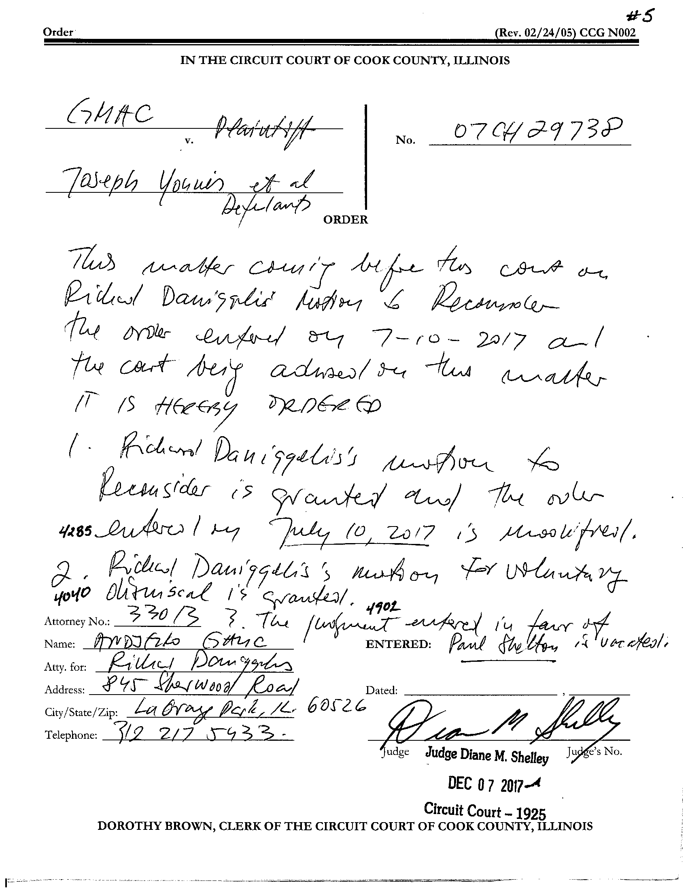
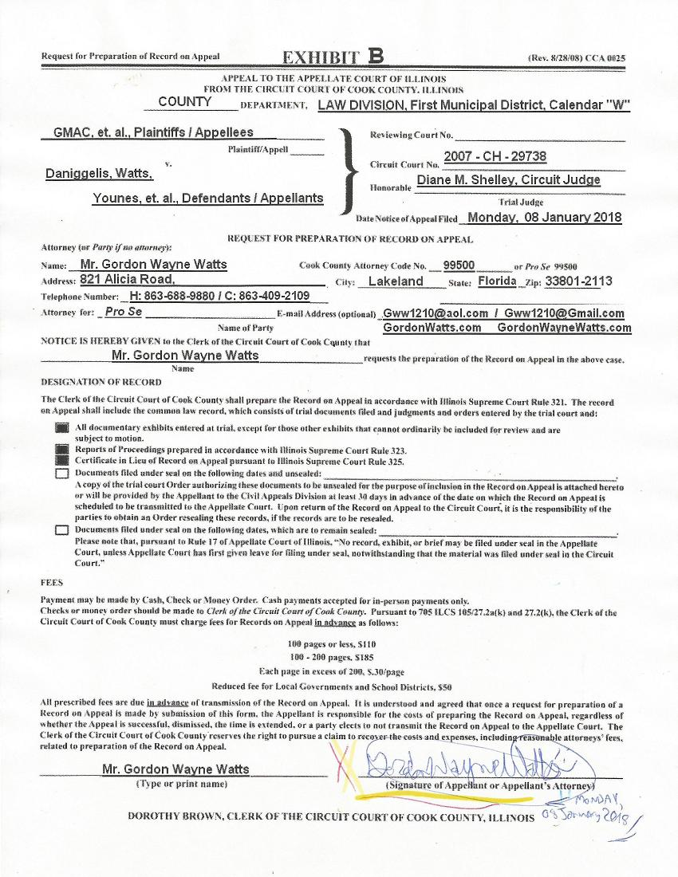
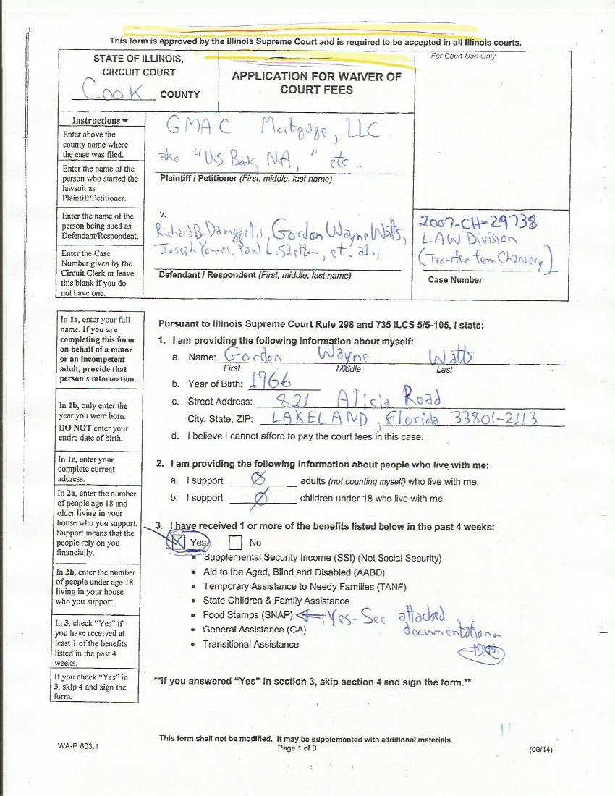
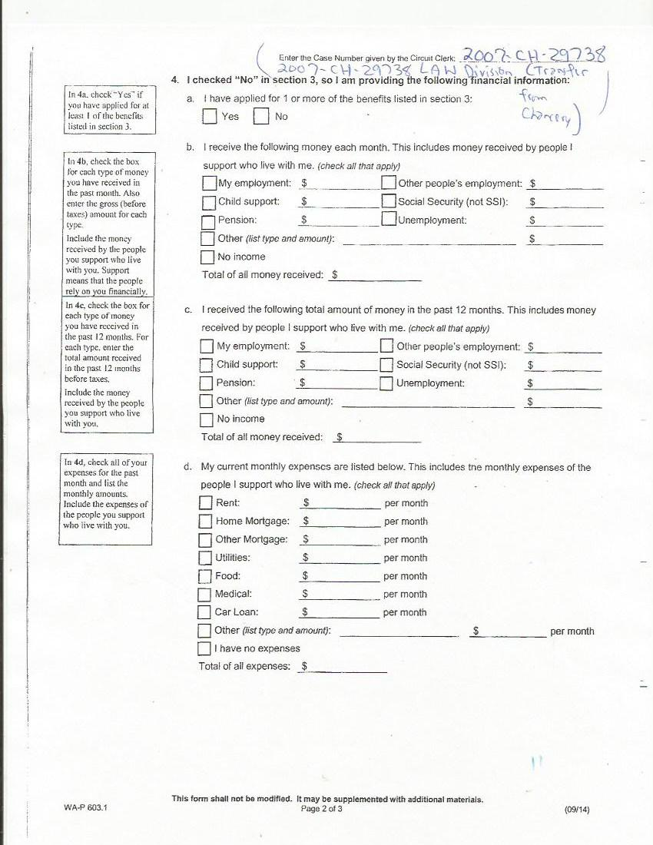
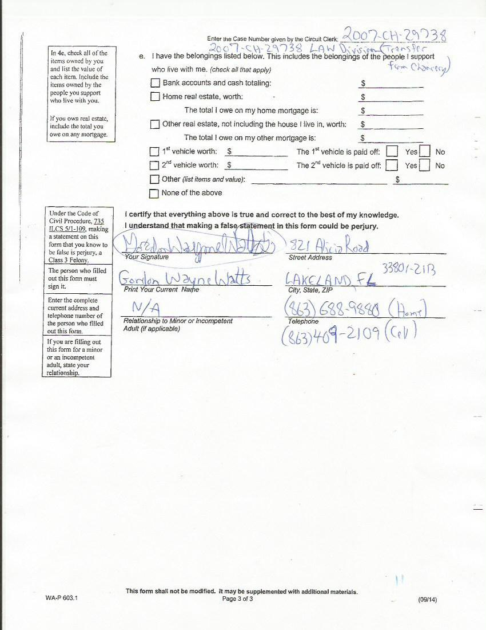
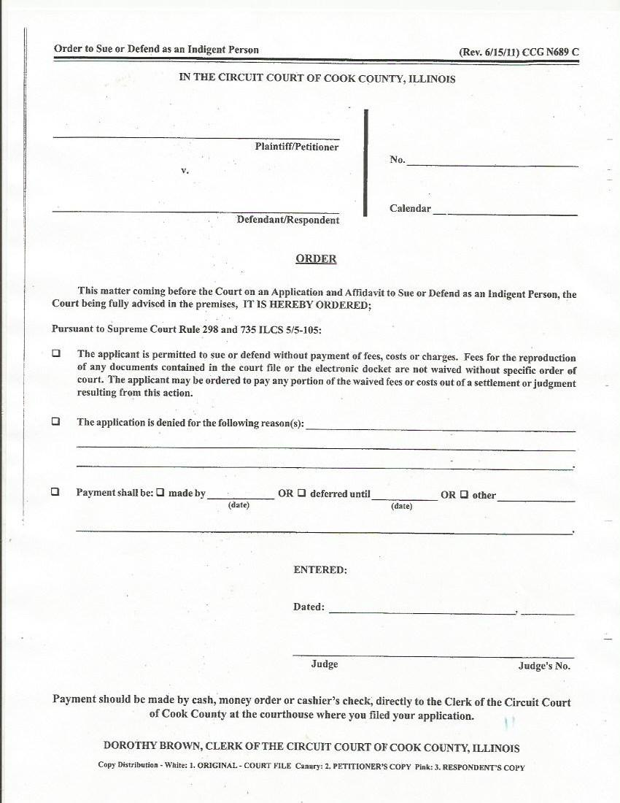
GMAC v Daniggelis, Watts, Younes, et al., 2007-CH-29738 (Notice of Appeal)
Letter to Judge Flannery (1 page) Exhibit-D

From the Desk of: Gordon Wayne Watts
821 Alicia Road – Lakeland, FL 33801-2113
H: (863) 688-9880 – C: (863) 409-2109 – W: (863) 686-3411 or: (863) 687-6141
Email: Gww1210@aol.com / Gww1210@Gmail.com
Web: www.GordonWatts.com / www.GordonWayneWatts.com

Hon. James P. Flannery, Jr., Circuit Judge–Presiding Judge, Law Division
50 W. Washington St., Room 2005, Chicago, IL 60602, Ph:312-603-6343

Re: “Waiver of Court Fees” confusion in this case Monday, 08 January 2018

Dear Judge Flannery:

It has come to my attention that there's confusion regarding my application for fee waiver. As you were the presiding judge who adjudicated my last application, it's instructive to revisit the issue: As you recall, I was a prospective Amicus Curiae aka a “Friend of the Court,” and you denied my application on grounds that I wasn't a party. As much as I disagree, I admit this is a “gray” area of case law, & any review of it would be “de novo.” As such, there's a good argument that you were right in your order (dated Feb. 22, 2016, in the underlying Chancery case, which was transferred to the Law Division) denying me fee waiver.
However, when speaking by phone with Pat O'Brian, deputy chief of Civil Appeals, she assured me that your denial of my application last time means that I must be denied now. Since Ms. O'Brian is very intelligent (knowledgeable of Supreme Court rules, much more-so than her staff, I must say), if she can get confused, judges can also—after all, judges are human too. While you might've been right to deny me last time, things have changed. I asserted intervention (see my Motion to Intervene, dated Thursday, 06 July 2017), an absolute right under IL case law: Where intervention as of right is asserted, “the trial court’s jurisdiction is limited to determining timeliness, inadequacy of representation and sufficiency of interest; once these threshold requirements have been met, the plain meaning of the statute directs that the petition be granted.” City of Chicago v. John Hancock Mutual Life Ins. Co., 127 Ill.App.3d 140, 144 (1st Dist. 1984). I satisfy all 3 requirements, giving me a right to intervene under 735 ILCS 5/2-408(a)(3). As there was no denial of my motion, the docket's official listing of me as a defendant is prima facia evidence that I'm now a party, and thus qualify for fee waiver to sue or defend. Let me remind you Rule 10-100(a) (Illinois Supreme Court Commission on Access to Justice) states: “The Illinois Supreme Court Commission on Access to Justice is established to promote, facilitate, and enhance equal access to justice with an emphasis on access to the Illinois civil courts and administrative agencies for all people, particularly the poor and vulnerable,” which, of course, would include myself. Should the Law Division vacate the order I'm appealing before my appeal is docketed, & grant summary judgment as I've asked, this would 'moot' my appeal, saving the courts a lot of headache, I think. Unless the court awards me for my various losses, which I documented in my Intervention Motion, I will have sufficiency of interest, and thus qualify to Intervene—and obtain fee waiver. This is IL case law; you may check to verify, but you must comply. With kind Regards, I am, Sincerely,
________________________________
Gordon Wayne Watts

Page 13 of 15 (08 January 2018, Watts “Notice of Appeal”in 07-CH-29738)
GMAC v Daniggelis, Watts, Younes, et al., 2007-CH-29738 (Notice of Appeal)

Prior Waiver denial before I was a party to the case (1 page) Exhibit-E
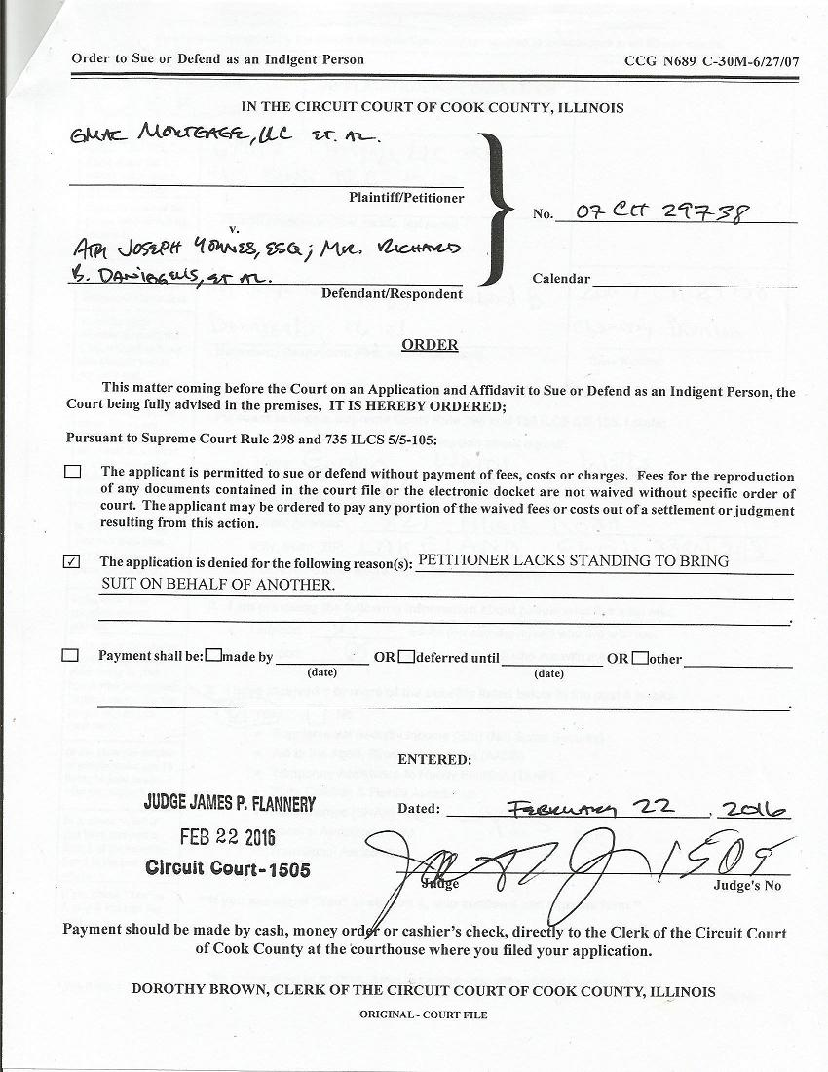
Page 14 of 15 (08 January 2018, Watts “Notice of Appeal”in 07-CH-29738)
GMAC v Daniggelis, Watts, Younes, et al., 2007-CH-29738 (Notice of Appeal)

Documentation that I'm currently on Food Stamps Exhibit-F
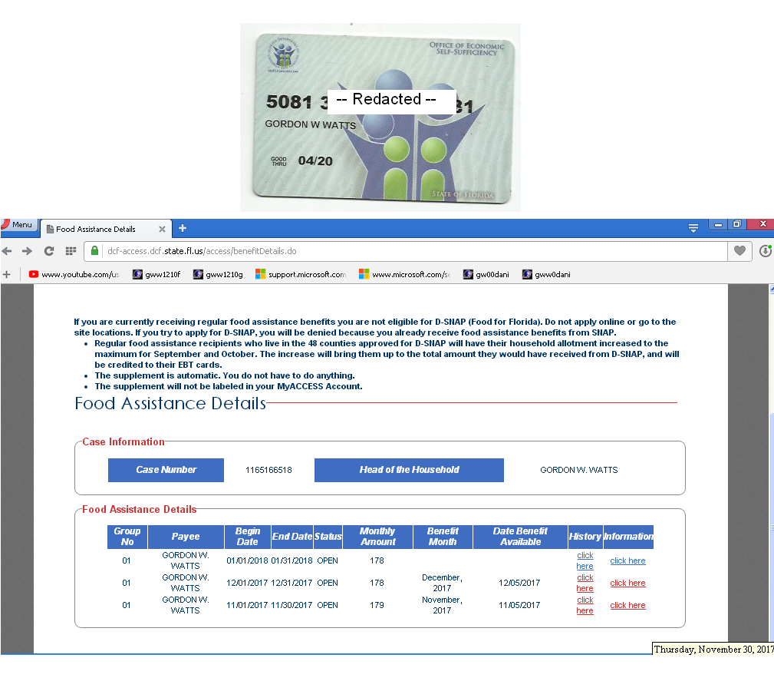
Page 15 of 15 (08 January 2018, Watts “Notice of Appeal”in 07-CH-29738)

