E-Mail Cover Sheet

From the Desk of: Gordon Wayne Watts
821 Alicia Road – Lakeland, FL 33801-2113
H: (863) 688-9880 – C: (863) 409-2109 – W: (863) 686-3411 or: (863) 687-6141
Email: Gww1210@aol.com / Gww1210@Gmail.com
Web: www.GordonWatts.com / www.GordonWayneWatts.com

To: Atty. Rita C. Greggio, Esq., Litigation Counsel c/o: Attorney Registration & Disciplinary Commission  130 E. Randolph Dr., STE 1500  Chicago, IL 60601  PH: 312-540-5209  E-mail: RGreggio@iardc.org  Cc's: Information@iardc.org, RBader@iardc.org, EAWelsh@iardc.org, Webmaster@iardc.org | Cc: Joseph Younes Law Offices http://ChicagoAccidentAttorney.net  120 W Madison St Ste 1405  Chicago, IL 60602-4128  PH: 312-372-1122 FX: 312-372-1408  E-mail is: RoJoe69@yahoo.com per http://www.ZoomInfo.com/p/Joseph-Younes/599467626 | Cc: Peter King (Atty. for Joseph Younes) (Atty. No.: 48761) c/o: King Holloway LLC  101 N. Wacker Dr., STE 2010  Chicago, IL 60606  Direct: (312) 724-8221  E-mail: PKing@khl-law.com
Cc: Paul L. Shelton, Esq.  10 North Adams Street  Hinsdale, IL 60521  E-mail: PMSA136@aol.com,  per: http://www.il-reab.com/agents/26812-paul-l-shelton-shelton-associates-hinsdale-il-60523  PLShelton@SBCGlobal.net  per: http://www.zoominfo.com/p/Paul-Shelton/-939241 | Cc: Paul L. Shelton, Pro Se  3 Grant Square, SUITE #363  Hinsdale, IL 60521-3351  PH: 630-842-0126 per caller ID | Cc: Andjelko Galic, Esq. (Atty. No.: 33013), Atty. for Defendant, Mr. Richard B. Daniggelis, e.g., the elderly victim of the mortgage fraud rescue scheme  134 N. LaSalle St., STE 1040  CHICAGO IL, 60602 – (Cell: 312-217-5433, FAX: 312-986-1810, PH: 312-986-1510)  E-mail:  AndjelkoGalic@Hotmail.com,  and:  AGForeclosureDefense@Gmail.com
Cc: KING HOLLOWAY LLC
(Atty. for Joseph Younes) www.KingHolloway.com/contact.htm
Attn: Peter M. King, Esq.

One North LaSalle Street, Suite 3040, Chicago, IL 60602
(312) 780-7302 / (312) 724-8218

Date: Thursday, 08 October 2015
Subject: Re: Your grievance against Illinois attorneys Shelton and Younes
Comments: Dear Atty. Greggio, I am in receipt of your postal mail dated Oct. 01, 2015. I received it by postal mail on Monday, 05 October 2015. Thank you for your response.

Below, in chronological order, is a record of *all* of our communications –with one exception –along with my response. The exception was this: I'm omitting my initial complaint, for the sake of brevity, but it was basically a copy of some court filings with a short note telling you that I thought that fraud was committed and needed to be looked into.

I shall attempt to 'reply to all' by both email and postal mail. Please see below for said docs:

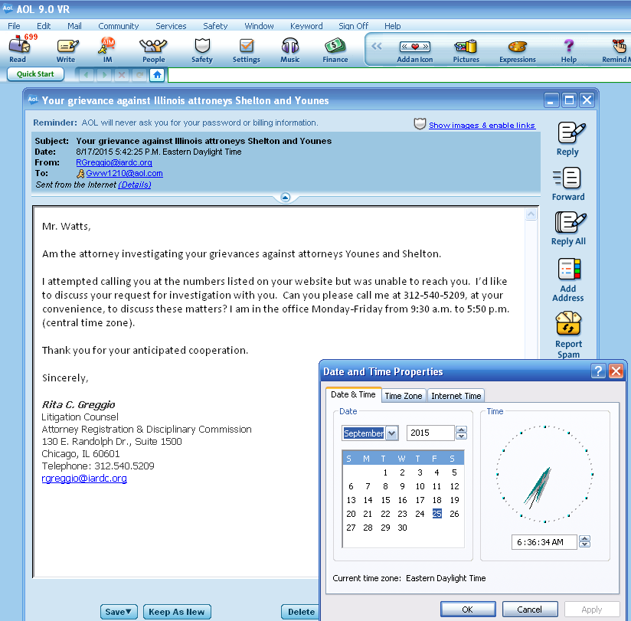

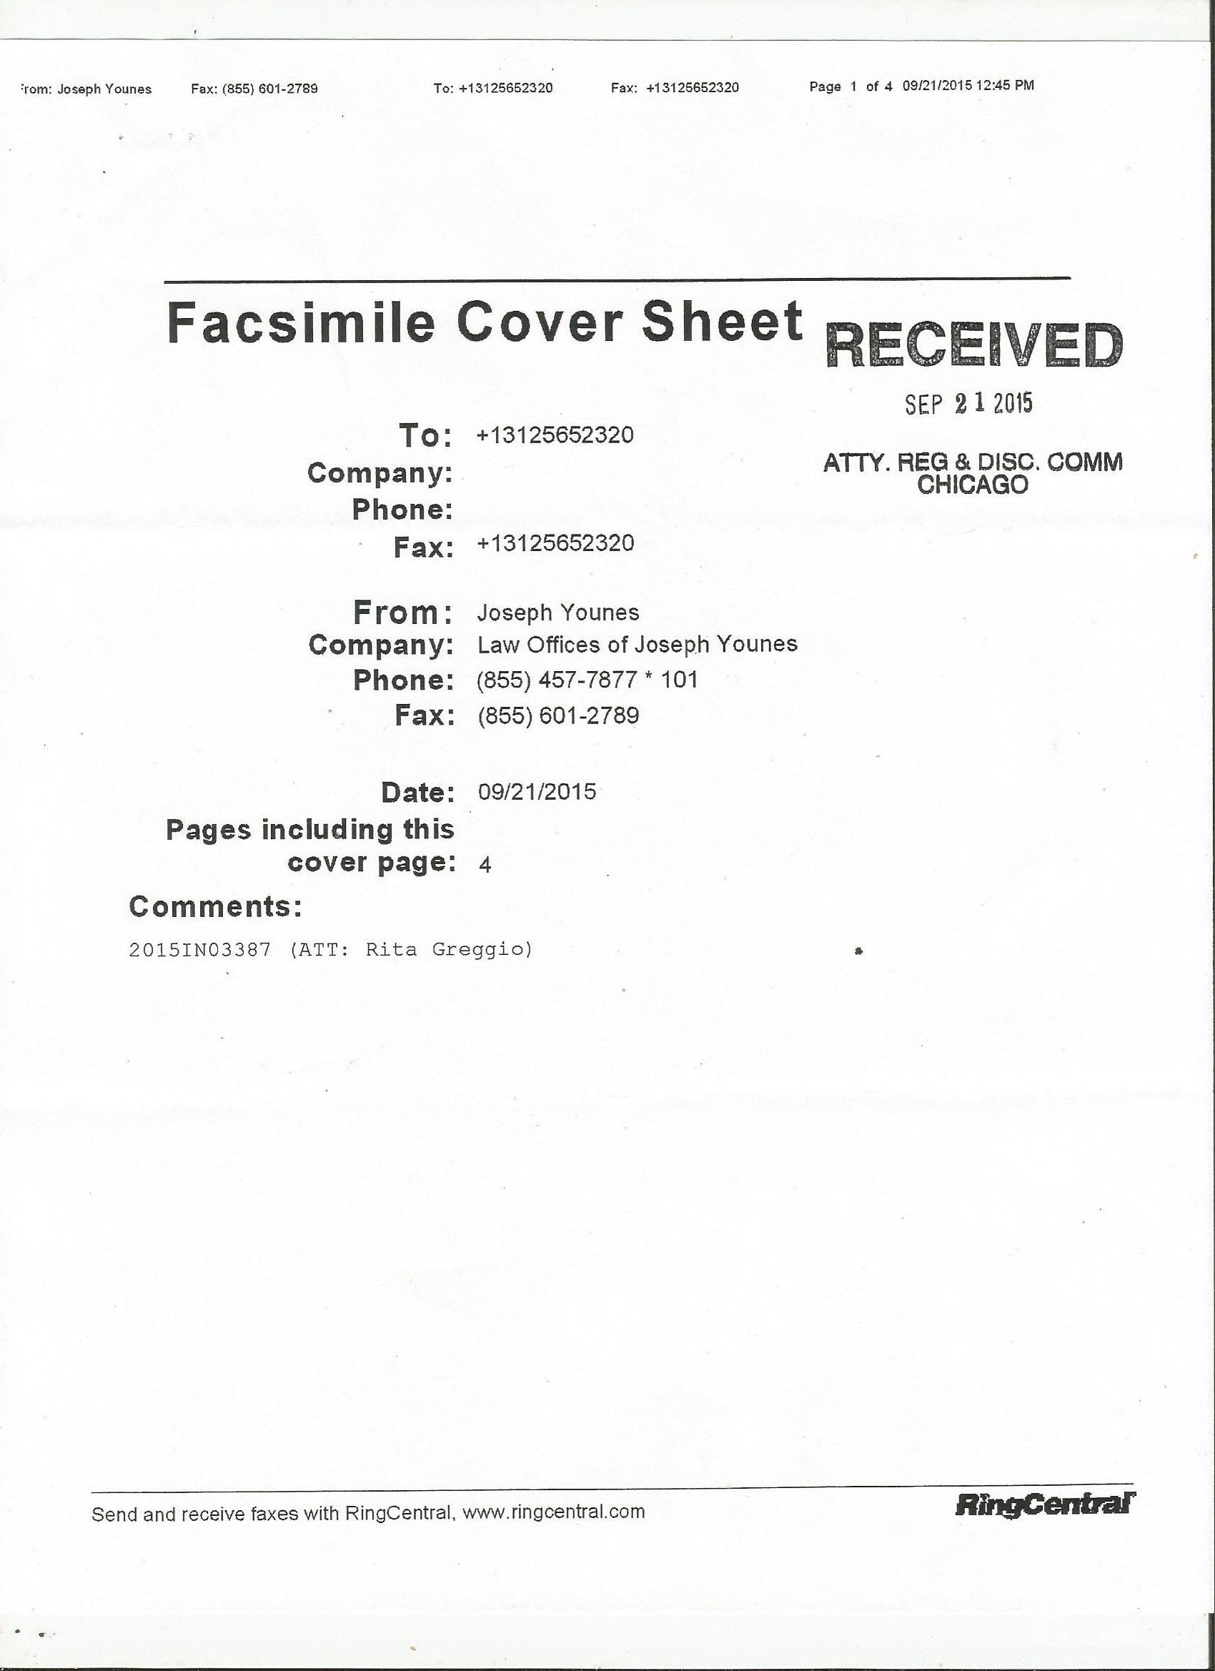
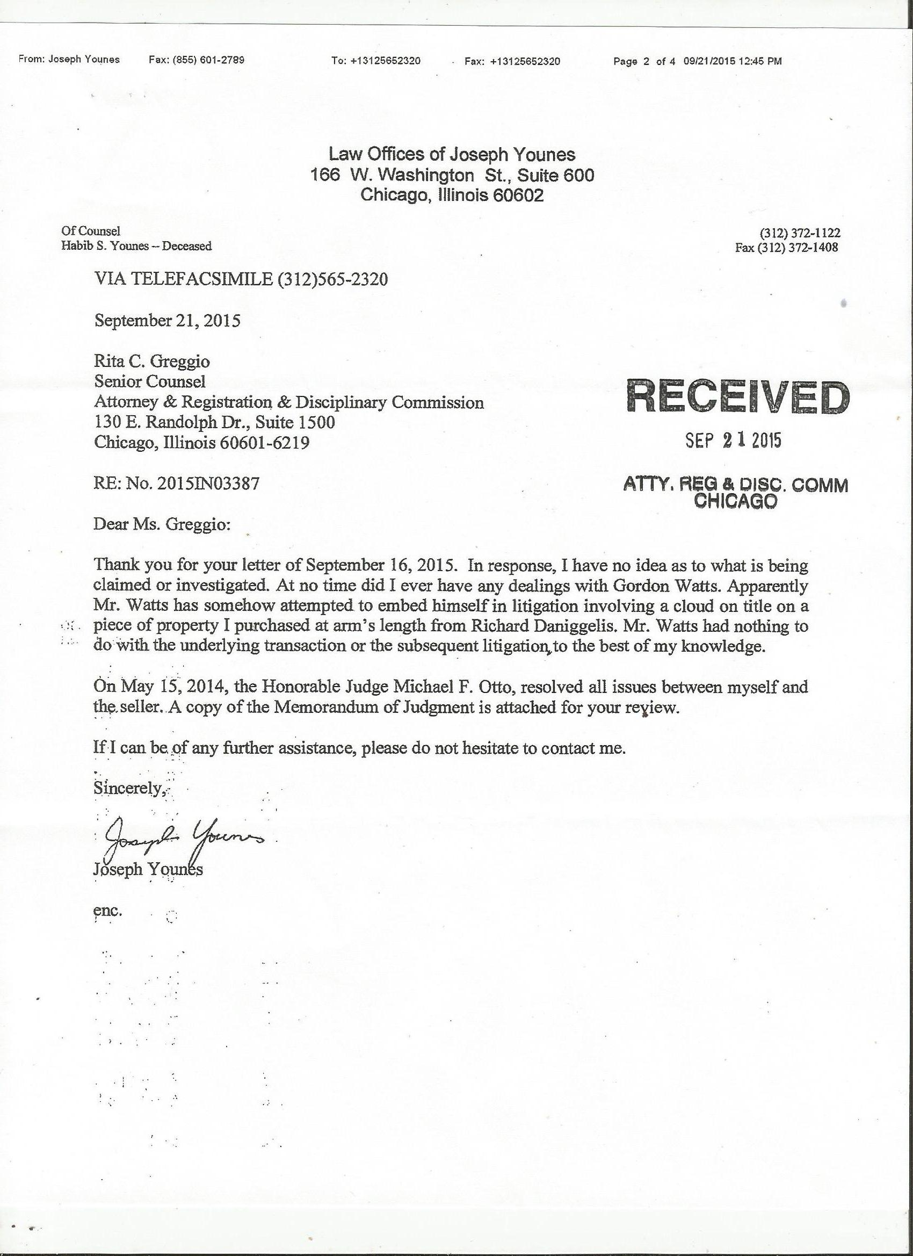
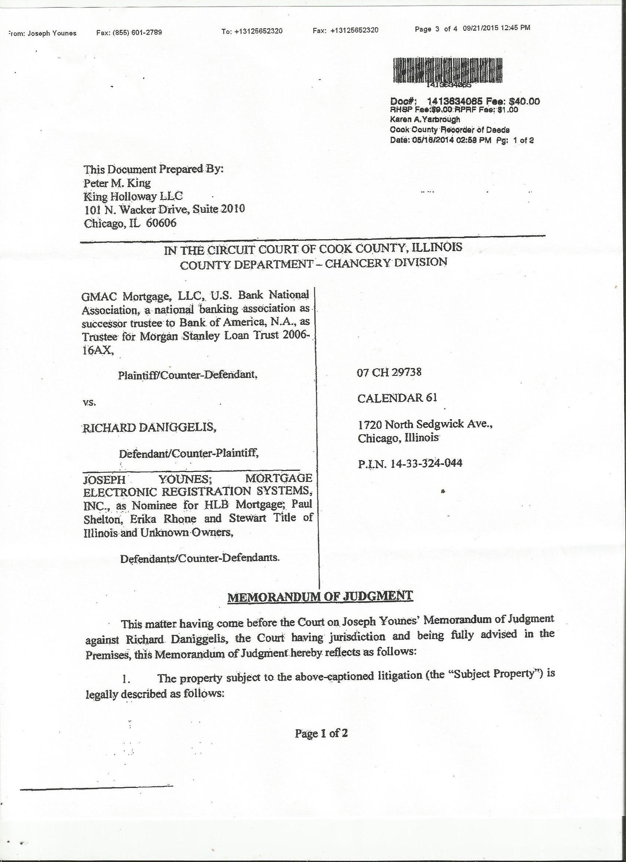
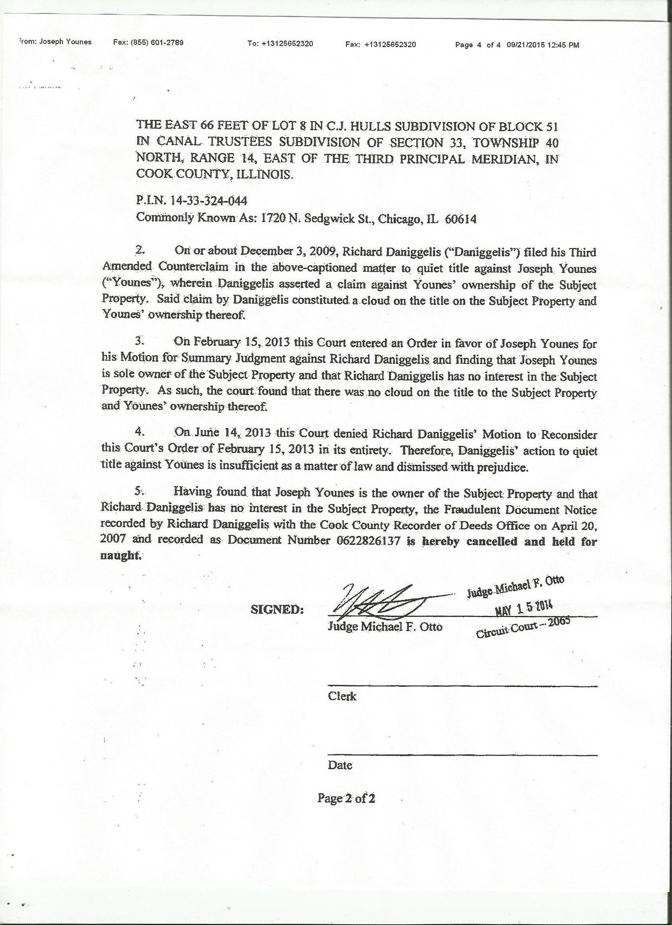

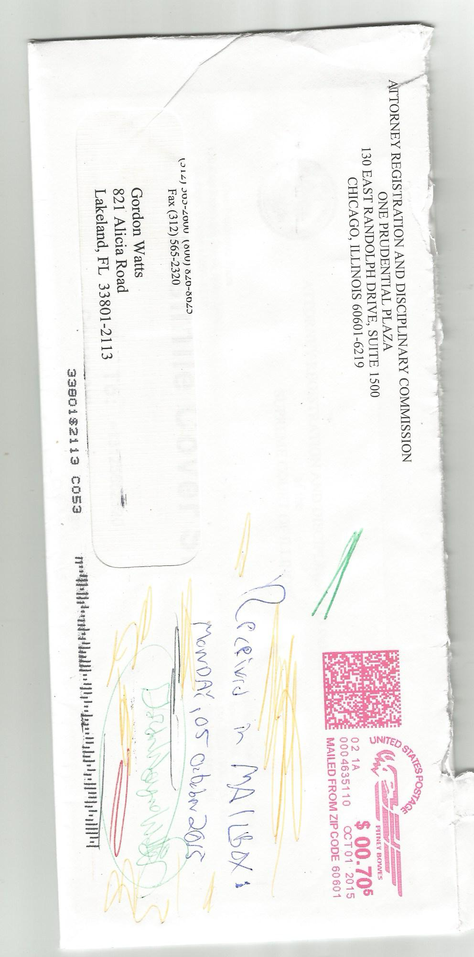

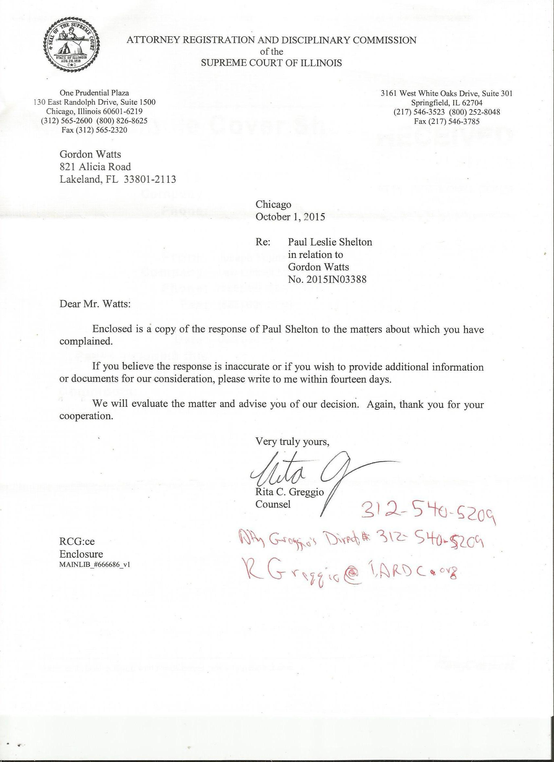

From the Desk of: Gordon Wayne Watts
821 Alicia Road – Lakeland, FL 33801-2113
H: (863) 688-9880 – C: (863) 409-2109 – W: (863) 686-3411 or: (863) 687-6141
Email: Gww1210@aol.com / Gww1210@Gmail.com
Web: www.GordonWatts.com / www.GordonWayneWatts.com

Atty. Rita C. Greggio, Esq., Litigation Counsel Date: Thursday, 08 October 2015
c/o: Attorney Registration & Disciplinary Commission
130 E. Randolph Dr., STE 1500
Chicago, IL 60601
PH: 312-540-5209
E-mail: RGreggio@iardc.org

Thank you, once again, for your response here. Before I reply on the merits of the issue, I wish to address two points in your response. It would appear that you made a couple of typos: First, your enclosure has a response from Attorney Joseph Younes, not Attorney Paul Leslie Shelton, whom you reference. Secondly, in comparing the case number in your response with that provided in Mr. Younes' response, it would appear that there are two (2) different case numbers assigned to my complaint: It would appear that 2015-IN-03387 refers to Mr. Younes' case, and that 2015-IN-03388 refers to Mr. Shelton's case. If my inference, here, are correct, then both investigations can be assigned properly without any confusion.

Next, however, I shall take you up on your offer to reply to Mr. Younes' response and/or provide additional information and/or documents for your consideration and evaluation. Mr. Younes' response is partly true and partly false. I shall address each one of his points, one-by-one, starting from the very top of the reply –and working down, in order:

First, I notice his law partner, who is of counsel, in his letterhead, is deceased: Atty. Habib S. Younes, Esq. has exactly the same last name, which I infer is not by coincidence: This is obviously his father or other close relative.
Before I say anything about my own complaint, I should extend my deepest condolences to Joseph for his loss. → Joseph, I am sorry for your loss, and even tho you and I have some fundamental disagreements, I do not wish to cause you any additional grief or add to the pain that you and your family are –and have been –surely experiencing. In fact, if, in the unlikely (but non-zero) chance that you, yourself, become homeless in the process of these ongoing matters, I will do everything within my power to help you find a place to stay.
These are not mere words: In fact, when I, myself, was a mere financially-challenged, poor college student, I took in three (3) homeless individuals: a visiting missionary couple for the night (to save them hotel costs) and a fellow-student (who could not afford the on-campus dormitory housing rental).

Page 1 of of 10 -of Gordon Wayne Watts' formal reply to the IARDC

Next, I notice that Mr. Younes used a FAX transmission to communicate with the IARDC. While I am open to new options, I don't presently have the technology to send or receive FAX transmissions without great financial cost to myself. Anyone can (usually) effect communication by the other 'traditional' means: Home and Cell Telephone, E-mail, postal mail, UPS, FedEx, and/or in persona visits. My home number has a much more clear connection (and more 'minutes') than my cell phone, which is a backup. Also, for your convenience (and the convenience of others here), I hope to post copies of the legal filings to my personal website. (Some are already posted for your convenience, but sometimes there is a delay in updating with new docs. Some contact data is on my official websites.)

Now, to address – and reply to – Mr. Younes' response, above: First, he claims: “In response, I have no idea as to what is being claimed or investigated.” I find that response very disingenuous! Mr. Younes is not stupid or uneducated. He is fully aware of the complaints that I lodged against him (and Mr. Shelton, Ms. Rhone, and others) in my court filings of GMAC v. Daniggelis, 2007-CH-29738 (where Younes was a fellow-defendant along with Daniggelis) as well as Younes v. Daniggelis, 2014-M1-701473 (where Younes was the plaintiff, suing Daniggelis for the house and property in question), before the Chancery and Civil divisions of the Cook County trial court, respectively. He can NOT claim ignorance – with a straight face!
In fact, take a look, below, for proof that I really did serve him copies of the pleadings. Mr. Younes was – and is – fully aware of my various complaints that he broke the law, and was not caught initially –simply because both Atty. Benji Phillips and Atty. Andjelko Galic, the victim's attorneys, failed to bring to the court's attention that the two different Warranty Deeds have exactly the same signature, which we all know can not be by coincidence: The latter signature is obviously a photocopy, and thus a forgery, and of course, felony fraud. This was not my only complaint but it was a chief complaint. Another obvious fraud was the fact that Younes got the house without any payment, and not only is lack of consideration “legally” sufficient to void any sale contract – even were it otherwise valid (it is not due to the forgery), moreover, it is “morally” reprehensible to steal not only the old man's only home, but also steal the hundreds of thousands of dollars of equity – making the 76-year old elderly gentlemen homeless in the process.
I served all parties – and their attorneys – by multiple methods, as indicated in the Certificate of Service. Younes is being less than honest when he claims ignorance here. See e.g., just some of the proofs of delivery, below.

Page 2 of of 10 -of Gordon Wayne Watts' formal reply to the IARDC

Sources: https://www.FedEx.com/apps/fedextrack/?tracknumbers=781090134892
and: http://GordonWatts.com/MortgageFraud-Court-Filings/Mon03Aug2015-FedEx-and-USPS-Tracking/Younes-Mon03Aug2015-FedEx_POD.pdf
and: http://GordonWayneWatts.com/MortgageFraud-Court-Filings/Mon03Aug2015-FedEx-and-USPS-Tracking/Younes-Mon03Aug2015-FedEx_POD.pdf
Cf: www.GordonWatts.com/MortgageFraud-Court-Filings/Service-Delivery-Details.pdf
www.GordonWayneWatts.com/MortgageFraud-Court-Filings/Service-Delivery-Details.pdf

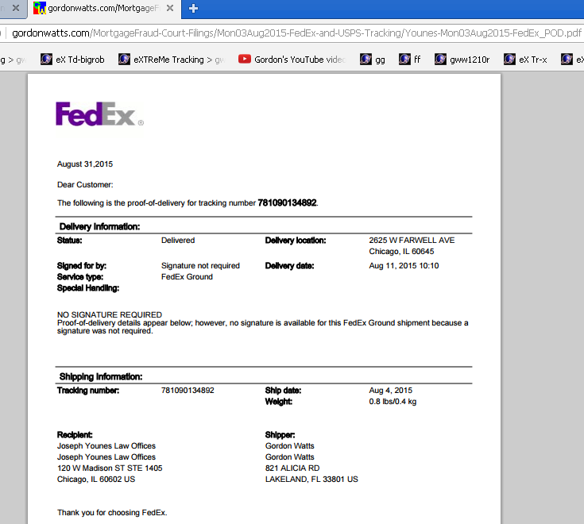

Page 3 of of 10 -of Gordon Wayne Watts' formal reply to the IARDC

Sources: https://www.FedEx.com/apps/fedextrack/?tracknumbers=781161195905
and: http://GordonWatts.com/MortgageFraud-Court-Filings/Sun16Aug2015-FedEx-and-USPS-Tracking/Younes-Sun16Aug2015-FedEx_POD.pdf
and: http://GordonWayneWatts.com/MortgageFraud-Court-Filings/Sun16Aug2015-FedEx-and-USPS-Tracking/Younes-Sun16Aug2015-FedEx_POD.pdf
Cf: www.GordonWatts.com/MortgageFraud-Court-Filings/Service-Delivery-Details.pdf
www.GordonWayneWatts.com/MortgageFraud-Court-Filings/Service-Delivery-Details.pdf

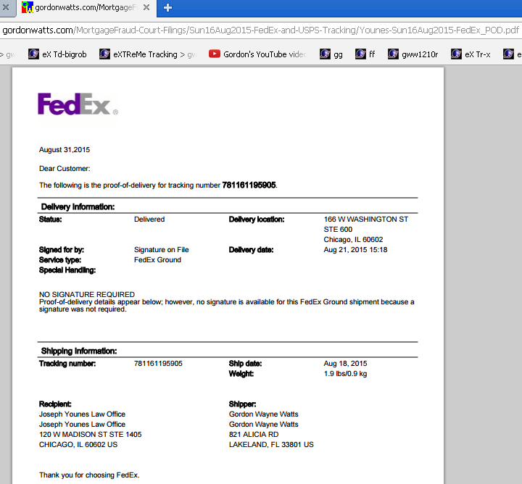

Page 4 of of 10 -of Gordon Wayne Watts' formal reply to the IARDC

Source: https://www.FedEx.com/apps/fedextrack/?tracknumbers=781310879740

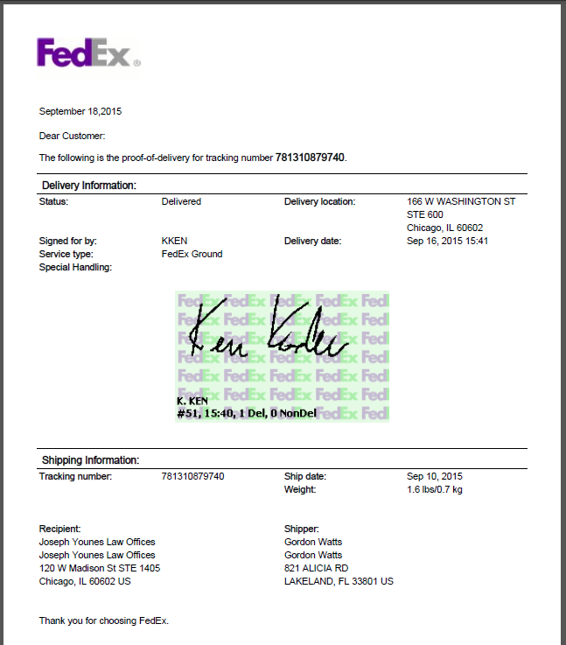

Page 5 of of 10 -of Gordon Wayne Watts' formal reply to the IARDC

Next, Younes says: “At no time did I ever have any dealings with Gordon Watts.” This statement, more-or-less, is basically correct. However, there were 2 notable exceptions:

First off, of course, I served him my court pleadings, in which I accused him of gross wrongdoing. Secondly, I called him on the phone (and I'm sure he will verify my claim here), apologising because, in my mind, he appeared to have “fallen into the wrong crowd,” and I felt bad that it took me over a year to properly notify him of the fact that I had documentation that verified the “tall tales” that Daniggelis had told me re: forgery.
You see, Rita, at that time, I saw Atty. Paul Shelton's involvement, and knowing his discipline and disbarment of his realtor's license (before the IDFPR), and knowing that he also has another complaint (besides mine) before the IARDC, and, given the weight of the evidence, I thought that he was the “mastermind” and had led astray Mr. Younes, who, while profiting from these proceedings, might well have been “otherwise” innocent.
Also, Daniggelis told me some positive things about Younes, and, being an honest (even if imperfect) person, I not only included them in my legal filings, but I also seriously considered that perhaps Younes was not criminally guilty of anything more than an accessory after the fact, and, for that reason, I called him to apologise for my slackness and delay in notifying him of these matters with documentation sufficient to verify my claims. (My delay was due to the slowness of the court's granting of my public records request.)
Mr. Younes, when I called and asked if I got Atty. Younes, said “that would be me,” and I proceeded to apologise. Then, he replied something along the lines of: “don't ever call me again.” I responded something along the lines of: “oh, really? But, if you don't want me to contact you, I shall not.” I'm sure Younes can verify my recollection of events. But, basically, his statement above is correct.

Then, Younes, in his response to you, goes on to say: “Apparently Mr. Watts has somehow attempted to embed himself in litigation involving a cloud on the title on a piece of property that I purchased at arm's length from Richard Daniggelis.” This statement, here, Rita, is a mixture of truth and falsehood. Let address each part, in turn: First off, yes, he is correct in claiming that I “attempted to embed” myself in this litigation. (This would be obvious to a blind person!) Of course, it is also true that you, yourself, are “embedding” yourself in this matter, and it would also be true to claim that a police officer arresting a bank robber would be “embedding” himself/herself in the robbery attempt – and that a Good Samaritan who saw a person being mugged or attacked would be “embedding” himself in the mugging if he/she attempted to intervene and save the person -or call 911. (In this, latter, analogy, I am analogous to the Good Samaritan, insofar as I am exercising my Redress and Due Process rights to notify the proper authorities.) However, the balance of his statement is legally incorrect – and he knows that, I suspect.

Page 6 of of 10 -of Gordon Wayne Watts' formal reply to the IARDC

There was, indeed, a cloud on the title, as he claims, above, due to Daniggelis' effecting an affidavit of forgery to both the Cook County Recorder's Office, as well as (with the help of an attorney) to The Court (as I document in the Exhibits of my own filings).
That much was true; however, Younes goes on to claim that this was a “piece of property that I purchased at arm's length from Richard Daniggelis.”

I'm sure you remember LAW 101, in which the definition of an “At Arm's Length” Transaction was given: “adj. the description of an agreement made by two parties freely and independently of each other, and without some special relationship, such as being a relative, having another deal on the side or one party having complete control of the other.” Source: http://Legal-Dictionary.TheFreeDictionary.com/arm's+length This means that the purchase and transaction is: “1: a distance discouraging personal contact or familiarity,” and that “2: the condition or fact that the parties to a transaction are independent and on an equal footing.” Source: http://www.Merriam-Webster.com/dictionary/arm's%20length [Underline bold added for clarity; not in original]
(Of course, since Younes entered an appearance for Danigellis in Deutch Bank v. Daniggelis, 2004-CH-10851, there was both 'control' and a 'special relationship.')
When an “At Arm's Length” transaction is made, there are no 'conflicting' factors, and it is likely that the sale price will be at the “Fair Market Value”: http://www.Investopedia.com/video/play/arms-length-transaction/
The opposite of this is an “Arm in Arm” transaction: “A transaction in which the two parties somehow do have an interest in helping each other, such as a transaction between family or friends, is called an arm-in-arm transaction. This is much less likely to produce a sale price that is fair market value, because one party may give favorable terms to the other.” Cf: Ibid. (Bold and underline added for emphasis; italics in original)
See also: http://www.BusinessDictionary.com/definition/arm-s-length-transaction.html
and: http://TheLawDictionary.org/armslength-transaction/
Now, by now, I'm sure you've scanned the legal landscape, Rita, and verified my claims that Daniggelis received no consideration (payment) for his property or house. (And, it is 'his' in true fact, whether or not legal fiction is made the law of the case.) In fact, I'm sure that no one – on either side – disputes the claims that Daniggelis never received any payment – whatsoever – for this “sale.” So, besides being an “illegal” transaction (one that lacks 'consideration'), and an “immoral” one (for obvious reasons), Younes is also knowingly lying to you here: This is not an “arm's length transaction” if for no other reason than that the sale price (which was ZERO) was clearly and obviously not a 'Fair Market' value for a huge home with hundreds of thousands of dollars of equity in it (not to mention the 'intangible' market value from the prospects that Daniggelis could have rented out one – or more – of the rooms – had there not been a cloud on the title, which scared away any actual renters, other than an occasional transient or freeloader).

Page 7 of of 10 -of Gordon Wayne Watts' formal reply to the IARDC

Next, Younes, in his response to you, goes on to say: “Mr. Watts had nothing to do with the underlying transaction or subsequent litigation, to the best of my knowledge.”

Well, this is partly-true, Rita: I did not, indeed, have anything to do with the “underlying transaction” (other than, after the fact, to learn of the forgery – and then have to wait over a year for the release of court records to verify this claim).

However, I am heavily involved in the “subsequent litigation,” as a pull of the court records will show. (Oddly-enough, their online docket lists me as “pro se,” when it does list me at all, so I am not listed by name, but I am, indeed, heavily involved in the “subsequent litigation,”as all know, and thus Younes is being “less than forthright” in his claim here. I'm not sure what he's hoping to accomplish by these myriads of misleading legal fictions??)

Then, Younes states that: “On May 15, 2014, the Honorable Judge Michael F. Otto, resolved all issues between myself and the seller. A copy of the Memorandum of Judgment is attached for your review.”
This, technically, is true – well, partly, anyhow: Judge Otto did, indeed, rule on this matter – and Younes did, indeed, attach a copy of that ruling for your review. However, this ruling, most assuredly, did not “resolve” any of the issues between Younes and Daniggelis – any more than the United States Supreme Court “resolved” all the issues between Blacks and Whites in its famous (infamous) holding – in the which a 7-2 supermajority of America's highest court, not too long ago, held that “[T]he negro might justly and lawfully be reduced to slavery for his benefit.” Chief Justice Roger B. Taney, writing for the Court. Dred Scott v. John F. Sanford, 15 L.Ed. 691; 19 How. 393; 60 US 393 at 407.(US 1857).

Lastly, Younes tells you that: “If I can be of any further assistance, please do not hesitate to contact me.” I find this claim to be disingenuous for what may (or may not) be a counter-intuitive (but actually correct) reason. If you don't figure it out, here is why I feel this way: My elders and mentors have taught me that, if you have a dispute with a person, you should go to them privately first, and not involve others, so as to keep things discrete and avoid embarrassment and the like. Now, I do admit that I filed in court before I contacted Younes, directly, but contact him, I did. While I have spoken by phone with a number of attorneys (including Paul Shelton, who called me to discuss a few matters, and including both of Younes' attorneys, King and a prior attorney, Perry Perleman, regarding whether they were still involved in the case –and needed to be served pleadings by USPS or FedEx means), only one attorney was rude to me: That would be Mr. Younes.
To be clear, both Peter King and Paul Shelton did not see “eye to eye” with me on all issues, but neither of them was rude to me, nor did they warn me to never contact them again. (And, I would hope that I, likewise, was not rue to any of them – no, not even Mr. Younes.)
Page 8 of of 10 -of Gordon Wayne Watts' formal reply to the IARDC

So, in conclusion, I do not wish any harm or offense towards Mr. Younes. All that I said in the inception of my letter was (and is) correct. However, he probably has a place to live – if not several homes. Younes does NOT need to steal an elderly man's home – in like manner was was done with Lessie Towns, the famous mortgage fraud victim involved in the case in which Mr. Shelton lost his realtor's license. Even former IL governor, Pat Quinn, got involved, remember? http://www.idfpr.com/news/newsrls/05132009MortgageFraudScheme.asp
Cf: http://abclocal.go.com/story?section=news/local&id=7799653
and: http://articles.chicagotribune.com/2009-05-10/news/0905090103_1_trust-bungalow-house-payments

Cf: http://GordonWatts.com/MortgageFraud-Court-Filings/
and: http://GordonWayneWatts.com/MortgageFraud-Court-Filings/
and: www.GordonWatts.com/MortgageFraud-PublicRecords-Docs/archive-of-cached-press-coverage.pdf
and: www.GordonWayneWatts.com/MortgageFraud-PublicRecords-Docs/archive-of-cached-press-coverage.pdf

However, Mr. Daniggelis' case is worse than Ms. Town's case – for two (2) reasons: First off, while Towns did, in fact, sign away her house (even if through coercion, and the like), Daniggelis was smart enough to attach stipulations to the contract – which fell through – prompting somebody (we don't know) to, then, forge his signature. (Towns' signature was never forged: She actually did fall for the mortgage-rescue scheme!) Secondly, Towns never became homeless and living on the street as was Daniggelis. So, if ONE governor visited with Ms. Towns in her back yard, Daniggelis is deserving of 2 or 3 governors' visits! (And, of course, justice here.)
This brings me up top my last point: You recall I lodged complaints against Shelton as well as Younes. I notice that Shelton didn't reply – and while I'd appreciate his input on these matters, most of them can be resolved without his assistance, I think.

After careful review, it would appear that Atty. Paul L. Shelton may not be guilty of some or all of the crimes in question. Here are some new findings I have discovered: As far as I can tell, Younes stood to gain financially from the transaction in question, but I don't see any money-trail wherein Shelton profited or benefited from the mortgage fraud that occurred with the “legal theft” of Daniggelis' house and property.

This is especially important, I think, because, since Shelton already has another complaint before the IARDC and has already received discipline from the the IDFPR in the Towns case (read: “is in 'hot water'”), I think that we should be especially careful in “piling on” & “assuming guilt” when Shelton is the “likely suspect.” He may be innocent.

Page 9 of of 10 -of Gordon Wayne Watts' formal reply to the IARDC

I don't know the specifics of his current IARDC complaint, nor am I clear on why he apparently signed a Power of Attorney (POA) that appears to have been subsequently notarised after the fact by Shelton – as I elucidate in my own filings. Indeed, I am still confused on the POA issue: How could a copy of the POA make it to the court filings without Shelton's notary seal and signature, and then, later, another copy make it into the selfsame court's exhibits with the seal & signature. Did he notarise Daniggelis' POA afterwards, outside of Daniggelis' precense, as Daniggelis claims? (But, even if true, Daniggelis admits that he signed the POA in question, and so, this matter, even if it constituted a crime, is small: It is not 'right' in my view, but many 'Notaries Public' notarise things after the fact, based on credible word that the party in question did sign it.) Nonetheless, given this new information on the money trail (“Follow the money,” they always say), and given Shelton's candid attempts to answer my questions when we spoke several times, I think that he should be given the benefit of the doubt, and I would presume him innocent of the forgery issue in the matter of the Warranty Deeds. I'd hope that all parties are allowed to offer testimony on all the points I raise in my court filings. Yes, Judge Otto not only ruled in favour of Younes, but dismissed the quiet title action “With Prejudice” (a legal term meaning: “That's it”: we've shut our ears to any new evidence to the contrary, and our ruling in final! Take it up with the appeals court, if you disagree).
However, last I heard, all judges are mere mortals, and are subject to make mistakes – yes, including Otto entering a bad ruling because Phillips and Galic did not inform the court of clear fraud: Two warranty deeds with identical signatures: You know as well as I do, Rita, that we are both mere mortals, and, therefore, unable to sign our name exactly the same way twice in a row: If, in fact, you see your signature on 2 different documents, and it's IDENTICAL, then you can rightly assume that (at least) one of them is a photocopy.
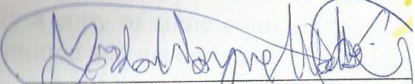
While Otto may have held in a certain way, this does not abrogate or annul Younes' responsibility as an attorney to uphold the highest standards. To that end, please know that I have filed an updated version of my sworn and notarised AFFIDAVIT with legal arguments in a newly-discovered LAW DIVISION case. (I corrected a few typos and clarified a few points.) Also, my request to supplement the record on appeal in the CHANCERY and CIVIL cases was necessary due to the many delays in the trial court to grant my public records requests. As well, there were scary new developments, not the least of which was Younes' attempt to do illegal construction or demolition on the subject house, which I was able to document. Therefore, please find enclosed the following five (5) docs: (1) Affidavit, (2) Amicus w/ motion & exhibits, (3) requisite “notice of motion” (4) Motion to Supplement the Record on Appeal, and (5) a Judicial Notice of scary new developments. NOTE: My “email copy” to you will have copies of these for all recipients, but my “postal mail copy” will only include the attachments to you, Rita, since I've already served all the other parties. I know you all have a difficult job, but I'm trying to provide you with the information you need to make your jobs as easy as possible. With kind regards, I am, Sincerely
_______________________
Gordon Wayne Watts
Page 10 of of 10 -of Gordon Wayne Watts' formal reply to the IARDC

