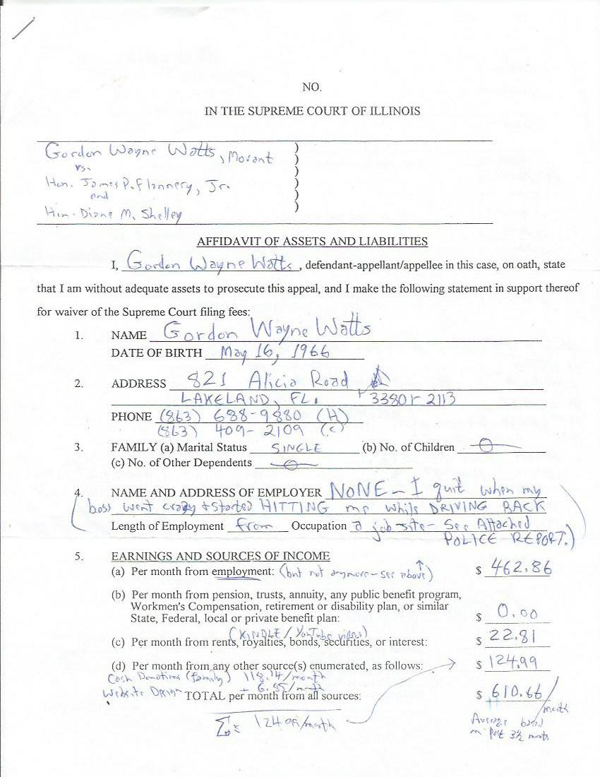
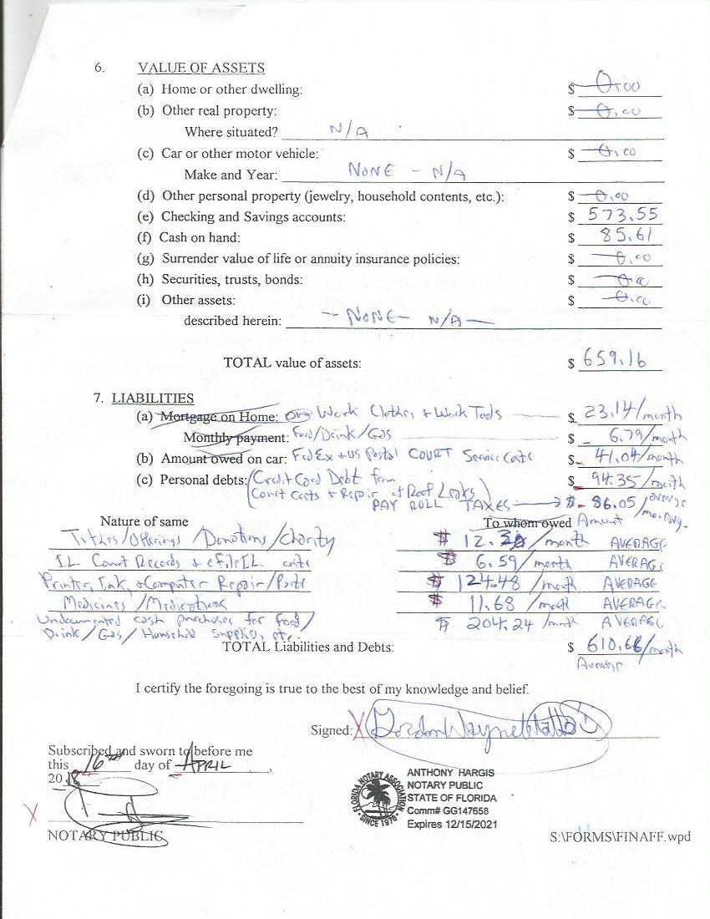
IN THE
SUPREME COURT OF ILLINOIS

Gordon Wayne Watts, ||
Plaintiff, ||
||
vs. ||
||
Hon. James P. Flannery, Jr., in his capacity as presiding || Docket Number: ________
judge, Law Division, Cook County, IL circuit court ||
||
and ||
||
Hon. Diane M. Shelley, in her capacity as circuit judge, ||
Law Division, Cook County, IL circuit court, ||
Defendants. ||

Motion to Proceed in Forma Pauperis

[[A]] STATEMENT OF FACTS: I, Gordon Wayne Watts, am unable even to pay 'basic' filing fees, much less the costs to print and mail Service Copies, to prosecute my appeal. Indeed, as the record below reflects: All other parties fail to comply with basic service, and I am the only litigant who complies with the Rules and serves all the parties, including the rule 383(b) 'nominal' parties, which costs too much for me at this time.
[[B]] Moreover, I am a Food Stamp recipient, and qualify under the guidelines used by the circuit and appeals courts, as indigent aka unable to pay aka In Forma Pauperis.
[[C]]Lastly, my construction boss, on the way back from our job, went crazy, and began hitting me while he was driving down the road, at a high rate of speed, out of anger, because I apparently misunderstood his request to look for cars 'in front', and not 'in the rear', to see if the way was clear to pass a slow-moving car in the left lane. [The police report has 'de minimus' errors, on this point, but, on balance, is accurate.] – See all four 'exhibits,' below, to document [[B]] and [[C]] above: 2 each re food stamp & police.
[[D]] I immediately quit my job, for very obvious reasons, and now am without sufficient funding to proceed accordingly.
MOTION PROPER: Therefore, I respectfully move This Honourable Court to allow me to Proceed In Forma Pauperis, and prosecute my appeal (e.g., my Rule 383 Motion for Supervisory Orders) without payment of filing fees.
Respectfully submitted,

Gordon Wayne Watts, Plaintiff, pro se [Code: '99500' = Non-Lawer, pro se]
821 Alicia Road, Lakeland, FL 33801-2113
PH: (863) 688-9880 [home] or (863) 409-2109 [cell]
Web: http://www.GordonWatts.com / http://www.GordonWayneWatts.com
Email: Gww1210@aol.com / Gww1210@gmail.com
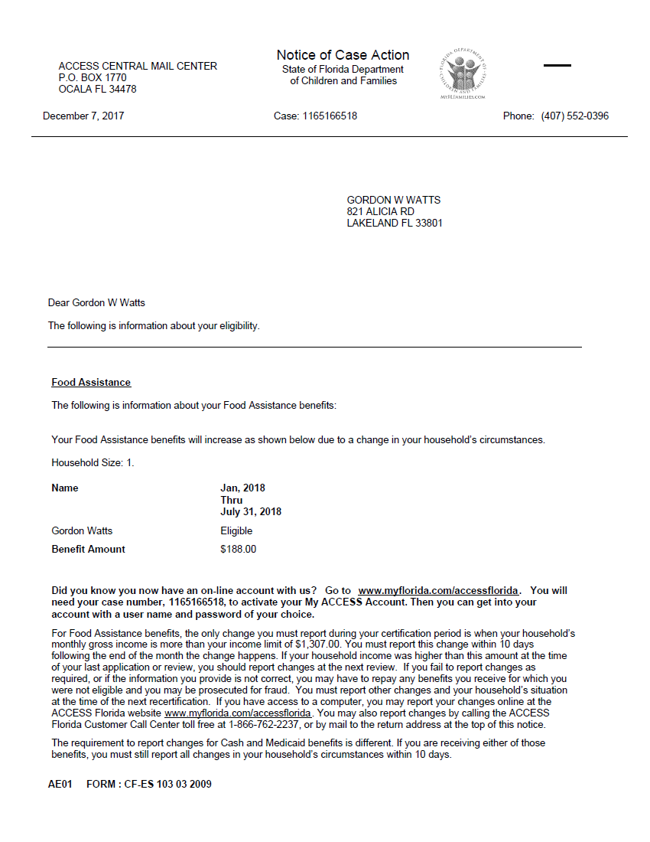
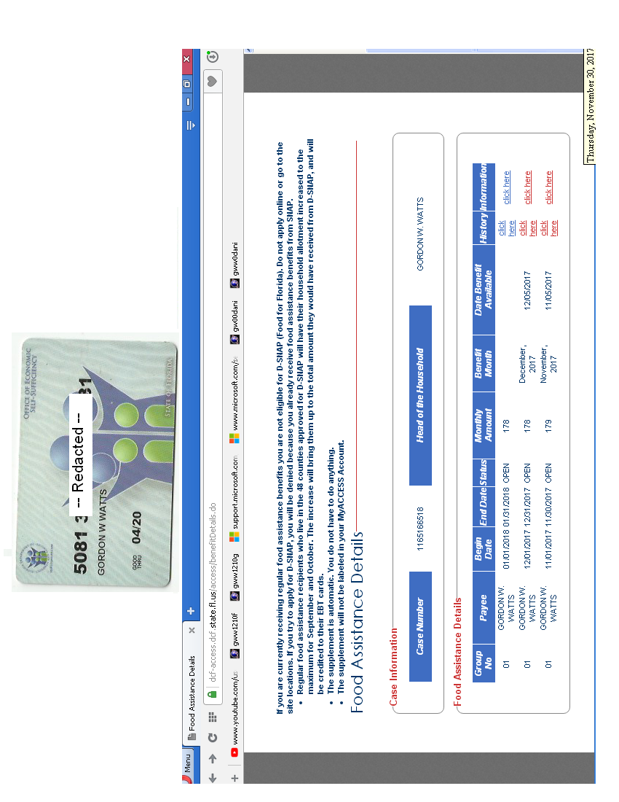
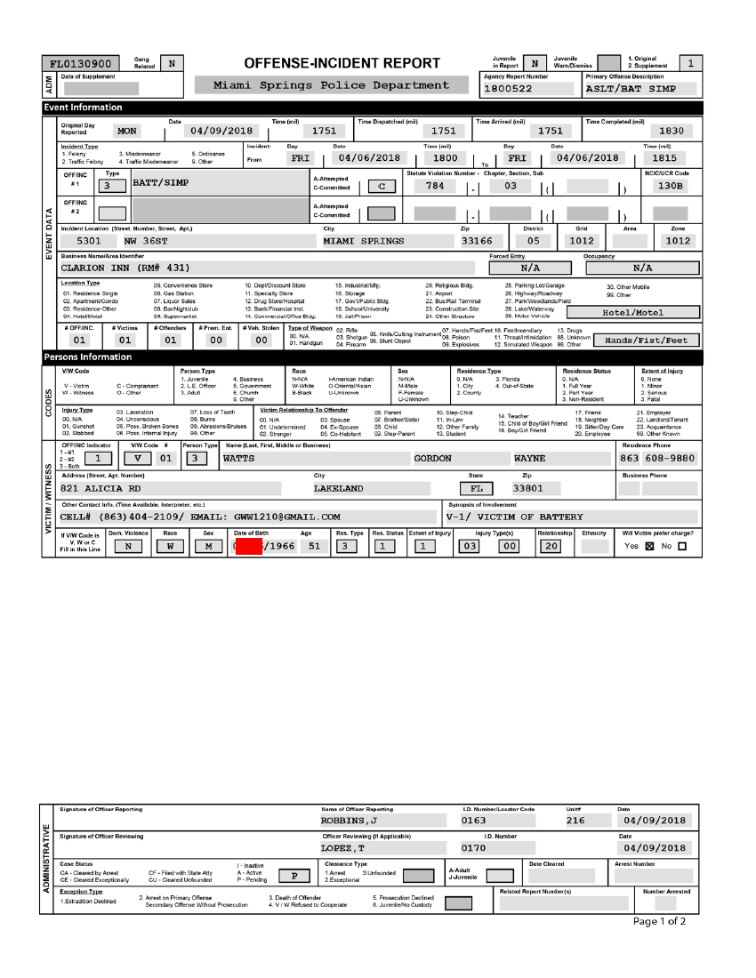
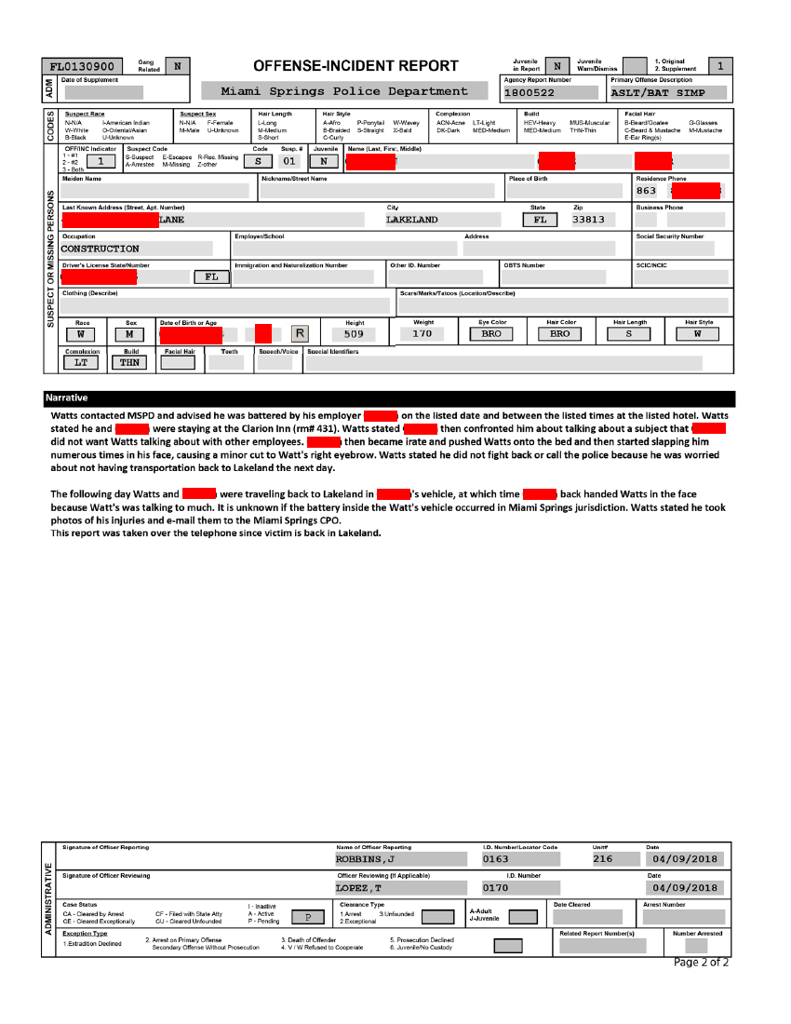
IN THE
SUPREME COURT OF ILLINOIS

Gordon Wayne Watts, ||
Plaintiff, ||
||
vs. ||
||
Hon. James P. Flannery, Jr., in his capacity as presiding || Docket Number: ________
judge, Law Division, Cook County, IL circuit court ||
||
and ||
||
Hon. Diane M. Shelley, in her capacity as circuit judge, ||
Law Division, Cook County, IL circuit court, ||
Defendants. ||

ORDER

The Motion by Movant, Pro Se, for Leave to Proceed in Forma Pauperis, is hereby: ALLOWED / DENIED.

__________________________________________
Justice

SERVICE LIST

* ILLINOIS SUPREME COURT – Supreme Court Building, Office Hours: 8:30am-4:30pm CST, Mon-Fri, Excl. Holidays, PH: (217) 782-2035 ; TDD (217) 524-8132, Attention: Clerk's Office – 200 E. Capitol Ave. – Springfield, IL 62701-1721 [[served by eFiling , and, if accepted/docketed, thirteen (13) hard copies]]

*Hon. Timothy C. Evans, Chief Judge (Ph 312-603-6000, 4299, 4259 TTY: 6673) Circuit Court of Cook County, 50 W. Washington St., Room 2600, Richard J. Daley Center Chicago, IL 60602, Courtesy copy via: Timothy.Evans@CookCountyIL.gov [served by email only, as a courtesy, since he is not a party proper]

* Hon. James P. Flannery, Jr., Circuit Judge–Presiding Judge, Law Division 50 W. Washington St., Room 2005, Chicago, IL 60602, Ph:312-603-6343, Courtesy copy via: James.Flannery@CookCountyIL.gov [served in all ways, as Judge Flannery is a defendant]

* Law Division and Hon. Diane M. Shelley, Circuit Judge, Daley Center, 50 W. Washington St., Rm. 1912, Chicago, Illinois 60602 Law@CookCountyCourt.com ; ccc.LawCalendarW@CookcountyIL.gov ; Diane.Shelley@CookCountyIL.gov [served in all ways, as Judge Shelley is a defendant]

* Richard B. Daniggelis [true owner of 1720] 312-774-4742, c/o John Daniggelis,
2150 North Lincoln Park West, Apartment #603, Chicago, IL 60614-4652

* Richard B. Daniggelis (who receives mail, via USPS mail-forwarding at his old address) 1720 North Sedgwick St., Chicago, IL 60614-5722

* Andjelko Galic Atty for Richard B. Daniggelis (Atty#:33013) C:312-217-5433, Fx:312-986-1810, Ph:312-986-1510, AGForeclosureDefense@Gmail.com ; AndjelkoGalic@Hotmail.com 845 Sherwood Road, LaGrange Park, IL 60526-1547

* Robert J. More ( Anselm45@Gmail.com ) [Note: More's name is misspelled on docket as: “MOORE ROBERT”] P.O. Box 6926, Chicago, IL, 60680-6926, PH: (708) 317-8812 [[Mr. More has made a formal request by email to receive service solely by email, and waives hard-copy service—see Exhibits, with a statement from Mr. More.]]

* Associated Bank, N.A., 200 North Adam Street, Green Bay, WI 54301-5142

* MERS (Mortgage Electronic Registration Systems, Inc.) https://www.MersInc.org/about-us/about-us a nominee for HLB Mortgage, (703) 761-0694 / (800)-646-MERS (6377) / 888-679-MERS (6377) ATTN: Sharon McGann Horstkamp, Esq., Corporate Counsel, Mortgagee: https://www.MersInc.org/component/content/article/8-about-us/401-sharon-horstkamp Senior Vice President, Chief Legal and Legislative Officer, and Corporate Secretary for MERSCORP Holdings, Inc. – PH: (703) 761-1270, FAX: (703) 748-0183,
SERVICE LIST (continued from above)

SharonH@MersInc.org ; SharonH@MersCorp.com Cc: Janis Smith, 703-738-0230, VP, Corp. Comm. is no longer with MersCorp, and Amy Moses (AmyM@MersCorp.com ; AmyM@MersInc.org) has replaced her as an email contact; Sandra Troutman 703-761-1274, E: SandraT@MersInc.org ; SandraT@MersCorp.com) Dir, Corporate Communications, Karmela Lejarde, Communications Manager, Tel~ 703-761-1274, Mobile: 703-772-7156, Email: KarmelaL@MersInc.org ; KarmelaL@MersCorp.com C/o: MERS (Mortgage Electronic Registration Systems, Inc.), 1901 East Vorhees Street, Suite 'C', Danville, IL 61834-4512

* COHON RAIZES®AL LLP (90192) (Atty for STEWART TITLE ILLINOIS)
Attn: Carrie A. Dolan, pPh:(312) 726-2252
208 S LASALLE, Suite #1860, CHICAGO IL, 60604

* Stewart Title, Attn: Leigh Curry
http://www.Stewart.com/en/stc/chicago/contact-us/contact-us.html
2055 W. Army Trail Rd., STE 110, Addison, IL 60101 [ph:(630) 889-4050]

* Richard Indyke, Esq. Atty. No. 20584, (RIndyke@SBCGlobal.net ; 312-332-2828 ; 773-593-1915 most recent “Attorney of record” for LaSalle Bank Natl. Assn.), 111 South Washington Ave., Suite 105, Park Ridge, IL 60068-4292 [[Mr. Indyke claims to not represent any party in the instant appeal, but the undersigned can not find any more recent atty of record for defendant, LaSalle Bank, and reluctantly will keep Mr. Indyke on the service list, unless excused by The Court—see Exhibits, with a statement from Mr. Indyke.]]

* Peter King (Atty. for Joseph Younes) (Atty. No.: 48761)
(312) 780-7302 / (312) 724-8218 / Direct: (312) 724-8221
http://www.KingHolloway.com/contact.htm ; Attn: Peter M. King, Esq. PKing@khl-law.com or: PKing@KingHolloway.com ; One North LaSalle Street, Suite 3040, Chicago, IL 60602

* Joe Younes: 2625 West Farewell Avenue, Chicago, IL 60645-4522 JoeYounes@SbcGlobal.net

* Joseph Younes (Atty#:55351) Law Offices / http://ChicagoAccidentAttorney.net
312-635-5716, per website, Ph: 312-372-1122 ; 312-802-1122 ; Fax: 312-372-1408 E: RoJoe69@yahoo.com 166 West WASHINGTON ST, Ste. 600, Chicago, IL 60602-3596

* Paul L. Shelton, Pro Se, (Atty. #15323, disbarred per IARDC)
E: PMSA136@Gmail.com ; PLShelton@SBCGlobal.net – 3 Grant Square, SUITE #363, Hinsdale, IL 60521-3351

* Erika R. Rhone 22711 Southbrook Dr., Sauk Village, IL 60411-4291

IN THE
SUPREME COURT OF ILLINOIS

Gordon Wayne Watts, Plaintiff, ||
||
vs. ||
||
Hon. James P. Flannery, Jr., in his capacity as presiding || Docket Number: _________
judge, Law Division, Cook County, IL circuit court ||
||
and ||
||
Hon. Diane M. Shelley, in her capacity as circuit judge, ||
Law Division, Cook County, IL circuit court, ||
||
Defendants. ||
||

CERTIFICATE AND AFFIDAVIT OF DELIVERY (aka: Certificate of Service)
* The undersigned Plaintiff, Gordon Wayne Watts, hereby certifies under penalties of perjury as provided by law pursuant to 735 ILCS 5/1-109, that the above Affidavit of Assets and Liabilities, Motion to Proceed in Forma Pauperis,and inline-attached exhibits, copies of which are attached hereto are being herewith served upon you—and upon the parties listed in the attached Service List, above – this Friday, 20 April 2018, via the Odyssey eFileIL (TylerHost.net) Electronic Filing system if they're e-file registered.
* I'm concurrently serving all parties via First Class U.S. Postal Mail and/or FedEx 3rd-party Commercial Carrier—whichever shall prove more convenient..
* Additionally, I'm serving all parties by email, if indicated in the Service List.
* Lastly, I shall, when practically possible, post a TRUE COPY of this filing –and related filings –online at my official websites, infra –linked at the “Mortgage Fraud” story, dated Fri. 14 April 2017.

Under penalties as provided by law pursuant to Section 1-109 of the Code of Civil Procedure, the undersigned certifies that the statements set forth in this instrument are true and correct.

Respectfully submitted,
______________________________ /s/ Gordon Wayne Watts
(Actual Signature, if served upon clerk) (Electronic Signature)
Gordon Wayne Watts Gordon Wayne Watts

Gordon Wayne Watts, pro se [Code: '99500' = Non-Lawer, pro se]
821 Alicia Road, Lakeland, FL 33801-2113
PH: (863) 688-9880 [home] or (863) 409-2109 [cell]
Web: http://www.GordonWatts.com / http://www.GordonWayneWatts.com
Email: Gww1210@aol.com / Gww1210@gmail.com

