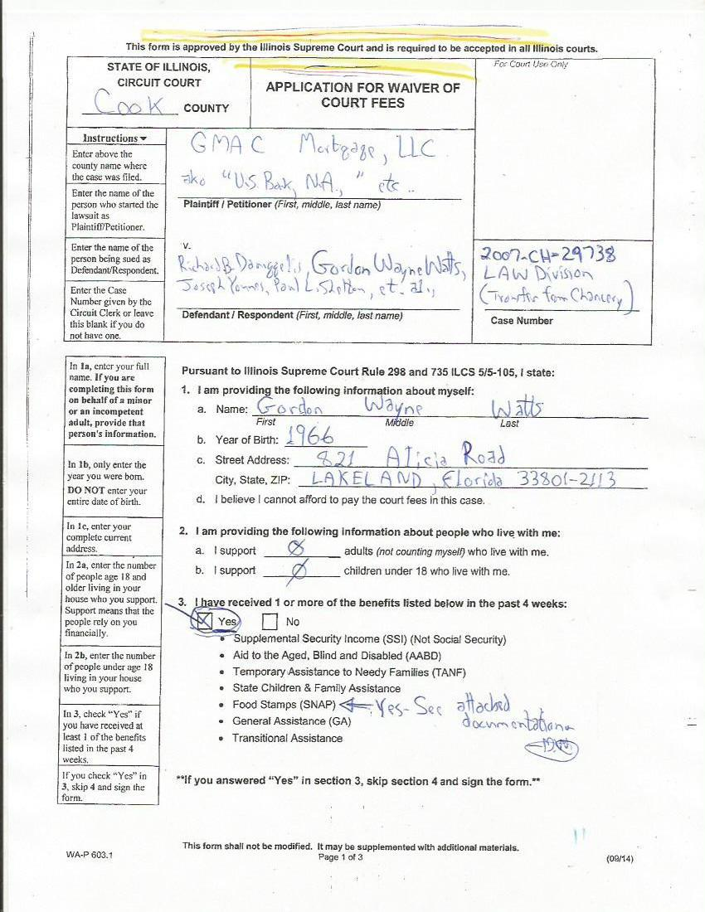
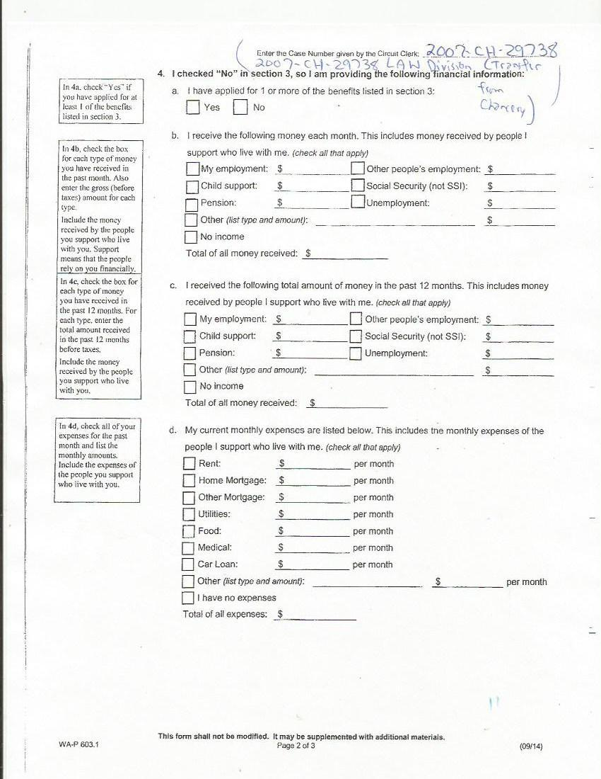
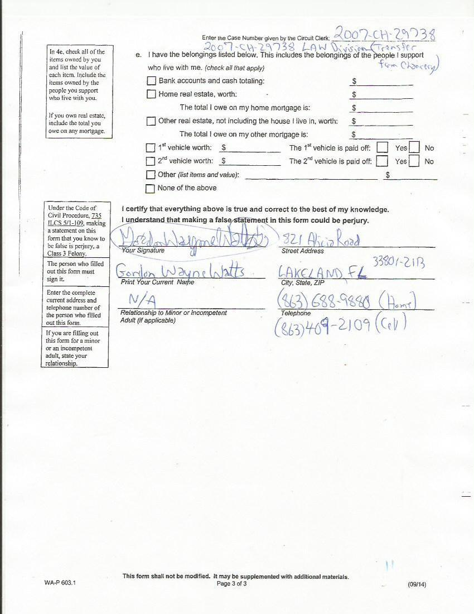
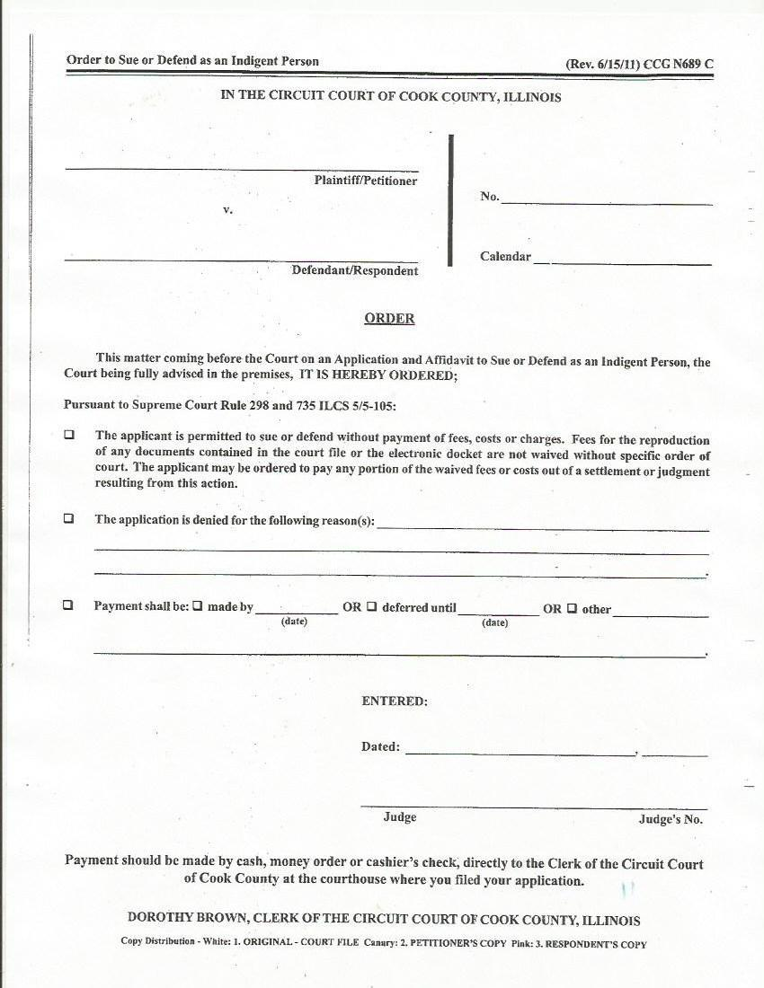
GMAC v Daniggelis, Watts, Younes, et al., 2007-CH-29738 (Notice of Appeal)

From the Desk of: Gordon Wayne Watts
821 Alicia Road – Lakeland, FL 33801-2113
H: (863) 688-9880 – C: (863) 409-2109 – W: (863) 686-3411 or: (863) 687-6141
Email: Gww1210@aol.com / Gww1210@Gmail.com
Web: www.GordonWatts.com / www.GordonWayneWatts.com

Hon. James P. Flannery, Jr., Circuit Judge–Presiding Judge, Law Division
50 W. Washington St., Room 2005, Chicago, IL 60602, Ph:312-603-6343

Re: “Waiver of Court Fees” confusion in this case Friday, 19 January 2018

Dear Judge Flannery:

It has come to my attention that there's confusion regarding my application for fee waiver. As you were the presiding judge who adjudicated my last application, it's instructive to revisit the issue: We recall I was a prospective Amicus Curiae aka a “Friend of the Court,” and you denied my application on grounds that I wasn't a party. As much as I disagree, I admit this is a “gray” area of case law, & any review of it would be “de novo.” As such, there's a good argument that you were right in your order (dated Feb. 22, 2016, in the underlying Chancery case, which was transferred to the Law Division) denying me fee waiver. However, when speaking by phone with Pat O'Brien, deputy chief of Civil Appeals, she assured me that your denial of my application last time means that I must be denied now. **UPDATE** Correction—since writing this (in my last letter, which was Exhibit-D in my Notice of Appeal), I spoke with Ms. O'Brien, who says I misrepresented her view, as to why she disagrees with me. I think she simply thinks that I needed an explicit order –but she's wrong: See the case-law below...
My application for fee waiver this past Monday, 08 January 2018 (the day I filed my notice of appeal) was rejected because it was an 'Exhibit,' and had to have been a stand-alone filing, so I get a redo.
Anyhow, I mean no disrespect to Patricia –but here's my point: Since Ms. O'Brien is very intelligent (knowledgeable of Supreme Court rules, much more than her staff), if she can get confused, judges can also—after all, judges are human too. While you might've been right to deny me last time, things have changed. I asserted intervention (see my Motion to Intervene, dated Thursday, 06 July 2017), an absolute right under IL case law: Where intervention as of right is asserted, “the trial court’s jurisdiction is limited to determining timeliness, inadequacy of representation and sufficiency of interest; once these threshold requirements have been met, the plain meaning of the statute directs that the petition be granted.” City of Chicago v. John Hancock Mutual Life Ins. Co., 127 Ill.App.3d 140, 144 (1st Dist. 1984). I satisfy all 3 requirements, giving me right to intervene under 735 ILCS 5/2-408(a)(3). As there was no denial of my motion, the docket's official listing of me as a defendant is prima facia evidence that I'm now a party, and thus qualify for fee waiver to sue or defend. (And, as I could sue Joe Younes anyhow, my cross-complaint and appeal constitutes suit, thus qualifying me.) Recall Rule 10-100(a) Illinois Supreme Court Commission on Access to Justice: “The Illinois Supreme Court Commission on Access to Justice is established to promote, facilitate, and enhance equal access to justice with an emphasis on access to the Illinois civil courts and administrative agencies for all people, particularly the poor and vulnerable,” which includes me. Therefore, my Notice of Appeal, and my Request for Preparation of the Record on Appeal, both Sine Qua Non necessary to grant me Due Process to proceed indigent in my appeal, require a grant of my request for a Fee Waiver. Otherwise, the injustices occurring in this case can not be reviewed on appeal. Unless your court awards me for my various losses, which I've documented in my Intervention Motion, I'll have sufficiency of interest & thus qualify to Intervene—and obtain fee waiver. This is IL case law; you may check to verify, but you must comply.

With kind Regards, I am, Sincerely,
/s/ Gordon Wayne Watts
Gordon Wayne Watts
Prior Waiver denial before I was a party to the case (1 page)
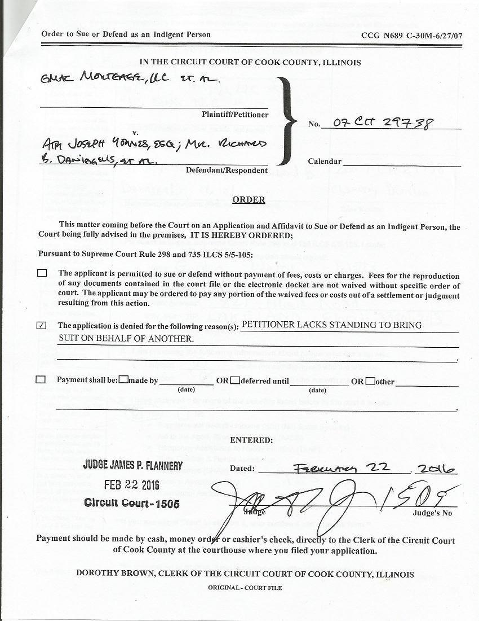
Prior Waiver denial before I was a party to the case (1 page)
