“Exhibit-E” – GMAC v. Watts, et al., 1-18-0091 ( ILLINOIS First Appellate Court)

DESCRIPTION: This is documentation of returned mail, from service copies of that which I served in the above-captioned case.

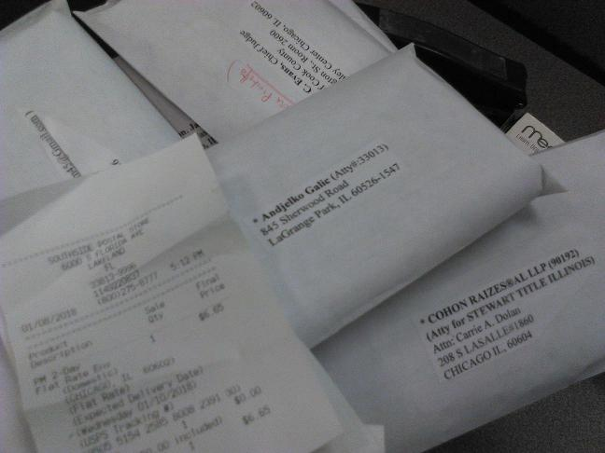

* Main purpose : To clearly document which 'service addresses' are bad – in order that The ILLINOIS First Appellate Court might have the “most accurate” Service List available.

* Axillary Purpose : Since I'm an “unknown” & a non-Lawyer litigant, there may be questions about whether I'm “really” serving all the parties, as I'm required to do by law. I'm human – I will admit – but, on my honour, I'm attempting to comply with court rules, and thereby show proper respect to all the litigants—and The Court. Let this serve as documentation.

Electronically Signed: /s/Appellant, Gordon Wayne Watts

“Exhibit-E” – GMAC v. Watts, et al., 1-18-0091 ( ILLINOIS First Appellate Court)
