IN THE CIRCUIT COURT OF COOK COUNTY, ILLINOIS
Municipal Department – District 1 - Housing Section

CITY OF CHICAGO ) Case No.: 2017-M1-400775
Plaintiff ) Before: Hon. PATRICE MUNZEL
) BALL-REED, Associate Judge
vs. ) Case Type: HOUSING
) District: First Municipal
1720 N SEDGWICK ST, ASSOCIATED BANK NA, )
NON-RECORD CLAIMANTS, UNKNOWN OWNERS ) TIME-SENSITIVE: to be heard
Atty. Joseph Younes, Esq. ) in Court Room:1105, by 04/27/2017
Defendants. ) Court Time: 11:00am (CST)

Time-Sensitive Judicial Notice of Adjudicative Facts

This notice is filed to bring to The Court's attention facts overlooked twice before, which almost resulted in the house, at question, being destroyed or otherwise subject to illegal construction and/or demolition, both times resulting in “Stop Work Orders” by the City of Chicago to stop illegal activity done by defendant, Joseph Younes. If I do not file this notice, then the “3rd time will be a charm,” and Mr. Younes may succeed in gutting and destruction of the house. Under Rule 201(c)(2), Fed.R.Civ.P., The Court must take judicial notice if a party requests it and The Court is supplied with the necessary information. While Dual Federalism might preclude the Supremacy Clause from applying this Federal Rule to This (State) Court, nonetheless, it is still a good guideline, and, to that end, I shall do my best to provide This Honourable Court the necessary information to make it's job as easy as reasonably possible.
As a legal point, I may have rights as a “non-record claimant,” and an interest in this case, since the ownership of this house is being litigated in another case (see below), in which Richard Daniggelis, who is 78-years old, and who is the true owner, is contesting ownership: Mr. Daniggelis has promised me some unspecified funds for research I've done for him, thus I am vested with an interest in this litigation (which will affect his ability to continue the other case, win ownership of the house, and be in a better position to pay me what he asserts he owes me). Thus, I have small (but non-zero) rights of intervention. (Mr. Daniggelis is thus an “unknown owner,” and a named defendant.) This would also make me a non-record claimant, and a named defendant.
Moreover, This Court should know, realise, & understand one thing: I am filing this with the motives to help The Court, and provide helpful information, so if I am in error in any manner, please forgive and overlook my human limitations, and carefully review that which I take time to provide you.

This Court certainly remembers when Mr. Daniggelis, an elderly, 78-year-old man, asked to speak at the Thursday, 03/30/2017, 09:30am (CST) hearing before This Court regarding the “HOUSING COMPLAINT FILED.” If This Court is concerned about the welfare of the elderly, then I ask you to take note of these facts: When Mr. Daniggelis asked to speak, Judge Ball-Reed told him that he had no legal standing, as he was not the owner. While Judge Reed had good intentions, she was incorrect: Mr. Daniggelis' signature was forged, thus making him the true owner (even if not the 'legal' owner): see “AFFIDAVIT FILED” and “EXHIBITS FILED” (Activity Date: 8/10/2015, Participant: NON RECORD CLAIMANTS, Attorney: PRO SE) in GMAC v. Daniggelis, et al. (Case#: 2007-CH-29738 in CHANCERY). A courtesy copy of the WATTS filings (Amicus & Sworn Affidavit), dated Aug. 03, 2015, filed 08/10/2015, is included for the judge's chambers as a courtesy, but not provided to those parties already served (see Certificate of Service). While we don't know who executed the forgery, even the State's Attorney's office admits a forgery was done. (See exhibits) They also admit other crimes were committed, but unprosecuteable, due to the statute of limitations being tolled.

Page 1 of 2 (Time-Sensitive Judicial Notice of Adjudicative Facts)
The State's Attorney's statements:

Looking at three (3) things that Asst. State Attorney, Thomas Simpson says, This Court has information that will be useful in determining this HOUSING case:

(#1) First, Asst. St. Atty. Simpson (in paragraph 2) does not call it “alleged” forgery. Rather, he calls in “this forgery.” While Younes may not have committed this forgery, he was eventually notified of it, via my court filings, and yet he continued to fight for possession of property that he knew was stolen property. That he did not know who did this is unimportant: For example, if a Pawn Shop gets possession of The Batmobile, buying it from some young 17-year-old, the Police might not be able to find out who sold it to them, but since everyone knows that The Batmobile belongs in a museum (or in the Bat Cave), the Pawn Shop's actions are criminal: they are knowingly dealing in hot (stolen) property, and so is Younes.

(#2) Secondly, Simpson admits that financial crimes were committed, but that he can not prosecute because the “statutes of limitations are exhausted for everything save forgery.” Since Younes is benefiting from these financial crimes, he is guilty (but can not be “criminally” prosecuted due to statutes of limitations running out. Since no one has provided a copy of the warranty deed used to transfer title with an original (not photocopied) signature, we have even more proof that it was indeed a photocopy, as documented in the filings cited above.

(#3) Third and last, Simpson admits (par. 3) that he believes that “he (Daniggelis) was taken in a scheme,” meaning there were guilty parties, obviously including Younes, who benefited from the illegal transfer of title—by getting a FREE house, for which Daniggelis received NO documented payment (no payment at all).

Conclusion

While This Court only considers the 'Housing' matter, nonetheless, the documented criminal actions of Atty. Joseph Younes are relevant and adjudicative facts: First, I warned The Court, in my “Time-Sensitive Judicial Notice...” (dated Sept. 09, 2015, docketed Sept. 11, 2015 in 2007-CH-29738, in Chancery), that Younes was attempting illegal construction/demolition, and I showed This Court photos of a “STOP WORK ORDER,” but this court, in its infinite wisdom, ignored me. Because of that, Younes, again, attempted much greater illegal construction/demolition, again drawing the ire of The City of Chicago (which resulted in this case, City of Chicago vs. Younes, 2017-M1-400775, being filed – and made local news media: See recent DNAinfo and The Register news coverage, listed elsewhere). While Younes may have not been guilty of the actual forgery, he certainly participated in a scheme, and benefited from it, and was only able to escape jail time & criminal prosecution because the police did not bring charges fast enough, allowing the statutes of limitations to slip by.

While I can not advise This Court on what, precisely, should be done, the statement made in open court by Judge Ball-Reed that Younes would not be be allowed to destroy the house is a good statement, and these filings are submitted by the undersigned to help This Court weight and balance the interests of The City with the facts about Younes' character, honesty, and known criminal activity to help is have all the facts.

Page 2 of 2 (Time-Sensitive Judicial Notice of Adjudicative Facts)
CERTIFICATE AND AFFIDAVIT OF DELIVERY (aka: Certificate of Service)
The undersigned, hereby certifies under penalties of perjury as provided by law pursuant to 735 ILCS 5/1-109, that the above “Time-Sensitive Judicial Notice of Adjudicative Facts,” and its exhibits were delivered to the following parties as indicated – this Saturday, the 22nd day of April 2017:

CIVIL DIVISION: Richard J. Daley Center, 50 West Washington St., Room 601 [8:30 a.m. to 4:30 p.m., Monday through Friday, Excluding Court Holidays] Telephone Numbers: (312) 603-5116, (312) 603-5122, (312)603-5252, Chicago, IL 60602 – , Hours: 8:30a.m.-4:30p.m., Mon-Fri, Excl. Holidays

Hon. Patrice Munzel Ball-Reed, Associate Judge, Civil Division, District 1 - Housing Section
Daley Center, 50 W. Washington St., Rm. 1105, Chicago, Illinois 60602, (312) 603-4536 [This number is listed on Judge's page: http://www.CookCountyCourt.org/JudgesPages/BallReedPatrice.aspx but clerk says that this is wrong number and goes to room 1107.] Note: I may include (for proper context) prior filings for the judge's chambers, not served upon Mr. Younes, but that is because I already served him said papers, when originally filing, so he is not in need of service a second time.

City of Chicago, CORPORATION COUNSEL, 30 N LASALLE 900, CHICAGO IL, 60602, Phone: (312) 742-0200, Note: See not above regarding judge's chambers: Ibid. for City Counsel.

Joseph Younes Law Offices / http://ChicagoAccidentAttorney.net (312)635-5716, per website: 166 W WASHINGTON ST, Ste. 600, Chicago, IL 60602; Phone: (312) 372-1122 ; Fax: (312) 372-1408. Email is (or was?) RoJoe69@yahoo.com per http://www.ZoomInfo.com/p/JosephYounes/599467626 Note: Mr. Younes recently refused service of his copy of a filing I filed via FedEx [see exhibits to verify], so all he gets this time is “standard postal mail” or otherwise 'standard' service (not expensive signature confirmation), but I certify he is being served. If This Court doubts, it may effect service (e.g., “Postcard” Mr. Younes & other litigants), and send me a nominal bill for said service, but, I doubt anyone would question me on this.

I, Gordon Wayne Watts, the undersigned, hereby certify under penalties of perjury as provided by
law pursuant to 735 ILCS 5/1-109, that the above “Time-Sensitive Judicial Notice of Adjudicative Facts,” and its exhibits, were served upon all parties listed above, this __22nd__ day of ___April___, 2017 by the following methods:
• United State Postal Service: I am serving the parties proper via my city's local post office on the date listed – and with proper postage and/or by FedEx 3rd-party commercial carrier (whichever proves more convenient). I hope to obtain certification of delivery with return receipt and signature confirmation on as many packages as I can afford.
• E-mail: I may, later, serve all the parties listed above via email, in such cases as I have their e-mail address—as a courtesy. Or, then again, I may not (as it is not required), but if I serve any party electronically (via email), then I will serve all parties, so as to keep everybody in the loop.
• Internet: I shall, when practically possible, post a TRUE COPY of this filing – and related filings – online at my official websites, infra-- linked at the “Mortgage Fraud” story, dated. Fri. 14 Apr. 2017.

Signature: _______________________________ Date: _____________________
Gordon Wayne Watts, Amicus Curiae*
821 Alicia Road
Lakeland, FL 33801-2113
PH: (863) 688-9880
Web: www.GordonWatts.com / www.GordonWayneWatts.com
Email: Gww1210@aol.com / Gww1210@gmail.com
Date: Monday, 17 January 2017
* Watts, acting counsel of record, is not a lawyer. Per Local Rule 2.1, “Notice
of Hearing of Motions,” Watts, appearing pro se, is giving notice of his motion
INDEX TO THE EXHIBITS

Instrument Docket/Tab#

FedEx package refused by Atty. Joseph Younes Exhibit-A

Email exchange with Cook County State's Attorney Office Exhibit-B

FedEx package refused by Atty. Joseph Younes Exhibit-A

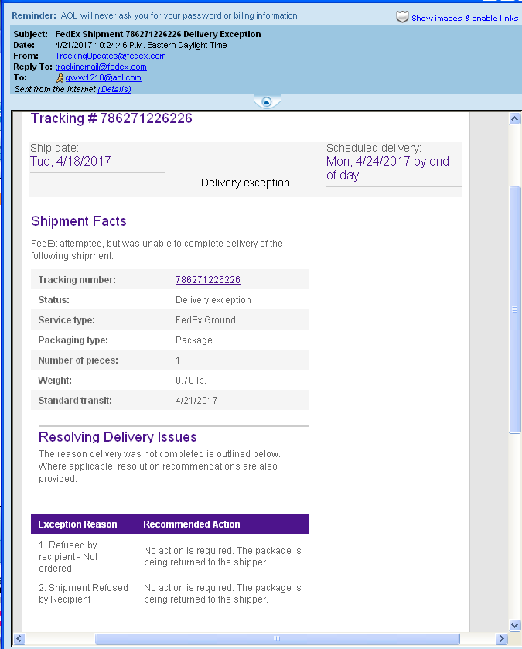

Email exchange with Cook County State's Attorney Office Exhibit-B

