IN THE CIRCUIT COURT OF COOK COUNTY, ILLINOIS
Municipal Department – District 1 - Housing Section

CITY OF CHICAGO ) Case No.: 2017-M1-400775
Plaintiff, )
) Before: Hon. PATRICE MUNZEL
vs. ) BALL-REED, Associate Judge
) Case Type: HOUSING
1720 N SEDGWICK ST, ASSOCIATED BANK NA, ) District: First Municipal
NON-RECORD CLAIMANTS, UNKNOWN OWNERS, )
Atty. Joseph Younes, Esq., et al. ) TIME-SENSITIVE: to be heard
Defendants, and ) in Court Room:1105, by
) 08/31/2017, Gordon Wayne Watts, ) Court Time: 11:00am (CST)
Proposed Intervening Defendant. )

NOTICE OF FILING

To: see attached service list

You are hereby notified that today, Saturday, 26 August 2017, I am filing, via First Class U.S. Postal Mail and/or FedEx 3rd-party commercial carrier, a copy of my Supplement to Motion for Limited Intervention, a copy of which is attached and hereby served upon you.

Date: Saturday, 26 August 2017 _____________________
Gordon Wayne Watts
Gordon Wayne Watts, Intervenor, pro se
821 Alicia Road, Lakeland, FL 33801-2113
PH: (863) 688-9880 [home] or (863) 409-2109 [cell]
Web: www.GordonWatts.com / www.GordonWayneWatts.com
Email: Gww1210@aol.com / Gww1210@gmail.com

CERTIFICATE AND AFFIDAVIT OF DELIVERY (aka: Certificate of Service)

The undersigned Movant, Gordon Wayne Watts, hereby certifies under penalties of perjury as provided by law pursuant to 735 ILCS 5/1-109, that the above “Notice of Filing,” my Supplement to Motion for Limited Intervention, and its exhibits (which are attached hereto) were delivered to the parties listed in the attached Service List, below – this Saturday, 26 August 2017 via First Class U.S. Postal Mail and/or FedEx 3rd-party commercial carrier (whichever proves more convenient). I may, later, cc all parties via email, when practical. Additionally, I shall, when practically possible, post a TRUE COPY of this filing – and related filings – online at my official websites, supra – linked at the “Mortgage Fraud” story, dated. Fri. 14 Apr. 2017.

_____________________
Gordon Wayne Watts
Page 1 of 11 (8-26-17 Watts filing in CoC v 1720 N Sedgwick, Younes, et al. 2017-M1-400775)
City of Chicago v. 1720 N. Sedgwick Street, Atty. Joseph Younes, et al., 2017-M1-400775
SERVICE LIST

*CIVIL DIVISION: Richard J. Daley Center, 50 West Washington St., Room 601, Ph: (312) 603-5116, (312)603-5122, (312)603-5252, Chicago, IL 60602-1313, Hours: 8:30a.m.-4:30p.m., M-F
*Hon. Patrice Munzel Ball-Reed, Associate Judge, Civil Div., Dist 1 (Housing), Daley Center, 50 W. Washington St., Rm. 1105, Chicago, IL 60602-1316, Ph 312-603-4536 [Judge Ball-Reed's copy and the Clerk's copy sent to Emma J. Burse, Mail Room Manager (312-603-3117, EJBurse@CookCountyCourt.com), since previously, Priority mail to the judge got delayed.]

*City of Chicago, CORPORATION COUNSEL, Attn: City of Chicago, Department of Law: Building & License Enforcement Unit: 30 N LASALLE 700, CHICAGO IL 60602-2503
Ph: 312-742-0200; 312-744-7764, Attn: Greg Janes (Atty.#:90909) 312-744-9555, Glenn Angel, 312-744-4033, 312-744-8791 GJanes@CityOfChicago.org, Greg.Janes@cityofchicago.org, GAngel@CityOfChicago.org, Glenn.Angel@CityOfChicago.org, Benna.Solomon@CityOfChicago.org, Edward.Siskel@CityOfChicago.org

*Richard B. Daniggelis [true owner of 1720] 312-774-4742, c/o John Daniggelis 773-327-7198
2150 North Lincoln Park West, Apartment #603, Chicago, IL 60614-4652

*Unknown Owners/NonRecord Claimants 1720 North Sedgwick Street, Chicago, IL 60614-5722

*Andjelko Galic (Atty#:33013) C:312-217-5433, F:312-986-1810, Ph:312-986-1510) 845 Sherwood Road, LaGrange Park, IL 60526-1547 (Please take note: Mr. Galic, Daniggelis' atty in 2007-CH-29738, just recently changed business addresses as reflected in recent Law Division filings.) Email: AndjelkoGalic@Hotmail.com, AGForeclosureDefense@Gmail.com

*Associated Bank, N.A., 200 North Adam Street, Green Bay, WI 54301-5142

* Joe Younes: 2625 West Farewell Avenue, Chicago, IL 60645-4522 JoeYounes@SbcGlobal.net
* Joseph Younes (Atty#:55351) Law Offices / http://ChicagoAccidentAttorney.net (312)635-5716, per website 166 West WASHINGTON ST, Ste. 600, Chicago, IL 60602-3596; Ph: 312-372-1122, 312-802-1122, Fax: 312-372-1408. Email: RoJoe69@yahoo.com
* Younes' attorney Hugh Howard (Atty#:33492), c/o: Law Offices of Hugh D. Howard, 166 W Washington St, Suite 600, Chicago, IL 60602-3596, Ph:312-781-1002, HowardHughD@Gmail.com, Hugh@HughDHowardLaw.com

*Heavner Beyers Mihlar LLC, P.O. Box 740, Decatur, IL 62525-0740, Attn: Austin Schultz Croom (Atty#:40387), Ph: (217) 422-1719, (312)-999-9110, AustinSchultz@HSBattys.com, OrdinanceViolations@HSBattys.com Cc: RickHeavner@hsbattys.com, JulieBeyers@hsbattys.com, FaiqMihlar@hsbattys.com, MeredithPitts@hsbattys.com

*CR Realty Advisors, LLC 325 W. Huron, Suite 708, Chicago, IL 60654-3617, P: 312.332.7100, E: Info@cr-ra.com, JoshN@cr-ra.com, DaveM@cr-ra.com [NOT Suite 230, their old address]

Page 2 of 11 (8-26-17 Watts filing in CoC v 1720 N Sedgwick, Younes, et al. 2017-M1-400775)
IN THE CIRCUIT COURT OF COOK COUNTY, ILLINOIS
Municipal Department – District 1 - Housing Section

CITY OF CHICAGO ) Case No.: 2017-M1-400775
Plaintiff, )
) Before: Hon. PATRICE MUNZEL
vs. ) BALL-REED, Associate Judge
) Case Type: HOUSING
1720 N SEDGWICK ST, ASSOCIATED BANK NA, ) District: First Municipal
NON-RECORD CLAIMANTS, UNKNOWN OWNERS, )
Atty. Joseph Younes, Esq., et al. ) TIME-SENSITIVE: to be heard
Defendants, and ) in Court Room:1105, by
) 08/31/2017, Gordon Wayne Watts, ) Court Time: 11:00am (CST)
Proposed Intervening Defendant. )

Supplement to Motion for Limited Intervention by Intervenor, Gordon Wayne Watts
concurrent with
Responsive pleadings regarding Scrivener's Errors, etc.

Movant, Gordon Wayne Watts, having carefully examined the record in the case at bar, and having discovered numerous errors (numerous Scrivener's errors by other litigants, and one substantive oversight on his own part), as well as having discovered new developments that impact the merits of this case (and his motion), NOW COMES Movant, Gordon Wayne Watts, pro se; MR. WATTS HEREBY MOVES AS FOLLOWS:

Scrivener's Errors: First, I will “get out of the way” the boring (but legally necessary) stuff, so as to allow better attention to be given to the matters of weight:
    - The City of Chicago, in its 3-22-2017 complaint lists Associated Bank's zip code as “543101,” but it is actually: 54301-5142.
    - The zip code for 1720 North Sedgwick Street was listed on the Heavner notice, dated 26 April 2017 as “60644,” but the correct zip is: 60614-5722.
    - Mr. Younes, his attorney, Mr. Howard, and the Heavner law firm all have additional contact information not initially apparent from the record. Please see the newly-updated Service List for current service data.
    - According to official word I have received from FedEx, CR Reality's old address of record, Suite 230, is no longer valid, and the correct address is 325 W. Huron, Suite 708, Chicago, IL 60654-3617. [Zip code courtesy of USPS lookup.]
    - According to both Mr. Daniggelis himself, and an update I got from Paul L. Shelton [See Exhibit-A], Hon. Diane M. Shelley (Law Division) has forbidden Atty. Andjelko Galic (attorney for Richard Daniggelis, the true owner of 1720 N. Sedgwick) from withdrawing in the related Law Division case, 2007-CH-29738. Accordingly, I am including Galic on this service list, since Hon. Patrice Ball-Reed has invited Daniggelis to intervene in the case at bar.

Page 3 of 11 (8-26-17 Watts filing in CoC v 1720 N Sedgwick, Younes, et al. 2017-M1-400775)
City of Chicago v. 1720 N. Sedgwick Street, Atty. Joseph Younes, et al., 2017-M1-400775

    - When I reviewed the entire case file of the case at bare (via a Public Records request made to the Civil Division), I noticed that numerous pages in my filings were IN REVERSE ORDER. And one page was genuinely missing, specifically, one exhibit showing that Mr. Younes refused service of his copy of a FedEx filing to This Court made by the undersigned Movant. But, thankfully, this same exhibit was included in another filing, since Movant was aware that humans are involved, and occasionally make mistake. Thus, in this regard, nothing is missing, but simply grossly out-of-order, and hard to read. [In fact, when the clerk ran out of printer paper, in preparation of the electronic PDF file, and had to “re-do” my Records Request, the corrected PDF was identical in the “random” ordering of pages, excepting that it was complete, unlike the prior PDF, thus I know that the error is in the record, not the action of the clerks.] HOWEVER, such errors are minor, and an astute legal reader can “re-order” the pages in his/her head when reading the Court's Record—and “read thru” such ordering typos.
    - Lastly, since Mr. Daniggelis is the true owner (and ONLY owner—even tho, I admit, not currently the 'legal' owner—which is why we are all litigating to no end) of 1720 N. Sedgwick, I am legally bound to serve him a copy of all my pleadings (which is why I included his attorney in the related case, in my service list). HOWEVER, while Mr. Daniggelis has expressed to me (numerous times, I add) that he is very private and would prefer to remain hidden, anonymous, unlisted, and such regarding his contact information, nonetheless, Rules of the Court mandate (and leave me no discretion) in this matter that I do NOT exclude him (or his attorney in the Law case) from service. Accordingly, I am including Daniggelis in the Service List, which contact information I obtained, mostly, from the July 10, 2017 pleading filed by Galic in GMAC v. Younes, Watts, Daniggelis, et al., file #: 2007-CH-29737, currently pending on Motion for Reconsideration before Hon. Diane M. Shelley, in the related Law Division case.
    - One last Scrivener's error: The City's complaint (p.2) lists the (forged) Warranty Deed as document #: “0622826137.” The actual doc # is: 0622826138.

* Matters of Weight: I was also granted Intervention in the sister-case, GMAC v. ...
First off, since my last filing in the case at bar, there has been a major development that will impact my Motion for Intervention: I ask This Court to take Judicial Notice of the latest development in GMAC v. Younes, Watts, Daniggelis, et al., file #: 2007-CH-29737, before the Law Division. The undersigned Movant, Gordon W. Watts, made a similar motion for Intervention in the Law Division case, which has been granted: While no order specifically mentions him by name, the Court's docket [See Exhibit B] lists as the second lead defendant, Mr. Watts, and thus the “style” of the case is now: GMAC v. Younes, Watts, Daniggelis, et al., file #: 2007-CH-29737. While This Court must evaluate each motion de novo, the grant of Watts' motion to Intervene in the sister-case implies that he has legal standing to intervene here, as well.
Note: While it appears, on first glance, GMAC is over, that is not so: The motion is still pending.

Page 4 of 11 (8-26-17 Watts filing in CoC v 1720 N Sedgwick, Younes, et al. 2017-M1-400775)
City of Chicago v. 1720 N. Sedgwick Street, Atty. Joseph Younes, et al., 2017-M1-400775

*Matters of Weight (continued from above) –Huge Oversight by Movant, Gordon W. Watts

I have taken note of the fact that the Order of The Court dated July 13, 2017 contains a scratch-out, with the judge reversing her prior order to deny my Intervention. Whether the initial order was due to my not having ability to physically present in court, “In Propia Persona,” or whether it was due to the FedEx OVERNIGHT having been late (due to snow storms, as documented in my prior exhibits), it is uncertain, but The Movant is not unaware of the fact that This Court is trying to be “fair” in its dispensing of Due Process for all litigants—even poor, out-of-state, “non-lawyer” litigants, such as Watts. To that end, I must apologise to The Court for a huge oversight on my part: In my previous filings, I asserted INTERVENTON on the basis of City of Chicago v. John Hancock Mutual Life Ins. Co., 127 Ill.App.3d 140, 144 (1st Dist. 1984), which lists the 3-prong test for Intervention: (#1) timeliness, (#2) inadequacy of representation, and (#3) sufficiency of interest.

*** It is without question that I met prong-1: My motion was timely, because my motion and prior notices were the FIRST responsive pleadings entered on the docket, drawing “first blood,” so to speak.

*** Also, the copious receipts I listed in my exhibits showed (easily) several hundred dollars of “lien” on the property for work done. (And, I might add, since the last pleading, I have done more research for Daniggelis, costing my loads in Public Records fees, and my litigation to defend my rights must be counted too, which now includes additional mailing service, printing, more time lost from work, etc.) While I'm too pressed for time, as I write this motion to include more receipts, we all must know, realise, & understand that these things don't happen “for free”: Thus, I easily meet prong-3, “sufficiency of interest,” and ask the court to double the amount I claim.

*** However, was there “inadequacy of representation” (prong-2)? Well, I admit that the City of Chicago did a “strong” job in representing my interests in holding Joseph Younes accountable for numerous (and willful, I might add) CODE violations, attempts to destroy the property to “get around” Historic Landmark restrictions, etc. But, I'm glad to report that I “technically” met the “letter of the law,” insofar as I provided copious additional legal AND FACTUAL predicates upon which This Court can act—I.e., The City of Chicago couldn't have done as good a job as me, & would've been VERY “inadequate” in representing Intervenor, Watts' interest. Nonetheless, I omitted one KEY thing, which I must include it to uphold, the “Spirit of the Law” & act in good faith: While I complained about a problem (Younes' willfully dishonest actions), I didn't propose a solution. (My apologies: This was a “legal toughie” & I need time to mull over it.) The City of Chicago desires to fine the pure living daylights out of Younes for the code violations. (And: I represent to This Court that Daniggelis has told me he wants enough fines to drive Younes away from this house.) While I am in agreement with this goal, I must disagree as to the ordering: To fine Younes FIRST might drive him away, and make him unwilling (or unable, financially) to make repairs on the damage he's done. I would respectfully ask This Court

Page 5 of 11 (8-26-17 Watts filing in CoC v 1720 N Sedgwick, Younes, et al. 2017-M1-400775)
City of Chicago v. 1720 N. Sedgwick Street, Atty. Joseph Younes, et al., 2017-M1-400775

to compel Younes (under threat of criminal prosecution) to repair the property FIRST, and THEN consider any fines as need be.

Insofar as Daniggelis (the true owner) and The City of Chicago both appear to have a legal tact differing from my own, I would assert that I easily meet prong-2, “sufficiency of interest,” here. [Not that I didn't already meet it, but I only strengthen my Intervention argument, and respectfully ask This Court to grant Intervention, and then treat my request, here, as a Motion for Summary Judgment, thereby ruling against Younes—but for him to repair the house first, before fines are taken, and under threat of both more fines and criminal prosecution.]

In summary, since The CoC and Daniggelis have differing solutions, my interest are not being represented without my presence. [But, that aside, my other contributions – both legal and factual – merit intervention on those bases alone.]

** The Most Important Supplement to the Motion to Intervene **

Since my Motion to Intervene, in the above-captioned case, I noticed one other HUGE oversight, but one which could not have foreseeably been foreseen—namely this:

When Mr. Richard Bruce Daniggelis, elderly friend of the undersigned Movant, came before This Court on several occasions, Hon. Patrice Munzel Ball-Reed, Associate Judge #1897, assigned to this case, repeatedly invited Daniggelis to intervene. However, while the judge acted in good faith, she did not know one key fact, which resulted in an unforeseen (and unintended) denial of Due Process for Daniggelis: While Daniggelis (technically) has an attorney in the sister case (GMAC v. Daniggelis, Watts, Younes, et al.), the attorney is working pro bono (for free) and not only making grave oversights, but also working under compulsion of the court (and not willingly). TRANSLATION: Daniggelis is helpless—He has NO attorney to be his voice!

For this reason, Mr. Daniggelis, who is very elderly (and is caring for his brother, who sits on his deathbed) can probably not make a “written” motion to Intervene (as is this Movant). Even if, by some miracle, he can get someone to take dictation any type it up, he is not a lawyer—nor does he play one on TV—so expecting him to file “written” style is an unreasonably request to make.

THEREFORE, I respectfully move This Court to do one of the following:
    - If Daniggelis can show up for court, please allow him to make his motion orally (verbally) in open court. [In fact, look again at Exhibit-A: If the sister court allowed Paul Shelton, who was once an attorney, to make an “oral” motion, why not let Daniggelis do the same?]
    - In the alternative, This Court might sua sponte (of its own accord) take judicial note of his pending case in GMAC v. Daniggelis (07-CH-29738) and accord him Intervention on that basis, alone.

Page 6 of 11 (8-26-17 Watts filing in CoC v 1720 N Sedgwick, Younes, et al. 2017-M1-400775)
City of Chicago v. 1720 N. Sedgwick Street, Atty. Joseph Younes, et al., 2017-M1-400775

Lastly, no supplement would be complete without a response to Younes' answer (filed by his attorney, Hugh D. Howard, his attorney this past Friday, 21 July 2017).

I have carefully read Younes' answer to the City's numerous complaints, and, without getting into the mire of the details, I find as follows: Younes admits he had control of the subject property, which is de facto admitting he had ability (but not willingness) to make the needed repairs and/or avoid doing illegal (read: excess) work.

Moreover, on p.2 of Younes' answer (where he claims that the City's “Paragraph 8” is not a “well plead fact”), that is nonsense: Let's take a look at the City's paragraph 8, shall we? The City simply states the legal standards for buildings, and, unless Younes is willing to call the Legislature a liar (or claim the statute was misquoted), I'm calling Younes on this 'smoke-and-mirrors' argument.

Lastly, Younes denies Point 11 of the City's complaint. Oh, really? Younes expects us to believe he maintained a “safe and stable” condition for the building? In what universe is that? The balance of Younes' answer does not merit response, and none will be given.

In Conclusion:
I freely admit that a Chancery Court took title from Daniggelis and gave it to Younes. I also freely admit that the Common Law concept of Stare Decisis¹ would suggest that This Court give good faith and credit to the ruling by Hon. Judge Otto taking title from Daniggelis. Since This Court must determine, de novo, the claims put before it, I would ask this one thing: Unless This Court can give an explanation as to why it was legally justifiable to simply “snatch” title from Daniggelis and give it to Younes, please do not apply the doctrine of Stare Decisis to Daniggelis regarding the theft of his house, title, and land. While this court is not a court of chancery, the judges that oversee it are no less legally-astute, and thus great things are expected from the court.

Respectfully submitted,

Date: Saturday, 26 August 2017 _____________________
Gordon Wayne Watts
_______________________
^{1 “}Stare decisis,” which is is Latin for “to stand by things decided,” is the legal principle of determining points in litigation according to precedent. However, it is not reasonable to assume that “just because a court” said so, it makes it so. (For example: Gordon Hirabayashi, Fred Korematsu, and Minoru Yasui, Japanese Americans who are best known for their principled resistance to the internment of Japanese Americans during World War, all three had their convictions overturned through writs of coram nobis, and they were each awarded the Presidential Medal of Freedom. As well, America's Highest Court held, by a overwhelming margin of a 7-2 split decision, that: "...that the negro might justly and lawfully be reduced to slavery for his benefit." -Chief Justice Roger B. Taney, writing for the Court. (Dred Scott v. John F. Sanford, 15 L.Ed. 691; 19 How. 393; 60 US 393 at 407. (December Term, 1856) Lastly, in December 2014, a writ of coram nobis was granted by a federal court to posthumously vacate the conviction of George Stinney, a 14-year-old African-American boy who was wrongfully-convicted of murder and executed in June1944, in a one-day trial of the first-degree murder of two white girls. Thus, it gives The Court a bad name to wrongly apply Stare Decisis.
Page 7 of 11 (8-26-17 Watts filing in CoC v 1720 N Sedgwick, Younes, et al. 2017-M1-400775)
City of Chicago v. 1720 N. Sedgwick Street, Atty. Joseph Younes, et al., 2017-M1-400775

Verification by Certification

I, Gordon Wayne Watts, the undersigned Movant, under penalties as provided by law pursuant to 735 ILCS 5/1-109, Section 1-109 of the ILLINOIS Code of Civil Procedure, hereby certify that the statements set forth in this instrument are true and correct, except as to matters therein stated to be on information and belief, and, as to such matters, the undersigned certifies as aforesaid that he verily believes the same to be true.

“Any pleading, affidavit or other document certified in accordance with this Section may be used in the same manner and with the same force and effect as though subscribed and sworn to under oath.” Source: 735 ILCS 5/1-109:
http://www.ILGA.gov/legislation/ilcs/documents/073500050K1-109.htm

Nonetheless, This Court has on record my sworn, witnessed, and notarised affidavit, just to remove any and all doubt hereto.

Date: Saturday, 26 August 2017 _____________________
Gordon Wayne Watts

Gordon Wayne Watts, Intervenor, pro se
821 Alicia Road, Lakeland, FL 33801-2113
PH: (863) 688-9880 [home] or (863) 409-2109 [cell]
Web: www.GordonWatts.com / www.GordonWayneWatts.com
Email: Gww1210@aol.com / Gww1210@gmail.com

Page 8 of 11 (8-26-17 Watts filing in CoC v 1720 N Sedgwick, Younes, et al. 2017-M1-400775)
City of Chicago v. 1720 N. Sedgwick Street, Atty. Joseph Younes, et al., 2017-M1-400775

INDEX TO THE EXHIBITS

Instrument Docket/Tab#

Update from Paul L. Shelton Exhibit-A

Court's docket in GMAC v. Daniggelis, Watts, Younes, et al. Exhibit-B

Page 9 of 11 (8-26-17 Watts filing in CoC v 1720 N Sedgwick, Younes, et al. 2017-M1-400775)
City of Chicago v. 1720 N. Sedgwick Street, Atty. Joseph Younes, et al., 2017-M1-400775

Update from Paul L. Shelton (Exhibit-A)

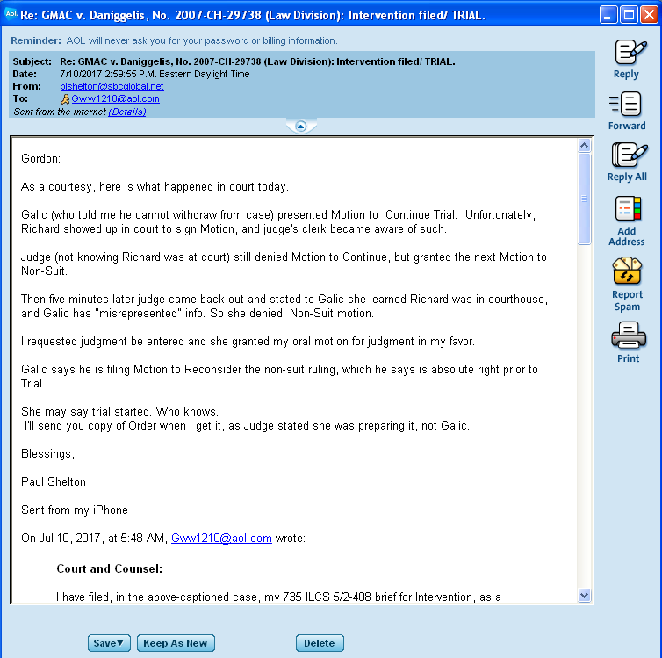

Page 10 of 11 (8-26-17 Watts filing in CoC v 1720 N Sedgwick, Younes, et al. 2017-M1-400775)
City of Chicago v. 1720 N. Sedgwick Street, Atty. Joseph Younes, et al., 2017-M1-400775

Court's docket in GMAC v. Daniggelis, Watts, Younes, et al. (Exhibit-B)

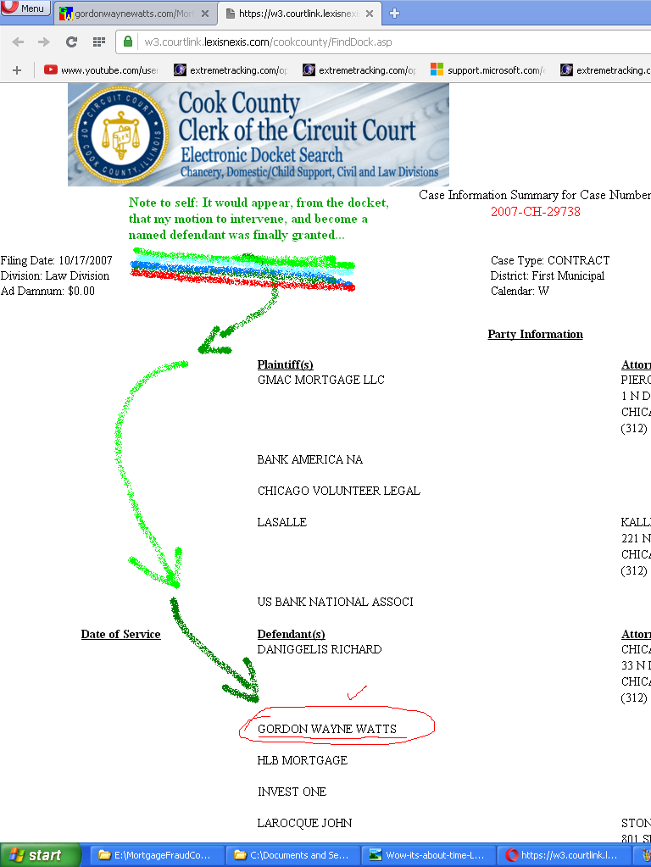
Page 11 of 11 (8-26-17 Watts filing in CoC v 1720 N Sedgwick, Younes, et al. 2017-M1-400775)

