IN THE CIRCUIT COURT OF COOK COUNTY, ILLINOIS
MUNICIPAL DEPARTMENT – FIRST DISTRICT

Joseph Younes, )
Plaintiff )
vs. ) Case No.: 2014-M1-701473
)
Richard B. Daniggelis, )
Defendant )

Motion for leave to file Supplemental Record

Pursuant to Supreme Court Rule 329, Supplemental Record on Appeal, material omissions in the record may be corrected by stipulation of the parties or by the trial court, either before or after the record is transmitted to the reviewing court, or by the reviewing court or a judge thereof. The trial court retains jurisdiction regarding supplemental record preparation. Therefore, motions for leave to file a supplemental record should be filed in the first instance in the trial court. (See: IL Appellate Court 1st Dist. Local R.19, SUPPLEMENTALRECORDS) This Court was kind enough to docket the following items (see Court Docket: “Activity Date: 8/10/2015” / “Attorney: PRO SE”) which I filed:
- “AFFIDAVIT OF GORDON WAYNE WATTS”
- “Notice of Motion”
- “Motion for leave to file Amicus Curiae brief”
- “AMICUS CURIAE BRIEF OF GORDON WAYNE WATTS IN SUPPORT OF DEFENDANT / APPELLANT, RICHARD B. DANIGGELIS”
- Exhibits 'Watts-A' through 'Watts-G' Filed, along with an “INDEX TO THE EXHIBITS”

This case was appealed to the 1st Appellate Court, in case number 1-15-0662 Younes v Daniggelis, and I trusted my filings would be “on record” for the reviewing court to review. However, Chief Deputy Clerk, Patricia O'Brien was kind enough to inform me that my filings wouldn't be included in the Record on Appeal, since I filed them after the notice of appeal. It is true that I was tardy & late in filing these pleadings, but that wasn't through any fault of my own: Please see Exhibit Watts-Sat-15-Aug-2015-A & B. This screen shot of an email I sent to your court is proof that, on 06-30-2014, I made a formal request for public records related to fraud which Mr. Daniggelis described to me in case numbers 2007-CH-29738 (GMAC v Daniggelis) and 2014-M1-701473 (Younes v Daniggelis). And, this was well before the “Notice of Appeal” filed on 05/6/2015 in the CH case or the 02/26/2015 “Notice of Appeal” filed in the M1 Civil case. However, even after many lengthy conversations by email and phone, in the which I requested an estimated cost for the records, I received no formal reply until July 16, 2015 (See Exhibit Watts-Sat-15-Aug-2015-C & D). Therefore, I wasn't able to file any pleadings to prove fraud, since I needed documentation, not mere hearsay, to verify & prove my claims.

Page 1 of Motion for leave to file Supplemental Record
Since these arguments proving fraud (pleadings supra) were supposed to go into the record back when I filed a timely public records request, and attempted to file pleadings in a timely fashion (and not “after the fact” as here), then they constitute material omissions in the record which may be corrected by stipulation of the parties or by the trial court

The attorneys of record are welcome to stipulate that my filings supra be included (and I hereby invite them in this filing), however, given the fact that I may get plaintiff clients into serious trouble by proving forgery fraud (and also embarrass my friend, who is defendant's attorney, for failure to make several key arguments), I do not realistically expect them to stipulate inclusion. (I.e., since the lawyers are looking out for their clients, I feel that herding cats would be an easier legal task than getting all these lawyers to agree on anything.)

Therefore, this motion for leave to file a supplemental record is filed in the first instance in the trial court.

PRAYER FOR RELIEF: Please grant my motion for leave to file a supplemental record with the five (5) items enumerated supra.

Notice of three Scrivener's Errors

First Error: In “IV. Argument – E. Predatory (sub-prime) lending,” inter alia, of my “AMICUS CURIAE BRIEF OF GORDON WAYNE WATTS IN SUPPORT OF DEFENDANT / APPELLANT, RICHARD B. DANIGGELIS,” I referred to Joseph Younes as having represented Daniggelis as his lawyer. This claim was based on the “NOTICE OF MOTION,” docketed on June 23, 2006 in Deutch Bank Nat'l v. Daniggelis, NO. 04-CH-10851, wherein Younes entered an appearance for Daniggelis. However, when I recently spoke by phone with Daniggelis, he complained that my statement on that head was an “inaccuracy,” and was very angry with me insofar as he claimed that Younes was never his lawyer. For the purposes of verification, I, Gordon Wayne Watts, now state, assert, and certify under penalties of perjury as provided by law pursuant to 735 ILCS 5/1-109 (Sec. 1-109. Verification by certification.), that Richard Daniggelis, the defendant in this case, did indeed tell me this. THEREFORE, I may, possibly, have made a 'Scrivener's Error' in my claims that Younes was Daniggelis' lawyer. (I do not know what actually transpired; I only know what I see in Younes' Notice and what Daniggelis told me, and I suspect that there was either an honest misunderstanding on the part of both men –or, in the alternative, perhaps Younes entered an appearance without Daniggelis' authorisation and permission. But, I presume both men to be innocent until proven guilty, and infer an honest understanding here. Nonetheless, I feel this should be “looked into” further, and therefore am mentioning it now.)

Second Error: In my affidavit, supra, I said: “The property which is the subject of all this litigation, 1720 N. Sedgwick St., Chicago IL 60614, is a house and land which was in Daniggelis' family for many years, and, at some point, passed down to him, with him as the sole owner.”

While this over-broad “passed down to him” language seemed technically correct to me, given

Page 2 of Motion for leave to file Supplemental Record
that I did not know the details of how it was “passed down” (inheritance, gift, purchase, buyout, etc.?), when speaking with Mr. Daniggelis by phone recently, he said this was imprecise and an inaccurate description: He claims that he bought out the shares of other relatives, in gaining ownership of his house. Let this notice serve as a correction.

Third Error: On page 1 of my affidavit, I said: “...Robert. J. More, [] was his [Mr. Daniggelis'] tenant from about Jan 2011 until about Oct 2013...,” which was seemingly contradicted by my statement in “IV. Argument – I. Civil Damages” of my Amicus brief, where I made the claim that “While Younes complains he could not collect rent while a cloud hung over the title, likewise Daniggelis could not collect rent as well.” I mistakenly omitted a clarification here of the civil damages Daniggelis incurred: While it is true that More did occasional research and introduced Daniggelis to Galic (which might constitute “a little rent”), I was human and made a scrivener's error of omission, and what I meant to say in “IV. Arg. I” was this:

“While Younes complains he could not collect rent while a cloud hung over the title, likewise Daniggelis was also unable to collect rent “of any substance” or attract any actual 'regular' renter willing to pay any “substantial” amount: The spectre of eviction that hung over the property “like a dark cloud” scared off any prospective renters (besides an occasional freeloader or transient) who were looking for a stable place to live.”

CERTIFICATE AND AFFIDAVIT OF DELIVERY (aka: Certificate of Service)

The undersigned, hereby certifies under penalties of perjury as provided by law pursuant to 735 ILCS 5/1-109, that the above “Motion for leave to file Supplemental Record” and “Notice of two Scrivener's Errors” were delivered to the following parties as indicated:

Dorothy Brown, Clerk of the Circuit Court (CourtClerk@CookCountyCourt.com)
Richard J. Daley Center, Room 1001, 50 West Washington Street, Chicago, Illinois 60602, PH: 312-603-5031 (5133: Chancery / 5116: Civil)

Andjelko Galic, Esq. (atty for Defendant, Daniggelis) (Atty No.: 33013)
134 N. LaSalle St., STE 1040 – Email: AndjelkoGalic@Hotmail.com
CHICAGO IL, 60602 (Cell: 312-217-5433, FAX: 312-986-1810, PH: 312-986-1510)

Richard B. Daniggelis (Defendant), 1720 N. Sedgwick, Chicago, IL 60614-5722

William D. and Linda D. Gerould, (Owners of record of subject property, according to http://CookRecorder.com) 49 Lorelei Lane, Menlo Park, CA 94025-1715

Mr. Robert J. More (Anselm45@Gmail.com) (Former tenant of Daniggelis)
P.O. Box 6926, Chicago, IL, 60680-6926 ; PH: (608) 445-5181

Peter King (Atty. for Joseph Younes) (Atty. No.: 48761)
c/o: King Holloway LLC, 101 N. Wacker Dr., STE 2010 ; Chicago, IL 60606

Page 3 of Motion for leave to file Supplemental Record
KING HOLLOWAY LLC (Atty. for Joseph Younes) http://www.KingHolloway.com/contact.htm
Attn: Peter M. King, Esq. PKing@khl-law.com One North LaSalle Street, Suite 3040, Chicago, IL 60602 – PH: (312) 780-7302 / (312) 724-8218 / Direct: (312) 724-8221

Perry Perelman (Atty no: 57398) (PPerelman@PerelmanDorf.com) (Atty. for Joseph Younes)
PERELMAN | DORF, LLC http://PerelmanDorf.com/contact/ Email: Info@PerelmanDorf.com
2059 W. Chicago Ave., Chicago, IL 60622 ; PH: (312) 888-9608 / FAX: +1-312-674-7644

Joseph Younes Law Offices / http://ChicagoAccidentAttorney.net
120 W Madison St Ste 1405, Chicago, IL 60602-4128 ; Phone: (312) 372-1122 ; Fax: (312) 372-1408, Email is thought to be: RoJoe69@yahoo.com per http://www.ZoomInfo.com/p/Joseph-Younes/599467626)

Craig A. Cronquist, Esq., c/o: Maloney & Craven, P.C. (Attys. for Joseph Younes)
2093 Rand Road, DesPlaines, IL 60016

Paul L. Shelton, Shelton Law Group, LLC, 700 E. Ogden Ave., STE 101, Oak Brook, IL 69559

Paul L. Shelton (PLShelton@SBCGlobal.net) (PMSA136@aol.com)
http://www.il-reab.com/agents/26812-paul-l-shelton-shelton-associates-hinsdale-il-60523
c/o: Shelton Law Group, LLC, https://www.youtube.com/user/PaulSheltonLawGroup
1010 Jorie Blvd. #144, Oak Brook, IL 60523 ; (630) 993-9999, (630) 333-4009, (630) 286-5100

I, Gordon Wayne Watts, the undersigned, hereby certify under penalties of perjury as provided by law pursuant to 735 ILCS 5/1-109, that the above notice and all attached pleadings ((the attached
“Motion for leave to file Supplemental Record,” with supporting Exhibits and an Index of said
Exhibits)) were served upon all parties listed above, this __16th__ day of ___August___, 2015 by the following methods:

- FedEx 3rd-party commercial Carrier: Every party was served by FedEx [[with delivery confirmation and tracking, should it be necessary to verify service]] excepting the cases of a PO Box, which are not serviced by FedEx –and Mr. Daniggelis who is not always home to receive a FedEx delivery, since he was evicted.
- United State Postal Service: Those parties with PO Boxes were served by USPS, as was Mr. Daniggelis.
- Facsimile: I am not serving any parties by FAX. [[I am neither willing nor able to receive FAX transmissions.]]

Page 4 of Motion for leave to file Supplemental Record
- Electronic Mail: In every case where I could obtain an email address (see above) for a party, I am effecting service by email, and attaching said documents in PDF form. [[I
consent to service by email at the email addresses listed below.]]
- Electronic Filing: If I am able to successfully register an account with the Cook County, IL Clerk of the Circuit Court, I shall effect service electronically therewith.
- Internet: I shall, when practically possible, post a TRUE COPY of this filing – and related filings – online at my official websites, infra.

Signature: _______________________________ Date: _____________________

Gordon Wayne Watts, Amicus Curiae*
821 Alicia Road
Lakeland, FL 33801-2113
PH: (863) 688-9880
Web: www.GordonWatts.com / www.GordonWayneWatts.com
Email: Gww1210@aol.com / Gww1210@gmail.com

Date: Sunday, 16 August 2015
* Watts, acting counsel of record, is not a lawyer. Per Local Rule 2.1, “Notice
of Hearing of Motions,” Watts, appearing pro se, is giving notice of his motion

Page 5 of Motion for leave to file Supplemental Record
INDEX TO THE EXHIBITS

Instrument Docket/Tab#

06/30/2014 Public Records Request Exhibit Watts-Sat-15-Aug-2015-A

06/30/2014 Public Records Request (zoom view) Exhibit Watts-Sat-15-Aug-2015-B

07/16/2015 Public Records Reply Exhibit Watts-Sat-15-Aug-2015-C

07/16/2015 Public Records Reply (zoom view) Exhibit Watts-Sat-15-Aug-2015-D

06/30/2014 Public Records Request Exhibit Watts-Sat-15-Aug-2015-A

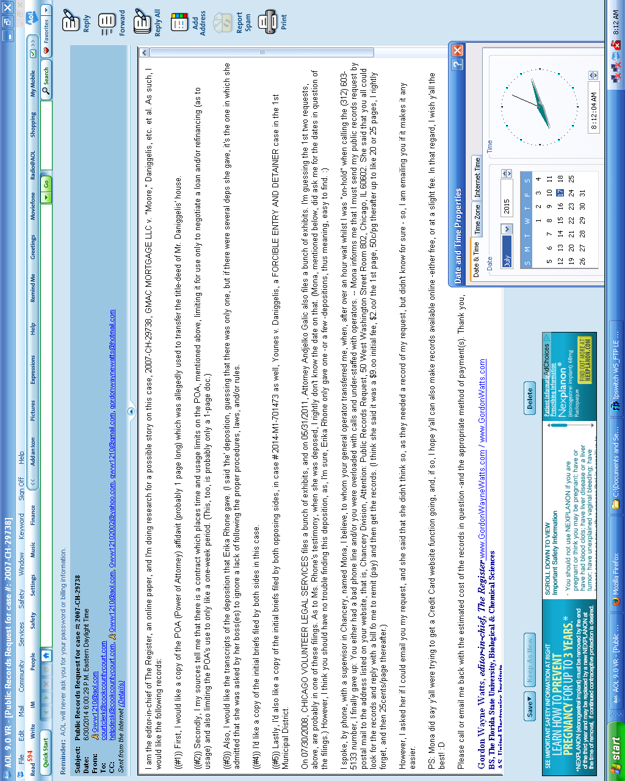

06/30/2014 Public Records Request (zoom view) Exhibit Watts-Sat-15-Aug-2015-B

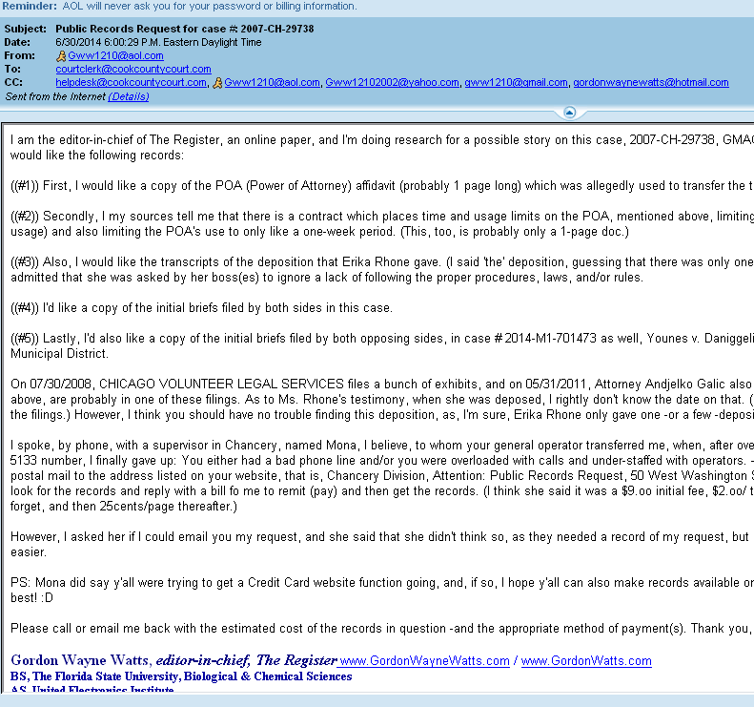

07/16/2015 Public Records Reply Exhibit Watts-Sat-15-Aug-2015-C

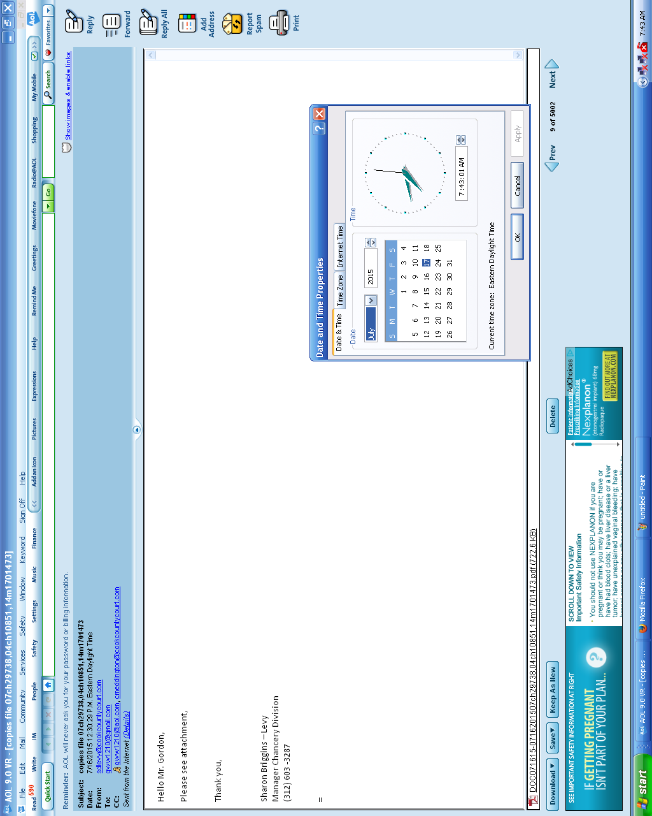

07/16/2015 Public Records Reply (zoom view) Exhibit Watts-Sat-15-Aug-2015-D

