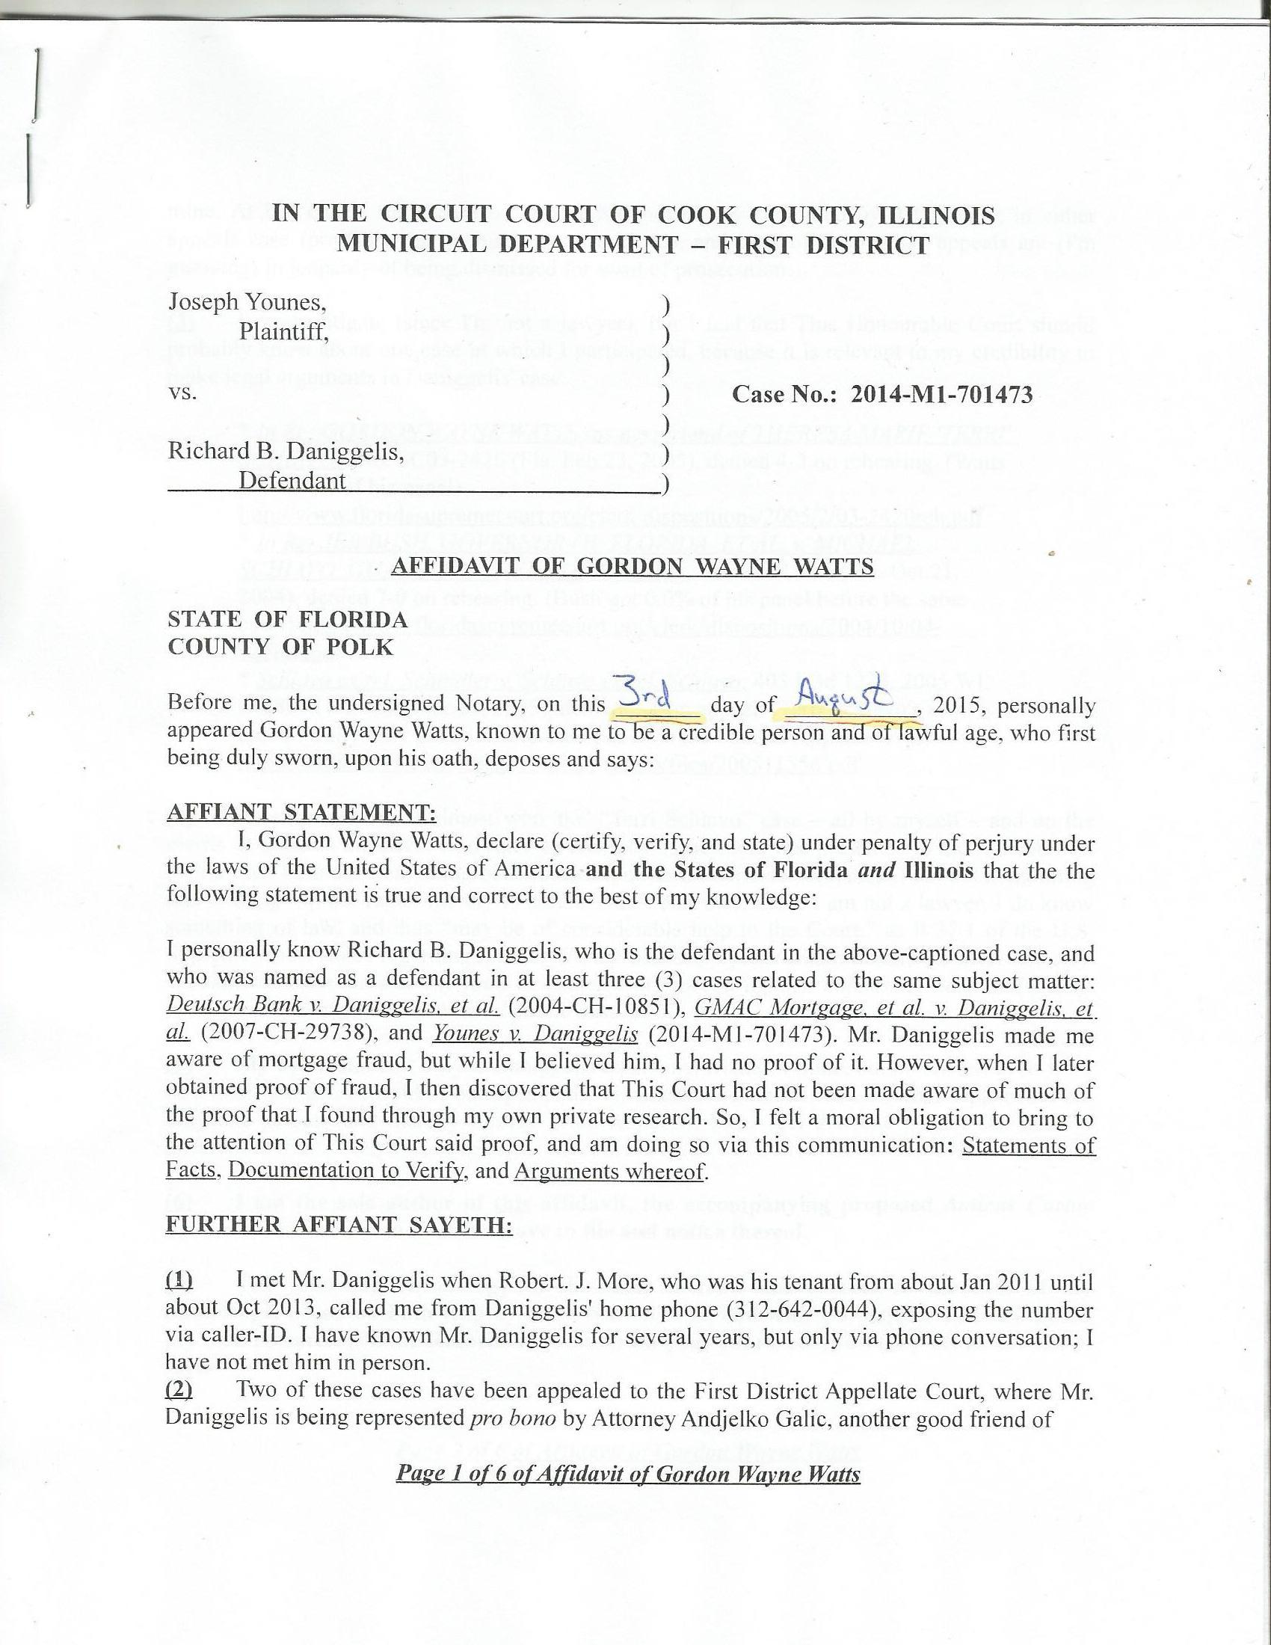

IN THE CIRCUIT COURT OF COOK COUNTY, ILLINOIS
MUNICIPAL DEPARTMENT – FIRST DISTRICT

Joseph Younes, )
Plaintiff, )
)
vs. ) Case No.: 2014-M1-701473
)
Richard B. Daniggelis, )
Defendant )

AFFIDAVIT OF GORDON WAYNE WATTS

STATE OF FLORIDA
COUNTY OF POLK

Before me, the undersigned Notary, on this _______ day of ___________, 2015, personally appeared Gordon Wayne Watts, known to me to be a credible person and of lawful age, who first being duly sworn, upon his oath, deposes and says:

AFFIANT STATEMENT:
I, Gordon Wayne Watts, declare (certify, verify, and state) under penalty of perjury under the laws of the United States of America and the States of Florida and Illinois that the the following statement is true and correct to the best of my knowledge:

I personally know Richard B. Daniggelis, who is the defendant in the above-captioned case, and who was named as a defendant in at least three (3) cases related to the same subject matter: Deutsch Bank v. Daniggelis, et al. (2004-CH-10851), GMAC Mortgage, et al. v. Daniggelis, et al. (2007-CH-29738), and Younes v. Daniggelis (2014-M1-701473). Mr. Daniggelis made me aware of mortgage fraud, but while I believed him, I had no proof of it. However, when I later obtained proof of fraud, I then discovered that This Court had not been made aware of much of the proof that I found through my own private research. So, I felt a moral obligation to bring to the attention of This Court said proof, and am doing so via this communication: Statements of Facts, Documentation to Verify, and Arguments whereof.

FURTHER AFFIANT SAYETH:

(1) I met Mr. Daniggelis when Robert. J. More, who was his tenant from about Jan 2011 until about Oct 2013, called me from Daniggelis' home phone (312-642-0044), exposing the number via caller-ID. I have known Mr. Daniggelis for several years, but only via phone conversation; I have not met him in person.
(2) Two of these cases have been appealed to the First District Appellate Court, where Mr. Daniggelis is being represented pro bono by Attorney Andjelko Galic, another good friend of

Page 1 of 6 of Affidavit of Gordon Wayne Watts
mine. At last check, the record on appeal was not timely submitted by Atty. Galic, in either appeals case (probably due to his heavy workload), and both of Daniggelis' appeals are (I'm guessing) in jeopardy of being dismissed for want of prosecution.

(3) I rarely litigate (since I'm not a lawyer), but I feel that This Honourable Court should probably know about one case in which I participated, because it is relevant to my credibility to make legal arguments in Daniggelis' case:

* In Re: GORDON WAYNE WATTS (as next friend of THERESA MARIE 'TERRI' SCHIAVO), No. SC03-2420 (Fla. Feb.23, 2005), denied 4-3 on rehearing. (Watts got 42.7% of his panel) http://www.floridasupremecourt.org/clerk/dispositions/2005/2/03-2420reh.pdf
* In Re: JEB BUSH, GOVERNOR OF FLORIDA, ET AL. v. MICHAEL SCHIAVO, GUARDIAN: THERESA SCHIAVO, No. SC04-925 (Fla. Oct.21, 2004), denied 7-0 on rehearing. (Bush got 0.0% of his panel before the same court) http://www.floridasupremecourt.org/clerk/dispositions/2004/10/04-925reh.pdf
* Schiavo ex rel. Schindler v. Schiavo ex rel. Schiavo, 403 F.3d 1223, 2005 WL 648897 (11th Cir. Mar.23, 2005), denied 2-1 on appeal. (Terri Schiavo's own blood family only got 33.3% of their panel on the Federal Appeals level) http://media.ca11.uscourts.gov/opinions/pub/files/200511556.pdf

(4) As shown above, I almost won 'the' “Terri Schiavo” case – all by myself – and on the merits (it got past the clerk, who rules on technical issues, and was presented to the full court on the merits). I almost won, doing better than all others on our side combined. I am not mentioning this to brag[**], but rather merely to assure This Court that, while I am not a lawyer, I do know something of law, and thus “may be of considerable help to the Court,” as R.37.1 of the U.S. Supreme Court states regarding Amicus Curiae briefs. [**]This was a double miracle: not only my skill but even more-so my faith or courage to proceed against impossible odds and strong opposition in a highly controversial public case.

(5) My Interests: Not only is Daniggelis a personal friend of mine, but moreover, even were he a total stranger, I would be outraged at the injustices here, once I realised what happened. I am only one person (and thereby limited in all respects), but I feel that one person can make a difference.

(6) I am the sole author of this affidavit, the accompanying proposed Amicus Curiae brief, and the related motion for leave to file and notice thereof.

(7) The following chronology of the facts is true and correct to the best of my knowledge, based on both lengthy conversations I've had with Daniggelis, and also based my own research (Public Records requests from your court, etc.) to verify his assertions of fact:

Page 2 of 6 of Affidavit of Gordon Wayne Watts
The property which is the subject of all this litigation, 1720 N. Sedgwick St., Chicago IL 60614, is a house and land which was in Daniggelis' family for many years, and, at some point, passed down to him, with him as the sole owner. At some later point, Daniggelis became overwhelmed with the combined financial burden of the upkeep and, particularly, the payments, since it is an expensive house, and he was the sole owner. Subsequently, he put an ad in the paper to seek help, either for refinancing, investors, tenets, and/or repairs in exchange for reduced rent. (The details and timing of his requests are of no import: The only thing that matters is who responded and what transpired.) On 7/8/2004, the bank filed a complaint (Deutsch Bank v. Daniggelis, et al. 2004-CH-10851) against him for mortgage foreclosure. After proceeding pro se for a while, he retained Attorney JosephYounes to represent him against the bank. On 8/9/2006, the bank moved This Court to dismiss, claiming, inter alia, that Daniggelis paid of the subject loan, and Judge Robert Quinn granted and dismissed. That case is not being appealed.
On 10/17/2007, GMAC Mortgage filed a complaint (GMAC Mortgage, et al. v. Daniggelis, et al. 2007-CH-29738) against Daniggelis to foreclose, apparently a result of subsequent financial distress, and apparently, US BANK NATIONAL ASSN subsequently purchased the loan and sought to continue to pursue foreclosure under subrogation. Robert J. More, an acquaintance of mine, was staying with Daniggelis from about Jan 2011 until about Oct 2013, for little or no rent, and he did light chores and research to help Daniggelis. (Mr. More introduced Mr. Daniggelis to both myself and Attorney Andjelko Galic, who currently represents Daniggelis.) When Plaintiffs named defendants, they included Mr. More, apparently in response to More's filing numerous pleadings in this case, starting with the 6/21/2013 “INCOMING CORRESPONDENCE FILED,” which he filed pro se. More's name is misspelled on the docket
Page 3 of 6 of Affidavit of Gordon Wayne Watts
as 'Moore,' but the correct spelling is 'More.' Robert J. More is also trespassed from this Court House, and must have an escort to conduct business. Moreover, he is a restricted filer in this and other courts, based on allegations of being a vexatious litigant. However, More has told me that he has a legal right to intervene in this case, as he has an interest that is not being represented by any of the parties, since, according to More, Mr. Daniggelis may owe him some consideration for his research assistance and for putting him in touch with Atty. Galic. Because of this, and his prior presence on the service list in this case (2007-CH-29738), I am including him on the service list today. Lastly, while More probably does warrant censure of vexatious litigant restrictions (due to the incoherence in his filings), I will go on record as stating that More is a legal genius, a virtual walking case-law Encyclopædia, a savant on the order of “Rain man,” the famous 1988 movie starring American actor, Dustin Hoffman. Thus, I feel that Mr. More may have something to offer This Court in the way of legal analyses.
On 7/16/2008, Chicago Volunteer Legal Service entered an appearance for Daniggelis, but did not represent Daniggelis' claims after 1/20/2010. Plaintiffs filed multiple motions for This Court to dismiss, and said motions were eventually granted. On April 20, 2007, Daniggelis executed a Fraudulent Document Notice to both the Cook County Recorder's office (doc number: 0711039132, on 4/20/2007) and to This Court (exhibit 'F' of the July 30, 2008 filing by Atty. Benji Philips) that the July 09, 2006 Warranty Deed (doc no: 0622826137 at the Recorder's Office, on 8/16/2006) was a forgery. Daniggelis made this declaration (thereby placing a cloud on the title), but did not offer substantive proof (duplicate signatures, etc.) as I am doing now. On 4/8/2011, Atty. Galic entered an appearance for Daniggelis, apparently to replace Chicago Volunteer Legal Service. On 02/15/2013, Judge Michael F. Otto, in this case
Page 4 of 6 of Affidavit of Gordon Wayne Watts
(GMAC, et al., vs. Daniggelis, et al., 2007-CH-29738), entered an order in favour of Younes upon his Motion for Summary Judgment and held, as a finding of law, that Younes was sole owner of the property in question and that Daniggelis had no legal interest in said property, thereby clearing the cloud that was on the title. For reasons that are not clear to me, on 8/12/2014, Judge Moshe Jacobius entered an order transferring this case to the Law Division. Galic made a late appeal to the First Appellate Court, which was denied, but appealed to the Illinois Supreme Court, which, on 03/25/2015, entered the following order: “In the exercise of this Court's supervisory authority, the Appellate Court, First District, is directed to vacate its order in GMAC Mortgage, LLC v. Daniggelis, case No. 1-14-2751 (09/24/14), denying Richard Daniggelis leave to file a late notice of appeal. The appellate court is instructed to allow Richard Daniggelis to file a late notice of appeal and hear the case.” (27 N.E.3d 610 (2015)) This case is pending before the appeals court in case #:1-14-2751.
On 01/22/2014, Attorney Joseph Younes, who had previously represented Daniggelis in the 2004 foreclosure case, supra, filed a F.E.D. (FORCIBLE ENTRY AND DETAINER) case against Daniggelis in the Civil Division (Younes vs. Daniggelis, 2014-M1-701473). This was well before the 08/12/2014 order of Judge Moshe Jacobius, transferring this case to the Law Division.
On 01/27/2015, and after much litigation that did not include key findings of fact which I found (detailed in the attached Amicus Curiae brief), Judge George Scully entered an ORDER FOR POSSESSION in Younes vs. Daniggelis, 2014-M1-701473 – apparently in response to Judge Otto's 02/15/2013 finding in GMAC, et al., vs. Daniggelis, et al., 2007-CH-29738 that Younes was sole owner. On 2/26/2015, Galic filed a notice of appeal to the First Appellate Court
Page 5 of 6 of Affidavit of Gordon Wayne Watts
in Younes v. Daniggelis, case No. 1-15-0662, and the appeal is pending filing of the record. On 7/2/2015, Judge Diane Rosario entered an order extending the time for enforcement of Judge Scully's order. The Sheriff's Department served an eviction notice to enforce Scully's order, and, at last check, Daniggelis is now in the process of moving his belongings with the help of some employees of Younes.

FURTHER AFFIANT SAYETH NAUGHT.
_________________________________
Gordon Wayne Watts, Affiant
STATE OF FLORIDA
COUNTY OF POLK

The foregoing instrument was acknowledged, subscribed, and sworn before me this _____ day of ___________, 2015, by GORDON WAYNE WATTS, Affiant, who ( is / is not ) personally known to me, who ( did / did not ) produce identification as shown below, and who ( did / did not ) take an oath.

IDENTIFICATION TYPE: ______________________________________________

IDENTIFICATION NUMBER: (*) ___________________________________________

(*) In compliance with Rule 138, ILLINOIS SUPREME COURT RULES, “Personal Identity Information” (b)(2), “driver’s license numbers,” I am not including my full Driver's License Number. However, in accordance with Rule 138 (c)(2), “A redacted filing of personal identity information for the public record is permissible and shall only include: the last four digits of the driver’s license number.” Therefore, I am asking This Notary to use only the last 4 digits.
See: http://www.IllinoisCourts.gov/supremecourt/rules/art_ii/artii.htm

Notary Public: ____________________________________ Date: ________________

(Notary Stamp) My Commission Expires: ______________

Page 6 of 6 of Affidavit of Gordon Wayne Watts
