IN THE CIRCUIT COURT OF COOK COUNTY, ILLINOIS
COUNTY DEPARTMENT – LAW DIVISION

GMAC Mortgage, LLC n/k/a: Bank of America, N.A. ) Case No.: 2007 CH 29738
aka: “LaSalle Bank National Association,” aka “US Bank, )
NA,”as trustee for Morgan Stanley Loan Trust 2006-16AX, ) Before: Hon. DIANE M. SHELLEY,
Plaintiff, ) Circuit Judge
vs. ) Case Type: CONTRACT
) District: First Municipal
Atty. Joseph Younes, Esq., Mr. Richard B. Daniggelis, et al., ) Calendar "W", Courtroom 1912
Defendants, and )
) TIME-SENSITIVE: to be heard
Gordon Wayne Watts, ) in Court Room:1912, by 07/10/2017
Proposed Intervening Defendant. ) Court Time: 10:30am (CST)

Notice of Motion

To: This Honourable Court and all parties being served (see attached service list, below)
From: Mr. Gordon Wayne Watts, LAKELAND, Fla. (full contact data, below)

Notice Proper: Pursuant to Local Rule 2.1 [“Notice of Hearing of Motions”], the undersigned movant is hereby giving this honourable court and all parties proper notice of the attached “MOTION TO INTERVENE BY INTERVENOR, GORDON WAYNE WATTS,” being filed instanter, in the above-captioned case—a copy of which is attached hereto and is being served upon you.
Due to unfamiliarity with this very uncommon “local rule,” movant did not give proper “notice” of past motions, via the “notice of motion,” in accordance with said local rule, which is peculiar to this court alone. As This Court can see, the attached Motion to Intervene gives overwhelming evidence of Movant's right to claim legal standing to intervene – and that the interests not being represented are **not** “de minimus,” (unless the court and parties are willing/able to reimburse to Mr. Watts the full amount documented herewith, and then some for unrecorded costs, time lost from work, and emotional losses).
Moreover: The undersigned Intervenor, Gordon Wayne Watts, through human fault, committed three (3) unintentional offenses against This Court (and all parties), and, by virtue of this pleading, is offering a sincere apology:
(1) While the undersigned litigant has generally had excellent and professional relations with the many clerks and lawyers involved (in Chancery, Civil, and Law Divisions, as well as numerous judges' chambers and the chambers of the Chief Judge, as well as the Office of the State Attorney, and the IL Attorney General), on rare occasion he has expressed human emotion to certain unnamed clerk(s), expressing profound disappointment over the rulings in the various cases regarding defendant, Daniggelis. While this is inexcusable and indefensible, Intervenor, Watts, views Daniggelis as sort-of a grandfather-figure (whom he feels was cheated out of a house, property, and hundreds of thousands of dollars of equity therewith), and, all of us being human can understand that if you kick a dog repeatedly (Mr. Watts is comparing himself to a dog), the dog will eventually yelp or holler. This does not justify the yelping bark, but it is offered up as “mitigating circumstances.” Therefore, Mr. Watts offers his sincere apologies for occasional lapses in professionalism.
(2) Although Mr. Watts' legal standing to Intervene is very strong (see above—and the attached motion to intervene), he felt an “amicus” brief would be less invasive and more acceptable. While this may be the view of most courts, nonetheless, for reasons unknown, case law suggests that Cook County, IL courts take a much dimmer view of amicus curiae briefs than they do of, say, Intervention actions. Therefore, Mr. Watts offers his sincere apologies for taking an unintentionally-offensive legal tact, and is hereby changing course to a more accepted and conventional course: that of direct intervention, as provided by statutory and case law.

Page 1 of 6, Notice of Motion, by Intervenor, Gordon Wayne Watts
(3) As mentioned in the instant “Notice of Motion,” Intervenor, Watts, was unfamiliar with this uncommon rule (Local Rule 2.1, requiring a “notice of motion” to accompany motions) which appears unique to Cook County, IL courts—and therefore didn't comply with the rules of the court. Therefore, pursuant to R.2.1, proper notice is being given of the above-mentioned motion—and an apology herewith is tendered to the court and parties.

Details: Normally, a notice of motion contains a promise for the movant to appear as such-and-such time in such-and-such courtroom to present the motion: “Please take notice that on (certain date) and at (certain time), I shall appear before (named judge) – or any other judge, as may be holding court, in his/her absence – in (certain courtroom) to present (certain motion), which is attached hereto.”

The undersigned Movant understands the value and importance of in propia persona physical appearance (to be available, for example, to answer any questions in real time, as well as connect name & face). However, physical appearance (as is normally done) is mathematically impossible, and yet Due Process requires that This Court consider the matter on the merits, so notice is given – with arguments for an alternative.

Problem: Movant lives in a far, distant locale called “Lakeland, Florida” (which is squarely between Tampa and Orlando, Fla.), and has neither a local attorney retained (to appear on his behalf), nor resources to glibly travel at the drop-of-a-hat whim to Chicago, Illinois (to appear for himself), due to oppressive and ever-present financial constraints.

Proposed Solution: This motion should be considered on its merits via written submission to This Court. In the alternative, This Court may also (if it so chooses) invoke Art. II, Rule 185 (Telephone Conferences), R.Civ. Proceedings in the Trial Court, and/or Rule 206(h)(Remote Electronic Means Depositions), etc., by calling movant at either of his two phone numbers of record: 863-688-9880 (home) and/or 863-409-2109 (cell)

Arguments Whereof: It is very common legal precedent for motions to be considered in written form only. (In fact, this is probably the most common form, or at least a close second, if not first-place.) Here are but a few examples:

(1) Intervenor, Gordon Wayne Watts, filed direct intervention as “next friend” in the Florida Supreme Court on behalf of the late Theresa Marie “Terri” Schindler-Schiavo (see e.g., Exhibit-A). While the court eventually ruled against him in a razor-thing 4-3 split decision (garnering almost 43% of his panel), Mr. Watts' motions, nonetheless, were considered on the merits before the full Supreme Court of his home state, in this high-profile case, and, in fact, his intervention got even farther than that of former Florida Governor, John Ellis “Jeb” Bush, who filed similar intervention on behalf of Ms. Schiavo (Bush lost 7-0), or even Schiavo's blood family (who got only about 33% of their panel in Federal Court).

Watts lost 4-3 on rehearing. Bush lost 7-0 on rehearing – before the same panel, and on the same issue. (Apparently, the court liked Watts' “food/water” arguments better than the similar, but inferiour “feeding tube” arguments presented by both Gov. Jeb Bush and Schiavo's parents.) Although Watts occasionally visited The Florida Supreme Court in person while he was a student at The Florida State University (in Tallahassee, Fla.), he never appeared in person to present the his motions for intervention in the infamous “Terri Schiavo” case, and yet The Court still considered the matter on the merits. (See Exhibit-A)

(2) Subsequently, Mr. Watts decided to file an Amicus Curiae (a friend of the court brief) in one of the recent “Gay Marriage” cases pending before the Federal Appeals court in his circuit. In fact, he even went as far as to ask The Court for leave to amend 'out of time' (a rare procedure to allow a litigant to amend a brief, even though filing deadlines have passed, to correct errors and/or to add additional materiel, facts, arguments, etc.). It is believed that Watts was the only non-Lawyer litigant allowed participation in this case. (In fact, Watts was

Page 2 of 6, Notice of Motion, by Intervenor, Gordon Wayne Watts
permitted to amend his initial brief, out of time, even though another pro se non-Lawyer was denied: Ex-B) In any event, although Mr. Watts did not present, “in person,” his motion for leave to file an amicus brief, nor the amicus brief itself, by traveling to The U.S. 11th Circuit FEDERAL Court of Appeals, in Atlanta, GA, nonetheless, the court considered his brief and all related motions on the merits. (See, e.g., Exhibit-B)

(3) Let us also consider the case of an imprisoned Illinois prisoner – in some state or county jail: many a “jailhouse lawyer” exists in our correctional institution's incarcerated population. They file all kinds of frivolous lawsuits, motions, and torts! While most of them end up in “file-13” of that great wastebasket of the Judicial System, nonetheless, state and federal Due Process requires these motions be considered on the merits. While the undersigned litigant has no “expert” knowledge of The State of Illinois court system, it goes without saying that not all prisoners are carted “back and forth” to the court for numerous frivolous motions (for very obvious cost-restraint reasons—in fact, Illinois is currently facing a financial crisis!). These prisoners, many of whom do not appear in person to present their motions, nonetheless, get “their day in court”: They don't appear in person, and yet their motions are still considered on the merits!

(4) Perhaps, the best argument for consideration of a motion, where the litigant can't travel to The Court in person to present it, comes from This Court itself! (And would, thus, be legally-binding case-law precedent.)

Looking at GMAC MORTGAGE LLC, et al. v. RICHARD DANIGGELIS, et al. (case number: 2007-CH-29738), which was heard before the Chancery Division of the Cook County, IL circuit court (not to be confused with a case heard in the Law Division, and by the same style and case number, which was subsequently transferred from Chancery to Law), we see a spirited fight put up for justice in this case, by no less than Mr. Watts, himself: As but one example of a motion considered without litigant appearing in person, we find from the docket in the above-mentioned case, on 11/30/2015, Watts moved for rehearing (without appearing in person), and on 12/07/2015, The Court (Hon. Michael F. Otto, associate judge, presiding in this case) ruled, in courtroom 2804, in a ruling titled: “MISCELLANEOUS MOTION – ALLOWED.” While Judge Otto commits a tort of slander on page 3 of his Dec. 07, 2015 ruling¹, nonetheless, he does rule on the merits of Watts request to Supplement the Record on Appeal (in the appeal that was pending at that time).

Although the undersigned movant would argue that rulings made by Hon. Judge Michael F. Otto (Associate Judge, #2605) were exceptionally incorrect (as a matter of case law, statutory law, and State & Federal constitutional rights), as applied to the facts of that case, nonetheless, Judge Otto finally (after much prodding and begging) considered the motions on the merits—and issued a ruling (right or wrong), not just once, but several times. (Judge Otto should be commended for an “A+” performance of granting “Procedural Due Process,” even if “Substantive Due Process” was trampled upon by what movant argues were “unjust” rulings.)

Therefore, even This Court's own legally-binding precedent confirms that State and Federal Due Process require all redresses, grievances, suits at law, and related motions to be heard on the merits—whether or not litigants seeking redress can physically travel to The Court in propia persona: The Court does not discriminate nor deny due process to litigants simply for being “too poor” to afford to hire a lawyer to appear—or to travel to appear themselves. Discrimination is wrong—in any of its forms or manifestations.

_______________________
¹ Falsely claiming that Watts is arguing that vexatious litigants practices are 'OK'—direct quote: “The argument that all strangers to a case should be allowed to engage in the tactics of a vexatious litigant is so unpersuasive as to require no further discussion.”—Watts **never** said such things within the “4 Corners” of any of his briefs, arguing only that if vexatious litigants be given a fair hearing, then he should be heard & treated fairly too. Thus judge's statement/claims was false, and slanderous, but we're all human, and make mistakes—and this argument & documentation of slander/libel is **not** meant as disrespectful of the judge or the court.

Page 3 of 6, Notice of Motion, by Intervenor, Gordon Wayne Watts
Prayer(s) for Relief: Therefore, please review and rule on my motion for intervention, filed instanter, granting speedy relief to effect justice for both Defendant, Mr. Daniggelis, as well as Intervenor, Mr. Watts.

Arguments defending this position are on docket, as This Court has been good enough to grant extensive Procedural Due Process and document (by docketing) the sworn affidavit and arguments of the undersigned Intervenor—in prior filings he has submitted within the last several years to the Chancery, Civil, and Law Divisions of the Cook County, IL circuit/trial courts.

While a “CASE SET ON TRIAL CALL” [whether “bench trial” or a “trial by jury”] might theoretically grant justice, this is passing the buck; and, as The Court created this problem (by transferring title without legal justification—a brute show of force, and no more), therefore the court, which created the problem should decline to “pass the buck” to a “trial call,” and, instead, solve that problem which it, itself, created. Now, I pray This Court speedily grant speedy Substantive Due Process on any & all claims of Redress which I've previously made—and which were made by Defendant, Mr. Richard B. Daniggelis.

I realise that I'm effectively asking for a “Summary Judgment,” which is addressed and circumscribed by Local Rule 2.1(f) (“Filing motions for summary judgment in the Law Division”). This sub-section states en toto: “All motions for summary judgement shall be filed and duly noticed for hearing such that the motion comes before the court for initial presentation and entry of a briefing schedule not later than forty-five (45) days before the trial date, except by prior leave of court and for good cause shown or unless a deadline for dispositive motions is otherwise specified in the case management order.” [Emphasis added for clarity; not in original]

Here is 'Good Cause': Since the nature and magnitude of the injustices are egregious, and since the court and parties have all had very ample opportunities to hash out their arguments, it would prejudice no one should the court issue an order of show cause to Mr. Younes as to why title should not transfer back to its rightful owner—or (simpler & better yet), should the court issue a summary judgment as a matter of law—in favour of Daniggelis. To decline to issue a summary judgment would fulfill the prophecy: “Justice delayed = Justice denied.”

Specifically, This Court is asked to return title of 1720 N. Sedgwick St. to its rightful owner, Richard B. Daniggelis (and award damages as it sees fit for his numerous losses—not the least of which is the fact that he's losing huge amounts of monies paid out-of-pocket for storage of his belongings, as well, possibly, as rent to procure a replacement housing—so that he does not have to live on the streets or in his van—as was reported widely, in the recent past), unless The Court can offer an excellent, detailed, and coherent explanation to the contrary. [Note: While Judge Otto made valiant efforts to argue against justice here, none of his legal arguments were sound or persuasive, excepting the one pointing out that the trial courts had temporarily lost jurisdiction when the matter was on appeal. The mandate has issued, and that appeal is finalised, so no longer will that dog hunt: The trial court is responsible for cleaning up it own messes.] Respectfully: If This Court disagrees with the legal arguments herewith, I hereby move The Court – and all of its judges – to grant a motion for clarification to the contrary. Barring that, relief is sought as previously requested.

This Court may also (if it so chooses) invoke Art. II, Rule 185 (Telephone Conferences), R.Civ. Proceedings in the Trial Court, and/or Rule 206(h)(Remote Electronic Means Depositions), etc., by calling movant at either of his two phone numbers of record: 863-688-9880 (home) and/or 863-409-2109 (cell).

Dated: This Thursday, July 06, 2017
_______________________

Page 4 of 6, Notice of Motion, by Intervenor, Gordon Wayne Watts
CERTIFICATE AND AFFIDAVIT OF DELIVERY (aka: Certificate of Service)

The undersigned Movant, Gordon Wayne Watts, hereby certifies under penalties of perjury as provided by law pursuant to 735 ILCS 5/1-109, that the above “Notice of Motion,” and its exhibits were delivered to the following parties as indicated – this Thursday, the 6th day of July, 2017:

LAW DIVISION: Richard J. Daley Center, 50 West Washington St., Room 801
Law@CookCountyCourt.com ; (312) 603-6930 ; (312) 603-5426
Chicago, IL 60602 – , Hours: 8:30a.m.-4:30p.m., Mon-Fri, Excl. Holidays

Hon. Diane M. Shelley, Circuit Judge, Law Division:
[Note: I may, for the convenience of the new judge, who replaces Judge Sanjay T. Tailor, include a few hard copies of old filings, but shall not serve them upon other parties, as I've already served them properly.] ; ccc.LawCalendarW@CookcountyIL.gov
(312) 603-5940, (312) 603Diane.Shelley@CookCountyIL.gov-7551, (312) 603-4811
Daley Center, 50 W. Washington St., Rm. 1912, Chicago, Illinois 60602

Andjelko Galic, Esq. (atty for Defendant, Daniggelis) (Atty No.: 33013)
(Cell: 312-217-5433, FAX: 312-986-1810, PH: 312-986-1510)
Email: AndjelkoGalic@Hotmail.com ; AGForeclosureDefense@Gmail.com
134 N. LaSalle St., STE 1040, CHICAGO IL, 60602
(Note: The Nov. 16, 2015 proposed order by Mr. Galic in the Law Division case by the same case number suggests that STE 1810 is a old address and that he is now in STE 1040.)

Richard Indyke, Esq. (312-332-2828 Atty for LaSalle Bank Natl. Assn.), Email: RIndyke@SBCGlobal.net
221 N. LaSalle St. STE 1200, Chicago, IL 60601-1305

Mr. Robert J. More (Anselm45@Gmail.com) I represent to the court that Mr. More has consented to email service and prefers this method exclusively.

Peter King (Atty. for Joseph Younes) (Atty. No.: 48761)
(312) 780-7302 / (312) 724-8218 / Direct: (312) 724-8221
http://www.KingHolloway.com/contact.htm ; Attn: Peter M. King, Esq. PKing@khl-law.com
or: PKing@KingHolloway.com ; One North LaSalle Street, Suite 3040, Chicago, IL 60602
(Note: Mr. King has informed me that the Wacker Drive address is outdated and that this address is the current service address, and his law office website, listed above, confirms this is correct.) I represent to the court that Mr. King has graciously consented to email service, but, just to be safe, I shall attempt to effect service in all standard methods.

Paul L. Shelton, Esq.
E-mail: PMSA136@aol.com ; PLShelton@SBCGlobal.net As the court has seen fit to deem Shelton a non-party and not in need of service (see comments in the orders in question, and the service list of same), I'm not serving Mr. Shelton a hard copy, just electronic copies.

* Joseph Younes Law Offices / http://ChicagoAccidentAttorney.net (312)635-5716, per website: 166 W WASHINGTON ST, Ste. 600, Chicago, IL 60602; Phone: (312) 372-1122 ; Fax: (312) 372-1408. Email is (or was?) RoJoe69@yahoo.com per http://www.ZoomInfo.com/p/JosephYounes/599467626 Note: Mr. Younes recently refused service of his copy of a filing I filed via FedEx [see e.g., EXHIBIT-C in the instant filing], so all he gets this time is “standard postal mail” or otherwise 'standard' service (not expensive signature confirmation), but I certify he is being served. If This Court doubts, it may effect service (e.g., “Postcard” Mr.

Page 5 of 6, Notice of Motion, by Intervenor, Gordon Wayne Watts
Younes & other litigants), and send me a nominal bill for said service, but, I doubt anyone would question me on this. In fact, Younes will have to get his service copy from his attorney, Hugh Howard, who uses the same mailing address: Younes' attorney Hugh Howard, c/o: Law Offices of Hugh D. Howard, 166 W Washington St, Suite 600, Chicago, Il 60602, Phone | 312-781-1002, Email | Hugh@HughDHowardLaw.com, per: http://www.HughDHowardLaw.com

MERS (Mortgage Electronic Registration Systems, Inc.)
https://www.mersinc.org/about-us/about-us
a nominee for HLB Mortgage, Janis Smith – (703) 738-0230 – Email: JanisS@mersinc.org
Vice President, Corporate Communications, Sandra Troutman – (703) 761-1274 – Email:
SandraT@mersinc.org – Director, Corporate Communications
Note: MERS is only being served electronically per above.

I, Gordon Wayne Watts, the undersigned, hereby certify under penalties of perjury as provided by
law pursuant to 735 ILCS 5/1-109, that the above “Notice of Motion,” and its exhibits, were served upon all parties listed above, this __6th__ day of ___July___, 2017 by the following methods:
• United State Postal Service: I am serving the parties proper via my city's local post office on the date listed – and with proper postage and/or by FedEx 3rd-party commercial carrier (whichever proves more convenient). I hope to obtain certification of delivery with return receipt and signature confirmation on as many packages as I can afford. (NOTE: Only those parties whose street addresses are listed above are being served hard copies by US Postal Mail.)
• E-mail: I am contemporaneously serving all the parties listed above via email, in such cases as I have their e-mail address.
• Internet: I shall, when practically possible, post a TRUE COPY of this filing – and related filings – online at my official websites, infra-- linked at the “Mortgage Fraud” story, dated. Fri. 14 Apr. 2017.

Signature: _______________________________ Date: _____________________
Gordon Wayne Watts, Intervenor, pro se
821 Alicia Road
Lakeland, FL 33801-2113
PH: (863) 688-9880 (home) or: (863) 409-2109 (cell)
Web: www.GordonWatts.com / www.GordonWayneWatts.com
Email: Gww1210@aol.com / Gww1210@gmail.com
Date: Thursday, 06 July 2017

Page 6 of 6, Notice of Motion, by Intervenor, Gordon Wayne Watts
INDEX TO THE EXHIBITS

Instrument Docket/Tab#

Case law citations to the “Terri Schiavo”
(aka: the Florida 'feeding tube girl') case Exhibit-A

Court ruling & docketing information in the recent
“Gay Marriage” case, heard before the U.S. 11th Circuit
FEDERAL Court of Appeals, in Atlanta, Georgia Exhibit-B

FedEx package refused by Atty. Joseph Younes Exhibit-C
C-1 (FedEx proof of Service to Defendant, Joseph Younes, Esq.: April 18, 2017)
C-2 (AOL email dated April 21, 2017 from FedEx showing Defendant, Younes, refused court service)
C-3 (Returned FedEx service copy of briefs to Atty. Joseph Younes, Esq., dated April 21, 2017)

Case law citations to the “Terri Schiavo”
(aka: the Florida 'feeding tube girl') case Exhibit-A

* In Re: GORDON WAYNE WATTS (as next friend of THERESA MARIE 'TERRI' SCHIAVO),
No. SC03-2420 (Fla. Feb.23, 2005), denied 4-3 on rehearing. (Watts got 42.7% of his panel) http://www.FloridaSupremeCourt.org/clerk/dispositions/2005/2/03-2420reh.pdf

* In Re: JEB BUSH, GOVERNOR OF FLORIDA, ET AL. v. MICHAEL SCHIAVO,
GUARDIAN: THERESA SCHIAVO, No. SC04-925 (Fla. Oct.21, 2004), denied 7-0 on rehearing.
(Bush got 0.0% of his panel before the same court)
http://www.FloridaSupremeCourt.org/clerk/dispositions/2004/10/04-925reh.pdf

* Schiavo ex rel. Schindler v. Schiavo ex rel. Schiavo, 403 F.3d 1223, 2005 WL 648897 (11th
Cir. Mar.23, 2005), denied 2-1 on appeal. (Terri Schiavo's own blood family only got 33.3% of
their panel on the Federal Appeals level)
http://Media.ca11.UsCourts.gov/opinions/pub/files/200511556.pdf

Court ruling & docketing information in the recent “Gay Marriage” case, heard before
the U.S. 11th Circuit FEDERAL Court of Appeals, in Atlanta, Georgia Exhibit-B (1st of 3 pages)

[January 06, 2015 Order of Hon. Beverly B. Martin, Federal Cir. Judge granting Mr. Gordon Wayne Watts' (Pro Se) motion for leave to file an amended Amicus Curiae brief and denying Mr. Anthony Clare Citro's (Pro Se) motions for leave to file out of time and for leave to file as Amicus Curiae]

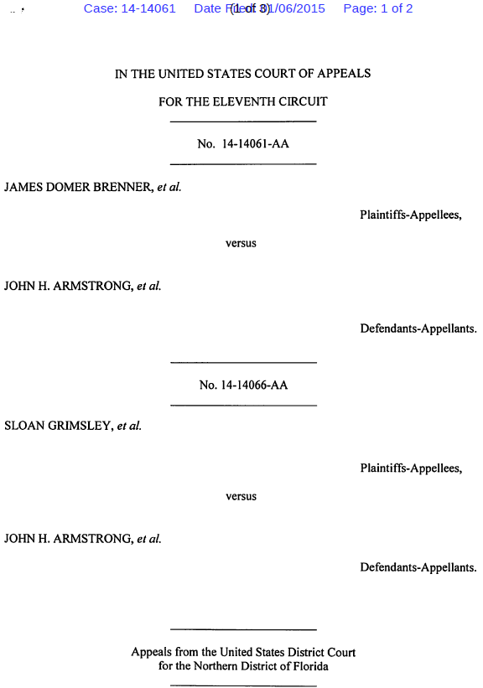
Exhibit-B (2nd of 3 pages) (continued from above)

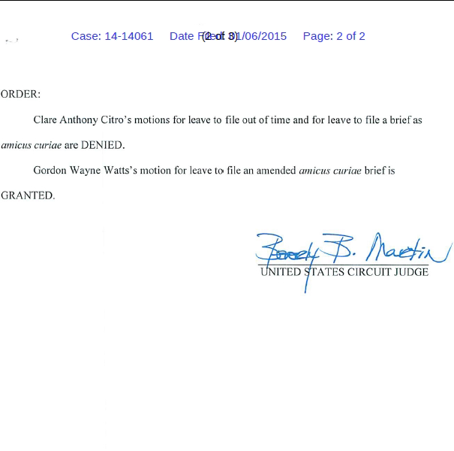

Exhibit-B (3rd f 3 pages) (continued from above)

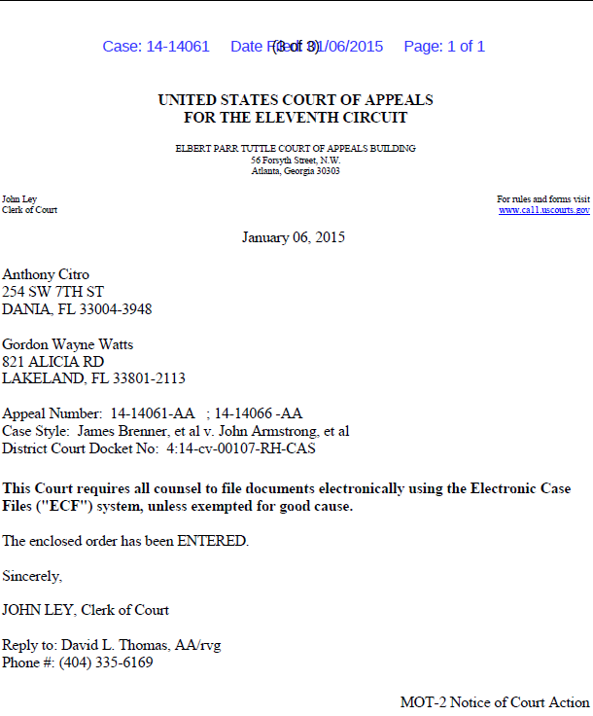

FedEx package refused by Atty. Joseph Younes Exhibit-C
C-1 (FedEx proof of Service to Defendant, Joseph Younes, Esq.: April 18, 2017)

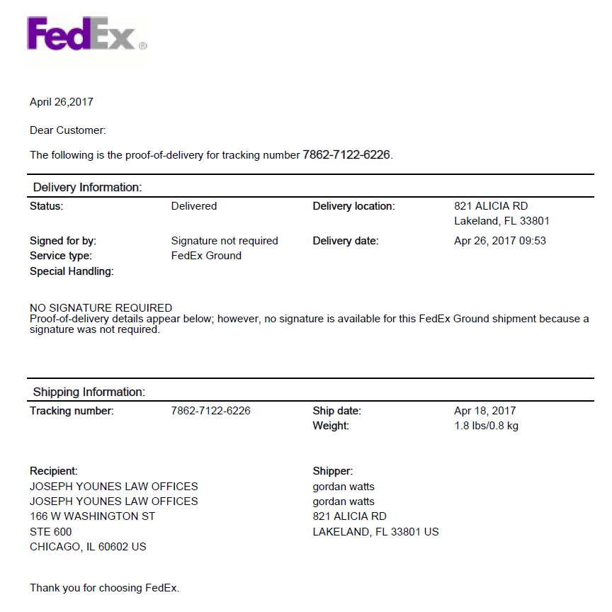

FedEx package refused by Atty. Joseph Younes Exhibit-C
C-2 (AOL email dated April 21, 2017 from FedEx showing Defendant, Younes, refused court service)

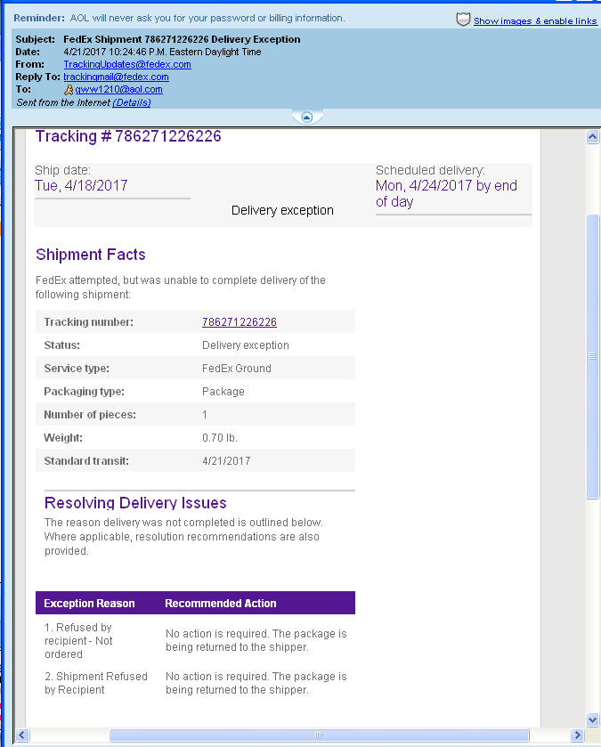
FedEx package refused by Atty. Joseph Younes Exhibit-C
C-3 (Returned FedEx service copy of briefs to Atty. Joseph Younes, Esq., dated April 21, 2017)

