IN THE CIRCUIT COURT OF COOK COUNTY, ILLINOIS
COUNTY DEPARTMENT – LAW DIVISION

GMAC Mortgage, LLC n/k/a: Bank of America, N.A., )
aka: “LaSalle Bank National Association,” aka: “US Bank, NA,” )
as trustee for Morgan Stanley Loan Trust 2006-16AX, )
Plaintiff, ) Case No.: 2007 CH 29738
) (Transfer to Law Division)
vs. ) Before: Hon. DIANE M. SHELLEY,
) Circuit Judge
Richard B. Daniggelis, Gordon Wayne Watts, Joseph )
Younes, LEGATEES, NON-RECORD CLAIMANTS, ) Case Type: CONTRACT
UNKNOWN HEIRS, UNKNOWN OWNERS, et. al., ) District: First Municipal
Defendants. ) Calendar "W", Courtroom 1912

NOTICE OF FILING
To: see attached service list

You are hereby notified that today, Saturday, 09 September 2017, I am filing, electronically, with the Clerk of the Circuit Court, and via First Class U.S. Postal Mail and/or FedEx 3rd-party commercial carrier, a copy of my Motion in Opposition to Richard Daniggelis' 8-8-17 Motion to Reconsider 7-10-17 Order, a copy of which is attached and hereby served upon you.
Date: Saturday, 09 September 2017 /s/ Gordon Wayne Watts
Gordon Wayne Watts
Gordon Wayne Watts, pro se [Code: '99500' = Non-Lawer, pro se]
821 Alicia Road, Lakeland, FL 33801-2113
PH: (863) 688-9880 [home] or (863) 409-2109 [cell]
Web: www.GordonWatts.com / www.GordonWayneWatts.com
Email: Gww1210@aol.com / Gww1210@gmail.com

CERTIFICATE AND AFFIDAVIT OF DELIVERY (aka: Certificate of Service)
The undersigned Movant, Gordon Wayne Watts, hereby certifies under penalties of perjury as provided by law pursuant to 735 ILCS 5/1-109, that the above “Notice of Filing,” my Motion in Opposition to Richard Daniggelis' 8-8-17 Motion to Reconsider 7-10-17 Order, and its exhibits (which are attached hereto) were delivered to the parties listed in the attached Service List, below – this Saturday, 09 September 2017, via the Cook County, IL Electronic Filing system if they're e-file registered. I am concurrently serving all parties via First Class U.S. Postal Mail and/or FedEx 3rd-party commercial carrier (whichever proves more convenient) and shall complete service if not prevented by Hurricane Irma (bearing down on Lakeland, Fla.) or another similar “Act of God.” Additionally, I shall, when practically possible, post a TRUE COPY of this filing –and related filings –online at my official websites, supra –linked at the “Mortgage Fraud” story, dated Fri. 14 April 2017. Lastly, I may, later, cc all parties via e-mail.
/s/ Gordon Wayne Watts
Gordon Wayne Watts
Page 1 of 27 (9-9-2017 Watts filing: GMAC v Daniggelis, Watts, Younes, et al 2007-CH-29738)
GMAC v Daniggelis, Watts, Younes, et al., 2007-CH-29738 (Transfer to Law Division)
SERVICE LIST

*Hon. Timothy C. Evans, Chief Judge (Ph 312-603-6000, 4299, 4259 TTY: 6673) Circuit Court of Cook County, 50 W. Washington St., Room 2600, Richard J. Daley Center Chicago, IL 60602

* LAW DIVISION Law@CookCountyCourt.com (312) 603-6930 ; (312) 603-5426
[830a-430p, M-F] Richard J. Daley Center, 50 W. Washington St., Room 801 Chicago, IL 60602

* Hon. Diane M. Shelley, Circuit Judge, Law Division ccc.LawCalendarW@CookcountyIL.gov Diane.Shelley@CookCountyIL.gov (312) 603-5940, (312) 603-7551, (312) 603-4811
Daley Center, 50 West Washington Street, Room 1912, Chicago, Illinois 60602

* Richard B. Daniggelis [true owner of 1720] 312-774-4742, c/o John Daniggelis 773-327-7198
2150 North Lincoln Park West, Apartment #603, Chicago, IL 60614-4652
* Unknown Owners/NonRecord Claimants 1720 North Sedgwick St., Chicago, IL 60614-5722
* Andjelko Galic (Atty#:33013) Cell:312-217-5433, Fax:312-986-1810, Phone:312-986-1510
845 Sherwood Road, LaGrange Park, IL 60526-1547 (Please take note of Mr. Galic's new address) Email: AndjelkoGalic@Hotmail.com ; AGForeclosureDefense@Gmail.com
* Robert J. More ( Anselm45@Gmail.com ) More has consented to email service & prefers this method exclusively. [Note: More's name is misspelled on docket as: “MOORE ROBERT”]

* Associated Bank, N.A., 200 North Adam Street, Green Bay, WI 54301-5142

* Richard Indyke, Esq. (312-332-2828 Atty for LaSalle Bank Natl. Assn.), Email: RIndyke@SBCGlobal.net ; 221 N. LaSalle St. STE 1200, Chicago, IL 60601-1305

* Peter King (Atty. for Joseph Younes) (Atty. No.: 48761)
(312) 780-7302 / (312) 724-8218 / Direct: (312) 724-8221
http://www.KingHolloway.com/contact.htm ; Attn: Peter M. King, Esq. PKing@khl-law.com
or: PKing@KingHolloway.com ; One North LaSalle Street, Suite 3040, Chicago, IL 60602

* Paul L. Shelton, Esq. (disbarred) E: PMSA136@Gmail.com ; PLShelton@SBCGlobal.net
As Shelton is no longer a party, I'm just serving him just electronic copies.

* Joe Younes: 2625 West Farewell Avenue, Chicago, IL 60645-4522 JoeYounes@SbcGlobal.net
* Joseph Younes (Atty#:55351) Law Offices / http://ChicagoAccidentAttorney.net
312-635-5716, per website 166 West WASHINGTON ST, Ste. 600, Chicago, IL 60602-3596
Phone: 312-372-1122 ; 312-802-1122 ; Fax: 312-372-1408. Email: RoJoe69@yahoo.com

* MERS (Mortgage Electronic Registration Systems, Inc.) https://www.mersinc.org/about-us/about-us a nominee for HLB Mortgage, Janis Smith 703-738-0230, E: JanisS@mersinc.org VP, Corporate Communications, Sandra Troutman 703-761-1274, E: SandraT@mersinc.org Dir, Corporate Communications -MERS, whose mailing address is unknown, is only served via email.

Page 2 of 27 (9-9-2017 Watts filing: GMAC v Daniggelis, Watts, Younes, et al 2007-CH-29738)
IN THE CIRCUIT COURT OF COOK COUNTY, ILLINOIS
COUNTY DEPARTMENT – LAW DIVISION

GMAC Mortgage, LLC n/k/a: Bank of America, N.A., )
aka: “LaSalle Bank National Association,” )
aka: “US Bank, NA,”as trustee for ) Case No.: 2007 CH 29738
Morgan Stanley Loan Trust 2006-16AX, ) (Transfer to Law Division)
Plaintiff, )
) Before:
vs. ) Hon. DIANE M. SHELLEY,
) Circuit Judge
Richard B. Daniggelis, Gordon Wayne Watts, Joseph )
Younes, LEGATEES, NON-RECORD CLAIMANTS, ) Case Type: CONTRACT
UNKNOWN HEIRS, UNKNOWN OWNERS, et. al., ) District: First Municipal
Defendants. ) Calendar "W", Courtroom 1912

Motion in Opposition to Richard Daniggelis' 8-8-17 Motion to Reconsider 7-10-17 Order

Movant, Gordon Wayne Watts, having carefully examined the record in the case at bar, and having discovered an impending train-wreck in the legal disposition of this case (whereby ALL parties would lose, and NO parties would win), NOW COMES Movant, Gordon Wayne Watts, pro se; MR. WATTS HEREBY MOVES AS FOLLOWS:

Executive Summary: The “long-story-short” of this impending legal train-wreck is quite simple: Atty. Andjelko Galic's motion to reconsider the Order of This Court, entered on 10 July 2017 is flawless and unbeatable, on the merits. But the ramifications of granting Galic's motion would be continued headaches & legal “Red Tape” for a case that has “dragged on” for in excess of TEN (10) YEARS. The alternative offered by Hon. Diane M. Shelley, Circuit Judge, who is currently presiding on this case, is to dismiss the case with prejudice. Should this ruling not be reversed, the effect would also be a legal headache – the effects would be 4-fold:

- ** LEGAL ** This would be a ruling contrary to case law (and eventually overturned on appeal), as the judge admits (in Point 9) that she is without discretion to grant a properly-placed motion for non-suit: “The three requirements which must be satisfied in order to qualify for and receive a voluntary dismissal are: (1) no trial or hearing shall have begun; (2) costs must be paid; and (3) notice must be given..” Vaughn v. Northwestern Memorial Hospital 210 Ill. App.3d 253, 257 (Ill. App. Ct. 1991) appeal denied, 139 Ill. 2d 605 (1991)
- ** LEGAL ** Since the record easily shows multiple reasons that a finding of mortgage fraud is sustainable (even were it to go to an appellate court of review, where the standards are higher than in the trial court, as here), applying the Common Law concept of Stare Decisis (to uphold the Chancery Division's ruling transferring title from Younes to Daniggelis) would violate numerous statutory & case law standards.

Page 3 of 27 (9-9-2017 Watts filing: GMAC v Daniggelis, Watts, Younes, et al 2007-CH-29738)
GMAC v Daniggelis, Watts, Younes, et al., 2007-CH-29738 (Transfer to Law Division)

- ** PRACTICAL ** While the court must never decide cases based on public opinion or the pressures of the Free Press [this Movant supports Independence of the Judiciary, Judicial Immunity, etc.], nonetheless, if This Court enters a ruling that is both contrary to case law, as well as very embarrassing, it would harm the reputation of the Judicial Branch, thereby causing unnecessary headaches, and increasing the difficulty of doing the work of the People in deciding cases. This headache, if possible, is to be avoided. [For the record, Defendant, Joseph Younes, has been featured in no less than 7 news items related to his code violations of the house he stole from Daniggelis: See Exhibit-A]
- ** MORAL ** While the judges who sit must NEVER allow personal or religious beliefs to influence decisions (or even give that appearance), there are certain 'moral' standards that are common to ALL religions – and even to those WITHOUT religion, as to what is “right and wrong.” Specifically, if even one hair on the head of the elderly Daniggelis is harmed (he was, indeed, made homeless for a period, sleeping in his rental van), or if even one drop of blood is shed as a result of his having been made homeless thru this very plainly clear Mortgage Rescue Scheme / Scam / Fraud, there will be “blood guilt” upon the court. (And, referring to point #3, supra, it will diminish the name & reputation of the court, in the eyes of the Public, thereby making its job more difficult.)
* So, Movant, Gordon W. Watts, having carefully examined this “legal puzzle” has come up with a third (3rd) alternative that will get the court of of a bind, since The Court is backed up against a wall, and (under normal circumstances) would be without discretion to grant the non-suit motion.
* First, let's look again, at Galic's response to remove any doubt as to the court's predicament:

The ORDER of the court, dated 7-10-2017, finds two (2) faults with Daniggelis:
- In Point 10, the court complains that Daniggelis supposedly gave no notice of his non-suit motion. But that is simply not true: All parties were required to be in court at the trial, and The Court even admits that Daniggelis' attorney, Galic, made this motion in open court. Unless the parties present were blind, deaf, & dumb, they were without excuse as to notice: They were so notified.
- Next, in Point 11, the court takes issue with the payment of costs, as required by relevant case-law. Oh, really? Did The Court not take notice that Daniggelis **repeatedly** qualified for 298 Indigent status (thus waiving the fees)? First off, on 3/12/2014, Hon. George F. Scully, Jr., in Younes v. Daniggelis (2014-M1-701473) entered an order of: “SUE OR DEFEND AS A INDIGENT PERSON – ALLOWED,” according to the docket [See also Exhibit-B]. Secondly, the gentleman is elderly and was made homeless, hello? If that's not prima facie evidence of 298 Indigent status, I don't know what is. Lastly, since the left hand should know what the right hand is doing, Mr. Daniggelis' status, in the Civil Division case, as 298 Indigent should have been apparent to The Court in this Law Division case—in the same manner that dockets in ALL the divisions are UPDATED with an attorney's new address, even when he updates said info with ONE division.
- Though not legally relevant to Galic's non-suit motion, since the judge takes issue with other matters, I feel obligated to respond: In point 1, the judge notes that this case

Page 4 of 27 (9-9-2017 Watts filing: GMAC v Daniggelis, Watts, Younes, et al 2007-CH-29738)
GMAC v Daniggelis, Watts, Younes, et al., 2007-CH-29738 (Transfer to Law Division)

has been pending for over seven (7) years: Correct. However, it is wrong to blame Daniggelis for the delay: ANYONE whose house and land were stolen (and without ANY documented payment to him—and with LOADS of his equity stolen also) would continue to fight. Thus, the huge 7-year delay in the prosecution is, at least partly, the fault of the court for continuing to deny justice, when it enabled the illegal theft of house & home.
- The Court, in points 4-5, also acknowledges Galic's complaint that the Sheriff didn't pick up LaRocque, but never explains why we can ignore this denial of Due Process. Under normal circumstances, this – alone – would justify continuance, but since a Summary Judgment, returning Daniggelis' home to its rightful owner was (is) possible, this would moot Galic's complaint & allow the court to ignore Galic's complaint. The trial judge never addresses Galic's complaint, here, at all. In fact, the predecessor judge, Hon. Sanjay T. Tailor, threatens to dismiss the case if LaRocque isn't picked up by the Sheriff, as the current judge, in Point 2, admits; however, punishing the innocent for the crimes of a guiltily party who absconds from the sheriff, and for an incompetent Sheriff who can't (or won't?) pick up the absconder, turns justice on its head: What have we become when we punish the victim of this mortgage theft, but let off the 2 guilty parties, LaRocque, and the Sheriff – and those other absconders whom he refused to pick up?
- The court, in Point 5, takes issue with Daniggelis having appeared in court (to sign papers, we now know). While it is tempting to call Daniggelis and Galic a liar here, the undersigned Movant has personal knowledge, and on knowledge and belief hereby testifies that John Daniggelis does, indeed, lie at death's doorstep, and that Richard Daniggelis is taking care of both his brother, John, and another elderly sibling (a sister whose name I rightly forget). This is, in addition, to having to deal with housing and storage issues, which surfaced when his house was stolen from him in the mortgage fraud tort, here: Even if I, myself, would have preferred he go to trial, nonetheless, Daniggelis, indeed, had a legally-valid excuse for continuance, and his presence in court was (as Galic attests) merely to sign required papers, and nothing more. Denial of continuance here would disrespect the brother's eventual death, and necessarily bring a bad name upon the court – something to be avoided at all cost.
- Lastly, in Point 12, the court admits that former (disbarred) Attorney, Paul L. Shelton, was able to make an oral (verbal) motion in open court, considered it, and granted it. However, where is the justice, when Daniggelis was not permitted to do the same? In fact, when Daniggelis wanted to fire his attorney for incompetence (continually missing court dates, refusal to enter relevant items into the record, such as the CRIMINAL police report of the bank breaking into the house, or the POLICE REPORT of his complaint to the police re mortgage fraud, etc.), the court told Galic that he could not withdraw as Daniggelis' attorney. Indeed: This Movant has this on firsthand report, from Daniggelis, but Shelton, as well, was kind enough to confirm Daniggelis' claim, here: See Exhibit-C, where Shelton admits The Court told Galic he could not withdraw. If the court forces Daniggelis to keep an attorney who, even by this court's own admission, is incompetent, and has drawn the ire of numerous other courts [see Exhibit-D: Law Division cites him for no-show ; Exhibit-E: Appeals court chews out Galic so badly that one can feel the

Page 5 of 27 (9-9-2017 Watts filing: GMAC v Daniggelis, Watts, Younes, et al 2007-CH-29738)
GMAC v Daniggelis, Watts, Younes, et al., 2007-CH-29738 (Transfer to Law Division)

heat emanating from their terse 2-page ruling regarding Galic's repeated failures to timely submit briefs, request continuances, submit the record on appeal, etc.], but then punishes Daniggelis for the attorney's incompetence, who is at fault for Daniggelis being denied?

[[ Option A: GALIC'S MOTION ]] So, it is obvious that The Court is without discretion, and (under normal circumstances) must grant Atty. Galic's motion for non-suit aka “voluntary dismissal.” But, granting such would result in a Legal Red Tape headache, as this would merely continue this soap opera drama—and give The Court (and all parties) a guaranteed headache for the unforeseeable future. This would be a legal train-wreck if the court denied Galic's motion.

[[ Option B: THE COURT'S PREFERENCE ]] But allowing the court to dismiss with prejudice would deny Due Process, and this would be a Public Embarrassment, and a both a legal train wreck (as Daniggelis was genuinely denied justice) as well as a PR nightmare (should anything happen to him, or harm come his way as a result of the court's denial of justice).

[[ Option C: WATTS' SOLUTION ]] Both 'A' and 'B' are horrible!. So, the court is in a “tight spot” –and, without the direct and immediate intervention of This Movant, this would not turn out well, so what is “Option C” to avert disaster? Well, that is simple: The Law Division court, presently reviewing this motion in opposition to Galic's motion for reconsideration, should grant Summary Judgment in favour of Daniggelis, handing back the title. (As this court remembers, I have made this motion before, but the court has declined to act upon my motion—or clarify why it disagreed.) That would “moot” Galic's motion and allow the court to deny it, but also avoid all the headaches which will come if This Court chooses either 'A' or 'B' above.

There are numerous “urban legends” that claim that the Law Division is unable to do anything other than limited monetary torts. Just as one example, https://en.Wikipedia.org/wiki/Circuit_Court_of_Cook_County#Law_Division Wikipedia states that: “The Law Division hears civil suits for recovery of monetary damages in excess of $30,000 in the city of Chicago...” and says nothing about handing a title back to reverse a bad Chancery Division ruling. (If it's on the Internet, it must be true!) But, is it really true?...

No! The limitations of the Law Division are governed solely by ILLINOIS state law, and further as restricted by the Circuit Court of Cook County, IL, specifically, GENERAL ORDER NO. 1.2,2.1 - County Department: The IL Supreme Court clearly states that Circuit Judges “can hear any circuit court case.” (Emphasis added for clarify) http://www.IllinoisCourts.gov/CircuitCourt/CCInfoDefault.asp Moreover, the local rules of the court place a few restrictions on the Law Division, but there is NO restriction prohibiting a Law Division judge (particularly, a senior or circuit judge) from reversing an incorrect title-transfer ruling by a Chancery Division judge (such as junior or Associate Judge Michael F. Otto, who entered the erroneous order in question on May 15, 2014 [see Exhibit-F]). See e.g., where GENERAL ORDER NO. 1.2,2.1, section (a)(1), the rules, which begin by saying: “The Law

Page 6 of 27 (9-9-2017 Watts filing: GMAC v Daniggelis, Watts, Younes, et al 2007-CH-29738)
GMAC v Daniggelis, Watts, Younes, et al., 2007-CH-29738 (Transfer to Law Division)

Division hears civil actions at law, whether or not a jury is demanded, except:..” have absolutely NO exception prohibiting a Law Division judge from reversing Otto's ruling. Read it, and weep: It is the law. [ GENERAL ORDER NO. 1.2,2.1 - County Department, section (a)(1) ] [ see: Exhibit-G, which is a direct quote of the exceptions ]
Source:
http://www.CookCountyCourt.org/Manage/DivisionOrders/ViewDivisionOrder/tabid/298/ArticleId/188/GENERAL-ORDER-NO-1-2-2-1-County-Department.aspx

Should This Court decide to do “the right thing” and enter and order reversing Judge Otto's May 15, 2014 ruling in the above-captioned case, which was transferred from Chancery to the Law Division, Judicial Immunity would protect the judges (albeit, it would, admittedly, ruffle a lot of rich-and-powerful feathers).

By the same token, should This Court apply the Common Law doctrine of Stare Decisis¹ , and refuse to recede from the previous ruling, which stole the title from Daniggelis and gave it to Younes, the judges would likewise be protected from criminal (and possibly civil) prosecution by the Doctrine of Judicial Immunity. This Court has jurisdiction, and such a “bad” ruling would not be illegal. But, would it be the best, the most just, course of action? As shown in the footnotes, application of Stare Decisis is not always the wise move, and often results in not only injustice, but also huge (and easily-preventable) PR-nightmare embarrassment of The Judicial Branch.

Attached, as part of this pleading, I shall draft a proposed Order (which is a common practice for those moving the court for something) to make the “paperwork” load a bit easier on the judges who sit on this case. See below for said proposed order.

_______________________
^{1 “}Stare decisis,” which is is Latin for “to stand by things decided,” is the legal principle of determining points in litigation according to precedent. However, it is not reasonable to assume that “just because a court” said so, it makes it so. (For example: Gordon Hirabayashi, Fred Korematsu, and Minoru Yasui, Japanese Americans who are best known for their principled resistance to the internment of Japanese Americans during World War, all three had their convictions overturned through writs of coram nobis, and they were each awarded the Presidential Medal of Freedom. As well, America's Highest Court held, by a overwhelming margin of a 7-2 split decision, that: "...that the negro might justly and lawfully be reduced to slavery for his benefit." -Chief Justice Roger B. Taney, writing for the Court. (Dred Scott v. John F. Sanford, 15 L.Ed. 691; 19 How. 393; 60 US 393 at 407. (December Term, 1856) Lastly, in December 2014, a writ of coram nobis was granted by a federal court to posthumously vacate the conviction of George Stinney, a 14-year-old African-American boy who was wrongfully-convicted of murder and executed in June1944, in a one-day trial of the first-degree murder of two white girls. Thus, it gives The Court a bad name to wrongly apply Stare Decisis.

Page 7 of 27 (9-9-2017 Watts filing: GMAC v Daniggelis, Watts, Younes, et al 2007-CH-29738)
GMAC v Daniggelis, Watts, Younes, et al., 2007-CH-29738 (Transfer to Law Division)

Before closing my argument, I must concede the following: This Court (Judge Shelley, presiding on this case) is very justified in being angry [see the 7-10-2017 Order in this case] at Galic, who has also drawn the ire of Judge Tailor [Exhibit-D] and the First Appellate Court [Exhibit-E], as well as the undersigned Movant, Gordon W. Watts [who has, in his prior filings, expressed great disappointment with Galic for having overlooked key arguments in defending Daniggelis]. However, have we forgotten that it is Younes (and not Galic or Daniggelis) who committed (or admitted participation in conspiracy) to numerous felonies, and eventually obtained a house FREE AND CLEAR via mortgage fraud? Before we “pile on” to Galic, let us keep things in perspective, and realise & remember who the 'real' criminals, without honour, are—who escaped prosecution due merely to sloppy Police work and expired SOL's (Statues of Limitations), shall we?

Lastly, This Court has applied the “burden of proof” in a backwards manner, demanding that Daniggelis prove that the house is his (and demanding he go to trial). This is plainly backwards: Younes, was not required to “go to trial” as was Daniggelis (implicates Equal Protection) and who took a house, without having paid Daniggelis a dime—and via proven forgery—has the burden of proof to show it is his. Younes has not met this burden of proof, and This Court has given absolutely no justification to believe otherwise. [If the undersigned movant is wrong, please enter an Order of Clarification, justifying the transfer of title.]

Page 8 of 27 (9-9-2017 Watts filing: GMAC v Daniggelis, Watts, Younes, et al 2007-CH-29738)
IN THE CIRCUIT COURT OF COOK COUNTY, ILLINOIS
COUNTY DEPARTMENT – LAW DIVISION

GMAC Mortgage, LLC n/k/a: Bank of America, N.A., )
aka: “LaSalle Bank National Association,” )
aka: “US Bank, NA,”as trustee for ) Case No.: 2007 CH 29738
Morgan Stanley Loan Trust 2006-16AX, ) (Transfer to Law Division)
Plaintiff, )
) Before:
vs. ) Hon. DIANE M. SHELLEY,
) Circuit Judge
Richard B. Daniggelis, Gordon Wayne Watts, Joseph )
Younes, LEGATEES, NON-RECORD CLAIMANTS, ) Case Type: CONTRACT
UNKNOWN HEIRS, UNKNOWN OWNERS, et. al., ) District: First Municipal
Defendants. ) Calendar "W", Courtroom 1912

ORDER

This matter having come before the court on movant, Gordon Wayne Watts' motion in opposition to the August 08, 2017 motion for reconsideration by Defendant, Richard B. Daniggelis;
And: this court having jurisdiction and being fully advised on the premises; THE COURT HEREBY FINDS AS FOLLOWS:

- The above-captioned case was set for a bench trial on July 10, 2017, at 10:30am (CST), before the undersigned judge.
- Defendant, Richard Daniggelis, filed a written motion for continuance on the trial date, based on inability of the sheriff to serve one witness, and based on alleged inability of defendant to show up in court because he was taking care of an elderly, ill brother.
- This court initially granted continuance, until the undersigned judge became aware Daniggelis was in court. The undersigned denied the motion for continence, upon which Daniggelis moved for non-suit, aka voluntary dismissal—without prejudice to refile.
- This court then denied that motion as well in its July 10, 2017 order.
- On August 08, 2017, Daniggelis filed a written motion to reconsider this court's July 10, 2017 order, alleging he met the requirements for nonsuit.
- This court finds that Daniggelis was qualified as “indigent” aka 298 status, in a related Forcible Entry and Detainer case, on 3/12/2014, Hon. George F. Scully, Jr., in Younes v. Daniggelis (2014-M1-701473), and thus not required to pay court costs. Moreover, the court finds that Daniggelis properly notified all parties via his oral (verbal) motion in open court on July 10, 2017. His motion came before any trial date had commenced.
- Since all requirements were met, Daniggelis would normally be eligible for a grant of his motion, and this court would normally be without discretion to deny him. Vaughn v. Northwestern Memorial Hospital 210 Ill. App.3d 253, 257 (Ill. App. Ct. 1991) appeal denied, 139 Ill. 2d 605 (1991)

Page 9 of 27 (9-9-2017 Watts filing: GMAC v Daniggelis, Watts, Younes, et al 2007-CH-29738)
GMAC v Daniggelis, Watts, Younes, et al., 2007-CH-29738 (Transfer to Law Division)

- Normally, this court would be bound to comply with the case-law in point 7, supra, but the doctrine of mootness would abrogate, annul, and cancel any such motion were it applicable: “Mootness doctrine is a principle of judicial procedure whereby American courts will not decide moot cases that is, cases in which there is no longer any actual controversy. ”
Source: U.S. Legal website: https://Definitions.UsLegal.com/m/mootness-doctrine/

- This court, by virtue of the order entered today, reverses the erroneous May 15, 2014 order entered by Associate Judge Michael F. Otto, thereby handing title of 1720 North Sedgwick Street back to Defendant, Richard Daniggelis. Since this effectively grants redress for the torts, in question (the same as if trial had occurred), Daniggelis' motion for continuance is moot: There is no controversy, so far as Daniggelis is concerned, since this summary judgment effects the same goal as the bench trial would have, and thus this court may (and actually, must) deny Daniggelis motion for reconsideration at moot.
- This court hereby issues an Order of 'Show Cause' giving co-defendant, Joseph Younes, ten (10) days to file a response as to why he might object to This Court's order, today, receding from the ruling that Judge Otto entered when this case was in the Chancery Division. Failure to do so will result in this order becoming final, and with prejudice.
- This court, which is in the Law Division, does not normally hear cases in which it enters a ruling handing title back, as the Chancery Division normally does this task. However, this court has jurisdiction: The IL Supreme Court clearly states that Circuit Judges “can hear any circuit court case.” (Emphasis added for clarify) http://www.IllinoisCourts.gov/CircuitCourt/CCInfoDefault.asp Moreover, GENERAL ORDER NO. 1.2,2.1, section (a)(1), local rules governing the Cook County, IL Circuit Court, which begin by saying: “The Law Division hears civil actions at law, whether or not a jury is demanded, except:..” have absolutely no exception prohibiting a Law Division judge from reversing Otto's ruling. Therefore, the undersigned just has jurisdiction to correct an erroneous ruling.
- Defendant, Richard Daniggelis (through his attorneys, Benji Philips and his current attorney, Andjelko Galic) has raised numerous arguments as to why the transfer of title from him to Younes was illegal, including the lack of documented payment for the 'sale,' as well as the allegation that the signature was a forgery. Lack of payment is prima facie evidence that defendant did not want to sell his house, and substantiates defendant claims that the documents he signed were for the sole purpose of refinance. This, alone, might void the so-called 'sale': Stilk v. Myrick, 170 Eng. Rep. 1168, 1168 (1809) (L.R.C.P) (Ellenborough, L) (holding a renegotiated contract void due to lack of consideration).
- Co-defendant, Gordon Wayne Watts, who intervened as a matter of right, to protect numerous interests (not the least of which was monies owed to him by Daniggelis), raised the argument that the signatures on the two warranty deeds was identical (offering proof which Daniggelis did not), which proves the 'forgery' claims made by Daniggelis.

Page 10 of 27 (9-9-2017 Watts filing: GMAC v Daniggelis, Watts, Younes, et al 2007-CH-29738)
GMAC v Daniggelis, Watts, Younes, et al., 2007-CH-29738 (Transfer to Law Division)

- Co-defendant, Gordon Wayne Watts, also moved to file a friend of the court brief (amicus
curiae) before he sought Intervention. This court, by its inaction, effectively denied Watts' amicus motion. But his filings are still on file with the court, and are legally relevant, insofar as they contain useful documents that document or verify claims made in briefs filed by himself and co-defendant, Daniggelis. Since this court has allowed Watts to intervene, any complaints about his denial to file an amicus brief are likewise mooted.

- One of the documents filed by Watts (“Exhibit-D” of his “Second AMICUS CURIAE BRIEF...”) was an alleged complaint that co-defendant, Joseph Younes, made to the Office of the Attorney General (OAG), alleging a conspiracy between DOCX, US BanCorp, Nationwide Title Clearing, and Bank of America, N.A. However, Younes continued to participate in the very conspiracy he alleged—benefiting from it by gaining a “free” house, when Judge Otto erroneously transferred title to him.

- Watts' filing averred and claimed that this was a genuine document, and Younes never denied the authenticity of the alleged OAG complaint regarding a supposed conspiracy.
- Per 735 ILCS 5/15-1506(a), that which Younes didn't deny is admitted, and, as he admits a conspiracy, his participation in it is compelling evidence of his guilt in the matter.
- Younes also was properly served by Watts regarding the fact (which Watts documented) that 2 warranty deeds, with different dates, had identical signatures, giving credence to Daniggelis' claims of a forged signature. Insofar as Younes never denied this, he is guilty of trafficking in stolen property: Even if he, himself, did not effect the “photocopy forgery” in question, he, without any question or doubt, knew it was a forged instrument, and his continued attempts to obtain title to Daniggelis' house (even if supported by a favorable ruling from Judge Otto) were clear fraud.
- Neither Judge Otto's order (snatching title from Daniggelis and giving it to Younes) nor any of Younes' filings (asking for a transfer of title) offer any scintilla of legal basis which would justify taking title from one person, and giving it to another, without any payment of costs, and in the presence of clear forgery – and vocal protests by the victim that he did not consent to any such 'sale'.
- Forgery has no statutes of limitations, and, as such, this matter is being referred to the Criminal Division for prosecution of Joseph Younes in a scheme to defraud. Moreover, this court is making a formal referral for the IARDC (Illinois Attorney Registration & Disciplinary Commission) to investigate Mr. Younes for unprofessional conduct, since it was solely the Statutes of Limitations (SOL's) which protected him from much worse punishment, when he caught a “lucky break” and the police were slow to investigate and allowed the SOL's to expire.

Page 11 of 27 (9-9-2017 Watts filing: GMAC v Daniggelis, Watts, Younes, et al 2007-CH-29738)
GMAC v Daniggelis, Watts, Younes, et al., 2007-CH-29738 (Transfer to Law Division)

- For the foregoing reasons, This Court finds that summary judgment, reversing Judge Otto's ruling, and handing title back to Daniggelis, along with unspecified monetary damages (including theft of equity) is appropriate: Although summary judgment is appropriate if, as in this case, a cross-plaintiff, Joseph Younes (and the other cross-plaintiffs), cannot establish an element of his claim that Judge Otto's ruling should stand, it should only be granted when the right of the moving party is clear and free from doubt. Dardeen v. Kuehling, 213 Ill. 2d 329, 335 (2004). Here, based on copious evidence, there is no doubt that summary judgment, in favor of Richard Daniggels, and his attorney (who is due fees, after having worked pro bono for many years) is warranted.

IT IS HEREBY ORDERED:
A. The May 15, 2014 by Judge Michael F. Otto is reversed, and title is handed back to Richard Daniggelis.
B. Mr. Younes, and other co-defendants (including Stewart Title, which was ordered to pay a trifling judgment, in a prior ruling) who conspired to defraud, shall be ordered to pay unspecified damages in a forthcoming ruling to Daniggelis and his attorney, Andjelko Galic, unless they wish to counter-sue or defend, and set a trial date.
C. Those amounts of monies which Mr. Watts alleges Mr. Daniggelis owes him for various research and other assistance, shall be doubled, since he has no doubt incurred more costs since the last accounting. And his costs to file also should be counted, which may justify an even larger award. Mr. Watts shall be paid from a portion of any funds demanded from the guilty parties, a portion also going to Daniggelis, his attorney, Andjelko Galic, and also defendant Robert J. More, who was made homeless, partly as a result of Younes' theft of title of Daniggelis' house, where Mr. More was a nonpaying tenant of Daniggelis.

ENTERED: _____________________
Judge Diane M. Shelley, #1925

Date: _____________________

Prepared by:
Gordon Wayne Watts
821 Alicia Road
Lakeland, FL 33801-2113
(863) 688-9880, (863) 409-2109

Page 12 of 27 (9-9-2017 Watts filing: GMAC v Daniggelis, Watts, Younes, et al 2007-CH-29738)
GMAC v Daniggelis, Watts, Younes, et al., 2007-CH-29738 (Transfer to Law Division)

In Conclusion:

In conclusion, the proposed order, on pp.9-12, supra, should give a pretty good idea of what this motion seeks, and why it is not only legally justified, but also the only 'good' option available for This Court, and the litigants herein.

For the record, I represent to This Court that Co-Defendant Robert J. More (whose last name is misspelled as 'Moore' on the court's docket) has asked me to file a motion to replace the trial court judge (Hon. Diane M. Shelley), because he feels she would be biased. While that is, apparently, my right as a newly-placed Defendant on this docket of this case (see: 725 ILCS 5/114-5(b), which does not mention the trial call, for which this case was removed), I decline to exercise that right. Even if (as I surmise) it is my absolute right to have a “Sec. 114-5. Substitution of judge,” I still decline for at least 2 reasons:
    - It would place an undue burden on the successor judge (who would not be familiar with the numerous filings, documents, & arguments as is Judge Shelley).
    - Secondly, the Maxim: “you'd better be careful what you ask for: you just might get it” implies that I might be jumping “from the frying pan into the fire” and get what religious folk call an 'unjust judge' that would vex the various defendants event more—instead of finally doing justice in this vexingly long case.
    - As a bonus, Mr. More must not have noticed that Judge Shelley granted my motion to Intervene. (Either that or the clerk royally screwed up in naming me as a defendant on the docket: Exhibit-H.) That would make her a 'good' judge, and kicking her off the case would be unwise, at the least.

Mr. More named 2 other judges (whose names are not important for this pleading), and asked that I move that the case be transferred to them because they can “bear the burden” of the office better than the sitting judge. While, no doubt, some judges are better than others (judges being human), that is not only impermissible “judge shopping,” but it is also an affront to the sitting judges who, barring egregious evidence of bias, should not be disqualified. (Moreover, as Mr. More, while a good friend of mine, is nonetheless classed as a vexatious litigant, and generally barred or trespassed from the court properties, except possibly limited access with security escort, it is easily inferred that views like this are a “chief” reason why my filings get reviewed, and his get ignored, along with his having been barred from filing or coming onto the courthouse properties.)
Therefore, I will let my filings speak for me, and I respectfully ask This Court (whichever judge is assigned to sit) to review my proposed Order, supra, and, with only minor style modifications, if needed, endorse that order and make it so—or, in the alternative, to enter an Order of Clarification explaining, in detail, why it was 'justified' to snatch a house & land from one man & give it to another—without any payment whatsoever. Respectfully submitted,
Date: Saturday, 09 September 2017 /s/ Gordon Wayne Watts
Gordon Wayne Watts

Page 13 of 27 (9-9-2017 Watts filing: GMAC v Daniggelis, Watts, Younes, et al 2007-CH-29738)
GMAC v Daniggelis, Watts, Younes, et al., 2007-CH-29738 (Transfer to Law Division)

Verification by Certification

I, Gordon Wayne Watts, the undersigned Movant, under penalties as provided by law pursuant to 735 ILCS 5/1-109, Section 1-109 of the ILLINOIS Code of Civil Procedure, hereby certify that the statements set forth in this instrument are true and correct, except as to matters therein stated to be on information and belief, and, as to such matters, the undersigned certifies as aforesaid that he verily believes the same to be true.

“Any pleading, affidavit or other document certified in accordance with this Section may be used in the same manner and with the same force and effect as though subscribed and sworn to under oath.” Source: 735 ILCS 5/1-109:
http://www.ILGA.gov/legislation/ilcs/documents/073500050K1-109.htm

Nonetheless, This Court has on record my sworn, witnessed, and notarised affidavit, just to remove any and all doubt hereto.

Date: Saturday, 09 September 2017 /s/ Gordon Wayne Watts
Gordon Wayne Watts

Gordon Wayne Watts, pro se [Code: '99500' = Non-Lawer, pro se]
821 Alicia Road, Lakeland, FL 33801-2113
PH: (863) 688-9880 [home] or (863) 409-2109 [cell]
Web: www.GordonWatts.com / www.GordonWayneWatts.com
Email: Gww1210@aol.com / Gww1210@gmail.com

Page 14 of 27 (9-9-2017 Watts filing: GMAC v Daniggelis, Watts, Younes, et al 2007-CH-29738)
GMAC v Daniggelis, Watts, Younes, et al., 2007-CH-29738 (Transfer to Law Division)

INDEX TO THE EXHIBITS

Instrument Docket/Tab#

Selected news items featuring defendants,
Joseph Younes and/or Paul Shelton Exhibit-A

3/12/2014 Order of Hon.George F. Scully, Jr., granting 298
Indigent status to Defendant, Richard Daniggelis Exhibit-B

07/10/2017 Email from co-Defendant, Paul L. Shelton,
confirming Daniggelis' claim that Hon. Diane M. Shelley
would not let Atty. Galic withdraw Exhibit-C

09/02/2015 Order from Hon. Sanjay T. Tailor
(Law Division ruling citing Atty. Galic for no-show ) Exhibit-D

06/16/2016 Order from First Appellate court
(Short, 2-page appeals court ruling harshly
criticizing Galic for numerous violations) Exhibit-E

05/15/2014 Order of Hon. Michael F. Otto,
handing title of Daniggelis' house to Joseph Younes Exhibit-F

GENERAL ORDER NO. 1.2,2.1 – County Department Exhibit-G

Screenshot of the docket in the above-captioned case Exhibit-H

Page 15 of 27 (9-9-2017 Watts filing: GMAC v Daniggelis, Watts, Younes, et al 2007-CH-29738)
GMAC v Daniggelis, Watts, Younes, et al., 2007-CH-29738 (Transfer to Law Division)

Selected news items featuring defendants, Joseph Younes and/or Paul Shelton Exhibit-A-i

(Arranged by news source; and then, in chronological order)

DNAinfo, Chicago:

7-story series featuring Joseph Younes, 'owner' of the 'Rotted' house taken from Daniggelis

** “'Rotted' Historic Building In Old Town Triangle Could Be Seized By City,” by Ted Cox, DNAinfo, Mar 30, 2017: https://www.DNAinfo.com/chicago/20170330/old-town/rotted-historic-building-old-town-triangle-could-be-seized-by-city

** “'Rotted' Old Town Triangle House Owner Faces Daily $1K Fine As Charges Fly,” by Ted Cox, DNAinfo, Apr 07, 2017: https://www.DNAinfo.com/chicago/20170407/old-town/rotted-old-town-triangle-house-owner-faces-daily-1k-fine-as-charges-fly

** “'Rotted' Old Town House Slated For Repairs As Fines Threatened Again,” by Ted Cox, DNAinfo, Apr 28, 2017: https://www.DNAinfo.com/chicago/20170428/old-town/rotted-old-town-triangle-house-landmark-historic-district-1720-sedgwick-avenue-joseph-younes

** “Owner Of 'Rotted' Old Town Home Threatened With $150,000 Fine,” by Ted Cox, DNAinfo, Jul 07, 2017: https://www.DNAinfo.com/chicago/20170707/old-town/rotted-old-town-house-fines-building-violations-demolition-landmarks-joseph-younes

** “Owner Of 'Rotted' Old Town House Faces 'Significant Fines,' City Says,” by Ted Cox, DNAinfo, Jul 13, 2017: https://www.DNAinfo.com/chicago/20170713/old-town/owner-of-rotted-old-town-house-faces-significant-fines-city-says

** “'Rotted' Old Town House Cleared For Repairs,” by Ted Cox, DNAinfo, Jul 20, 2017 : https://www.DNAinfo.com/chicago/20170720/old-town/rotted-old-town-house-cleared-for-repairs

** “'Rotted' Old Town House Owner Given 45 Days To Come Up With Repair Plan,” by Ted Cox, DNAinfo, Sept 01, 2017: https://www.DNAinfo.com/chicago/20170901/old-town/rotted-old-town-house-owner-given-45-days-come-up-with-repair-plan

Page 16 of 27 (9-9-2017 Watts filing: GMAC v Daniggelis, Watts, Younes, et al 2007-CH-29738)
GMAC v Daniggelis, Watts, Younes, et al., 2007-CH-29738 (Transfer to Law Division)

Selected news items featuring defendants, Joseph Younes and/or Paul Shelton Exhibit-A-ii

(Arranged by news source; and then, in chronological order)

Chicago Tribune:
[ Featuring Lessie Towns, whose home was taken by defendant, Paul Shelton ]

** “While mom took care of others, she got taken,” By John Kass, Chicago Tribune, May 10, 2009: http://articles.ChicagoTribune.com/2009-05-10/news/0905090103_1_trust-bungalow-house-payments

** “From Quinn on down, all were on her side,” By John Kass, Chicago Tribune, August 21, 2009: http://articles.ChicagoTribune.com/2009-08-21/news/0908200904_1_towns-home-politicians-deacon

* ABC Local:
[ Featuring Lessie Towns, whose home was taken by defendant, Paul Shelton ]

** “Chicago owner loses home in mortgage scam,” By Paul Meincke, ABC Local, WLS-TV/DT;
June 12, 2009 2:50:32 PM PDT: http://abc7chicago.com/archive/6862674/

** “Woman allegedly swindled out of home allowed to stay,” By Paul Meincke, ABC Local, WLS-TV/DT; July 28, 2009 3:27:03 PM PDT: http://abc7chicago.com/archive/6937078/

** “Victory for South Side victim of mortgage fraud,” By Paul Meincke, ABC Local, WLS-TV/DT; November 19, 2010 3:35:06 PM PST: http://abc7chicago.com/archive/7799653/

* The Register:
[ News coverage of defendants, Paul Shelton, Joseph Younes, Richard Daniggelis, etc. ]

** “Chicago Courts refuse to help elderly 'Mortgage Rescue Scam' victim; make him homeless,” from Staff Reports, The Register, Tue. 01 Dec. 2015:
http://www.GordonWatts.com/#MortgageFraud-2015
http://www.GordonWayneWatts.com/#MortgageFraud-201 5

** “Chicago Courts refuse to stop illegal construction/demolition: “Mortgage Rescue Scam” victim's house almost destroyed,” from Staff Reports, The Register, Fri. 14 Apr. 2017; UPDATED Sat. 02 Sept. 2017: http://www.GordonWatts.com/#MortgageFraud-2017UPDATES
http://www.GordonWayneWatts.com/#MortgageFraud-2017UPDATES

Page 17 of 27 (9-9-2017 Watts filing: GMAC v Daniggelis, Watts, Younes, et al 2007-CH-29738)
GMAC v Daniggelis, Watts, Younes, et al., 2007-CH-29738 (Transfer to Law Division)

3/12/2014 Order of Hon.George F. Scully, Jr., granting 298
Indigent status to Defendant, Richard Daniggelis Exhibit-B-i

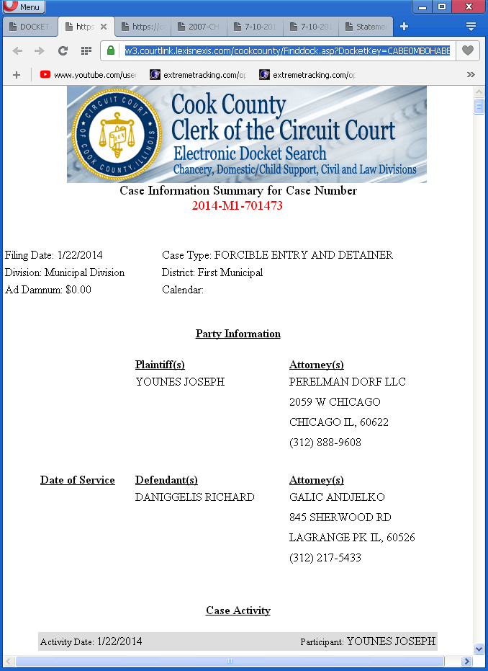
Page 18 of 27 (9-9-2017 Watts filing: GMAC v Daniggelis, Watts, Younes, et al 2007-CH-29738)
GMAC v Daniggelis, Watts, Younes, et al., 2007-CH-29738 (Transfer to Law Division)

3/12/2014 Order of Hon.George F. Scully, Jr., granting 298
Indigent status to Defendant, Richard Daniggelis Exhibit-B-ii

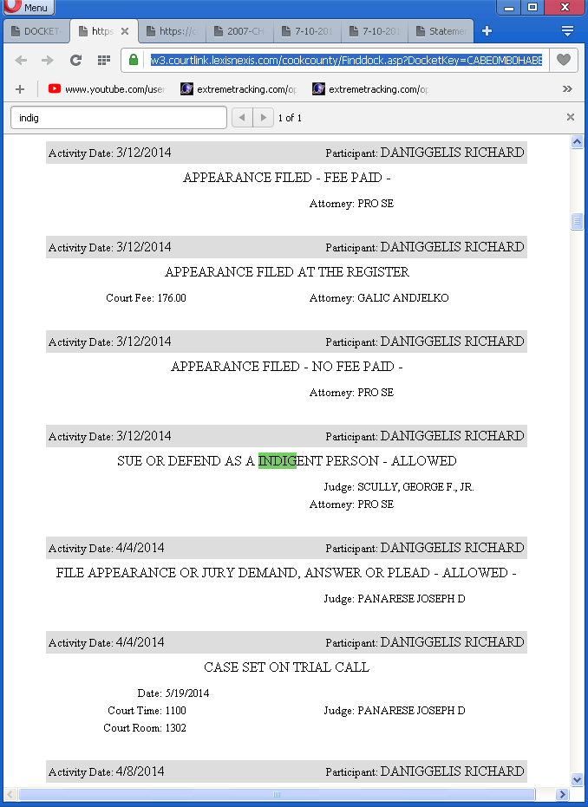
Page 19 of 27 (9-9-2017 Watts filing: GMAC v Daniggelis, Watts, Younes, et al 2007-CH-29738)
GMAC v Daniggelis, Watts, Younes, et al., 2007-CH-29738 (Transfer to Law Division)

07/10/2017 Email from co-Defendant, Paul L. Shelton, confirming Daniggelis'
claim that Hon. Diane M. Shelley would not let Atty. Galic withdraw Exhibit-C
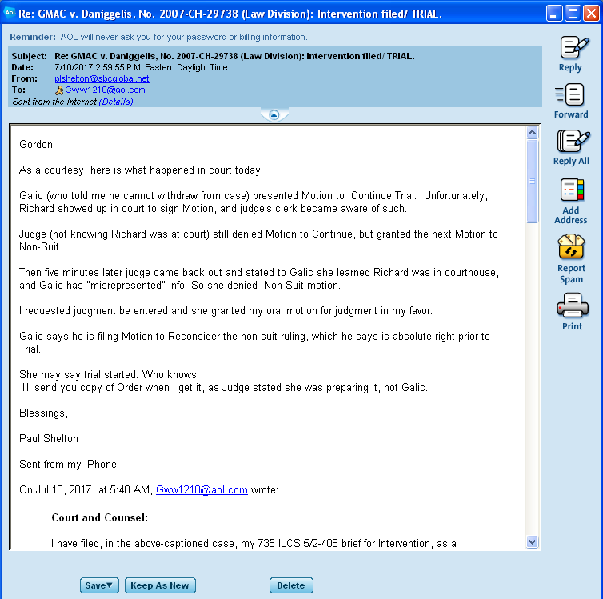
Page 20 of 27 (9-9-2017 Watts filing: GMAC v Daniggelis, Watts, Younes, et al 2007-CH-29738)
GMAC v Daniggelis, Watts, Younes, et al., 2007-CH-29738 (Transfer to Law Division)

09/02/2015 Order from Hon. Sanjay T. Tailor
(Law Division ruling citing Atty. Galic for no-show) Exhibit-D

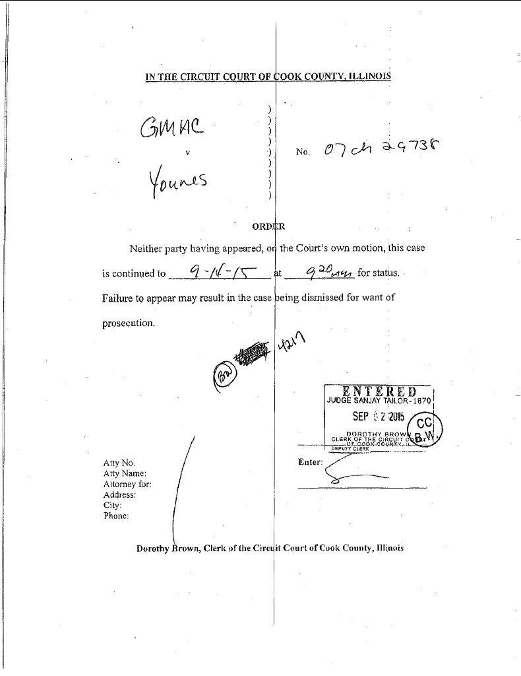
Page 21 of 27 (9-9-2017 Watts filing: GMAC v Daniggelis, Watts, Younes, et al 2007-CH-29738)
GMAC v Daniggelis, Watts, Younes, et al., 2007-CH-29738 (Transfer to Law Division)

06/16/2016 Order from First Appellate court (Short, 2-page appeals
court ruling harshly criticizing Galic for numerous violations) Exhibit-E-i
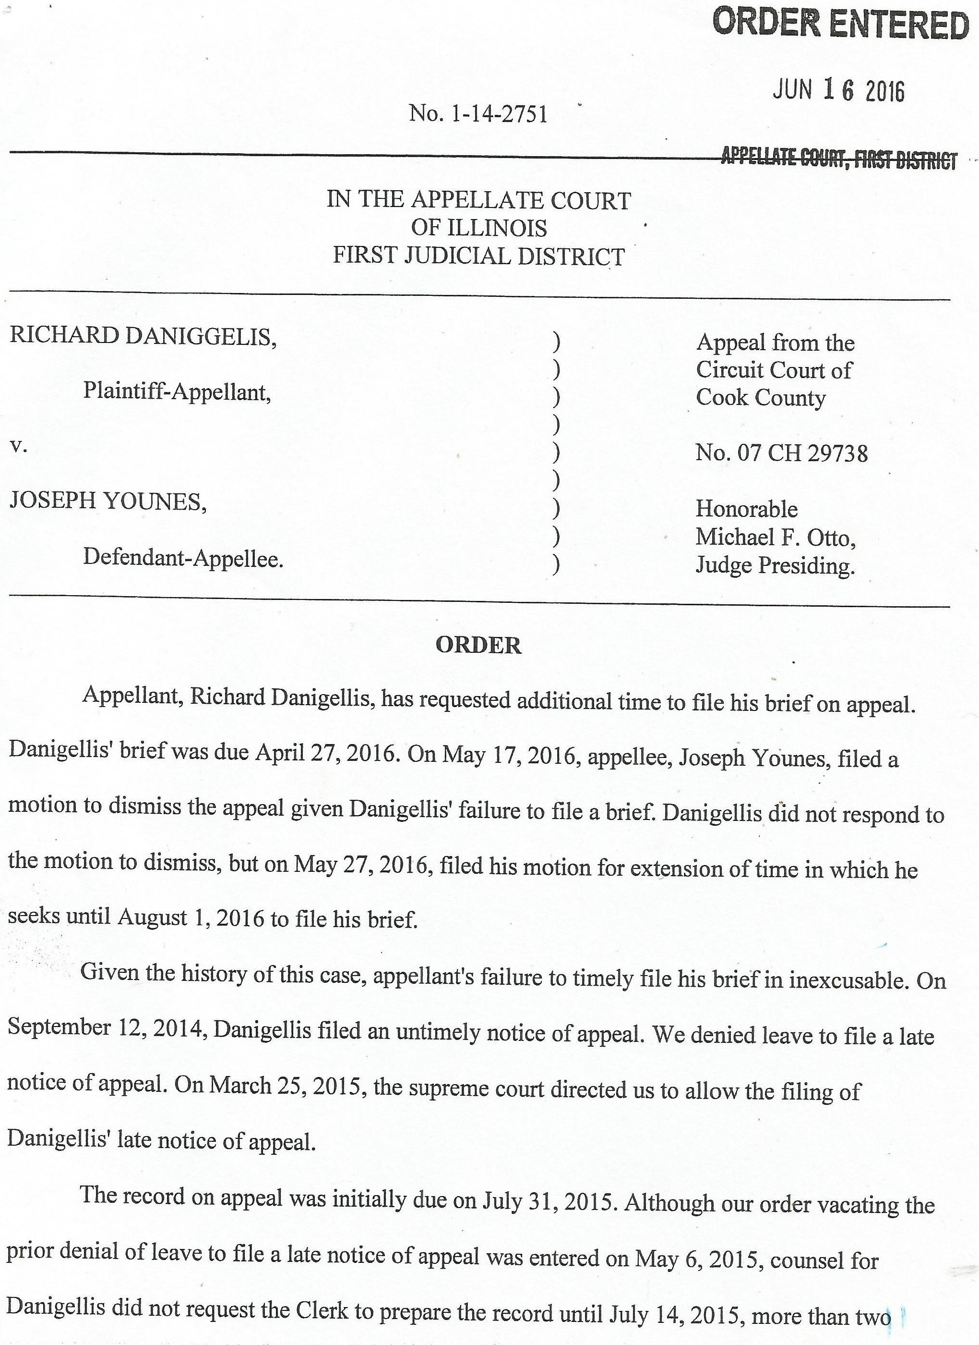
Page 22 of 27 (9-9-2017 Watts filing: GMAC v Daniggelis, Watts, Younes, et al 2007-CH-29738)
GMAC v Daniggelis, Watts, Younes, et al., 2007-CH-29738 (Transfer to Law Division)

06/16/2016 Order from First Appellate court (Short, 2-page appeals
court ruling harshly criticizing Galic for numerous violations) Exhibit-E-ii

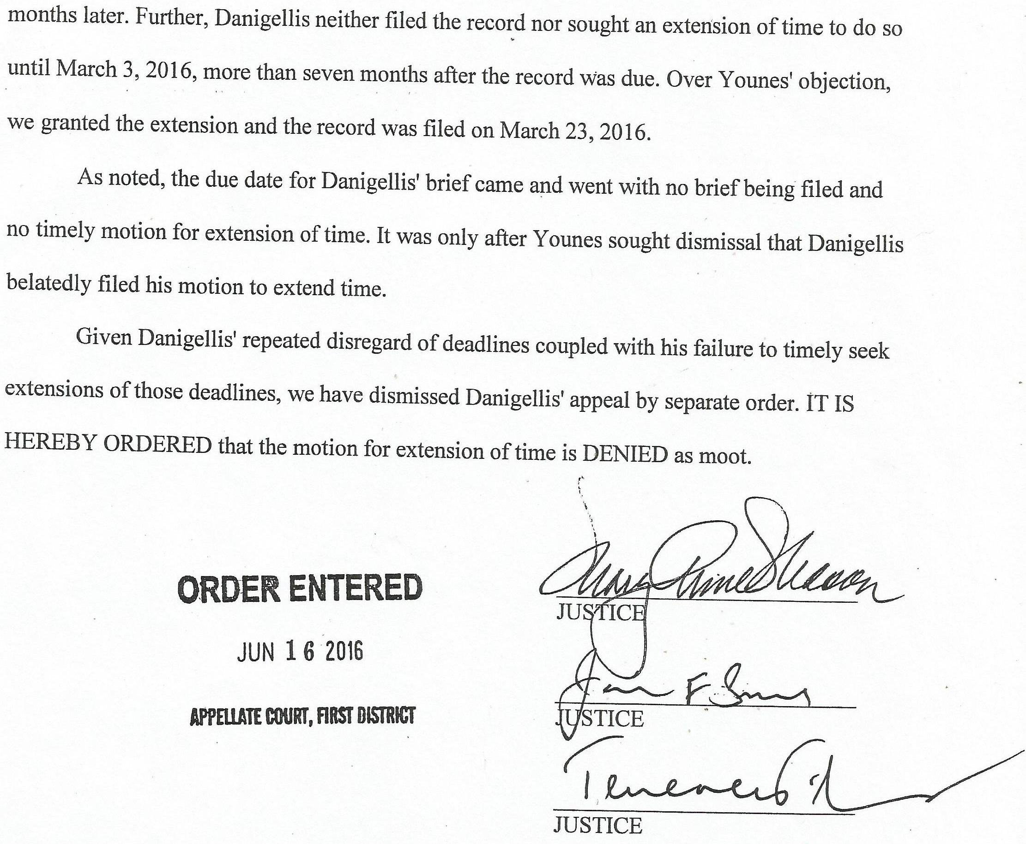

Page 23 of 27 (9-9-2017 Watts filing: GMAC v Daniggelis, Watts, Younes, et al 2007-CH-29738)

GMAC v Daniggelis, Watts, Younes, et al., 2007-CH-29738 (Transfer to Law Division)

05/15/2014 Order of Hon. Michael F. Otto,
handing title of Daniggelis' house to Joseph Younes Exhibit-F-i
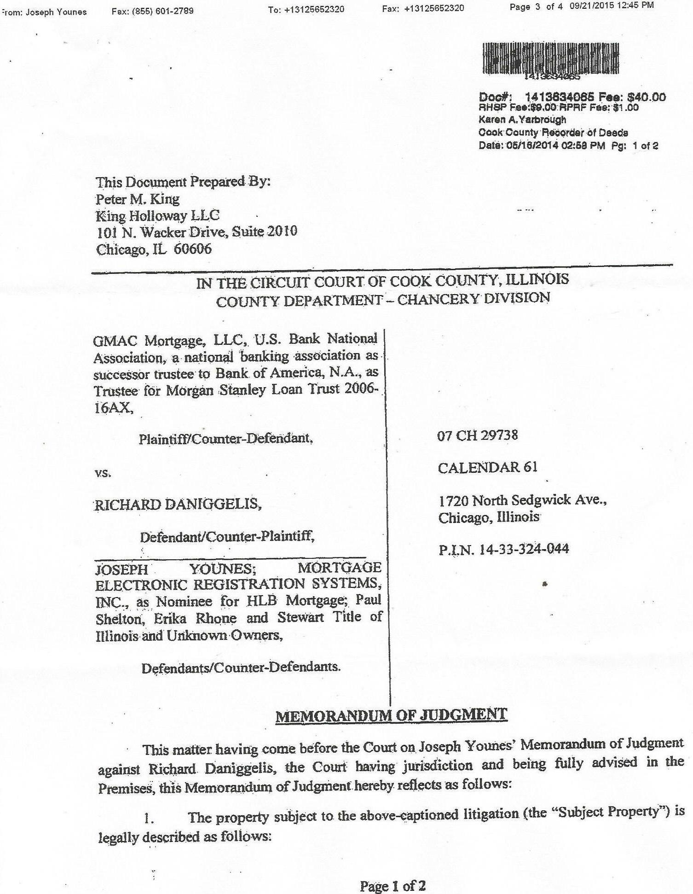
Page 24 of 27 (9-9-2017 Watts filing: GMAC v Daniggelis, Watts, Younes, et al 2007-CH-29738)
GMAC v Daniggelis, Watts, Younes, et al., 2007-CH-29738 (Transfer to Law Division)

05/15/2014 Order of Hon. Michael F. Otto,
handing title of Daniggelis' house to Joseph Younes Exhibit-F-ii
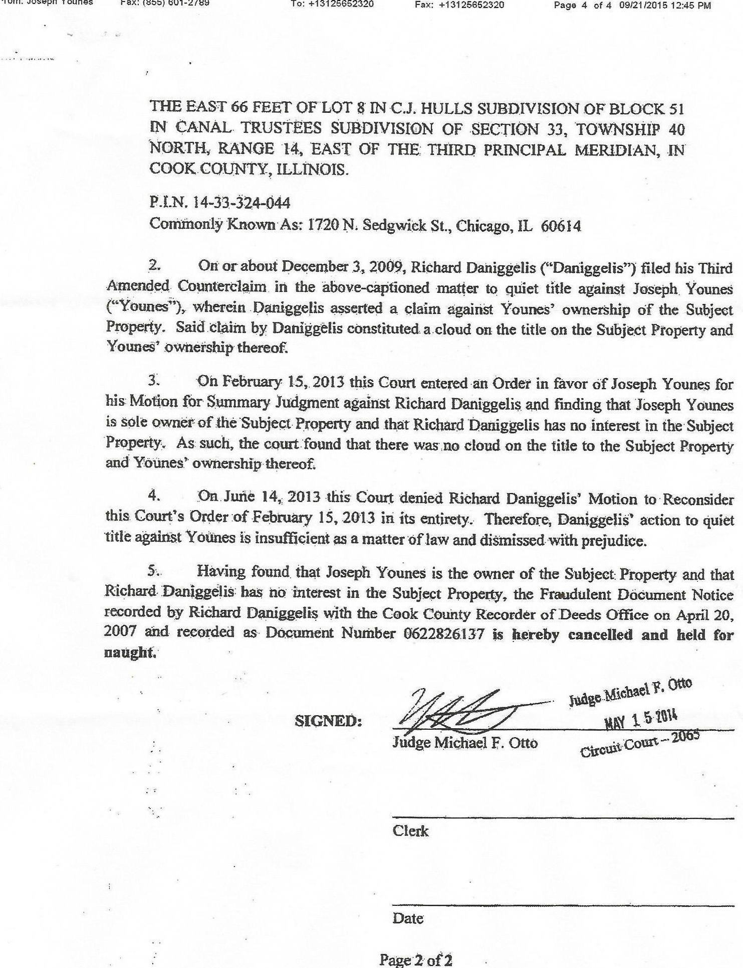
Page 25 of 27 (9-9-2017 Watts filing: GMAC v Daniggelis, Watts, Younes, et al 2007-CH-29738)
GMAC v Daniggelis, Watts, Younes, et al., 2007-CH-29738 (Transfer to Law Division)

GENERAL ORDER NO. 1.2,2.1 – County Department (excerpt, in relevant part) Exhibit-G

GENERAL ORDER NO. 1.2,2.1 - County Department

The County Department is composed of the following divisions:
(a) - Law Division
(1) The Law Division hears civil actions at law, whether or not a jury is demanded, except:
(i) Actions filed in Municipal District One with complaints or counterclaims for compensatory and consequential money damages not in
excess of $30,000 unless a tax claim in excess of $3,000 is involved;
(ii) Actions filed in Municipal Districts Two, Three, Four, Five or Six with complaints or counterclaims for compensatory and consequential
money damages not in excess of $100,000 unless a tax claim in excess of $3,000 is involved;
(iii) Actions for the recovery of property of a value not in excess of $30,000 filed in Municipal District One;
(iv) Action for the recovery of property of a value not in excess of $100,000 filed in Municipal Districts Two, Three, Four, Five and Six;
(v) Actions of forcible entry and detainer;
(vi) Actions arising under the Parentage Act of 1984, as amended (750 ILCS 45/1 et seq.);
(vii) Actions brought under the Land Titles Act of 1897, as amended.
(2) The amount of punitive damages sought may be considered in determining whether an action filed in the Law Division shall remain in
the Law Division if the court, in its discretion, finds a reasonable likelihood of proving facts at trial sufficient to support a substantial award
of punitive damages.
(3) The Law Division consists of the following sections:
(i) Motion Section;...

Page 26 of 27 (9-9-2017 Watts filing: GMAC v Daniggelis, Watts, Younes, et al 2007-CH-29738)

GMAC v Daniggelis, Watts, Younes, et al., 2007-CH-29738 (Transfer to Law Division)

Screenshot of the docket in the above-captioned case Exhibit-H

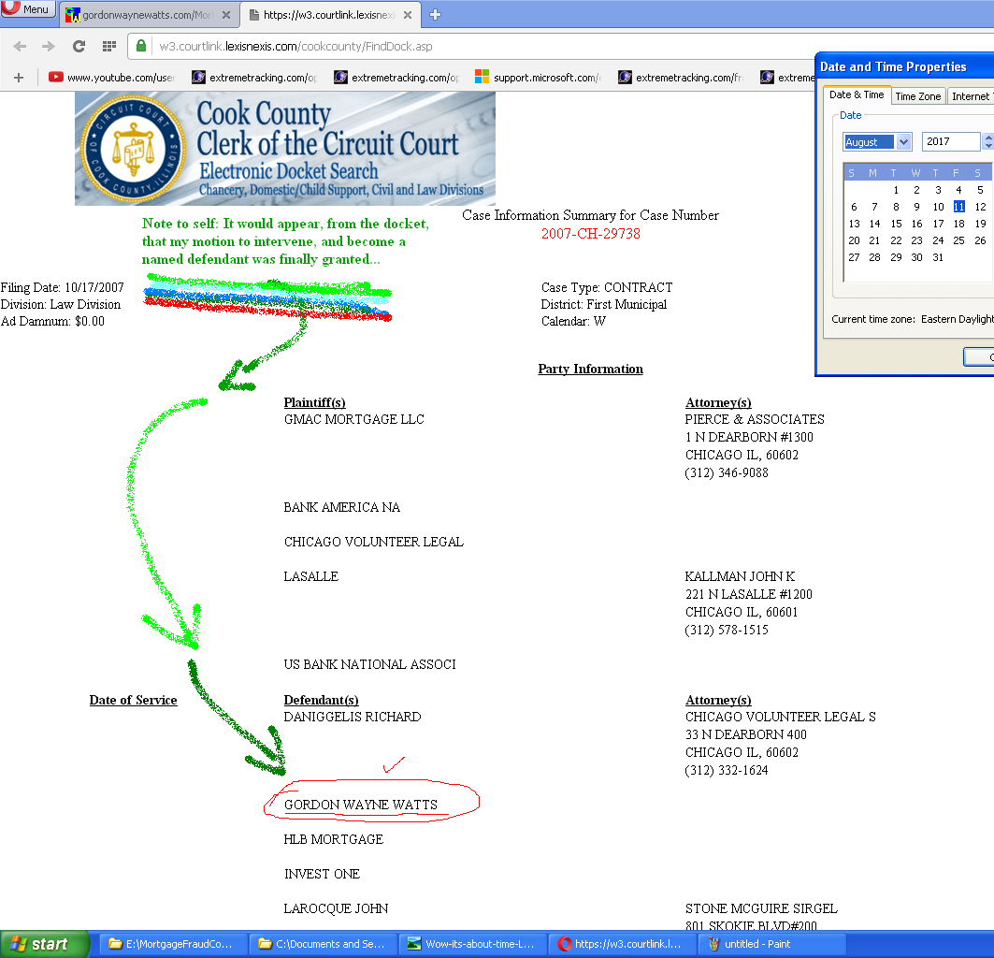

Page 27 of 27 (9-9-2017 Watts filing: GMAC v Daniggelis, Watts, Younes, et al 2007-CH-29738)

