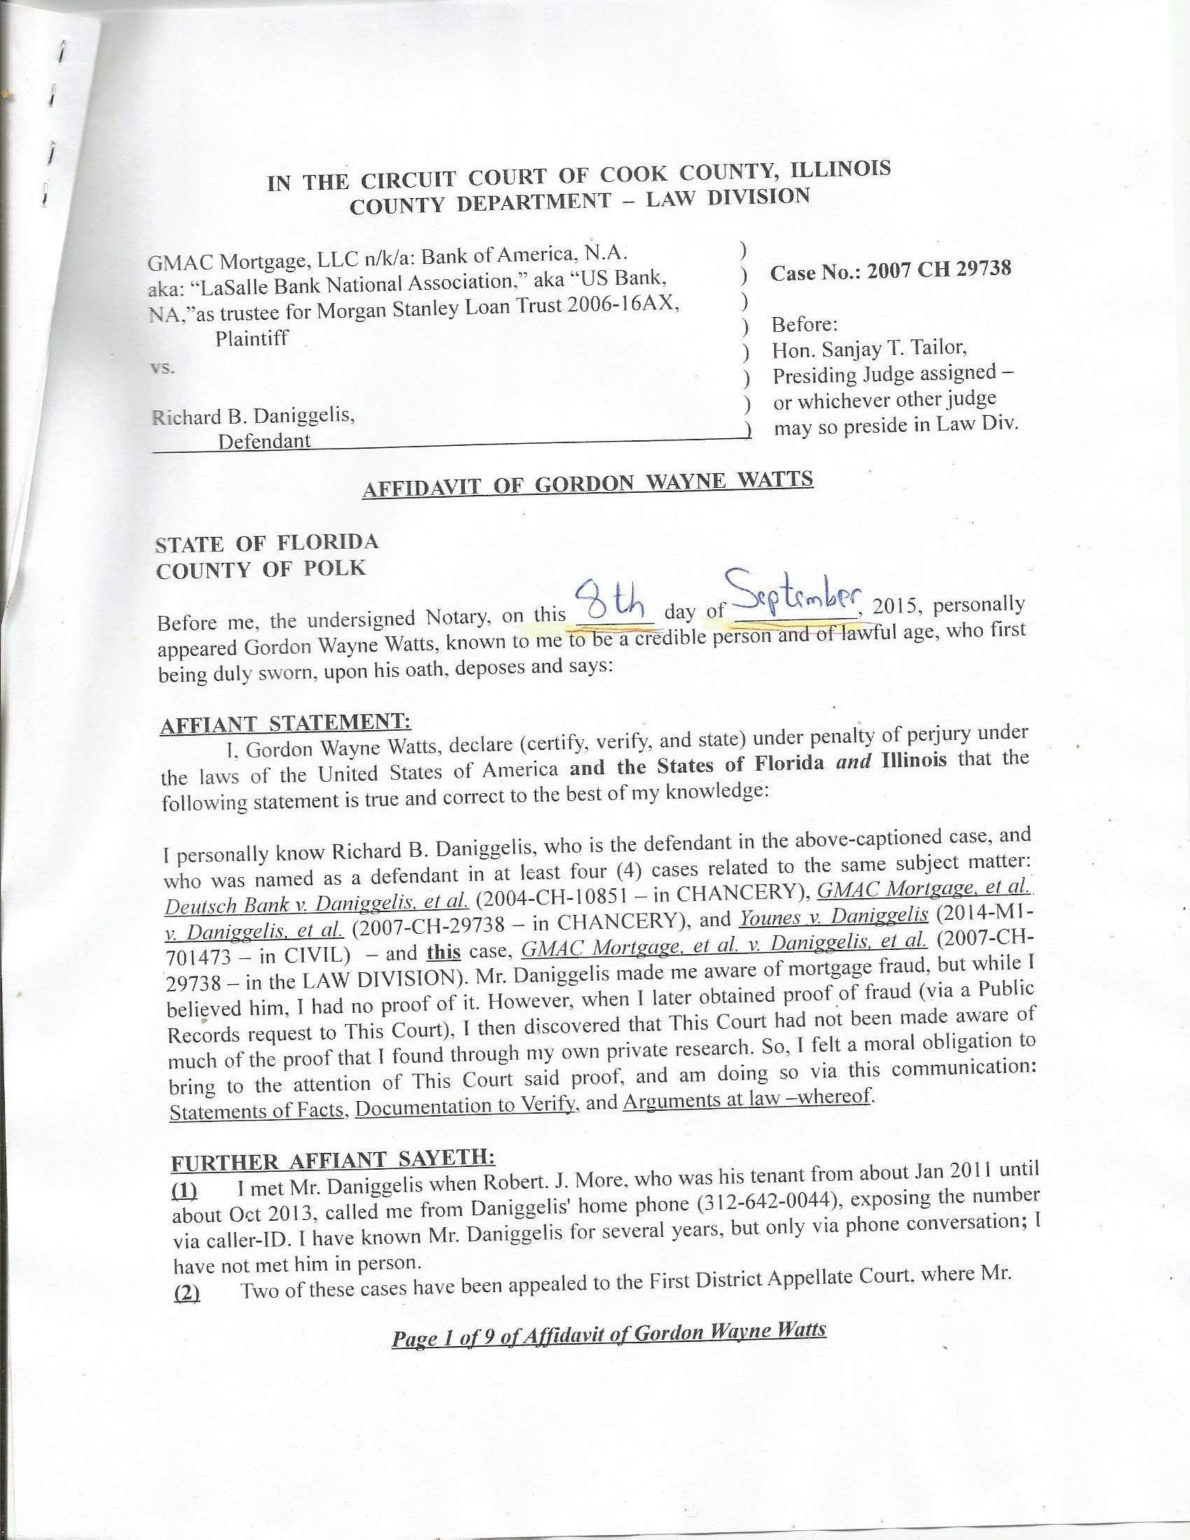
IN THE CIRCUIT COURT OF COOK COUNTY, ILLINOIS
COUNTY DEPARTMENT – LAW DIVISION

GMAC Mortgage, LLC n/k/a: Bank of America, N.A. )
aka: “LaSalle Bank National Association,” aka “US Bank, ) Case No.: 2007 CH 29738
NA,”as trustee for Morgan Stanley Loan Trust 2006-16AX, )
Plaintiff ) Before:
vs. ) Hon. Sanjay T. Tailor,
) Presiding Judge assigned –
Richard B. Daniggelis, ) or whichever other judge
Defendant ) may so preside in Law Div.

AFFIDAVIT OF GORDON WAYNE WATTS

STATE OF FLORIDA
COUNTY OF POLK

Before me, the undersigned Notary, on this _______ day of ___________, 2015, personally appeared Gordon Wayne Watts, known to me to be a credible person and of lawful age, who first being duly sworn, upon his oath, deposes and says:

AFFIANT STATEMENT:
I, Gordon Wayne Watts, declare (certify, verify, and state) under penalty of perjury under the laws of the United States of America and the States of Florida and Illinois that the following statement is true and correct to the best of my knowledge:

I personally know Richard B. Daniggelis, who is the defendant in the above-captioned case, and who was named as a defendant in at least four (4) cases related to the same subject matter: Deutsch Bank v. Daniggelis, et al. (2004-CH-10851 – in CHANCERY), GMAC Mortgage, et al. v. Daniggelis, et al. (2007-CH-29738 – in CHANCERY), and Younes v. Daniggelis (2014-M1-701473 – in CIVIL) – and this case, GMAC Mortgage, et al. v. Daniggelis, et al. (2007-CH-29738 – in the LAW DIVISION). Mr. Daniggelis made me aware of mortgage fraud, but while I believed him, I had no proof of it. However, when I later obtained proof of fraud (via a Public Records request to This Court), I then discovered that This Court had not been made aware of much of the proof that I found through my own private research. So, I felt a moral obligation to bring to the attention of This Court said proof, and am doing so via this communication: Statements of Facts, Documentation to Verify, and Arguments at law –whereof.

FURTHER AFFIANT SAYETH:
(1) I met Mr. Daniggelis when Robert. J. More, who was his tenant from about Jan 2011 until about Oct 2013, called me from Daniggelis' home phone (312-642-0044), exposing the number via caller-ID. I have known Mr. Daniggelis for several years, but only via phone conversation; I have not met him in person.
(2) Two of these cases have been appealed to the First District Appellate Court, where Mr.

Page 1 of 9 of Affidavit of Gordon Wayne Watts
Daniggelis is being represented pro bono by Attorney Andjelko Galic, another good friend of mine. At last check, the record on appeal was not timely submitted by Atty. Galic, in either appeals case (probably due to his heavy workload), and both of Daniggelis' appeals are (I'm guessing) in jeopardy of being dismissed for want of prosecution. [[Update: Since my earlier affidavit in the sister cases, I was informed by the First Appellate Court that one of the appeals, 1-15-0662, Younes v. Daniggelis, was indeed dismissed for want of prosecution, as I had feared. That case is still in grave jeopardy as I speak –and pending on motion for reinstatement by Daniggelis' attorney of record, Mr. Galic. My request to intervene as both an Amicus Curiae and also an interested party (non-record claimant prospective / heir-legatee), was time-stamped earlier than the dismissal, and my motions are also being reviewed; however my motions, being nunc pro tunc, due to the time-stamp, as guaranteed by Illinois Supreme Court Rule 373 (Date of Filing Papers in Reviewing Court; Certificate or Affidavit of Mailing) are timely, and not late as with Mr. Galic's filings.]]

(3) I rarely litigate (since I'm not a lawyer), but I feel that This Honourable Court should probably know about one case in which I participated, because it is relevant to my credibility to make legal arguments in Daniggelis' case:

* In Re: GORDON WAYNE WATTS (as next friend of THERESA MARIE 'TERRI' SCHIAVO), No. SC03-2420 (Fla. Feb.23, 2005), denied 4-3 on rehearing. (Watts got 42.7% of his panel) http://www.floridasupremecourt.org/clerk/dispositions/2005/2/03-2420reh.pdf
* In Re: JEB BUSH, GOVERNOR OF FLORIDA, ET AL. v. MICHAEL SCHIAVO, GUARDIAN: THERESA SCHIAVO, No. SC04-925 (Fla. Oct.21, 2004), denied 7-0 on rehearing. (Bush got 0.0% of his panel before the same court) http://www.floridasupremecourt.org/clerk/dispositions/2004/10/04-925reh.pdf
* Schiavo ex rel. Schindler v. Schiavo ex rel. Schiavo, 403 F.3d 1223, 2005 WL 648897 (11th Cir. Mar.23, 2005), denied 2-1 on appeal. (Terri Schiavo's own blood family only got 33.3% of their panel on the Federal Appeals level) http://media.ca11.uscourts.gov/opinions/pub/files/200511556.pdf

(4) As shown above, I almost won 'the' “Terri Schiavo” case – all by myself – and on the merits (it got past the clerk, who rules on technical issues, and was presented to the full court on the merits). I almost won, doing better than all others on our side combined. I am not mentioning this to brag[**], but rather merely to assure This Court that, while I am not a lawyer, I do know something of law, and thus “may be of considerable help to the Court,” as R.37.1 of the U.S. Supreme Court states regarding Amicus Curiae briefs. [**]This was a double miracle: not only my skill but even more-so my faith or courage to proceed against impossible odds and strong opposition in a highly controversial public case.

(5) My Interests: Not only is Daniggelis a personal friend of mine, but moreover, even were he a total stranger, I would be outraged at the injustices here, once I realised what happened. I am only one person (and thereby limited in all respects), but I feel that one person can make a difference.
Page 2 of 9 of Affidavit of Gordon Wayne Watts
(6) I am the sole author of this affidavit, the accompanying proposed Amicus Curiae brief, and the related motion for leave to file and notice thereof.

(7) The following chronology of the facts is true and correct to the best of my knowledge, based on both lengthy conversations I've had with Daniggelis, and also based my own research (Public Records requests from your court, etc.) to verify his assertions of fact:

The property which is the subject of all this litigation, 1720 N. Sedgwick St., Chicago IL 60614, is a house and land which was in Daniggelis' family for many years, and, at some point, passed down to him, with him as the sole owner. [[Correction and/or clarification: In an earlier version of this affidavit, which I had filed in the Chancery case, bearing the same case-file number, I used the phrase “passed down to him, with him as the sole owner,” as you see above. While this over-broad “passed down to him” language seemed technically correct to me, given that I did not know the details of how it was “passed down” (inheritance, gift, purchase, buyout, etc.?), when speaking with Mr. Daniggelis by phone recently, he said this was imprecise and an inaccurate description: He claims that he bought out the shares of other relatives, thus gaining ownership of his house. I shall leave the original language in for purposes of consistency with my prior filing –and transparency, admitting my grammatical snafu here; however: Let this notice serve as a correction to all prior versions filed in both the 2007-CH-29738 Chancery “sister case” and the other related case, 2014-M1-701473, Younes v. Daniggelis. – My apologies for any distractions that may dilute from my affidavit regarding these very grave injustices.]]
At some later point, Daniggelis became overwhelmed with the combined financial burden of the upkeep and, particularly, the payments, since it is an expensive house, and he was the sole owner. Subsequently, he put an ad in the paper to seek help, either for refinancing, investors, tenets, and/or repairs in exchange for reduced rent. (The details and timing of his requests are of
Page 3 of 9 of Affidavit of Gordon Wayne Watts
no import: The only thing that matters is who responded and what transpired.) On 7/8/2004, the bank filed a complaint (Deutsch Bank v. Daniggelis, et al. 2004-CH-10851) against him for mortgage foreclosure. After proceeding pro se for a while, he retained Attorney JosephYounes to represent him [see note of possible scrivener's error, below] against the bank. On 8/9/2006, the bank moved This Court to dismiss, claiming, inter alia, that Daniggelis paid off the subject loan, and Judge Robert Quinn granted and dismissed. That case is not being appealed.
[[NOTE: I referred to Joseph Younes as having represented Daniggelis as his lawyer in prior versions of this affidavit, whose language I am keeping, above. This claim was based on the “NOTICE OF MOTION,” docketed on June 23, 2006 in Deutch Bank Nat'l v. Daniggelis, NO. 04-CH-10851, wherein Younes entered an appearance for Daniggelis. However, when I recently spoke by phone with Daniggelis, he complained that my statement on that head was an “inaccuracy,” and was very angry with me insofar as he claimed that Younes was never his lawyer. For the purposes of verification, I, Gordon Wayne Watts, now state, assert, and certify under penalties of perjury as provided by law pursuant to 735 ILCS 5/1-109 (Sec. 1-109. Verification by certification.), that Richard Daniggelis, the defendant in this case, did indeed tell me this. THEREFORE, I may, possibly, have made a 'Scrivener's Error' in my claims that Younes was Daniggelis' lawyer. I do not know what actually transpired; I only know what I see in Younes' Notice and what Daniggelis told me, and I suspect that there was either an honest misunderstanding on the part of both men –or, in the alternative, perhaps Younes entered an appearance without Daniggelis' authorisation and permission. But, I presume both men to be innocent until proven guilty, and infer an honest understanding here. Nonetheless, I feel this should be “looked into” further, and therefore am mentioning it now.]]
Page 4 of 9 of Affidavit of Gordon Wayne Watts
On 10/17/2007, GMAC Mortgage filed a complaint (GMAC Mortgage, et al. v. Daniggelis, et al. 2007-CH-29738) against Daniggelis to foreclose, apparently a result of subsequent financial distress, and apparently, US BANK NATIONAL ASSN subsequently purchased the loan and sought to continue to pursue foreclosure under subrogation. Robert J. More, an acquaintance of mine, was staying with Daniggelis from about Jan 2011 until about Oct 2013, for little or no rent, and he did light chores and research to help Daniggelis. (Mr. More introduced Mr. Daniggelis to both myself and Attorney Andjelko Galic, who currently represents Daniggelis. It is my understanding that, although More stayed with him, nonetheless, Mr. Daniggelis was unable to attract any “regular” paying tenants, due to the dark cloud that hung over the title, and the foreclosure proceedings –and the subsequent mortgage fraud, described elsewhere, which instability probably scared off prospective paying tenants.) When Plaintiffs named defendants, they included Mr. More, apparently in response to More's filing numerous pleadings in this case, starting with the 6/21/2013 “INCOMING CORRESPONDENCE FILED,” which he filed pro se. More's name is misspelled on the docket as 'Moore,' but the correct spelling is 'More.' Robert J. More is also trespassed from this Court House, and must have an escort to conduct business. Moreover, he is a restricted filer in this and other courts, based on allegations of being a vexatious litigant. However, More has told me that he has a legal right to intervene in this case, as he has an interest that is not being represented by any of the parties, since, according to More, Mr. Daniggelis may owe him some consideration for his research assistance and for putting him in touch with Atty. Galic. Because of this, and his prior presence on the service list in this case (2007-CH-29738), I am including him on the service list today. Lastly, while More probably does warrant censure of vexatious litigant restrictions (due to the
Page 5 of 9 of Affidavit of Gordon Wayne Watts
incoherence in his filings), I will go on record as stating that More is a legal genius, a virtual walking case-law Encyclopædia, a savant on the order of “Rain man,” the famous 1988 movie starring American actor, Dustin Hoffman. Thus, I feel that Mr. More may have something to offer This Court in the way of legal analyses.
On 7/16/2008, Chicago Volunteer Legal Service entered an appearance for Daniggelis, but did not represent Daniggelis' claims after 1/20/2010. Plaintiffs filed multiple motions for This Court to dismiss, and said motions were eventually granted. On April 20, 2007, Daniggelis executed a Fraudulent Document Notice to both the Cook County Recorder's office (doc number: 0711039132, on 4/20/2007) and to This Court (exhibit 'F' of the July 30, 2008 filing by Atty. Benji Philips) that the July 09, 2006 Warranty Deed (doc no: 0622826137 at the Recorder's Office, on 8/16/2006) was a forgery. Daniggelis made this declaration (thereby placing a cloud on the title), but did not offer substantive proof (duplicate signatures, etc.) as I am doing now. On 4/8/2011, Atty. Galic entered an appearance for Daniggelis, apparently to replace Chicago Volunteer Legal Service. On 02/15/2013, Judge Michael F. Otto, in this case (GMAC, et al., vs. Daniggelis, et al., 2007-CH-29738), in the CHANCERY DIVISION (not this LAW DIVISION case), entered an order in favour of Younes upon his Motion for Summary Judgment and held, as a finding of law, that Younes was sole owner of the property in question and that Daniggelis had no legal interest in said property, thereby clearing the cloud that was on the title. For reasons that are not clear to me, on 8/12/2014, Judge Moshe Jacobius entered an order transferring this case to the Law Division (this case, that is). Galic made a late appeal to the First Appellate Court, of the CHANCERY DIVISION case with this same case number –which appeal was denied, but appealed to the Illinois Supreme Court, which, on 03/25/2015, entered the
Page 6 of 9 of Affidavit of Gordon Wayne Watts
following order: “In the exercise of this Court's supervisory authority, the Appellate Court, First District, is directed to vacate its order in GMAC Mortgage, LLC v. Daniggelis, case No. 1-14-2751 (09/24/14), denying Richard Daniggelis leave to file a late notice of appeal. The appellate court is instructed to allow Richard Daniggelis to file a late notice of appeal and hear the case.” (27 N.E.3d 610 (2015)) That case is pending before the appeals court in case #:1-14-2751. (This case, in the LAW DIVISION, so far as I see, however, has not been appealed.)
On 01/22/2014, Attorney Joseph Younes, who had previously represented Daniggelis in the 2004 foreclosure case, supra, filed a F.E.D. (FORCIBLE ENTRY AND DETAINER) case against Daniggelis in the Civil Division (Younes vs. Daniggelis, 2014-M1-701473). This was well before the 08/12/2014 order of Judge Moshe Jacobius, transferring this case to the Law Division.
On 01/27/2015, and after much litigation that did not include key findings of fact which I found (detailed in the attached Amicus Curiae brief), Judge George Scully entered an ORDER FOR POSSESSION in Younes vs. Daniggelis, 2014-M1-701473 – apparently in response to Judge Otto's 02/15/2013 finding in GMAC, et al., vs. Daniggelis, et al., 2007-CH-29738 that Younes was sole owner. On 2/26/2015, Galic filed a notice of appeal to the First Appellate Court in Younes v. Daniggelis, case No. 1-15-0662, and the appeal is pending filing of the record. On 7/2/2015, Judge Diane Rosario entered an order extending the time for enforcement of Judge Scully's order. The Sheriff's Department served an eviction notice to enforce Scully's order, and, at last check, when completing the prior versions of this affidavit, Daniggelis was in the process of removing his belongings with the help of some employees of Younes.
Subsequent to the prior affidavit I filed in the related cases, Daniggelis was evicted, and,
Page 7 of 9 of Affidavit of Gordon Wayne Watts
at last check, Daniggelis, an elderly seventy-six (76) year-old man, was homeless and living on the streets, except on some occasions where he was able to afford a rental van, into the which he slept, according to conversations I have had with him, tho I do not know specific details.
Since I filed the earlier versions of this affidavit of fact, besides the homelessness jeopardy mentioned above, three (3) other key developments have transpired: First, This Court lost or otherwise misplaced my request to supplement the record on appeal, even tho FedEx shows it was received and signed for by the same person who received the earlier items on docket in the sister cases. Secondly, after I heard reports from Daniggelis of a possible attempt by Younes to destroy the house (and thus “moot” the appeal), I made contact with a professional photographer in Chicago, and he took photos documenting a Stop Work order by City Code, which I am sure would not be necessary had no illegal demolition or construction been going on. (I am not accusing Younes of anything intentional or malicious, but it is what it is, and I document my strong claims.) Thirdly, and lastly, after all was said and done, I was made aware of the presence of case number: GMAC v. Daniggelis, 2007-CH-29738 in this LAW DIVISION as being a separate and distinct case –different from the case in CHANCERY by the same case number and style.
Since I fear for the life and health of my homeless, elderly friend, Mr. Daniggelis, and am certain that forgery fraud was committed (after seeing two identical signatures, “damning proof” of a photocopy of signature forgery), then I felt a moral (and legal) obligation to update my affidavit and submit it –along with arguments at law, and documents to verify –to This Honourable Court, and hope that my plebeian status {{as a “non-lawyer” who is not rich, and who is out-of-state –and thus unable to attend any court hearing, 'in-person,' to present any
Page 8 of 9 of Affidavit of Gordon Wayne Watts
motions}} would not be used as an 'excuse' to abrogate or deny justice, Equal Protection, Due Process, or an otherwise fair review of my concerns that laws were egregiously, and intentionally, broken.

FURTHER AFFIANT SAYETH NAUGHT.

_________________________________
Gordon Wayne Watts, Affiant
STATE OF FLORIDA
COUNTY OF POLK

The foregoing instrument was acknowledged, subscribed, and sworn before me this _____ day of ___________, 2015, by GORDON WAYNE WATTS, Affiant, who ( is / is not ) personally known to me, who ( did / did not ) produce identification as shown below, and who ( did / did not ) take an oath.

IDENTIFICATION TYPE: ______________________________________________

IDENTIFICATION NUMBER: (*) ___________________________________________

(*) In compliance with Rule 138, ILLINOIS SUPREME COURT RULES, “Personal Identity Information” (b)(2), “driver’s license numbers,” I am not including my full Driver's License Number. However, in accordance with Rule 138 (c)(2), “A redacted filing of personal identity information for the public record is permissible and shall only include: the last four digits of the driver’s license number.” Therefore, I am asking This Notary to use only the last 4 digits.
See: http://www.IllinoisCourts.gov/supremecourt/rules/art_ii/artii.htm

Notary Public: ____________________________________ Date: ________________

(Notary Stamp) My Commission Expires: ______________

Page 9 of 9 of Affidavit of Gordon Wayne Watts
