NO. 1-14-2751
Trial Court No.: 2007 CH 29738

IN THE APPELLATE COURT OF ILLINOIS
FIRST DISTRICT

GMAC Mortgage, LLC n/k/a: Bank of America, N.A. aka: )
“LaSalle Bank National Association,” aka “US Bank, NA,” )
as trustee for Morgan Stanley Loan Trust 2006-16AX, )
)
Plaintiff )
vs. )
)
Richard B. Daniggelis, )
Defendant )

SUPPORTING RECORD FOR Motion to Supplement Record Instanter
PURSUANT TO SUPREME COURT RULE 328 AND OTHER RELIEF

Pursuant to RULE 324, In lieu of renumbering the pages of exhibits, a list of exhibit numbers shall be provided:

Public Records Requests by Gordon Wayne Watts..........................S.R. 1

06/30/2014 Public Records Request S.R. 1-A

06/30/2014 Public Records Request (zoom view) S.R. 1-B

07/16/2015 Public Records Reply S.R. 1-C

07/16/2015 Public Records Reply (zoom view) S.R. 1-D

Documentation of Docketing in Trial Court.....................................S.R. 2

Clerk stamp for a filing in 2007-CH-29738 S.R. 2-A

Clerk stamp for a filing in 2014-M1-701473 (not available: court did not provide it as yet)

Docket Screen-shot for 2007-CH-29738 S.R. 2-B

Docket Screen-shot for 2014-M1-701473 S.R. 2-C

AFFIDAVIT OF GORDON WAYNE WATTS.................................S.R. 3

Notice of Motion..................................................................................S.R. 4

AMICUS CURIAE BRIEF OF GORDON WAYNE WATTS
IN SUPPORT OF DEFENDANT / APPELLANT, RICHARD B.
DANIGGELIS (with requisite motion for leave to file)...................S.R. 5

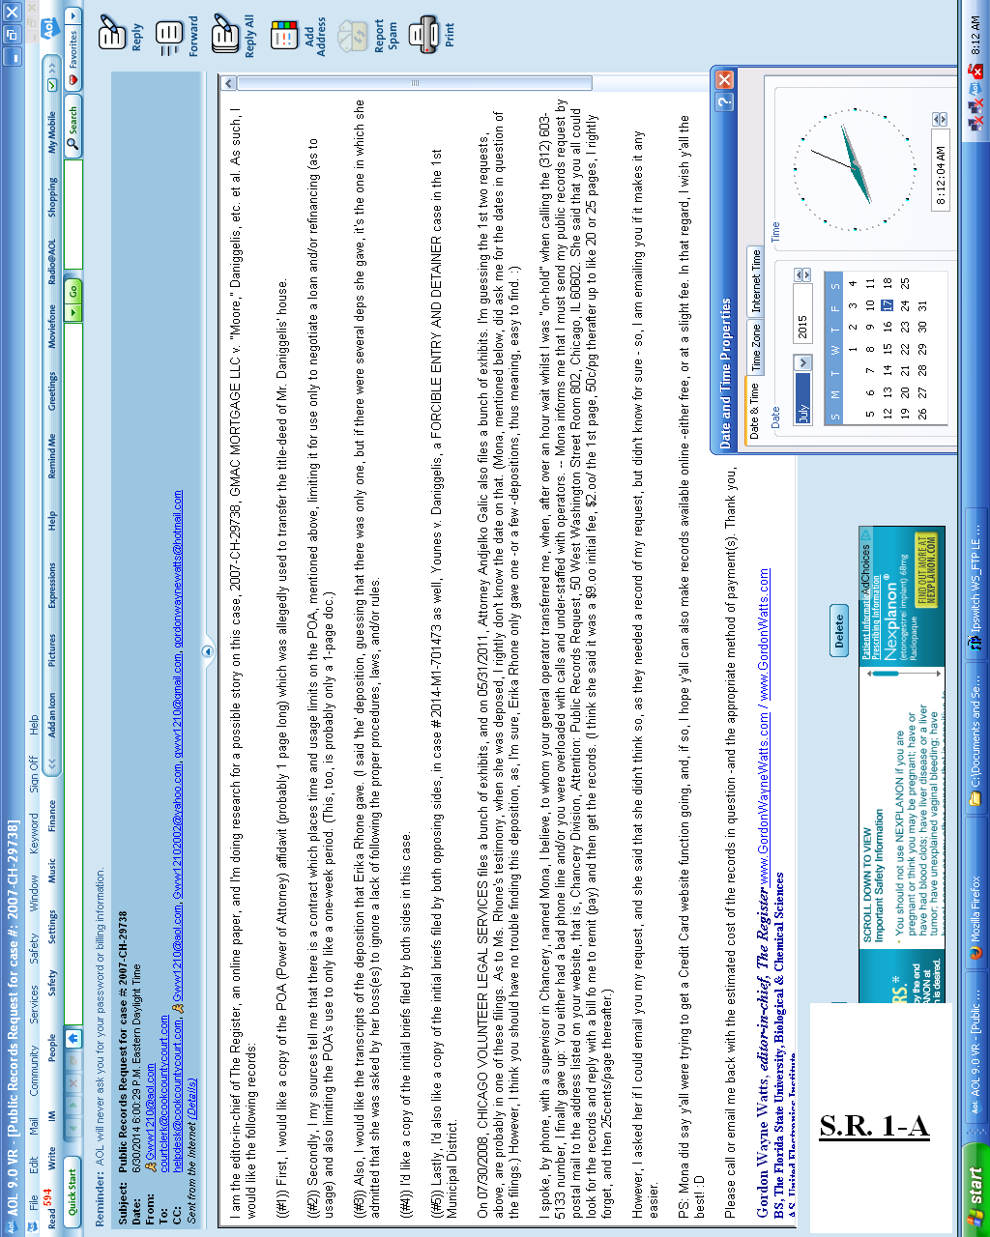

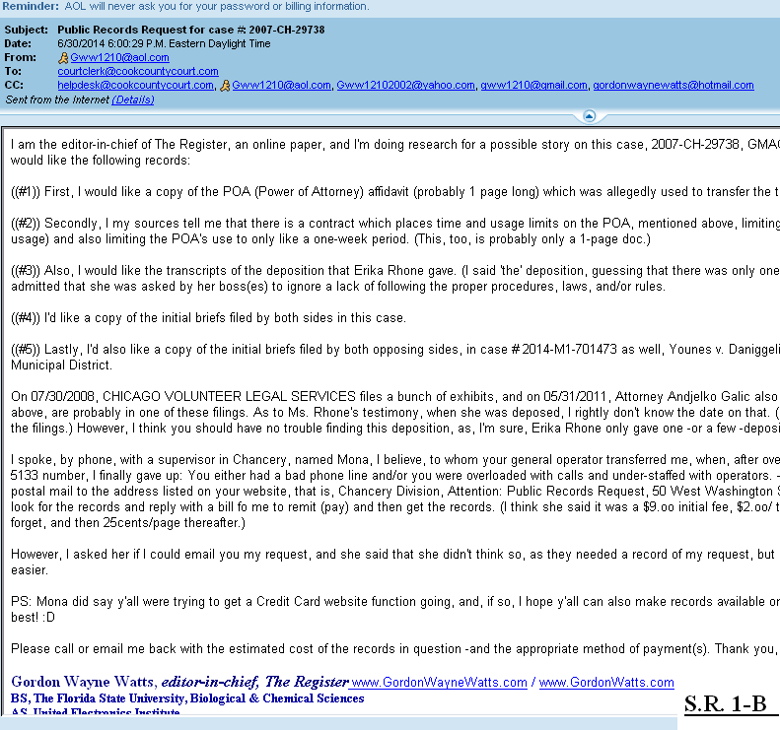

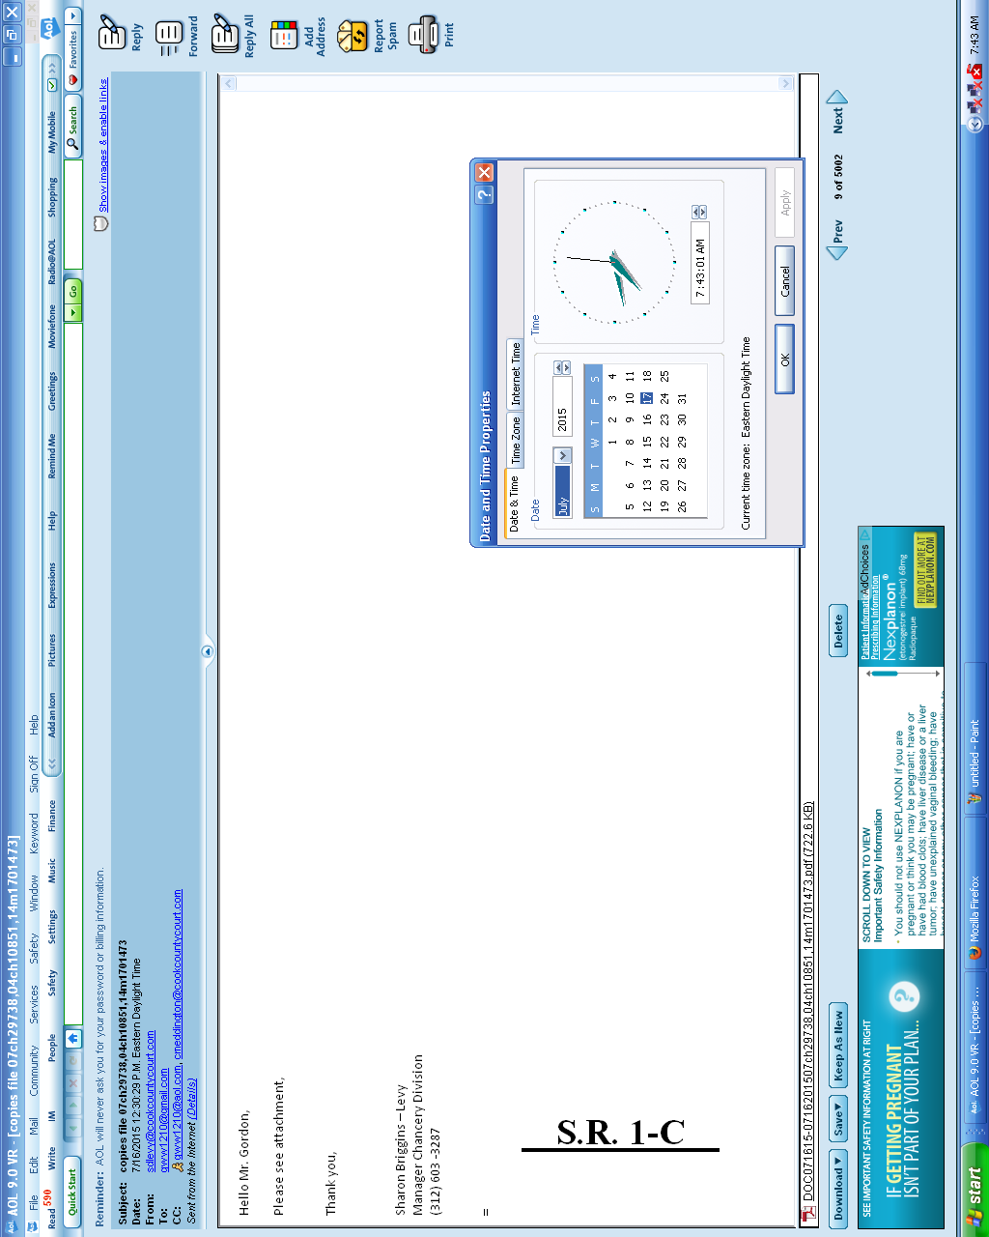

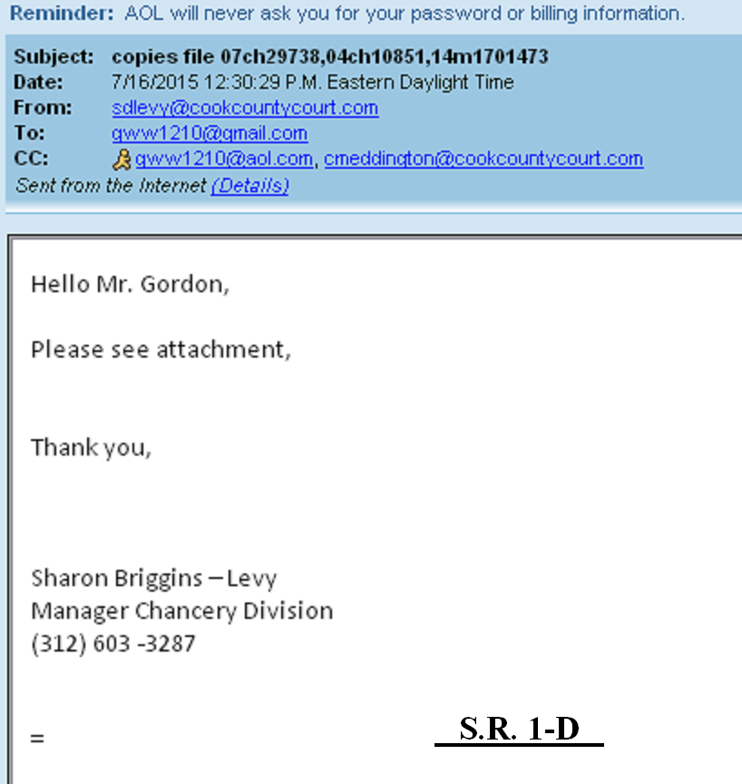

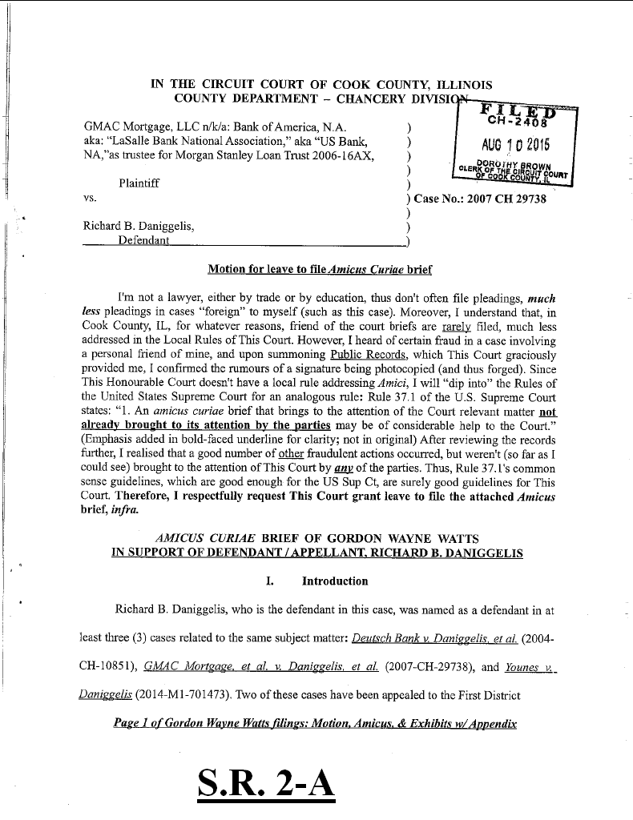

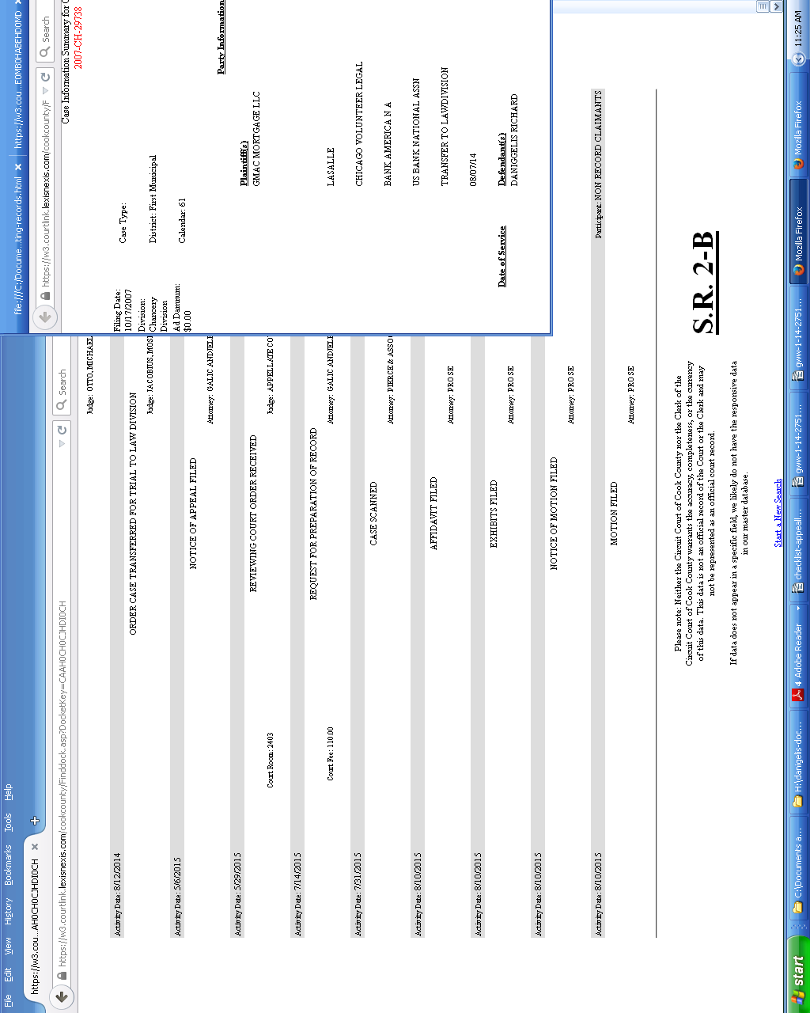

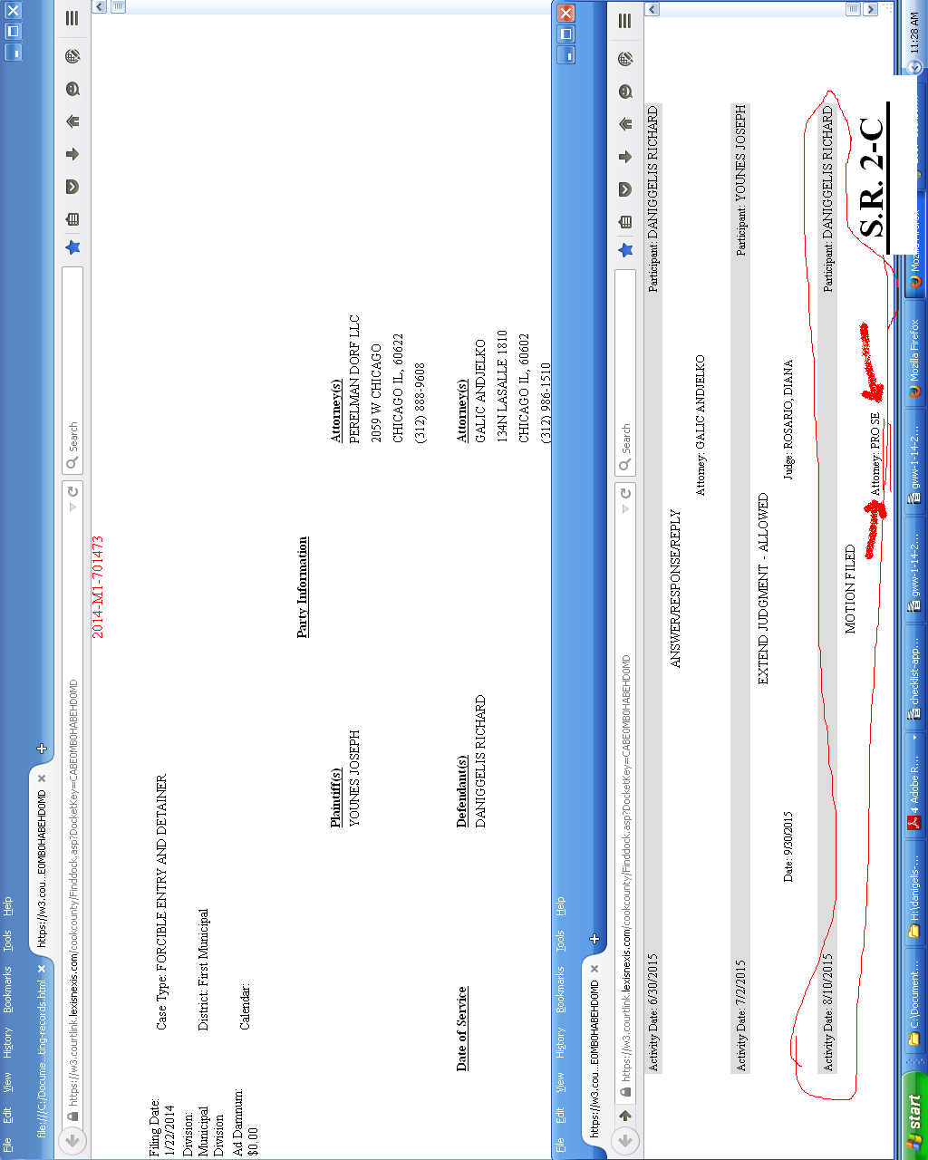

AFFIDAVIT OF GORDON WAYNE WATTS.................................S.R. 3

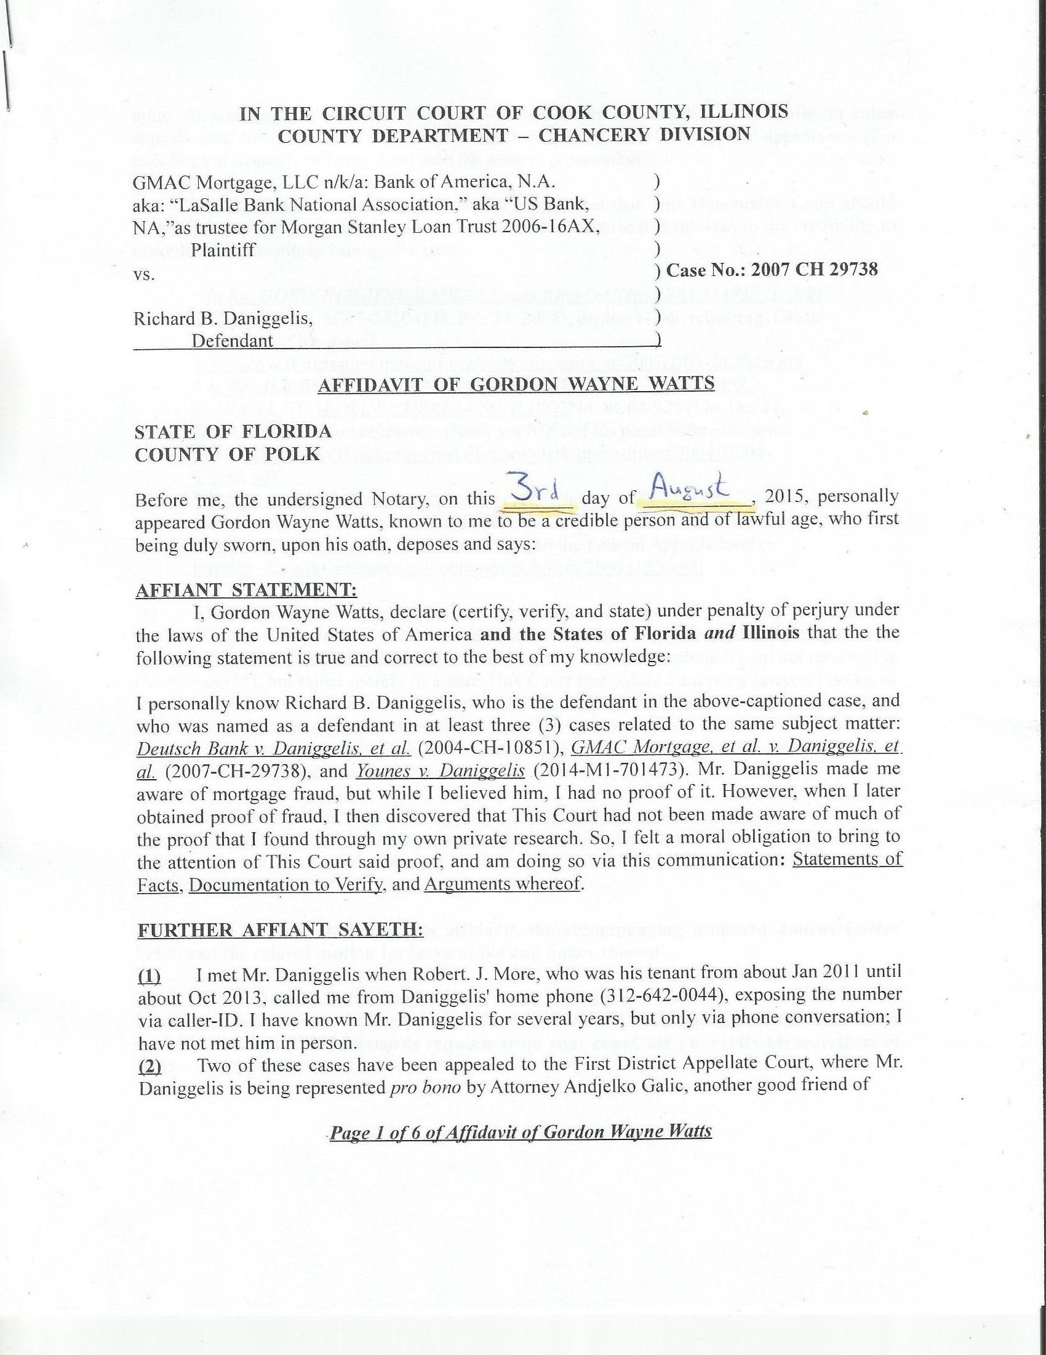

IN THE CIRCUIT COURT OF COOK COUNTY, ILLINOIS
COUNTY DEPARTMENT – CHANCERY DIVISION

GMAC Mortgage, LLC n/k/a: Bank of America, N.A. )
aka: “LaSalle Bank National Association,” aka “US Bank, )
NA,”as trustee for Morgan Stanley Loan Trust 2006-16AX, )
Plaintiff )
vs. ) Case No.: 2007 CH 29738
)
Richard B. Daniggelis, )
Defendant )

AFFIDAVIT OF GORDON WAYNE WATTS

STATE OF FLORIDA
COUNTY OF POLK

Before me, the undersigned Notary, on this _______ day of ___________, 2015, personally appeared Gordon Wayne Watts, known to me to be a credible person and of lawful age, who first being duly sworn, upon his oath, deposes and says:

AFFIANT STATEMENT:
I, Gordon Wayne Watts, declare (certify, verify, and state) under penalty of perjury under the laws of the United States of America and the States of Florida and Illinois that the the following statement is true and correct to the best of my knowledge:

I personally know Richard B. Daniggelis, who is the defendant in the above-captioned case, and who was named as a defendant in at least three (3) cases related to the same subject matter: Deutsch Bank v. Daniggelis, et al. (2004-CH-10851), GMAC Mortgage, et al. v. Daniggelis, et al. (2007-CH-29738), and Younes v. Daniggelis (2014-M1-701473). Mr. Daniggelis made me aware of mortgage fraud, but while I believed him, I had no proof of it. However, when I later obtained proof of fraud, I then discovered that This Court had not been made aware of much of the proof that I found through my own private research. So, I felt a moral obligation to bring to the attention of This Court said proof, and am doing so via this communication: Statements of Facts, Documentation to Verify, and Arguments whereof.

FURTHER AFFIANT SAYETH:

(1) I met Mr. Daniggelis when Robert. J. More, who was his tenant from about Jan 2011 until about Oct 2013, called me from Daniggelis' home phone (312-642-0044), exposing the number via caller-ID. I have known Mr. Daniggelis for several years, but only via phone conversation; I have not met him in person.
(2) Two of these cases have been appealed to the First District Appellate Court, where Mr. Daniggelis is being represented pro bono by Attorney Andjelko Galic, another good friend of

Page 1 of 6 of Affidavit of Gordon Wayne Watts
mine. At last check, the record on appeal was not timely submitted by Atty. Galic, in either appeals case (probably due to his heavy workload), and both of Daniggelis' appeals are (I'm guessing) in jeopardy of being dismissed for want of prosecution.

(3) I rarely litigate (since I'm not a lawyer), but I feel that This Honourable Court should probably know about one case in which I participated, because it is relevant to my credibility to make legal arguments in Daniggelis' case:

* In Re: GORDON WAYNE WATTS (as next friend of THERESA MARIE 'TERRI' SCHIAVO), No. SC03-2420 (Fla. Feb.23, 2005), denied 4-3 on rehearing. (Watts got 42.7% of his panel) http://www.floridasupremecourt.org/clerk/dispositions/2005/2/03-2420reh.pdf
* In Re: JEB BUSH, GOVERNOR OF FLORIDA, ET AL. v. MICHAEL SCHIAVO, GUARDIAN: THERESA SCHIAVO, No. SC04-925 (Fla. Oct.21, 2004), denied 7-0 on rehearing. (Bush got 0.0% of his panel before the same court) http://www.floridasupremecourt.org/clerk/dispositions/2004/10/04-925reh.pdf
* Schiavo ex rel. Schindler v. Schiavo ex rel. Schiavo, 403 F.3d 1223, 2005 WL 648897 (11th Cir. Mar.23, 2005), denied 2-1 on appeal. (Terri Schiavo's own blood family only got 33.3% of their panel on the Federal Appeals level) http://media.ca11.uscourts.gov/opinions/pub/files/200511556.pdf

(4) As shown above, I almost won 'the' “Terri Schiavo” case – all by myself – and on the merits (it got past the clerk, who rules on technical issues, and was presented to the full court on the merits). I almost won, doing better than all others on our side combined. I am not mentioning this to brag[**], but rather merely to assure This Court that, while I am not a lawyer, I do know something of law, and thus “may be of considerable help to the Court,” as R.37.1 of the U.S. Supreme Court states regarding Amicus Curiae briefs. [**]This was a double miracle: not only my skill but even more-so my faith or courage to proceed against impossible odds and strong opposition in a highly controversial public case.

(5) My Interests: Not only is Daniggelis a personal friend of mine, but moreover, even were he a total stranger, I would be outraged at the injustices here, once I realised what happened. I am only one person (and thereby limited in all respects), but I feel that one person can make a difference.

(6) I am the sole author of this affidavit, the accompanying proposed Amicus Curiae brief, and the related motion for leave to file and notice thereof.

(7) The following chronology of the facts is true and correct to the best of my knowledge, based on both lengthy conversations I've had with Daniggelis, and also based my own research (Public Records requests from your court, etc.) to verify his assertions of fact:

Page 2 of 6 of Affidavit of Gordon Wayne Watts
The property which is the subject of all this litigation, 1720 N. Sedgwick St., Chicago IL 60614, is a house and land which was in Daniggelis' family for many years, and, at some point, passed down to him, with him as the sole owner. At some later point, Daniggelis became overwhelmed with the combined financial burden of the upkeep and, particularly, the payments, since it is an expensive house, and he was the sole owner. Subsequently, he put an ad in the paper to seek help, either for refinancing, investors, tenets, and/or repairs in exchange for reduced rent. (The details and timing of his requests are of no import: The only thing that matters is who responded and what transpired.) On 7/8/2004, the bank filed a complaint (Deutsch Bank v. Daniggelis, et al. 2004-CH-10851) against him for mortgage foreclosure. After proceeding pro se for a while, he retained Attorney JosephYounes to represent him against the bank. On 8/9/2006, the bank moved This Court to dismiss, claiming, inter alia, that Daniggelis paid of the subject loan, and Judge Robert Quinn granted and dismissed. That case is not being appealed.
On 10/17/2007, GMAC Mortgage filed a complaint (GMAC Mortgage, et al. v. Daniggelis, et al. 2007-CH-29738) against Daniggelis to foreclose, apparently a result of subsequent financial distress, and apparently, US BANK NATIONAL ASSN subsequently purchased the loan and sought to continue to pursue foreclosure under subrogation. Robert J. More, an acquaintance of mine, was staying with Daniggelis from about Jan 2011 until about Oct 2013, for little or no rent, and he did light chores and research to help Daniggelis. (Mr. More introduced Mr. Daniggelis to both myself and Attorney Andjelko Galic, who currently represents Daniggelis.) When Plaintiffs named defendants, they included Mr. More, apparently in response to More's filing numerous pleadings in this case, starting with the 6/21/2013 “INCOMING CORRESPONDENCE FILED,” which he filed pro se. More's name is misspelled on the docket
Page 3 of 6 of Affidavit of Gordon Wayne Watts
as 'Moore,' but the correct spelling is 'More.' Robert J. More is also trespassed from this Court House, and must have an escort to conduct business. Moreover, he is a restricted filer in this and other courts, based on allegations of being a vexatious litigant. However, More has told me that he has a legal right to intervene in this case, as he has an interest that is not being represented by any of the parties, since, according to More, Mr. Daniggelis may owe him some consideration for his research assistance and for putting him in touch with Atty. Galic. Because of this, and his prior presence on the service list in this case (2007-CH-29738), I am including him on the service list today. Lastly, while More probably does warrant censure of vexatious litigant restrictions (due to the incoherence in his filings), I will go on record as stating that More is a legal genius, a virtual walking case-law Encyclopædia, a savant on the order of “Rain man,” the famous 1988 movie starring American actor, Dustin Hoffman. Thus, I feel that Mr. More may have something to offer This Court in the way of legal analyses.
On 7/16/2008, Chicago Volunteer Legal Service entered an appearance for Daniggelis, but did not represent Daniggelis' claims after 1/20/2010. Plaintiffs filed multiple motions for This Court to dismiss, and said motions were eventually granted. On April 20, 2007, Daniggelis executed a Fraudulent Document Notice to both the Cook County Recorder's office (doc number: 0711039132, on 4/20/2007) and to This Court (exhibit 'F' of the July 30, 2008 filing by Atty. Benji Philips) that the July 09, 2006 Warranty Deed (doc no: 0622826137 at the Recorder's Office, on 8/16/2006) was a forgery. Daniggelis made this declaration (thereby placing a cloud on the title), but did not offer substantive proof (duplicate signatures, etc.) as I am doing now. On 4/8/2011, Atty. Galic entered an appearance for Daniggelis, apparently to replace Chicago Volunteer Legal Service. On 02/15/2013, Judge Michael F. Otto, in this case
Page 4 of 6 of Affidavit of Gordon Wayne Watts
(GMAC, et al., vs. Daniggelis, et al., 2007-CH-29738), entered an order in favour of Younes upon his Motion for Summary Judgment and held, as a finding of law, that Younes was sole owner of the property in question and that Daniggelis had no legal interest in said property, thereby clearing the cloud that was on the title. For reasons that are not clear to me, on 8/12/2014, Judge Moshe Jacobius entered an order transferring this case to the Law Division. Galic made a late appeal to the First Appellate Court, which was denied, but appealed to the Illinois Supreme Court, which, on 03/25/2015, entered the following order: “In the exercise of this Court's supervisory authority, the Appellate Court, First District, is directed to vacate its order in GMAC Mortgage, LLC v. Daniggelis, case No. 1-14-2751 (09/24/14), denying Richard Daniggelis leave to file a late notice of appeal. The appellate court is instructed to allow Richard Daniggelis to file a late notice of appeal and hear the case.” (27 N.E.3d 610 (2015)) This case is pending before the appeals court in case #:1-14-2751.
On 01/22/2014, Attorney Joseph Younes, who had previously represented Daniggelis in the 2004 foreclosure case, supra, filed a F.E.D. (FORCIBLE ENTRY AND DETAINER) case against Daniggelis in the Civil Division (Younes vs. Daniggelis, 2014-M1-701473). This was well before the 08/12/2014 order of Judge Moshe Jacobius, transferring this case to the Law Division.
On 01/27/2015, and after much litigation that did not include key findings of fact which I found (detailed in the attached Amicus Curiae brief), Judge George Scully entered an ORDER FOR POSSESSION in Younes vs. Daniggelis, 2014-M1-701473 – apparently in response to Judge Otto's 02/15/2013 finding in GMAC, et al., vs. Daniggelis, et al., 2007-CH-29738 that Younes was sole owner. On 2/26/2015, Galic filed a notice of appeal to the First Appellate Court
Page 5 of 6 of Affidavit of Gordon Wayne Watts
in Younes v. Daniggelis, case No. 1-15-0662, and the appeal is pending filing of the record. On 7/2/2015, Judge Diane Rosario entered an order extending the time for enforcement of Judge Scully's order. The Sheriff's Department served an eviction notice to enforce Scully's order, and, at last check, Daniggelis is now in the process of moving his belongings with the help of some employees of Younes.

FURTHER AFFIANT SAYETH NAUGHT.
_________________________________
Gordon Wayne Watts, Affiant
STATE OF FLORIDA
COUNTY OF POLK

The foregoing instrument was acknowledged, subscribed, and sworn before me this _____ day of ___________, 2015, by GORDON WAYNE WATTS, Affiant, who ( is / is not ) personally known to me, who ( did / did not ) produce identification as shown below, and who ( did / did not ) take an oath.

IDENTIFICATION TYPE: ______________________________________________

IDENTIFICATION NUMBER: (*) ___________________________________________

(*) In compliance with Rule 138, ILLINOIS SUPREME COURT RULES, “Personal Identity Information” (b)(2), “driver’s license numbers,” I am not including my full Driver's License Number. However, in accordance with Rule 138 (c)(2), “A redacted filing of personal identity information for the public record is permissible and shall only include: the last four digits of the driver’s license number.” Therefore, I am asking This Notary to use only the last 4 digits.
See: http://www.IllinoisCourts.gov/supremecourt/rules/art_ii/artii.htm

Notary Public: ____________________________________ Date: ________________

(Notary Stamp) My Commission Expires: ______________

Page 6 of 6 of Affidavit of Gordon Wayne Watts
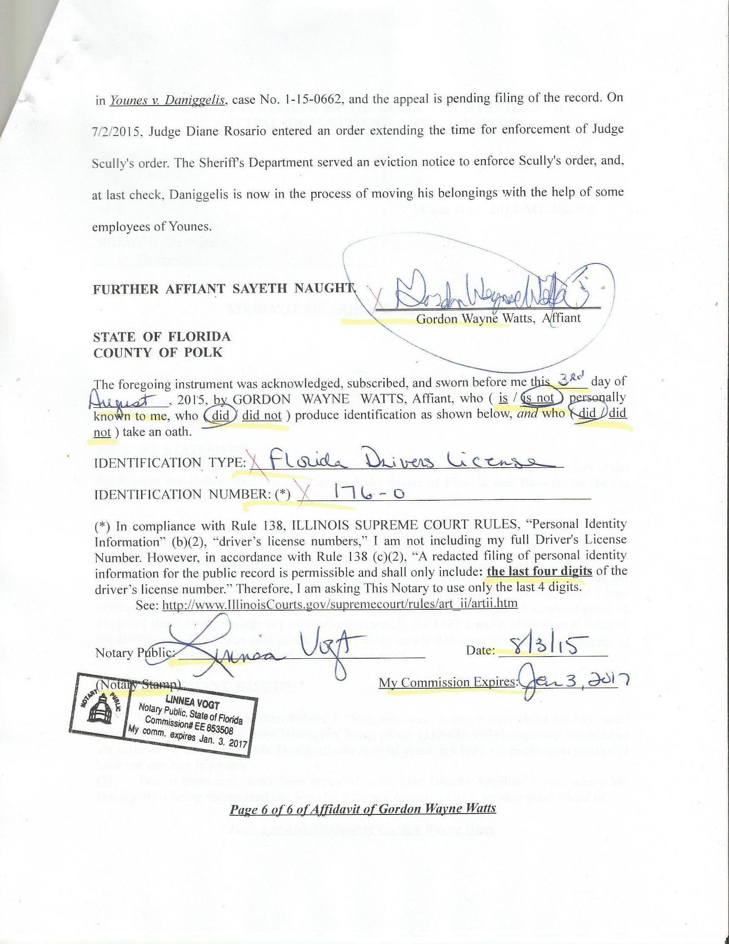

Notice of Motion..................................................................................S.R. 4

IN THE CIRCUIT COURT OF COOK COUNTY, ILLINOIS
COUNTY DEPARTMENT – CHANCERY DIVISION

GMAC Mortgage, LLC n/k/a: Bank of America, N.A. )
aka: “LaSalle Bank National Association,” aka “US Bank, )
NA,”as trustee for Morgan Stanley Loan Trust 2006-16AX, )
)
Plaintiff )
vs. ) Case No.: 2007 CH 29738
)
Richard B. Daniggelis, )
Defendant )

Notice of Motion

To: This Honourable Court and all parties being served (see attached service list, below)
From: Mr. Gordon Wayne Watts, LAKELAND, Fla. (full contact data, below)
Notice Proper: On such day and time as This Court deems appropriate, I shall[[**]] appear “telephonically” before any judge sitting assigned to this case and present all of the attached pleadings requesting This Court's consideration of certain assertions of fact, documentation to verify, and arguments of law, more fully elucidated in the attached motion and proposed Amicus brief. My appearance, if it is required (it may not be[[***]]) may not be in person, due to the fact that I reside in Lakeland, FL, which is too distant for me to reasonably travel from Lakeland (between Tampa & Orlando) to Cook County, IL.
[[**]] I shall, to the best of my ability, make myself available to This Court by telephone, email, and standard postal mail, and will do so, barring an Act of God or other unpreventable disaster.
[[***]] While I would like to appear “in person,” as is usually done in cases like this, I can not; however, many motions are considered by printed form only, so I trust that my travel handicap should not impair the wheels of justice or frustrate Due Process.

CERTIFICATE AND AFFIDAVIT OF DELIVERY (aka: Certificate of Service)

The undersigned, hereby certifies under penalties of perjury as provided by law pursuant to 735 ILCS 5/1-109, that the above notice and all attached pleadings were delivered to the following parties as indicated:

Dorothy Brown, Clerk of the Circuit Court (Main clerk email: CourtClerk@CookCountyCourt.com)
Chancery clerk emails: MZSaldivar@CookCountyCourt.com, RDMcMiller@CookCountyCourt.com, CMEddington@CookCountyCourt.com, SDLevy@CookCountyCourt.com
Richard J. Daley Center, Room 1001, 50 West Washington Street, Chicago, Illinois 60602
PH: 312-603-5031 (5133: Chancery / 5116: Civil)

Page 1 of 5
Andjelko Galic, Esq. (atty for Defendant, Daniggelis) (Atty No.: 33013)
134 N. LaSalle St., STE 1040 – Email: AndjelkoGalic@Hotmail.com
CHICAGO IL, 60602
(Cell: 312-217-5433, FAX: 312-986-1810, PH: 312-986-1510)

Richard B. Daniggelis (Defendant)
1720 N. Sedgwick
Chicago, IL 60614-5722

William D. and Linda D. Gerould
(Owners of record of subject property, according to http://CookRecorder.com)
49 Lorelei Lane
Menlo Park, CA 94025-1715

William D. and Linda D. Gerould (Owners of record of subject property)
(Owners of record of subject property, according to http://CookRecorder.com)
P.O. Box 1053
Genoa, NV 89411-1053

Mr. Robert J. More (Anselm45@Gmail.com) (Former tenant of Daniggelis)
P.O. Box 6926
Chicago, IL, 60680-6926
PH: (608) 445-5181

PIERCE & ASSOCIATES (Atty. for GMAC) (PA0715886)
URL: http://www.Atty-Pierce.com/index.php?option=com_content&view=article&id=223&Itemid=112
Attn: Joseph J. Knopic, II, Esq.,
1 North Dearborn St., STE #1300
CHICAGO IL, 60602
(312) 346-9088

Richard Indyke, Esq. (312-332-2828 Atty for LaSalle Bank Natl Assn),
John K. Kallman, Esq. (312-578-1515, atty for STG: atty no: 25182)
221 N. LaSalle St. STE 1200
Chicago, IL 60601-1305

STONE MCGUIRE SIEGEL, P.C. (Atty for JOHN LAROCQUE)
Attn: Carlo E. Poli, Esq.
801 SKOKIE BLVD, STE #200
NORTHBROOK IL, 60062
(847) 239-7555

Page 2 of 5
KROPIK PAPUGA AND SHAW (Atty for 'MERS' aka Mortgage Electronic Registration Systems, Inc.) Attn: Charanne M. Papuga, http://Kropik.net/contact.html / Kropik@Kropik.net
120 South LaSalle Street #1500
CHICAGO IL, 60603
(312) 236-6405

COHON RAIZES®AL LLP (90192) (Atty for STEWART TITLE ILLINOIS)
Attn: Carrie A. Dolan
208 S LASALLE#1860
CHICAGO IL, 60604
(312) 726-2252

Stewart Title, Attn: Leigh Curry
http://www.Stewart.com/en/stc/chicago/contact-us/contact-us.html
2055 W. Army Trail Rd., STE 110
Addison, IL 60101
(630) 889-4050

KING HOLLOWAY LLC (Atty. for Joseph Younes) http://www.KingHolloway.com/contact.htm
Attn: Peter M. King, Esq. PKing@khl-law.com
One North LaSalle Street, Suite 3040
Chicago, IL 60602
(312) 780-7302 / (312) 724-8218 / Direct: (312) 724-8221

Peter King (Atty. for Joseph Younes) (Atty. No.: 48761)
c/o: King Holloway LLC
101 N. Wacker Dr., STE 2010
Chicago, IL 60606

Perry Perelman (Atty no: 57398) (PPerelman@PerelmanDorf.com) (Atty. for Joseph Younes)
PERELMAN | DORF, LLC http://PerelmanDorf.com/contact/ Email: Info@PerelmanDorf.com
2059 W. Chicago Ave.
Chicago, IL 60622
PH: (312) 888-9608 / FAX: +1-312-674-7644

Joseph Younes Law Offices / http://ChicagoAccidentAttorney.net
120 W Madison St Ste 1405
Chicago, IL 60602-4128
Phone: (312) 372-1122 ; Fax: (312) 372-1408
Email is thought to be: RoJoe69@yahoo.com per http://www.ZoomInfo.com/p/Joseph-Younes/599467626)

Page 3 of 5
Craig A. Cronquist, Esq., c/o: Maloney & Craven, P.C. (Attys. for Joseph Younes)
2093 Rand Road
DesPlaines, IL 60016

Paul L. Shelton, Shelton Law Group, LLC
700 E. Ogden Ave., STE 101
Oak Brook, IL 69559

Paul L. Shelton (PLShelton@SBCGlobal.net) (PMSA136@aol.com)
http://www.il-reab.com/agents/26812-paul-l-shelton-shelton-associates-hinsdale-il-60523
c/o: Shelton Law Group, LLC, https://www.youtube.com/user/PaulSheltonLawGroup
1010 Jorie Blvd. #144
Oak Brook, IL 60523
(630) 993-9999, (630) 333-4009, (630) 286-5100

David J. Cooper
3622 N. Fremont St.
Chicago, IL 60613

MERS (Mortgage Electronic Registration Systems, Inc.)
https://www.mersinc.org/about-us/about-us
a nominee for HLB Mortgage
Janis Smith – (703) 738-0230 – Email: JanisS@mersinc.org
Vice President, Corporate Communications
Sandra Troutman – (703) 761-1274 – Email: SandraT@mersinc.org
Director, Corporate Communications
1595 Springhill Rd., STE 310
Vienna VA 22182
(703) 761-0694 / (800)-646-6377

I, Gordon Wayne Watts, the undersigned, hereby certify under penalties of perjury as provided by law pursuant to 735 ILCS 5/1-109, that the above notice and all attached pleadings (Affidavit of Gordon Wayne Watts, Notice of Motion, Motion for leave to file Amicus Curiae brief, Amicus Curiae of Gordon Wayne Watts in the above-captioned case, and related exhibits – with an Appendix of Exhibits) were served upon all parties listed above, this __3rd__ day of ___August___, 2015 by the following methods:

- FedEx 3rd-party commercial Carrier: Every party was served by FedEx [[with delivery confirmation and tracking, should it be necessary to verify service]] excepting the cases of a PO Box, which are not serviced by FedEx.
- United State Postal Service: Those parties with PO Boxes were served by USPS.
- Facsimile: I am not serving any parties by FAX. [[I am neither willing nor able to receive FAX transmissions.]]

Page 4 of 5
- Electronic Mail: In every case where I could obtain an email address (see above) for a party, I am effecting service by email, and attaching said documents in PDF form. [[I
consent to service by email at the email addresses listed below.]]
- Electronic Filing: If I am able to successfully register an account with the Cook County, IL Clerk of the Circuit Court, I shall effect service electronically therewith.
- Internet: I shall, when practically possible, post a TRUE COPY of this filing – and related filings – online at my official websites, infra.

Signature: _______________________________ Date: _____________________

Gordon Wayne Watts, Amicus Curiae*
821 Alicia Road
Lakeland, FL 33801-2113
PH: (863) 688-9880
Web: www.GordonWatts.com / www.GordonWayneWatts.com
Email: Gww1210@aol.com / Gww1210@gmail.com

Date: Monday, 03 August 2015
* Watts, acting counsel of record, is not a lawyer. Per Local Rule 2.1, “Notice
of Hearing of Motions,” Watts, appearing pro se, is giving notice of his motion

Page 5 of 5

AMICUS CURIAE BRIEF OF GORDON WAYNE WATTS
IN SUPPORT OF DEFENDANT / APPELLANT, RICHARD B.
DANIGGELIS (with requisite motion for leave to file)...................S.R. 5

IN THE CIRCUIT COURT OF COOK COUNTY, ILLINOIS
COUNTY DEPARTMENT – CHANCERY DIVISION

GMAC Mortgage, LLC n/k/a: Bank of America, N.A. )
aka: “LaSalle Bank National Association,” aka “US Bank, )
NA,”as trustee for Morgan Stanley Loan Trust 2006-16AX, )
)
Plaintiff )
vs. ) Case No.: 2007 CH 29738
)
Richard B. Daniggelis, )
Defendant )

Motion for leave to file Amicus Curiae brief

I'm not a lawyer, either by trade or by education, thus don't often file pleadings, much less pleadings in cases “foreign” to myself (such as this case). Moreover, I understand that, in Cook County, IL, for whatever reasons, friend of the court briefs are rarely filed, much less addressed in the Local Rules of This Court. However, I heard of certain fraud in a case involving a personal friend of mine, and upon summoning Public Records, which This Court graciously provided me, I confirmed the rumours of a signature being photocopied (and thus forged). Since This Honourable Court doesn't have a local rule addressing Amici, I will “dip into” the Rules of the United States Supreme Court for an analogous rule: Rule 37.1 of the U.S. Supreme Court states: “1. An amicus curiae brief that brings to the attention of the Court relevant matter not already brought to its attention by the parties may be of considerable help to the Court.” (Emphasis added in bold-faced underline for clarity; not in original) After reviewing the records further, I realised that a good number of other fraudulent actions occurred, but weren't (so far as I could see) brought to the attention of This Court by any of the parties. Thus, Rule 37.1's common sense guidelines, which are good enough for the US Sup Ct, are surely good guidelines for This Court. Therefore, I respectfully request This Court grant leave to file the attached Amicus brief, infra.

AMICUS CURIAE BRIEF OF GORDON WAYNE WATTS
IN SUPPORT OF DEFENDANT / APPELLANT, RICHARD B. DANIGGELIS

I. Introduction
Richard B. Daniggelis, who is the defendant in this case, was named as a defendant in at least three (3) cases related to the same subject matter: Deutsch Bank v. Daniggelis, et al. (2004-CH-10851), GMAC Mortgage, et al. v. Daniggelis, et al. (2007-CH-29738), and Younes v. Daniggelis (2014-M1-701473). Two of these cases have been appealed to the First District
Page 1 of Gordon Wayne Watts filings: Motion, Amicus, & Exhibits w/ Appendix
Appellate Court, where Mr. Daniggelis is being represented pro bono by Attorney Andjelko Galic, another good friend of Mr. Watts. At last check, the record on appeal was not timely submitted by Atty. Galic in either appeals case (apparently due to his heavy workload), and both of Daniggelis' appeals are likely in jeopardy of being dismissed for want of prosecution. As stated earlier, Watts rarely litigates (since he is not a lawyer), but This Honourable Court should probably know about one case in which he participated:
* In Re: GORDON WAYNE WATTS (as next friend of THERESA MARIE 'TERRI' SCHIAVO), No. SC03-2420 (Fla. Feb.23, 2005), denied 4-3 on rehearing. (Watts got 42.7% of his panel) http://www.floridasupremecourt.org/clerk/dispositions/2005/2/03-2420reh.pdf
* In Re: JEB BUSH, GOVERNOR OF FLORIDA, ET AL. v. MICHAEL SCHIAVO, GUARDIAN: THERESA SCHIAVO, No. SC04-925 (Fla. Oct.21, 2004), denied 7-0 on rehearing. (Bush got 0.0% of his panel before the same court) http://www.floridasupremecourt.org/clerk/dispositions/2004/10/04-925reh.pdf
* Schiavo ex rel. Schindler v. Schiavo ex rel. Schiavo, 403 F.3d 1223, 2005 WL 648897 (11th Cir. Mar.23, 2005), denied 2-1 on appeal. (Terri Schiavo's own blood family only got 33.3% of their panel on the Federal Appeals level) http://media.ca11.uscourts.gov/opinions/pub/files/200511556.pdf

Mr. Watts almost won 'the' “Terri Schiavo” case – all by himself – and on the merits (it got past the clerk, who rules on technical issues, and was presented to the full court on the merits). He almost won, doing better than all others on his side combined. This Amicus Curiae brief does not mentioning this to brag[**], but rather merely to assure This Court that, while Watts is not a lawyer, he does know something of law, and thus “may be of considerable help to the Court,” as R.37.1 supra states.
[**] This was a double miracle: not only Watts' skill, but even more-so his 'faith' or 'courage' to proceed against impossible odds and strong opposition in a highly controversial public case.
Page 2 of Gordon Wayne Watts filings: Motion, Amicus, & Exhibits w/ Appendix
II. Interests of the Amicus
Not only is Daniggelis a personal friend of Watts, but moreover, even were he a total stranger, Mr. Watts would be outraged at the injustices here, once he realised what happened. He feels that while he is only one person (and thereby limited in all respects), nonetheless, one person can make a difference.
III. Summary of the Case File / Subsequent Statement of Facts
The statements and affirmations of fact contained in the Affidavit of Amicus, Gordon Wayne Watts, filed in the above-captioned case, are incorporated by reference herein as if fully set forth herein.
IV. Argument
Both Atty. Benji Philips (Chicago Volunteer Legal Service) and Atty. Andjelko Galic[*-*] did excellent jobs of defending Richard Daniggelis against mortgage fraud; however, with all due respect to both attorneys, they failed to advance key arguments that showed clear fraud. Moreover, while Daniggelis knew of these facts, and he repeatedly attempted to make This Court aware of them, he was not allowed to speak (or so Watts vividly recalls him repeatedly telling him), and, since Daniggelis is not a lawyer, he didn't know the proper protocol and procedure to communicate with This Court (as Watts, who is more skilled in this area, is doing today). [*-*] Galic I to be especially commended: he is representing Daniggelis pro bono, at high financial and personal costs to himself, since Daniggelis, unable to access any equity in his home, which was taken in mortgage fraud, can not afford a 'Big Law' attorney, here.
Since Daniggelis wasn't afforded a fair hearing due to failure to introduce key evidence, Watts' Amicus Curiae brief must invoke an “ineffective counsel” defense (as much as it is
Page 3 of Gordon Wayne Watts filings: Motion, Amicus, & Exhibits w/ Appendix
unpleasant to state against these two fine attorneys –one of whom is a personal friend of Watts). This, of course, implicates Fundamental Due Process. Florida case law, which is persuasive (even if not binding) is clear on this point:
“When facts are to be considered and determined in the administration of statutes, there must be provisions prescribed for due notice to interested parties as to time and place of hearings with appropriate opportunity to be heard in orderly procedure sufficient to afford due process and equal protection of the laws…” Declaration of Rights, §§ 1,12. McRae v. Robbins, 9 So.2d 284, 151 Fla. 109. (Fla. 1942)

However, since Fla. case law is supported by Federal Law, then the Supremacy Clause controls, and is binding upon Illinois state courts too. While Substantive Due Process (SDP) is the standard for courts to enforce limits on legislative and executive powers (for example, over-broad or oppressive laws which have erroneous deprivations of liberty), Daniggelis' deprivation was a violation of Procedural Due Process (PDP), which guarantees a party the “right to be heard” and the “opportunity to meet it” in such proceedings (which didn't happen for Daniggelis), with courts basing their decision solely on the law and evidence adduced:
“The essence of due process is the requirement that "a person in jeopardy of serious loss [be given] notice of the case against him and opportunity to meet it." Joint Anti-Fascist Comm. v. McGrath, 341 U.S. at 341 U. S. 171-172 (Frankfurter, J., concurring).” Mathews v. Eldridge, 424 U.S. 319, at 348 (1976)

This may be a case of sub-prime or predatory lending, but that's moot in light of the newly discovered fraud. Without any further ado, here is the fraud which was not already brought to This Court's attention by all the parties in these three (3) cases:
IV. Argument – A. Photocopied (forged) signature
First off, if you look closely at the May 09, 2006 Warranty Deed (See Exhibit Watts-A), you will see that the signature on it is exactly identical to the signature on the July 09, 2006
Page 4 of Gordon Wayne Watts filings: Motion, Amicus, & Exhibits w/ Appendix
Warranty Deed. (See Exhibit Watts-B) No mere mortal can sign his or her name exactly the same twice in a row: the latter signature is obviously a forgery. Now, in all fairness to Daniggelis' attorneys, the 07/30/2008 filing by Atty. Benji Philips, in No. 07-CH-29738, did (at point 45 on page 6) mention that the word 'July' was hand written over an obvious “white out.” That should have raised red flags because the date, “09,” was type-written, meaning the month should have been too. (The month is more easily known in advance than the day, and if either was going to be a blank, it would have been the date, where a white-out could correct a typo.)
In all fairness to This Noble Court, since neither Philips nor Galic mentioned the duplicate (photocopied, forged) signature, then This Court might rightly have assumed that the date was a mere typo –and in need of “whiting-out” & correction.
However, this new piece of evidence, all by itself, establishes proof of fraud, and this alone is sufficient to bring criminal charges against some or all parties involved (and, of course, put a halt to and/or reverse any and all transfer of the title out of Daniggelis' name).
Before moving on to the next point, it bears mention that, after thorough review of the record, it would appear that there is no docket entry showing where Attorneys Paul Shelton or Joseph Younes complied with the lawful requests for depositions. This implies that they knew of the duplicate signatures, and were trying to avoid being forced to turn on one another. They are all innocent until proven guilty, but someone is guilty: the duplicate signature didn't just sign itself. Therefore, this Amicus feels that all parties (including Erika Rhone) should be called to testify against one another and do some explaining.
PROOF: A copy of the “May 09” deed is found as 'Exhibit C' of the 07/30/2008 Exhibits filed by Chicago Volunteer Legal Services. A copy of the “July 09” deed – with an exactly (and
Page 5 of Gordon Wayne Watts filings: Motion, Amicus, & Exhibits w/ Appendix
impossibly) identical signature – is found as 'Exhibit E' of same. (One does not need to be a “handwriting expert” to see the exactness. Look, in particular, to the way that the first cursive 'g' of 'Daniggelis' crosses the 'IS' of the printed name immediately below.)
IV. Argument – B. “Whited-out” (forged) date
This was already known to The Court, but it is being included in this enumeration to be complete.
IV. Argument – C. Lack of consideration (payment)
The 07/30/2008 filing by Philips, in No. 07-CH-29738, did (point 50, p.6) mention Daniggelis never cashed a check for $5,000.oo, which hinted Daniggelis never received any payment for the property. It is well-settled case-law that no contract is valid if it lacks consideration: Sometimes consideration is “nominal,” meaning it was stated for form only, such as “for and in consideration of TEN and NO/100ths Dollars ($10.oo) and other good and valuable consideration in hand paid,” (as was done on these Warranty Deeds) –and sometimes used to hide the true amount being paid. But it is also not disputed that Consideration must be of value (at least to the parties), and is exchanged for the performance or promise of performance by the other party. This, alone, might void the Warranty Deed: Stilk v. Myrick, 170 Eng. Rep. 1168, 1168 (1809) (L.R.C.P) (Ellenborough, L) (holding a renegotiated contract void due to lack of consideration). However, the more relevant fact was never clearly declared to This Honourable Court: While Daniggelis was, indeed, offered a small check, he never cashed it. (If you doubt this argument, check the record: No record exists of a Mr. Richard B. Daniggelis ever having accepted any payment whatsoever for his house and land.) While Arguments 'A' and 'B' above show Mens Rea (criminal intent) on the part of whomever forged the signature,
Page 6 of Gordon Wayne Watts filings: Motion, Amicus, & Exhibits w/ Appendix
Argument 'C' here (by contrast) clearly shows that Daniggelis' “intent,” if you will, was not to sell his house, but merely to seek refinancing. (Put another way, no person in his right mind would simply “give away” an homestead that has been in the family for ages!) Even a blind man could see that A and B prove forgery (fraud), and even a lowly plebeian can see that 'C' here, shows Daniggelis' intent was never to merely “give away” his house (as the trial courts implied by their respective rulings in both the 2007 Chancery and 2014 M1 Civil cases).
IV. Argument – D. Missing Funds (fraud)
Since the house was, de facto, “given away,” that begs a deeper question: what happened to the equity? In fact, the 07/30/2008 filing by Philips, in No. 07-CH-29738, did (at point 42 on page 5) mention that the total of the mortgages was $714,009.29, but inquired about “[t]wo additional payoffs totaling more than $100,000 [] made to unspecified recipients.” While this is not a “new” point (something an Amicus is supposed to bring), the fact of the matter is that the “missing funds” issue, here, was never really addressed. The question was asked, but nobody bothered to follow-up on it and answer: “Where did all the equity go?” Missing funds here, not accounted-for, constitute fraud. This, alone, is probably sufficient to stop all transfer of title, and invoke a criminal investigation. (With the house partly paid-off, possessing great equity, a “give away” is nothing short of theft.)
IV. Argument – E. Predatory (sub-prime) lending
Richard Daniggelis clearly told Amicus, Gordon W. Watts, on several occasions that Joe Younes wanted to “go after” the bank, back when he was representing Daniggelis. While neither of them ever figured out what made Younes so sure that he had a case, the only thing that seems a likely tort for which Younes might sue (back before all the mortgage fraud and theft of house,
Page 7 of Gordon Wayne Watts filings: Motion, Amicus, & Exhibits w/ Appendix
of course) was a possibly excessive or illegal interest scheme. The fact that Daniggelis often complained about the interest and/or fees, lent Amicus' theory credence. Watts was not sure if laws were broken in this regard, but as it seemed credible at the time, this Amicus brief is now mentioning this so that it can be investigated by those more expert than Watts in the areas of Predatory and Sub-prime lending.
IV. Argument – F. The 'Unclean Hands' problem
This home, according to the Cook County Recorder's office (See Exhibits Watts-C, D, and E), is still in William D. and Linda D. Gerould's name, Linda being the sister of Richard. (This, of course, means that even Daniggelis might get into trouble for doing business on it –unless he can show that it was transferred back to him but not recorded.) More importantly, though, it means that Younes and Shelton, who, apparently, had NO RECORD of the home being transferred out of Gerould's name, could not legally take possession of it: They have “unclean hands,” as they did business with a person who is not the legal owner. (Look at the Cook County Recorder's records if you do not believe me.) This fact alone is sufficient to halt all transfer to a third-party until it is resolved. (Of course, as none of the parties informed This Noble Court, it was never addressed, and thus never resolved.)
IV. Argument – G. Forged POA (Power of Attorney) – PROOF:
Here's something else that Philips & Galic missed: If you look at Exhibit 'D' of the 07/30/2008 filing by Philips, the “Limited Power Of Attorney” signed by “Richard Daniggelis” (See Exhibit Watts-F) you'll notice that the place for a notary public is left blank. This alone invalidates this article. That was never really “fleshed out” in the trial courts. However, there 's something even more sinister. A copy of this document, which Watts obtained from Daniggelis
Page 8 of Gordon Wayne Watts filings: Motion, Amicus, & Exhibits w/ Appendix
(apparently a 4/16/2015 exhibit filed in 2014-M1-701473) proves that Shelton did, subsequently, notarise this POA. (See Exhibit Watts-G) Shelton should testify about this, but since he surely testified previously that he & Daniggelis were present together when Daniggelis signed this doc, perhaps the “notarised” version Watts obtained from Daniggelis isn't needed to prove that Shelton claims he witnessed the signature.) Bottom line: Shelton is, on one hand, saying[[**]] he witnessed Daniggelis sign this doc, and relying upon said POA, but on the other hand, the record clearly shows that he did not actually sign or witness it until “after the fact.” – This is clear fraud, and this alone shows sufficient additional Mens rea (criminal intent) to invoke a State Atty. or Atty. General criminal investigation. [[**]] Even though this Amicus admits that he can't find where Shelton 'explicitly' testified to this effect, Shelton's claims that he witnessed Daniggelis sign it are implicit, since he is relying upon the authenticity of this POA: since Shelton probably never testified, and continued to evade deposition on this head, he (and all others) should probably be compelled to testify about this fraud here, too.
IV. Argument – H. Linda Green
Looking at the “Lost Assignment Affidavit” that was submitted as 'Exhibit B' of Galic's 11/21/2011 “Motion for Ruling...” in 2007-CH-39738, we see a familiar name: “Linda Green,” the infamous robo-signer. However, what is really troubling is that Joseph Younes' name was named in the document. In all fairness to This Court, Amicus must admit that Galic did address this matter in points 9—10 (comparing it, in point 11, with 'Exhibit C,' another 'Assignment' doc, showing clear fraud on the part of those invoking Linda Green's authorisation of reassignment!). While Amicus must admit that Galic did, in fact, address this matter in points 9—12 of said motion, this brief is including it (again) merely to be complete in the assessment (argument) of
Page 9 of Gordon Wayne Watts filings: Motion, Amicus, & Exhibits w/ Appendix
ascertaining whether there was, in fact, a bunch of fraud. (Besides: Ms. Linda Green was too good to pass up without at least cursory mention.)
IV. Argument – I. Civil Damages
While Younes complains he could not collect rent while a cloud hung over the title, likewise Daniggelis could not collect rent as well. This constitutes punitive and/or civil damages for Daniggelis. Of course, civil damages are only payable to Daniggelis if he is, in fact, found to be a victim of fraud, but, since a number of these issues (which all parties failed to address to This Court) constitute criminal charges, all this together probably constitutes R.I.C.O. - Racketeering Influenced Corrupt Organisation - if collusion among the parties to commit forgery, etc., can be shown. “It's a racket” –literally. And that off-centre and without honour. (Multiple forgery was proved supra, but collusion, e.g., R.I.C.O., so far, has not been proved: That's why witnesses need to be deposed to testify against one another as to whose hand was in the til –and who knew what, when.)
IV. Argument – J. RICO
Since Stewart Title also has more or less admitted some level of mortgage fraud (insofar as this Amicus has it on information that they settled with Daniggelis for a huge settlement), this is yet another reason that R.I.C.O. would be worth pursuing and possibly useful in compelling depositions and testimony to clarify the roles and relationship of the parties, as to who was guilty of what.
IV. Argument – K. Time-barred
The closing was outside the time frame of the May 09, 2006 Warranty Deed. (Remember: The July 09, 2006 deed was shown to be a forgery, in Arguments IV-A and IV-B, supra, so we
Page 10 of Gordon Wayne Watts filings: Motion, Amicus, & Exhibits w/ Appendix
may only consider the May 9 deed.) Looking at 'Exhibit C' that Philips filed, she, in fact, addresses this matter in point 31 of page 4 in her 07/30/2008 Answer: The May 09 deed was only to be used to close the contract “on or about” May 12th, 2006. However, more importantly, if the closing did not occur before May 19, 2006, that contract is “null and void” ab initio. This Amicus Curiae brief freely admits and acknowledges that this contract also called for a $10,000.oo payment of damages to Younes if the closing did not occur before May 19th, 2006; and, in fact, Daniggelis might be bound by this contract. However 2 legally-mitigating factors come into play: The first factor is “coercion,” to sign a contract, which also implies elder abuse, since Daniggelis was relying upon a professional: Shelton was an attorney, and possibly apparently (at that time) also a realtor, a professional, who used his credentials to mislead Daniggelis into plainly giving away the family house:
Apparently, Shelton was a realtor at that time, as the State of Illinois indicates that a “PAUL L SHELTON” had an active license, number: TA.16.1601271, from 05/29/2003 until 06/16/2009, which then expired, but which is presently in “Application Inactive' status due to a reason of “Withdrawn.”) Sources – Lookup: http://www.obrelookupclear.state.il.us/default.asp
Result: http://www.obrelookupclear.state.il.us/SearchDetail.asp?DivisionIdnt=3&ProfessionIdnt=null&Idnt=150319
As This Court knows, duress or coercion is intimidation of a victim to compel the individual to do some act against his or her will by the use of psychological pressure, physical force, or threats – as in “we need you to sign this Warranty Deed in order to renegotiate your loan.”
The second factor is the “unclean hands” doctrine: Even if Shelton and Younes
Page 11 of Gordon Wayne Watts filings: Motion, Amicus, & Exhibits w/ Appendix
otherwise might have a right to the enforcement of a contract, all parties inducing Daniggelis to sign over his property “for free” had unclean hands:
unclean hands – n. a legal doctrine which is a defense to a complaint, which states that a party who is asking for a judgment cannot have the help of the court if he/she has done anything unethical in relation to the subject of the lawsuit. Thus, if a defendant can show the plaintiff had "unclean hands," the plaintiff's complaint will be dismissed or the plaintiff will be denied judgment.

Source: http://legal-dictionary.thefreedictionary.com/unclean+hands

(Besides: Even assuming arguendo that Shelton could collect the 10 Grand, nonetheless, the torts committed by those who forged numerous docs supra far outweigh the mere $10,000.oo tort that Shelton might hope to collect, and so in the balance of equities, Shelton and company would come up in a huge net deficit – especially considering both various criminal frauds as well as civil damages: “more than $100,000 [] made to unspecified recipients” in equity theft, supra – and any rent earning which Daniggelis lost.)
IV. Argument – L. Conflict of Interest
The record is clear Attorney Joseph Younes was Daniggelis' attorney in 2004-CH-10851 (Deutsche Bank v Daniggelis), but then he gained privileged information as his attorney. His legal obligation was to safeguard his client's financial interests, not to use privileged information to enrich himself. In all fairness, Galic did finally get around to mentioning, in point 18 of his 10/29/2014 Answer in case# 2014-M1-701473, that both of Daniggelis' attorneys took advantage of an “elderly person,” but the fact that these two attorneys (Shelton and Younes) committed “triple” fraud in a case where multiple forgeries have just been discovered (in the instant Amicus brief, here) –and given the gravity of the crimes committed – this point must be clarified to distinguish the various frauds committed. First fraud: elder abuse. Second fraud: use of
Page 12 of Gordon Wayne Watts filings: Motion, Amicus, & Exhibits w/ Appendix
privileged information for pecuniary gain: Conflict of interest. Third fraud: abuse of position of power/authority by attorneys in order to effect duress or coercion.
IV. Argument – M. Res Adjudicata
In his 10/29/2014 Answer, in file# 2014-M1-701473, Galic argues that Younes is barred by Res Adjudicata on the possession claim, due to the fact that the foreclosure suit, heard in Chancery in file#: 2007-CH-29738, considered this issue, and further argues that the date of Younes' motion is relevant. Galic's 06/18/2014 Response, in file# 2014-M1-701473, argues at point 10 that Younes can not rely upon Otto's ruling, since said ruling was not final at that time, as a timely motion to reconsider had been filed. However, as apparently Otto subsequently denied Galic's motion, Daniggelis, himself, would be barred by Res Adjudicata. But it is well-settled at common law that an affirmative defense against Res Adjudicata can be successfully raised on either changed policy or changed factual circumstances (the latter is the case here, since this Amicus brings to The Court's attention previously unknown fact). Intentional fraud (as discovered in the case at bar) may also be an affirmative defense. Also, since Federal Due Process trumps state via the Supremacy Clause, Daniggelis' lack of Procedural Due Process, supra, controls, and Res Adjudicata may then be overcome. (Galic also addresses claim-splitting, but this point is omitted as moot.)
IV. Argument – N. Subrogation
Galic addresses subrogation (substitution) of one prospective mortgage-holder in place of another, arguing (in his July 27, 2011 “Reply to the Response...” case#: 2007-CH-29738, points 6-24) that the new plaintiff can't substitute itself as mortgage holder by merely paying the debt unless it has legal obligation to do so. When the plaintiff proceeded with foreclosure against
Page 13 of Gordon Wayne Watts filings: Motion, Amicus, & Exhibits w/ Appendix
Daniggelis, Galic relied on the apparently(*) defective chain of assignments of the mortgage in arguing that the plaintiff lacked required standing. (*-“Apparently”: Amicus, Gordon Watts, is not sure of the actual facts.) However, there's persuasive case law that missing or defective Mortgage assignments can be cured. On July 30, 2013, Ohio's 10th Dist. Appellate Court applied this doctrine in U.S. Bank Natl. Assn. V. Gray, 2013-Ohio-3340. The court held that where a promissory note is secured by a mortgage, the note is evidence of the debt & the mortgage is a mere incident of the debt. Therefore, proper transfer of a note operates as an equitable assignment of the mortgage, even if the mortgage isn't assigned or delivered. In other words, the mortgage follows the note, meaning that the new plaintiff probably has standing to pursue foreclose against Daniggelis. (While this is not binding upon Illinois, it makes sense, since otherwise the payment of the note would be in vain.) The court, in Gray, supra, thus answered a question that the legal community has been pondering since the Fed. Home Loan Mtge. Corp. v. Schwartzwald, 2012-Ohio-5017 holding that had language which stated “note or mortgage” (emphasis added), which implied that either the note or the mortgage was sufficient to have standing to pursue foreclosure. Thus, the Gray decision clarified this “gray area of case law” (pun intended) by essentially stating that 'or' means 'or,' and therefore, an interest in the note alone is sufficient to establish standing to pursue foreclosure. Again, Ohio's case law isn't binding upon Illinois, but these common sense guidelines might be helpful to Illinois Courts. Nonetheless, in the case at bar, all this is moot since fraud uncovered in of mammoth proportions overwhelms and makes moot any standard of law on standing.
V. Ante Conclusion
It is well-known that Paul Shelton has a history of serious corruption: “And Paul Shelton
Page 14 of Gordon Wayne Watts filings: Motion, Amicus, & Exhibits w/ Appendix
of Trust One Mortgage has agreed to a consent order that bans him for life from any work originating loans..."Lifetime bans are never issued without cause. There are always reasons for lifetime bans," said [Brent] Adams, [Illinois Department of Financial and Professional Regulation secretary].” Source: “Victory for South Side victim of mortgage fraud,” ABC Local, WLS-TV/DT; Date: Friday, November 19, 2010, URL: http://abclocal.go.com/story?section=news/local&id=7799653
See also: “While mom took care of others, she got taken,” Chicago Tribune, May 10, 2009, By John Kass
URL: http://articles.chicagotribune.com/2009-05-10/news/0905090103_1_trust-bungalow-house-payments
Here, we see something familiar: “"Mr. Shelton was essentially coordinating a mortgage-rescue scheme, whereby he would be conceiving home owners to eventually sign over their homes," said Brent Adams, Illinois Department of Financial and Professional Regulation secretary. "Those homes would be sold to a straw buyer and effectively flipped at a higher appraised value."” Source: ABC Local, Ibid.
Now, it must be emphasised that all parties are innocent until proven guilty. However, the record in the above-captioned cases clearly demonstrates and proves that someone (possibly several parties) are guilty: the fake signature sure didn't “sign itself,” nor did the POA erase its own Notary Public stamp. And the parties who willfully stole hundreds of thousands of dollars in equity – never to be found – or accounted for – again, all the while the title was still in Gerould's name (the sister of Daniggelis) did not do so because they were forced: they did so willingly. While Daniggelis told Amicus, G.W. Watts, that Younes lied about him on one occasion (claiming
Page 15 of Gordon Wayne Watts filings: Motion, Amicus, & Exhibits w/ Appendix
that Daniggelis had a bad back, and could not make it to a hearing), and while Younes is clearly profiting from these fraudulent transactions, this Amicus Curiae must be honest and share the positives about Younes as well: Daniggelis has told Amicus, Watts, that Younes is very patient in his eviction, even supplying men to help move his belongings. Moreover, Daniggelis has related to Watts that on several occasions he has had positive and friendly discussions about religion with Younes (since Younes, who is Jewish and Daniggelis, who is a Greek Orthodox Christian, have similar roots in their religion). This leads this Amicus to believe that Younes may not have committed fraud, himself, and may merely suspect that there is fraud. Whether Younes is totally guilty of collusion, or merely partly guilty of “keeping bad company” and thereby benefiting from the crimes of shady business partners, Amicus is very sad that his brief, here, will most likely cause Younes huge grief. In fact, Amicus isn't happy or eager even to cause grief or pain to the actual guilty party (whomever it may be: Shelton is the “likely suspect,” given his record, but he, along with the rest, is innocent until proven guilty).
VI. Conclusion
For the foregoing reasons, based both on previously-known fraud and newly-discovered fraud, This Court should probably depose all the parties who had the ability to effect the various fraud in question, and compel them to testify against one another and do some explaining to get to the bottom of all this. (In fact, the lack of such cross-examination in prior proceedings on these and other points was a fundamental violation of Due Process, not only of Daniggelis, but also all parties so involved.) In the mean time, This Court should issue a stay on the order of possession pending further review, since Daniggelis is likely to succeed on the merits – either at trial or on appeal, and, moreover, he is prejudiced greatly by the execution of the misplaced and
Page 16 of Gordon Wayne Watts filings: Motion, Amicus, & Exhibits w/ Appendix
unjustified order of possession. Also, a stay is needed to secure a fair chance at preserving the appeal, since, of course, the landlord may rent or sell the property, or otherwise muddy the waters – thus making the appeal (even if meritorious) a moot appeal, thus frustrating Due Process and Equity. This Court would have the community's gratitude to closely review this Amicus Curiae brief –and all documents on record –and effect justice. A fair and honest ruling would also set precedent to avoid future injustices: How many other people will have their houses and land stolen from them, thus making them homeless?
Thus, I respectfully suggest, as a good Friend of the Court, that it serves the cause of Justice to seek and enforce actual justice when true fraud is discovered, and to change course if a prior course was erroneous –and thereby enter such orders as is necessary to permit Daniggelis to remain on his own property pending litigation, appeal, and/or additional deposition and testimony sufficient to “get hold” of the truth.
CERTIFICATE AND AFFIDAVIT OF DELIVERY (aka: Certificate of Service)
The undersigned, hereby certifies under penalties of perjury as provided by law pursuant to 735 ILCS 5/1-109, that the above notice and all attached pleadings were delivered to the following parties as indicated:

Dorothy Brown, Clerk of the Circuit Court (Main clerk email: CourtClerk@CookCountyCourt.com)
Chancery clerk emails: MZSaldivar@CookCountyCourt.com, RDMcMiller@CookCountyCourt.com, CMEddington@CookCountyCourt.com, SDLevy@CookCountyCourt.com PH: 312-603-5031 (5133: Chancery / 5116: Civil)
Richard J. Daley Center, Room 1001, 50 West Washington Street, Chicago, Illinois 60602

Andjelko Galic, Esq. (atty for Defendant, Daniggelis) (Atty No.: 33013)
134 N. LaSalle St., STE 1040 – Email: AndjelkoGalic@Hotmail.com
CHICAGO IL, 60602 – (Cell: 312-217-5433, FAX: 312-986-1810, PH: 312-986-1510)

Richard B. Daniggelis (Defendant)
1720 N. Sedgwick
Chicago, IL 60614-5722

Page 17 of Gordon Wayne Watts filings: Motion, Amicus, & Exhibits w/ Appendix
William D. and Linda D. Gerould
(Owners of record of subject property, according to http://CookRecorder.com)
49 Lorelei Lane
Menlo Park, CA 94025-1715

William D. and Linda D. Gerould (Owners of record of subject property)
(Owners of record of subject property, according to http://CookRecorder.com)
P.O. Box 1053
Genoa, NV 89411-1053

Mr. Robert J. More (Anselm45@Gmail.com) (Former tenant of Daniggelis)
P.O. Box 6926
Chicago, IL, 60680-6926
PH: (608) 445-5181

PIERCE & ASSOCIATES (Atty. for GMAC) (PA0715886)
URL: http://www.Atty-Pierce.com/index.php?option=com_content&view=article&id=223&Itemid=112
Attn: Joseph J. Knopic, II, Esq.,
1 North Dearborn St., STE #1300
CHICAGO IL, 60602
(312) 346-9088

Richard Indyke, Esq. (312-332-2828 Atty for LaSalle Bank Natl Assn),
John K. Kallman, Esq. (312-578-1515, atty for STG: atty no: 25182)
221 N. LaSalle St. STE 1200
Chicago, IL 60601-1305

STONE MCGUIRE SIEGEL, P.C. (Atty for JOHN LAROCQUE)
Attn: Carlo E. Poli, Esq.
801 SKOKIE BLVD, STE #200
NORTHBROOK IL, 60062
(847) 239-7555

KROPIK PAPUGA AND SHAW (Atty for 'MERS' aka Mortgage Electronic Registration Systems, Inc.) Attn: Charanne M. Papuga, http://Kropik.net/contact.html / Kropik@Kropik.net
120 South LaSalle Street #1500
CHICAGO IL, 60603
(312) 236-6405

COHON RAIZES®AL LLP (90192) (Atty for STEWART TITLE ILLINOIS)
Attn: Carrie A. Dolan
208 S LASALLE#1860
CHICAGO IL, 60604
(312) 726-2252
Page 18 of Gordon Wayne Watts filings: Motion, Amicus, & Exhibits w/ Appendix
Stewart Title, Attn: Leigh Curry
http://www.Stewart.com/en/stc/chicago/contact-us/contact-us.html
2055 W. Army Trail Rd., STE 110
Addison, IL 60101
(630) 889-4050

KING HOLLOWAY LLC (Atty. for Joseph Younes) http://www.KingHolloway.com/contact.htm
Attn: Peter M. King, Esq. PKing@khl-law.com
One North LaSalle Street, Suite 3040
Chicago, IL 60602
(312) 780-7302 / (312) 724-8218 / Direct: (312) 724-8221

Peter King (Atty. for Joseph Younes) (Atty. No.: 48761)
c/o: King Holloway LLC
101 N. Wacker Dr., STE 2010
Chicago, IL 60606

Perry Perelman (Atty no: 57398) (PPerelman@PerelmanDorf.com) (Atty. for Joseph Younes)
PERELMAN | DORF, LLC http://PerelmanDorf.com/contact/ Email: Info@PerelmanDorf.com
2059 W. Chicago Ave.
Chicago, IL 60622
PH: (312) 888-9608 / FAX: +1-312-674-7644

Joseph Younes Law Offices / http://ChicagoAccidentAttorney.net
120 W Madison St Ste 1405
Chicago, IL 60602-4128
Phone: (312) 372-1122 ; Fax: (312) 372-1408
Email is thought to be: RoJoe69@yahoo.com per http://www.ZoomInfo.com/p/Joseph-Younes/599467626)

Craig A. Cronquist, Esq., c/o: Maloney & Craven, P.C. (Attys. for Joseph Younes)
2093 Rand Road
DesPlaines, IL 60016

David J. Cooper
3622 N. Fremont St.
Chicago, IL 60613

Paul L. Shelton (PLShelton@SBCGlobal.net) (PMSA136@aol.com)
http://www.il-reab.com/agents/26812-paul-l-shelton-shelton-associates-hinsdale-il-60523
c/o: Shelton Law Group, LLC, https://www.youtube.com/user/PaulSheltonLawGroup
1010 Jorie Blvd. #144
Oak Brook, IL 60523
(630) 993-9999, (630) 333-4009, (630) 286-5100

Page 19 of Gordon Wayne Watts filings: Motion, Amicus, & Exhibits w/ Appendix
Paul L. Shelton, Shelton Law Group, LLC
700 E. Ogden Ave., STE 101
Oak Brook, IL 69559

MERS (Mortgage Electronic Registration Systems, Inc.)
https://www.mersinc.org/about-us/about-us
a nominee for HLB Mortgage
Janis Smith – (703) 738-0230 – Email: JanisS@mersinc.org
Vice President, Corporate Communications
Sandra Troutman – (703) 761-1274 – Email: SandraT@mersinc.org
Director, Corporate Communications
1595 Springhill Rd., STE 310
Vienna VA 22182
(703) 761-0694 / (800)-646-6377

I, Gordon Wayne Watts, the undersigned, hereby certify under penalties of perjury as provided by law pursuant to 735 ILCS 5/1-109, that the above notice and all attached pleadings (Affidavit of Gordon Wayne Watts, Notice of Motion, Motion for leave to file Amicus Curiae brief, Amicus Curiae of Gordon Wayne Watts in the above-captioned case, and related exhibits – with an Appendix of Exhibits) were served upon all parties listed above, this __3rd__ day of ___August___, 2015 by the following methods:
- FedEx 3rd-party commercial Carrier: Every party was served by FedEx [[with delivery confirmation and tracking, should it be necessary to verify service]] excepting the cases of a PO Box, which are not serviced by FedEx.
- United State Postal Service: Those parties with PO Boxes were served by USPS.
- Facsimile: I am not serving any parties by FAX. [[I am neither willing nor able to receive FAX transmissions.]]
- Electronic Mail: In every case where I could obtain an email address (see above) for a party, I am effecting service by email, and attaching said documents in PDF form. [[I consent to service by email at the email addresses listed below.]]
- Electronic Filing: If I am able to successfully register an account with the Cook County, IL Clerk of the Circuit Court, I shall effect service electronically therewith.
- Internet: I shall, when practically possible, post a TRUE COPY of this filing – and related filings – online at my official websites, infra.

Signature: _______________________________ Date: _____________________

Gordon Wayne Watts, Amicus Curiae*
821 Alicia Road, Lakeland, FL 33801-2113 ; PH: (863) 688-9880
Web: www.GordonWatts.com / www.GordonWayneWatts.com
Email: Gww1210@aol.com / Gww1210@gmail.com
Date: Monday, 03 August 2015
* Watts, acting counsel of record, is not a lawyer. Per Local Rule 2.1, “Notice
of Hearing of Motions,” Watts, appearing pro se, is giving notice of his motion

Page 20 of Gordon Wayne Watts filings: Motion, Amicus, & Exhibits w/ Appendix
INDEX TO THE EXHIBITS

Note: These exhibits are genuine and not forged or altered; however, I, Gordon Wayne Watts, am supplying these merely as a convenience, and not as 'official' documents. To verify that these are accurate, I refer you to the official sources, namely the Cook County Clerk's Office and the Cook County Recorder's Office. ~Gordon Wayne Watts

Instrument Docket/Tab#
May 09, 2006 Warranty Deed Exhibit Watts-A
July 09, 2006 Warranty Deed Exhibit Watts-B
Cook County Recorder of Deeds screenshot Exhibit Watts-C
Assignment of Rents to Wm & Linda Gerould Exhibit Watts-D
Wm & Linda Gerould's PAO (Power of Attorney) Exhibit Watts-E
“Limited Power Of Attorney” (but not notarised) Exhibit Watts-F
“Limited Power Of Attorney” (which was later notarised) Exhibit Watts-G

May 09, 2006 Warranty Deed Exhibit Watts-A
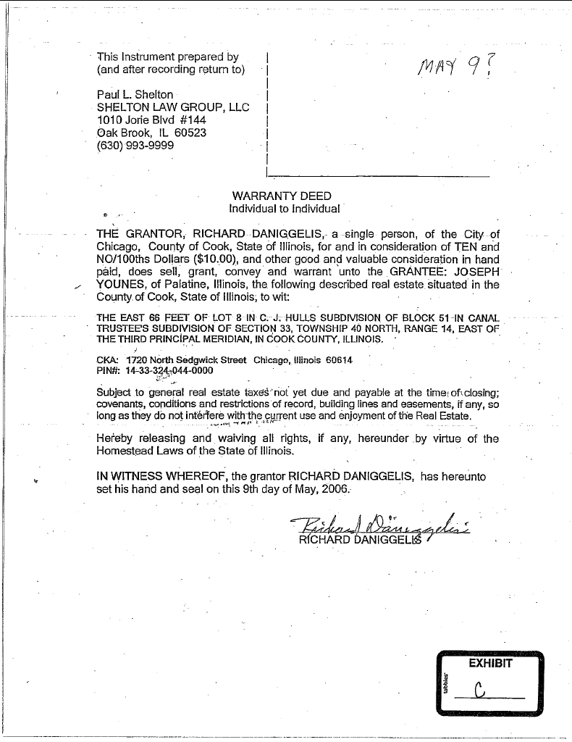
July 09, 2006 Warranty Deed Exhibit Watts-B
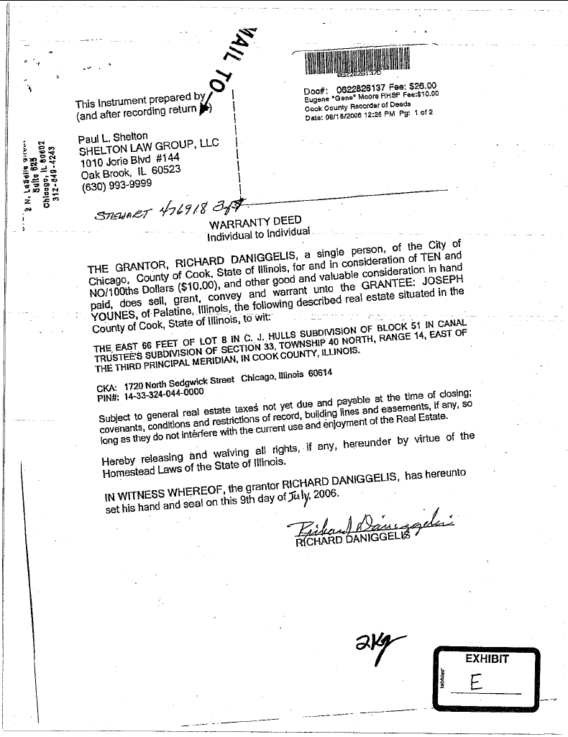
Cook County Recorder of Deeds screenshot Exhibit Watts-C
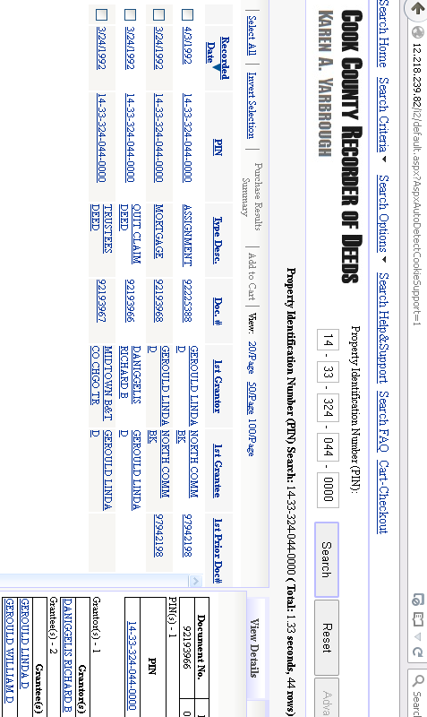
Assignment of Rents to Wm & Linda Gerould Exhibit Watts-D
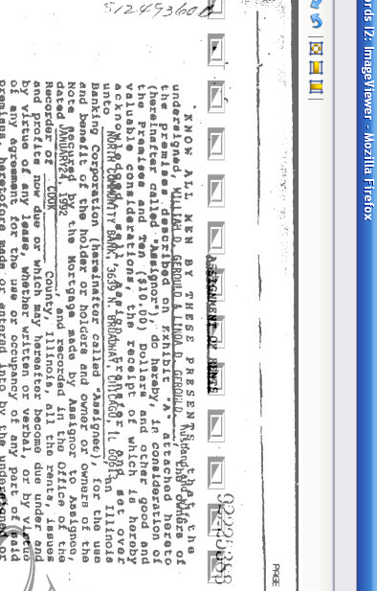

Wm & Linda Gerould's PAO (Power of Attorney) Exhibit Watts-E
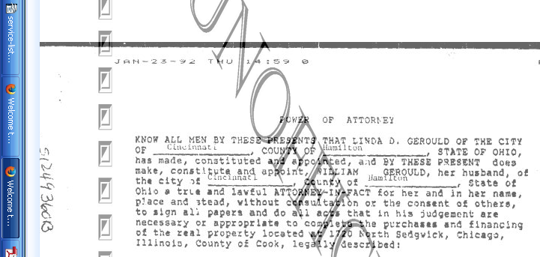

“Limited Power Of Attorney” (but not notarised) Exhibit Watts-F
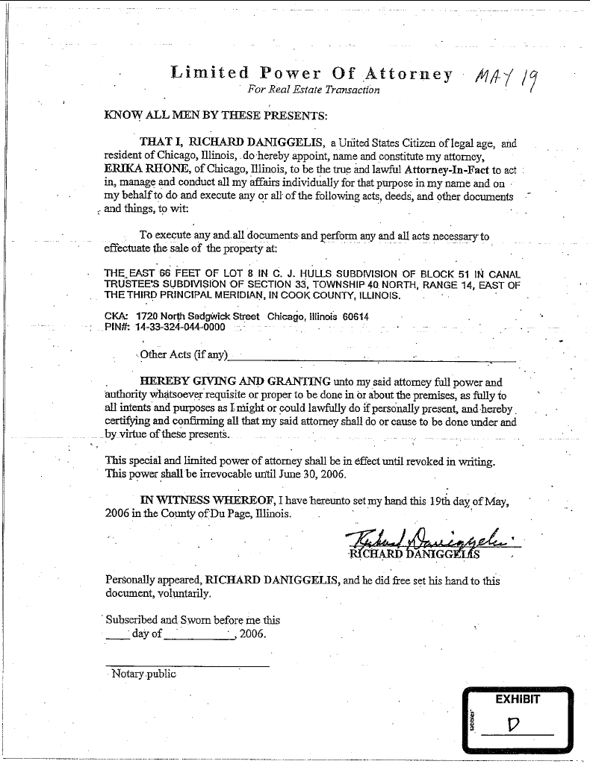
“Limited Power Of Attorney” (which was later notarised) Exhibit Watts-G
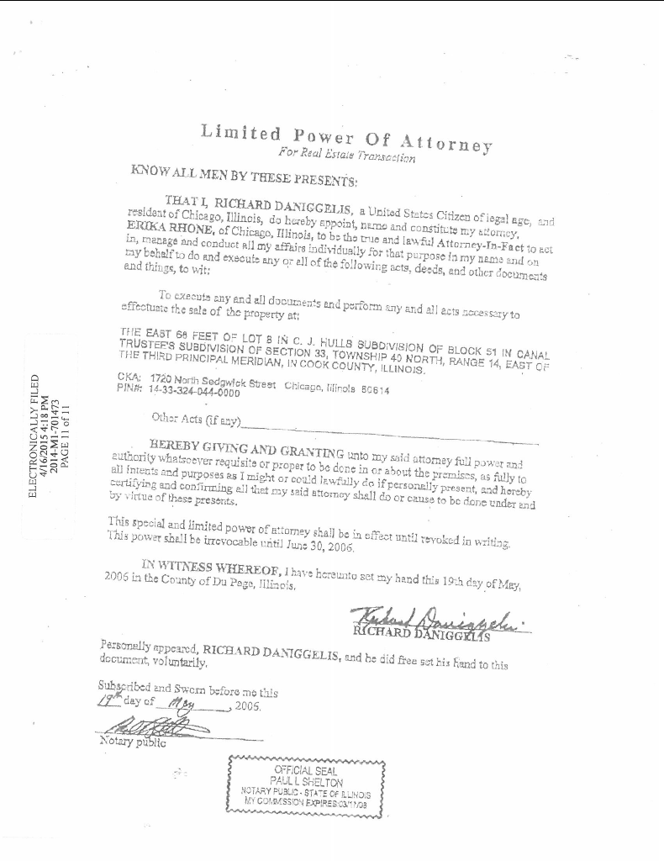

CERTIFICATE AND AFFIDAVIT OF DELIVERY (aka: Certificate of Service)

The undersigned, hereby certifies under penalties of perjury as provided by law pursuant to 735 ILCS 5/1-109, that the above SUPPORTING RECORD FOR Motion to Supplement Record Instanter PURSUANT TO SUPREME COURT RULE 328 AND OTHER RELIEF was delivered to the following parties as indicated:

1st District Appellate, Clerk's Office, 160 North LaSalle St., Chicago, IL 60601
(312) 793-5484 – Office Hours: 8:30 - 4:30

Andjelko Galic, Esq. (atty for Defendant, Daniggelis) (Atty No.: 33013)
134 N. LaSalle St., STE 1040 – Email: AndjelkoGalic@Hotmail.com
CHICAGO IL, 60602 (Cell: 312-217-5433, FAX: 312-986-1810, PH: 312-986-1510)

Richard B. Daniggelis (Defendant), 1720 N. Sedgwick, Chicago, IL 60614-5722

William D. and Linda D. Gerould, (Owners of record of subject property, according to http://CookRecorder.com) 49 Lorelei Lane, Menlo Park, CA 94025-1715

Mr. Robert J. More (Anselm45@Gmail.com) (Former tenant of Daniggelis)
P.O. Box 6926, Chicago, IL, 60680-6926 ; PH: (608) 445-5181

PIERCE & ASSOCIATES (Atty. for GMAC) (PA0715886)
URL: http://www.Atty-Pierce.com/index.php?option=com_content&view=article&id=223&Itemid=112
Attn: Joseph J. Knopic, II, Esq., 1 North Dearborn St., STE #1300
CHICAGO IL, 60602 ; (312) 346-9088

Richard Indyke, Esq. (312-332-2828 Atty for LaSalle Bank Natl Assn),
John K. Kallman, Esq. (312-578-1515, atty for STG: atty no: 25182)
221 N. LaSalle St. STE 1200, Chicago, IL 60601-1305

STONE MCGUIRE SIEGEL, P.C. (Atty for JOHN LAROCQUE)
Attn: Carlo E. Poli, Esq., 801 SKOKIE BLVD, STE #200
NORTHBROOK IL, 60062 ; (847) 239-7555

KROPIK PAPUGA AND SHAW (Atty for 'MERS' aka Mortgage Electronic Registration Systems, Inc.) Attn: Charanne M. Papuga, http://Kropik.net/contact.html / Kropik@Kropik.net
120 South LaSalle Street #1500, CHICAGO IL, 60603 ; (312) 236-6405

COHON RAIZES®AL LLP (90192) (Atty for STEWART TITLE ILLINOIS)
Attn: Carrie A. Dolan, 208 S LASALLE#1860, CHICAGO IL, 60604 ; (312) 726-2252

Page 1
Stewart Title, Attn: Leigh Curry
http://www.Stewart.com/en/stc/chicago/contact-us/contact-us.html
2055 W. Army Trail Rd., STE 110, Addison, IL 60101 ; PH: (630) 889-4050

KING HOLLOWAY LLC (Atty. for Joseph Younes) http://www.KingHolloway.com/contact.htm
Attn: Peter M. King, Esq. PKing@khl-law.com
One North LaSalle Street, Suite 3040, Chicago, IL 60602
(312) 780-7302 / (312) 724-8218 / Direct: (312) 724-8221

Peter King (Atty. for Joseph Younes) (Atty. No.: 48761)
c/o: King Holloway LLC, 101 N. Wacker Dr., STE 2010 ; Chicago, IL 60606

Perry Perelman (Atty no: 57398) (PPerelman@PerelmanDorf.com) (Atty. for Joseph Younes)
PERELMAN | DORF, LLC http://PerelmanDorf.com/contact/ Email: Info@PerelmanDorf.com
2059 W. Chicago Ave., Chicago, IL 60622 ; PH: (312) 888-9608 / FAX: +1-312-674-7644

Joseph Younes Law Offices / http://ChicagoAccidentAttorney.net
120 W Madison St Ste 1405, Chicago, IL 60602-4128 ; Phone: (312) 372-1122 ; Fax: (312) 372-1408, Email is thought to be: RoJoe69@yahoo.com per http://www.ZoomInfo.com/p/Joseph-Younes/599467626)

Craig A. Cronquist, Esq., c/o: Maloney & Craven, P.C. (Attys. for Joseph Younes)
2093 Rand Road, DesPlaines, IL 60016

Paul L. Shelton, Shelton Law Group, LLC, 700 E. Ogden Ave., STE 101, Oak Brook, IL 69559

Paul L. Shelton (PLShelton@SBCGlobal.net) (PMSA136@aol.com)
http://www.il-reab.com/agents/26812-paul-l-shelton-shelton-associates-hinsdale-il-60523
c/o: Shelton Law Group, LLC, https://www.youtube.com/user/PaulSheltonLawGroup
1010 Jorie Blvd. #144, Oak Brook, IL 60523 ; (630) 993-9999, (630) 333-4009, (630) 286-5100

David J. Cooper, 3622 N. Fremont St., Chicago, IL 60613

MERS (Mortgage Electronic Registration Systems, Inc.) https://www.mersinc.org/about-us/about-us a nominee for HLB Mortgage
Janis Smith – (703) 738-0230 – Email: JanisS@mersinc.org
Vice President, Corporate Communications
Sandra Troutman – (703) 761-1274 – Email: SandraT@mersinc.org
Director, Corporate Communications, 1595 Springhill Rd., STE 310
Vienna VA 22182 ; PH: (703) 761-0694 / (800)-646-6377

I, Gordon Wayne Watts, the undersigned, hereby certify under penalties of perjury as provided by law pursuant to 735 ILCS 5/1-109, that the above notice and all attached pleadings (the attached “SUPPORTING RECORD FOR Motion to Supplement Record Instanter PURSUANT TO

Page 2
SUPREME COURT RULE 328 AND OTHER RELIEF,” with supporting Exhibits and an Index of said Exhibits) were served upon all parties listed above, this __16th__ day of ___August___, 2015 by the following methods:

- FedEx 3rd-party commercial Carrier: Every party was served by FedEx [[with delivery confirmation and tracking, should it be necessary to verify service]] excepting the cases of a PO Box, which are not serviced by FedEx –and Mr. Daniggelis who is not always home to receive a FedEx delivery, since he was evicted.
- United State Postal Service: Those parties with PO Boxes were served by USPS, as was Mr. Daniggelis.
- Facsimile: I am not serving any parties by FAX. [[I am neither willing nor able to receive FAX transmissions.]]
- Electronic Mail: In every case where I could obtain an email address (see above) for a party, I am effecting service by email, and attaching said documents in PDF form. [[I consent to service by email at the email addresses listed below.]]
- Electronic Filing: If I am able to successfully register an account with the Cook County, IL Clerk of the Circuit Court, I shall effect service electronically therewith.
- Internet: I shall, when practically possible, post a TRUE COPY of this filing – and related filings – online at my official websites, infra.

Signature: _______________________________ Date: _____________________

Gordon Wayne Watts, Amicus Curiae*
821 Alicia Road
Lakeland, FL 33801-2113
PH: (863) 688-9880
Web: www.GordonWatts.com / www.GordonWayneWatts.com
Email: Gww1210@aol.com / Gww1210@gmail.com

Date: Sunday, 16 August 2015
* Watts, acting counsel of record, is not a lawyer. Per Local Rule 2.1, “Notice
of Hearing of Motions,” Watts, appearing pro se, is giving notice of his motion

Page 3

