 | *A Deep Dive into the Deaf Community:  Understanding Their Needs and Challenges*  By Jennica Pounds (aka: “Data Republican (small r)” / Guest columnist  Posted Saturday, March 22, 2025, at 06:49 A.M. (EST)  The deaf community is a diverse and vibrant group of individuals who share the common experience of hearing loss. While often perceived as a monolithic entity, the deaf community encompasses a spectrum of experiences, needs, and perspectives. This note aims to delve into the multifaceted world of deafness, exploring its history, cultural significance, communication dynamics, and the challenges faced by deaf individuals in various aspects of life.

The Spectrum of Deafness:

It's crucial to acknowledge that deafness exists on a spectrum, ranging from mild hearing loss to profound deafness. This spectrum influences the individual's communication needs, the impact on their daily life, and their access to resources.

Communication and Language:

Sign language is the primary mode of communication for many deaf individuals. It's a complex and nuanced language with its own grammar, syntax, and vocabulary. Sign languages vary geographically, with each region developing its own unique system. The existence of sign languages highlights the rich cultural heritage of the deaf community and its independent linguistic identity.

Historical Context:

The history of deafness is marked by periods of oppression and marginalization. Deaf individuals were often viewed as intellectually inferior and subjected to discriminatory practices, including attempts to force them to speak and integrate into hearing society. The emergence of the deaf community as a cultural and political force has challenged these historical narratives and advocated for deaf rights and empowerment.

Challenges and Barriers:

Deaf individuals face numerous challenges in navigating a hearing-centric world. These challenges can be categorized into:

* Communication Barriers: Lack of access to interpreters, captioned media, and accessible communication technologies creates barriers in education, healthcare, employment, and social interactions.

* Educational Disparities: Many deaf children lack access to quality education tailored to their needs. Limited resources, lack of qualified teachers, and reliance on outdated methods can hinder their academic success.

* Employment Discrimination: Deaf individuals often face employment discrimination due to misconceptions about their abilities and lack of accommodations in the workplace. This can lead to limited job opportunities and lower earning potential.

* Healthcare Access: Communication breakdowns in healthcare settings can lead to misdiagnosis, delayed treatment, and poorer health outcomes. The lack of deaf-friendly healthcare providers and accessible communication technologies exacerbates these issues.

* Social Isolation: Deaf individuals can experience social isolation due to communication barriers and a lack of opportunities for meaningful social interaction.

*A Call to Action: What Deaf People Need from the Government*

The deaf community, while vibrant and resilient, faces systemic barriers that hinder their full participation in society. Government intervention is crucial to dismantling these barriers and creating an inclusive environment where deaf individuals can thrive. Here's a comprehensive overview of what deaf people need from the government:  1. Accessibility and Communication:  * Funding for Interpreters and Captioning: Increased funding for qualified interpreters and captioning services is essential for equal access to education, healthcare, employment, and legal proceedings. This includes expanding the availability of interpreters in various languages and settings, including remote services.  * Mandated Accessibility in Public Spaces: Regulations requiring accessibility features like visual alarms, closed captioning in public spaces, and accessible websites are crucial for independent living and participation. | 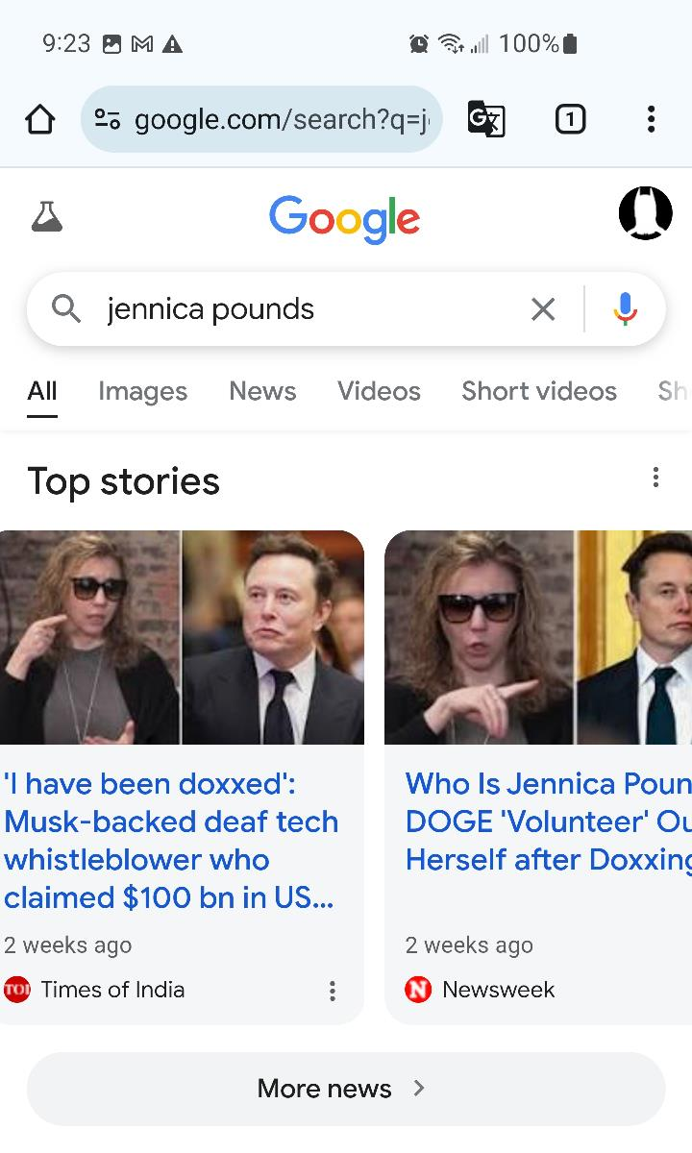

* Universal Design for Learning (UDL): Integrating UDL principles in education and public spaces ensures accessibility for all, including deaf individuals, by creating learning environments that are flexible, adaptable, and inclusive.

2. Education and Employment:

* Quality Deaf Education: Investment in specialized deaf education programs, qualified teachers, and culturally relevant curriculum is essential for academic success and social-emotional development. This includes promoting bilingual-bicultural education that embraces both sign language and spoken language.

* Vocational Training and Job Placement: Programs that provide vocational training tailored to the needs of deaf individuals and facilitate job placement in accessible and inclusive workplaces are critical for economic empowerment.

* Addressing Employment Discrimination: Enacting legislation that prohibits discrimination based on disability, including deafness, and enforcing anti-discrimination laws are essential for equal opportunities in the workplace.

3. Healthcare and Mental Health:

* Accessible Healthcare: Ensuring access to qualified medical professionals who are proficient in sign language and trained in deaf-specific healthcare needs is vital for accurate diagnosis and effective treatment.

* Mental Health Services: Providing culturally sensitive mental health services tailored to the specific needs of deaf individuals is crucial for addressing the unique challenges they face, including social isolation and communication barriers.

* Deaf-Specific Research: Funding research on deaf-specific health issues, including hearing loss, mental health, and communication needs, is essential for improving health outcomes and developing targeted interventions.

4. Cultural Recognition and Empowerment:

* Promoting Deaf Culture and History: Investing in initiatives that celebrate deaf culture, history, and achievements is essential . Government, we plead with you to act! Fund interpreters and captioning, mandate accessibility, and support quality deaf education. Ensure accessible healthcare and mental health services, and fight employment discrimination. Recognize and celebrate Deaf culture. These are not just requests, but essential steps towards an inclusive society where every deaf individual can thrive. We urge you to answer this call and create a world where deafness is not a barrier, but a vibrant part of our shared humanity.

*Dear Government,*

We are writing to inform you that our organization, has a dedicated account for receiving financial contributions specifically for supporting the deaf community. We are committed to using these funds to provide and ensure their access to vital resources.

Yes any of the lawmakers or staff can reach out to me through [[redacted]]

We believe that by working together, we can create a more inclusive and accessible society for deaf individuals. Please feel free to contact us if you have any questions or wish to explore further collaboration.

Sincerely,

*Jennica Pounds.*

Jennica Pounds – aka: “Data Republican (small r) Contact her at DataRepublican.com or X.com/DataRepublican – is an AI software engineer & data expert (The “small r” denotes her unbiased allegiance is not to the Republican Party, but rather to the Republic, in her advocacy to convey an unbiased approach for transparency in exposing & analyzing wasteful government spending by both political parties—and improve efficiency.) She is well-known for providing online resources for the public which she’s developed to expose connections between government grants, NGOs, & spending. She is a deaf, non-verbal activist who uses AI to scrape the Internet to provide detailed data on government spending with an online search portal. Pounds, whose identity was outed & doxxed recently, has been publicly supported by Elon Musk and other prominent figures regarding her research into USAID spending concerns, and she has well-over 600k followers on X / Twitter. When we recently contacted her by email to thank her for being nonpartisan and unbiased – seeking to expose irresponsible spending by both Democrats and Republicans – she responded and subsequently requested that we do news and commentary seeking assistance from the government for the needs of deaf Americans – and submitted this guest column – which we are publishing in this space because we believe that her request – needs of disabled citizens – reaches or surpasses the “60%” popularity threshold which we set for key issues of importance. Her resources are also listed among other bipartisan and nonpartisan funding trackers in the section above.

Contract With America: Part II® URL: https://ContractWithAmerica2.com
MIRROR-A: https://GordonWatts.com/n.index.html
MIRROR-B: https://GordonWayneWatts.com/n.index.html
Archive Today library: https://Archive.vn/contractwithamerica2.com
Wayback Machine library: https://Web.Archive.org/web/*/https://ContractWithAmerica2.com
The Register, Editor-in-Chief, Gordon Wayne Watts
MIRROR-A: https://GordonWatts.com
MIRROR-B: https://GordonWayneWatts.com
Archive Today library-A: https://Archive.ph/gordonwatts.com
Archive Today library-B: https://Archive.ph/gordonwaynewatts.com
Wayback Machine library-A: https://Web.Archive.org/web/*/https://GordonWatts.com
Wayback Machine library-B: https://Web.Archive.org/web/*/https://GordonWayneWatts.com

