IRAN:
EMP THREAT

The Islamic Republic of Iran’s Military Doctrine, Plans, and Capabilities for
Electromagnetic Pulse (EMP) Attack

Dr. Peter Vincent Pry
Executive Director
EMP Task Force on National and Homeland Security
April 30, 2022

TABLE OF CONTENTS

KEY JUDGMENTS………………………………………………………………………..1

Does Iran Have Nuclear Weapons?......................................................................................2

Iranian Missiles and EMP Threat………………………………………………………….5

Nuclear HEMP Attack By Satellite…………………………………………………………9

Super-EMP Satellites?.........................................................................................................10

Iran Defends Against Nuclear HEMP Attack……………………………………………..12

Nuclear HEMP Attack In Iran’s Military Doctrine……………………………………….13

Iran: Non-Nuclear EMP Threat…………………………………………………………..15

Scenario #1: Lower-Tech NNEMP Attack……………………………………….17
Scenario #2: Higher-Tech NNEMP Attack………………………………………19

Iran: Some Nuclear HEMP Scenarios……………………………………………………22

Iran Strikes Israel…………………………………………………………………22
Iran Strikes Egypt and Israel……………………………………………………...25
Iran Strikes Saudi Arabia and the Gulf States……………………………………27
The IRGC Strikes Italy…………………………………………………………...29

Strategic Implications of EMP Threat from Iran…………………………………………32

KEY JUDGMENTS

Washington’s bipartisan consensus is that Iran does not yet have nuclear weapons or missiles capable of threatening the United States with nuclear attack. But some Israeli analysts and some highly credible U.S. experts disagree with the “consensus view.”

Several senior Reagan and Clinton Administration national security officials warned in 2015 and again in 2021: “Regardless of intelligence uncertainties and unknowns about Iran’s nuclear weapons and missile programs, we know enough now to make a prudent judgment that Iran should be regarded by national security decision makers as a nuclear missile state capable of posing an existential threat to the United States and its allies…The fact of Iran’s…proximity to nuclear weapons necessitates that Iran be regarded as a nuclear missile state—right now… Iran probably has nuclear warheads for the Shahab-III medium-range missile, which they tested for making EMP attacks”

Iran has hundreds of medium-range and short-range ballistic missiles (MRBMs and SRBMs), more by far than any other nation in the Middle East. If armed with a nuclear warhead, any of these could be fused for high-altitude burst to make an EMP attack.

Iran has not demonstrated a military intercontinental missile equipped with a reentry vehicle capable of penetrating the atmosphere, accurate enough to strike a city. Yet a High-altitude Electromagnetic Pulse (HEMP) attack does not require a reentry vehicle or accuracy.

If North Korea, Iran’s strategic partner, gives the IRGC a Super-EMP nuclear weapon, they would not have to wait for a “true ICBM” but could use a satellite to blackout North America and terminate the “Great Satan.”

Iran’s intentions to exploit HEMP offensively may be reflected in their efforts to protect at least some of their critical infrastructures from HEMP attack.

An official Iranian military textbook endorses nuclear HEMP attack against the United States, as well as deception measures to conceal nuclear weapons in violation of international agreements.

Iran has demonstrated sophisticated cruise missiles and drones, using over 20 to make highly precise and coordinated attacks on Saudi Arabia’s oil processing facilities on September 14, 2019.
Such delivery vehicles could easily be armed with Non-Nuclear EMP (NNEMP) warheads.
NNEMP might be able to achieve results similar to a nuclear HEMP attack in blacking-out power grids, though the NNEMP attack would probably take hours instead of seconds.
If Iran acquires or develops nuclear HEMP attack capabilities, Iran's targets or that of its terrorist proxies will most likely be the populations of America and Israel.

The Islamic Revolutionary Guard Corps (IRGC) has access to all of Iran’s weapons and is so fanatical that a scenario cannot be ruled out where the IRGC acts independently of the political government of Iran and its spiritual leaders.

Does Iran Have Nuclear Weapons?

Washington’s bipartisan consensus is that Iran does not yet have nuclear weapons or missiles capable of threatening the United States with nuclear attack.

But some Israeli analysts and some highly credible U.S. experts disagree with the “consensus view.” For example, a 2015 article co-authored by several senior Reagan and Clinton Administration national security officials warned:

“Regardless of intelligence uncertainties and unknowns about Iran’s nuclear weapons and missile programs, we know enough now to make a prudent judgment that Iran should be regarded by national security decision makers as a nuclear missile state capable of posing an existential threat to the United States and its allies…The fact of Iran’s ICBM capability and their proximity to nuclear weapons necessitates that Iran be regarded as a nuclear missile state—right now.”

Experts assessing that Iran already has nuclear-armed missiles and an EMP attack capability include Ambassador R. James Woolsey (former CIA Director and Director of Central Intelligence), Dr. William R. Graham (former Science Advisor to President Reagan who ran NASA and served as Chairman of the Congressional EMP Commission), Fritz Ermarth (former Chairman of the National Intelligence Council), and Ambassador Henry Cooper (former Director of the Strategic Defense Initiative).

These stellar intelligence officers, strategic thinkers, and scientists played major roles helping win the Cold War. Perhaps we should listen to them now about Iran:

“Iran probably has nuclear warheads for the Shahab-III medium-range missile, which they tested for making EMP attacks…Iran already has the largest medium-range ballistic-missile force in the Middle East.”
“Iran could be building a nuclear-capable missile force, partly hidden in tunnels, as suggested by its dramatic revelation of a vast underground missile-basing system last year. Iran is building toward a large, deployable, survivable, war-fighting missile force — to which nuclear weapons can be swiftly added as they are manufactured.”

“And at a time of its choosing, Iran could launch a surprise EMP attack against the United States by satellite, as they have apparently practiced with help from North Korea.”

In 2021, national security wisemen Woolsey, Graham, Cooper, and Ermarth warned again that “Iran Probably Already Has The Bomb”:

“The IAEA and the U.S. intelligence community have long been poor nuclear watchdogs. IAEA inspections failed to discover clandestine nuclear-weapons programs in North Korea, Pakistan, Iraq, and Libya. In 1998, the intelligence community’s ‘Worldwide Threat Assessment’ failed to warn that, just a few months later, Pakistan and India would overtly ‘go nuclear’ with a series of nuclear-weapons tests. U.S. intelligence often underestimated nuclear threats from Russia, China, and North Korea. It is likely now doing the same with Iran. Contrary to mainstream thinking:”

• “Iran can build sophisticated nuclear weapons by relying on component testing, without nuclear testing. The U.S., Israel, Pakistan, and India have all used the component-testing approach. The U.S. Hiroshima bomb was not tested, nor have been more sophisticated U.S. thermonuclear warheads during the past 30 years. Pakistan and India’s 1998 nuclear tests were done for political reasons, not out of technological necessity.”
• “IAEA inspections are limited to civilian sites, and restricted from military bases, including several highly suspicious underground facilities where Iran’s nuclear-weapons program almost certainly continues clandestinely. Imagery of one vast underground site, heavily protected by SAMs, shows high-voltage powerlines terminating underground, potentially delivering enormous amounts of electricity, consistent with powering uranium enrichment centrifuges on an industrial scale. So IAEA reports on Iran’s enriched-uranium stockpile almost certainly are not the whole story.”
• “The U.S. intelligence assessment that Iran suspended its nuclear-weapons program in 2003 is contradicted both by Iran’s nuclear archives, stolen by Israel in 2018, indicating Iran’s ongoing nuclear-weapons program (reported at several sites in 2006, 2017, and 2019) and by Iran’s rapid resumption of enriching uranium to prohibited levels. This demonstrates an existing capability to quickly produce weapons-grade uranium. Reports from the Congressional Electromagnetic Pulse (EMP) Commission elaborate these and important related issues.”
• “Most estimates assume Iran needs five to ten kilograms of highly enriched (over 90 percent) uranium-235 or plutonium-239 to make an atomic weapon, as with the first crudely designed A-bombs that destroyed Hiroshima and Nagasaki. But a good design requires only one to two kilograms. Crude A-bombs can be designed with uranium-235 or plutonium-239 enriched to only 50 percent.”
• “Iran’s nuclear and missile programs are not just indigenous, but are helped significantly by Russia, China, North Korea, and probably Pakistan.”
• “While the intelligence community uses an in-country nuclear test as confirmation that a country, including Iran, has developed a nuclear weapon, this leaves it wide open to deceiving itself, our leadership, and our allies. Iran and North Korea have close working relations, North Korea will do anything for Iranian oil, and Iranians have reportedly been present at some of North Korea’s nuclear tests. North Korea could easily have exchanged information with Iran and even tested Iranian nuclear weapons as well as their own — if there is any difference — without the U.S. and its allies knowing whose weapons were being tested. North Korean scientists are known to be in Iran helping the Islamic Revolutionary Guard ‘space program’ that provides cover for developing ICBMs.”

“As we warned five years ago, it is implausible and imprudent to assume that Iran refrained from making atomic weapons for more than a decade, when they could do so clandestinely. Iran probably has nuclear warheads for the Shahab-III medium-range missile, which they tested for making EMP attacks. . . . And at a time of its choosing, Iran could launch a surprise EMP attack against the United States by satellite.”

In 2015 and 2019, David Albright, former nuclear inspector for the UN International Atomic Energy Agency (IAEA), and Olli Heinonen, former Deputy Director General of IAEA, and other experts, published Institute for Science and International Security reports based on Iran’s secret nuclear weapon archives clandestinely obtained by Israel’s Mossad:

“The archive shows that the AMAD program intended to build five nuclear warhead systems for missile delivery and possible use in preparation for an underground nuclear test; an actual test would require a decision to proceed. The program was also partially designed to have its own independent uranium mining, conversion, and enrichment resources. The documentation indicates that Iran’s nuclear weaponization efforts did not stop after 2003…”

“The United States incorrectly assessed with high confidence in a 2007 declassified National Intelligence Estimate (NIE) that ‘in fall 2003, Tehran halted its nuclear weapons program.’ Based on the information in the archives, Iran’s nuclear weapons program continued after 2003…Moreover, the 2007 NIE also incorrectly asserted that Iran had not re-started its nuclear weapons program as of mid-2007…However, there is no evidence that the program was ever fully halted, even up to today.”

“The information in the archive evaluated so far does not answer the question of what the current status of Iran’s nuclear weapons program is…”

In an interview, retired General Paul Vallely said Iran already has nuclear weapons and that “decades of intelligence” shows Russia, China, and North Korea helped:

“Iran already has a nuclear weapon, making the nuclear deal ‘a moot point’ retired U.S. Army Gen. Paul Vallely told Newsmax TV…Decades of intelligence reports show that Teheran has ‘gotten support from Russia, from North Korea and from China,’ Vallely told…host J.D. Hayworth. ‘It’s a cabal that’s been set up to support the Iranian nuclear program. They have the launch systems. They have the guidance-control system. They have the detonation system. They have the warhead. And guess what? Russia and North Korea’s tested everything for them. All they have to do is put it together like a tinker toy—and that’s why they have the nuclear capability now,’ Vallely said.

Assessments that Iran does not yet have nuclear weapons assume erroneously: our intelligence is perfect, Iran’s civilian nuclear program is all there is, no clandestine nuclear weapons program exists in Iran’s numerous underground military facilities—including unaccounted uranium and plutonium facilities for fueling nuclear weapons, as in North Korea.
However, a Defense Department report Assessment of Nuclear Monitoring and Verification Technologies by the blue ribbon Defense Science Board, concludes the following:

“Closing the nation’s global nuclear monitoring gaps should be a national priority. It will require, however, a level of commitment and sustainment we don’t normally do well without a crisis.”

“…monitoring for proliferation…presents challenges for which current solutions are either inadequate, or more often, do not exist. Among these challenges are…Small inventories of weapons and materials…Small nuclear enterprises designed to produce, store, and deploy only a small number of weapons…Undeclared facilities and/or covert operations, such as testing below detection thresholds, or acquisition of materials or weapons through theft or purchase…Use of non-traditional technologies…”

These intelligence blind-spots align perfectly with U.S. monitoring gaps against Iran’s nuclear program. The Defense Science Board report is tantamount to an admission that Iran probably already has the bomb.

Where Iran is concerned, our Intelligence Community appears to have learned nothing from its spectacular failures grossly underestimating the nuclear threat from North Korea. Does the Intelligence Community even want to know the truth about Iran’s Islamic bomb?

Reza Kahlili, the only CIA operative to successfully penetrate the scientific wing of Iran’s Revolutionary Guard, claimed Iran does have nuclear weapons and offered to procure photographs. Then President Obama’s Intelligence Community was not interested.

President Trump inherited an Intelligence Community that disagreed with him about almost everything, including his decision to withdraw from the Iran nuclear deal. According to the Intelligence Community, Iran was in technical compliance with the nuclear deal, officially the Joint Comprehensive Plan Of Action (JCPOA).

President Biden, over objections from Israel and moderate Arab states, is giving high-priority to reviving the JCPOA nuclear deal, offering billions of dollars in benefits, removing the Islamic Revolutionary Guard from the State Department’s list of terrorist organizations, despite Intelligence Community estimates that Iran is merely weeks from its “Islamic Bomb.”

If Intelligence Community estimates are correct, Iran is a threshold nuclear weapons state.
Prudence would dictate regarding Iran as a de facto nuclear threat.

But if Iran has already had nuclear weapons for years, perhaps since 2003, then Tehran was never in compliance with JCPOA, and the Intelligence Community can chalk-up another major intelligence failure, potentially far more consequential than Pearl Harbor or 9/11.

Iranian Missiles and EMP Threat

Iran has hundreds of medium-range and short-range ballistic missiles (MRBMs and SRBMs), more by far than any other nation in the Middle East. If armed with a nuclear warhead, any of these could be fused make a High-altitude EMP (HEMP) attack.

Iran’s Shahab-III MRBM may be clandestinely armed with a nuclear warhead for HEMP attack.

The IAEA discovered that, prior to 2003, Iran worked on over a dozen different configurations for the “physics package” of a nuclear bomb to fit inside the normal re-entry vehicle for the Shahab-III’s high-explosive (HE) warhead. Since it is far easier to change the shape of a re-entry vehicle than to alter the design of an atomic bomb, it seems obvious Iran was planning to disguise nuclear warheads as HE warheads, so it could deploy clandestinely a force of nuclear-armed Shahab-IIIs, Iran’s longest-range and best mobile MRBM.

Iran also successfully conducted several high-altitude exo-atmospheric fusing tests for the Shahab-III, consistent with practicing nuclear HEMP attacks. EMP Commission Chairman, Dr. William Graham, testified to Congress that these fusing tests had no other good explanation, except evidenced Iranian development of HEMP attack capabilities.

Iran's Shahab-III is capable of delivering a HEMP attack over the American heartland, if launched from a freighter in the Gulf of Mexico. Iran has demonstrated the capability to launch a ballistic missile from a vessel at sea.

Congressional testimony by EMP Commissioners warns of anonymous HEMP attack launched off a freighter by Iran or terrorists:

DR. GRAHAM: “Iran, the world’s leading sponsor of international terrorism, has practiced launching a mobile ballistic missile from a vessel in the Caspian Sea. Iran has also tested high-altitude explosions of the Shahab-III, a test mode consistent with EMP attack, and described the tests as successful. Iranian military writings explicitly discuss a nuclear EMP attack that would gravely harm the United States.”

DR. GRAHAM: “…it is possible to launch ballistic missiles—Scuds for example—from ships off our shore in a way that brings them very near our shores covertly and can propel nuclear weapons well above the atmosphere over our coastal regions. Scuds are a glut on the world market today. We have had instances of private collectors buying them and having them show up literally on our docks and facilities.”

DR. WOOD: “A determined adversary can achieve an EMP attack capability without having a high level of military or nuclear sophisticat[ion]. For example, a Scud missile launched from a freighter off the Atlantic coast of the United States could…enable a terrorist group to mount an EMP attack against roughly half the United States in population terms…Terrorists might buy, steal, or be given a ‘no fingerprints’ nuclear weapon…Iran, the world’s leading sponsor of international terrorism, is widely reported to have a nuclear weapons program that is more sophisticated than previously suspected and is known to have test launched a Scud missile from a vehicle in the Caspian Sea in a launch mode that could be adopted, as indeed Secretary of Defense Don Rumsfeld has noted twice in public, could be adapted to support attack against the United States from the sea, including EMP attacks.”

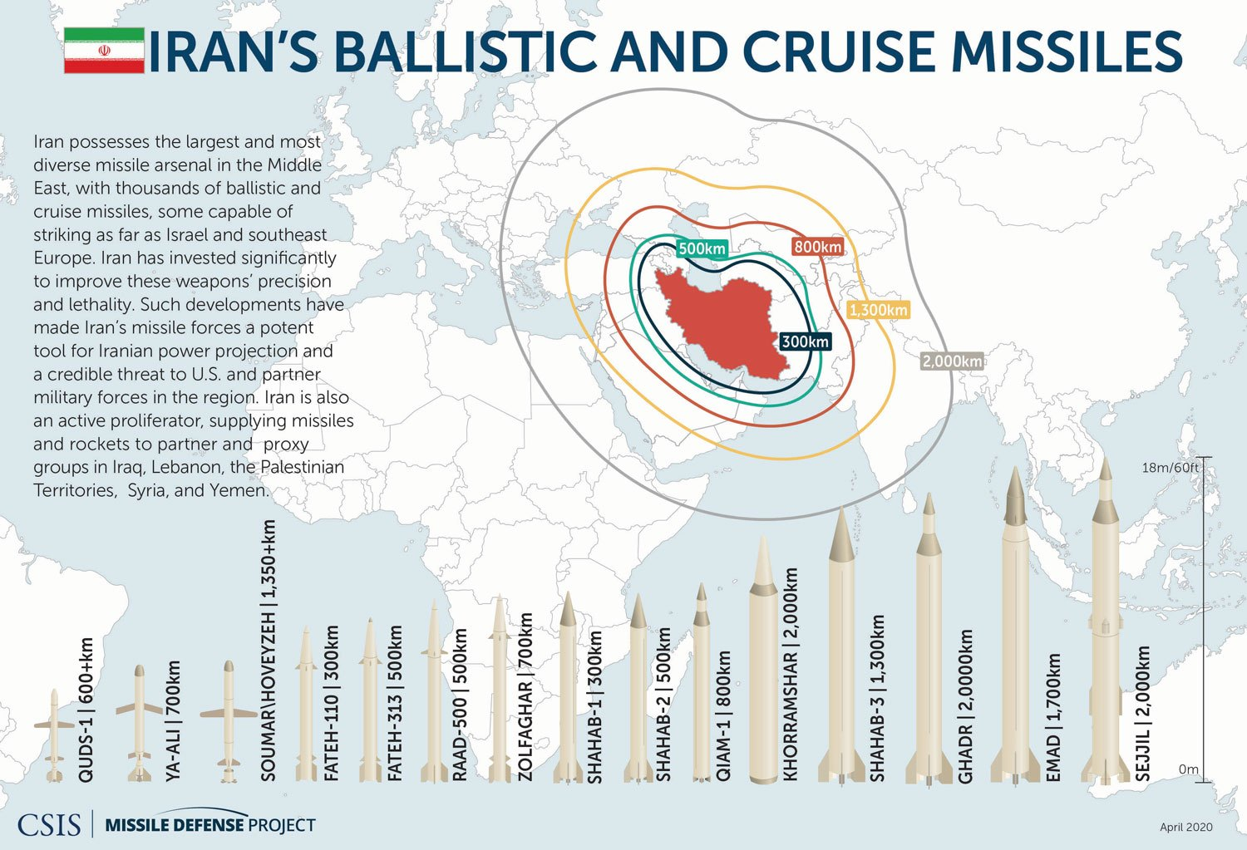

Nuclear HEMP Attack By Satellite?

“Iran states it has imaging capabilities—actually it’s a tumbling webcam in space, unlikely providing intelligence,” so General Jay Raymond, then chief of U.S. Space Command, belittled as non-threatening the first launch of a military satellite by Iran’s Islamic Revolutionary Guard Corps (IRGC), the world’s deadliest state-sponsored terrorist organization.
If U.S. Space Command will not take seriously that terrorists can now orbit a military satellite over the United States, that the IRGC is developing space weapons, then who will? Warning about possible threats from space weapons should be U.S. Space Command’s job #1.
The IRGC’s Noor-1 (“Light-1”) satellite, orbited on April 22, 2020, is easy to mock, especially by those determined to “see no evil.”
Noor-1 is tiny, having a volume of only a few liters and variously estimated as weighing only 5-14 kilograms (11-30 pounds)—too small for an effective “spy in the sky” or for much else militarily useful.
Noor-1 is certainly too small for a nuclear weapon.
Orbiting with Noor-1, however, was the third stage of the Qased (“Messenger”) missile that lofted Noor-1. The third stage was an expended solid fuel rocket motor, either the Arash-24 probably weighing over 100 kilograms (220 pounds) or the Salman probably weighing over 300 kilograms (661 pounds).
So counting Noor-1 and the third stage together, the Islamic Revolutionary Guard Corps demonstrated capability to orbit over the U.S. a net payload weighing about 105-334 kilograms (231-691 pounds)—enough for a nuclear weapon.
The IRGC might deliberately try to deceive the U.S. into underestimating their space weapon capabilities by separating Noor-1 from the third stage, hoping we will dismiss the significance of the tiny Noor-1 satellite, as done by U.S. Space Command.
U.S. Space Command and virtually all analysts are focused on the IRGC’s Qased missile as the real threat, not the satellite.
Rightly, U.S. Space Command and others are concerned about:
--Qased missile’s use of solid rocket motors in the second and third stages, a great leap forward in Iran’s missile technology.
--Solid rocket motors enable a missile to be launched quickly, with minimal preparation, increasing capability for surprise attack.
--Qased’s new Transporter-Erector-Launcher (TEL) enables the IRGC to launch from anywhere, increasing capability for surprise attack.
--The IRGC launched Noor-1 unannounced, attempting to achieve surprise.

If Iran can develop solid-fueled ICBMs and a mobile TEL to launch them, they will join Russia, China, and North Korea as the only nations in the world with a mobile ICBM: a missile optimized for surprise attack. Not even the United States has mobile ICBMs.

Iran has orbited civilian satellites in 2008, 2009, 2010, 2015; orbited a military satellite; has sub-orbited a monkey into space and returned it safely (2013); and has medium-range military missiles, more than any other nation in the Middle East.

However, Iran has not demonstrated a military intercontinental missile equipped with a reentry vehicle capable of penetrating the atmosphere, accurate enough to strike a city. Yet a High-altitude Electromagnetic Pulse (HEMP) attack does not require a reentry vehicle or accuracy.

U.S. Space Command worries about ICBM threats from Iran in the distant future, but not the potential threat from IRGC satellites here and now. U.S. Space Command does not think like a terrorist organization.

The Islamic Revolutionary Guard Corps thinks they are at war with the infidel West for the global triumph of Islam during the “end time” of history. They are willing to do anything to prevail, to take desperate strategic and technological chances.

Is it likely the IRGC will wait to weaponize their space capabilities until they can develop a “true ICBM” as defined by U.S. Space Command?

Right now, the IRGC is probably thinking about how to maximize the harm they can do to the U.S. by satellite delivery of a few hundred kilograms of payload.

Anthrax spores? Radioactive waste?

Not militarily effective, but psychologically terrorizing—which is what terrorists like the IRGC do. Nuclear HEMP attack by satellite would be militarily effective, catastrophic to U.S. life-sustaining critical infrastructures, and most terrorizing of all.

General Amir Hajizadeh, Commander of the IRGC Aerospace Force, was pleasantly surprised by America’s passive response to Noor-1, telling Iranian press:

“I did not believe they [the U.S.] wouldn’t respond. We had chosen 400 targets to strike in case the U.S. attacks.”

While U.S. Space Command derided Noor-1 as a joke, clearly a relieved IRGC General Hajizadeh expected the U.S. to see the satellite as such a grave potential threat it could trigger a war. Indeed, terrorist General Hajizadeh declared the military potential of little Noor-1 somehow meant: “We are now a superpower.”

The Great Generation that won World War II and the Cold War understood instantly the strategic threat from Russia’s Sputnik satellite orbited in 1957. Sputnik was merely the size of a beachball, weighed only 184 pounds.

Distracted by the Ukraine War and trying to negotiate revival of the JCPOA nuclear deal with Iran, Washington hardly noticed the Islamic Revolutionary Guard Corps’ successful launch of a second military satellite, Noor-2, on March 8, 2022.

Super-EMP Satellites?

The Congressional EMP Commission assesses that technology transfer from Russia has given North Korea the capability to make nuclear weapons specialized for generating extraordinarily powerful EMP fields, called “Super-EMP” weapons by Russia. Super-EMP warheads are potentially small enough to be orbited over the U.S. in North Korea’s KMS-3 and KMS-4 satellites.

If North Korea, Iran’s strategic partner, gives the IRGC a Super-EMP nuclear weapon, they would not have to wait for a “true ICBM” but could use a satellite to blackout North America and terminate the “Great Satan.”

Might North Korea sell nuclear-armed satellites with Super-EMP warheads to Iran? North Korea and Iran have been collaborating all along and have signed an agreement to cooperate in “science and technology.”

The EMP Commission Chairman’s Report warns North Korea’s KMS-3 and KMS-4 satellites are potential Super-EMP threats because of technology transfer from Russia including possibly “ultra-small warheads weighing less than 90 kilograms…Such weapons would be small enough for North Korea’s satellites.” Such a Super-EMP warhead would also be deliverable by a satellite from Iran.

Iran may already have Super-EMP satellites, as it has successfully launched several heavy satellites, including on southern polar trajectories, assisted by North Korean missile technology and North Korean technicians.

Iranian scientists have been present at all North Korean nuclear tests, according to press reports. North Korean scientists are known to be present in Iran. North Korea has been denounced by the United Nations for selling a facility to Syria for developing nuclear weapons, which was bombed by Israel. So if North Korea has sold nuclear weapons technology to Syria, why not Iran?

North Korea sold to Iran its most sophisticated theater ballistic missile, the Shahab-III, which is an improved version of North Korea's Nodong missile.

Conceivably, Iran could already have or be very close to developing a Super-EMP warhead.

Reza Kahlili, the only CIA operative to successfully penetrate the scientific wing of the Iranian Revolutionary Guard, now in a witness protection program and once working as a journalist, reports that Iran acquired several tactical nuclear warheads from Russia—including a neutron warhead. Neutron warheads, more accurately Enhanced Radiation Warheads because they also emit other enhanced radiation—including enhanced gamma rays that generate the EMP effect—
would be well-suited for making a HEMP attack.

In June 2002, when concern about Iran's nuclear weapons program was beginning in the West, Russian General Yuri Baluyevsky, Deputy Chief of the Russian General Staff, declared: "Iran does have nuclear weapons. These are non-strategic nuclear weapons...As for the danger of Iran's attack on the United States, the danger is zero."

This startling declaration, little reported in the Western press, by Russia's second highest military officer—who was soon promoted to Chief of the General Staff, the highest rank, equivalent to the U.S. Chairman of the Joint Chiefs of Staff—appears to confirm Reza Kahlili's warning that Iran already has tactical nuclear warheads from Russia.

How did General Baluyevsky know so much about Iran's nuclear weapons program, and why was he so complacent about Iran's already having tactical nuclear weapons?

After the fall of the USSR, in 1995 a military think tank called INOBIS, that serves the Russian General Staff, wrote a paper recommending that Russia deliberately proliferate missile and nuclear weapon technology to nations hostile to the United States—including Iran and North Korea. Nuclear proliferation would balance growing U.S. power, and thwart Washington's efforts to establish a New World Order dominated by America.

Is it possible that the Russian General Staff followed this policy, deliberately transferred tactical nuclear weapons, including an Enhanced Radiation Warhead, and purposely leaked the secret of the Super-EMP nuclear warhead to North Korea and Iran?

Iran Defends Against Nuclear HEMP Attack

Iran’s intentions to exploit EMP offensively may be reflected in their efforts to protect at least some of their critical infrastructures from HEMP attack.

Some analysts have suggested that a nuclear HEMP attack may be a way of stopping Iran's nuclear weapons program. If HEMP collapses Iran's electric grid and other critical infrastructures, and so neutralizes the effectiveness of the Iranian Revolutionary Guard, the Iranian people, a majority of whom oppose the Mullahs, would have a chance for successful regime change.

However, according to Iranian press—Iran has been hardening critical facilities against HEMP attack by smuggling in EMP protective devices embargoed by the West. On June 13, 2015, according to a report by Iran's MEHR News Agency, Saedi Rahimi, Director of Kosar Information and Communication Technology Institute, announced, "Iranian researchers...have built an Electromagnetic Pulse (EMP) filter that protects the country's vital organizations against cyber attacks." According to the report:

“Rahimi told MNA correspondent that the EMP (Electromagnetic Pulse) filter is one of the country's boycotted products and until now procuring it required considerable costs and various strategies. ‘But recently Kosar ICT knowledge-based group has managed to domestically manufacture the EMP filter for the first time in the country,’ said Rahimi. Noting the domestic EMP filter has been approved by security authorities, Rahimi added ‘the EMP filter protects sensitive devices and organizations against electromagnetic pulse and electromagnetic terrorism.’ He also said the domestic EMP filter has been implemented in a number of vital centers in Iran.”

Note in the above report that HEMP is equated with a "cyber-attack" just as in the military doctrines of Russia and China. Interestingly, the Iranian article is illustrated with artwork that appears to depict a satellite making a HEMP attack—like the Super-EMP satellites the EMP Commission warns may have been developed by North Korea.

Nuclear HEMP Attack In Iran’s Military Doctrine

An official Iranian military textbook endorses nuclear HEMP attack against the United States, as well as deception measures to conceal nuclear weapons in violation of international agreements. Iran’s military textbook is for training officers at their prestigious military academy and think tank—the Martyr Lt. General Sayad Shirazi Center for Education and Research.

Strangely for a book titled Passive Defense, its overarching focus is how to blackout electric grids—including by nuclear HEMP attack.

Prominently featured is Russian General Vladimir Slipchenko's theory that mankind is on the verge of a Revolution in Military Affairs where nations can be defeated without armies by Information Warfare and EMP weapons that destroy electric grids and other critical infrastructures that are vital to the existence of modern nation states.

By amazing coincidence, General Slipchenko is one of the two Russian EMP experts who demarched the Congressional EMP Commission in 2004 to warn that North Korea would "in a few years" develop a nuclear Super-EMP warhead based on design information that leaked from Russia, allegedly accidentally.

General Slipchenko's warning proved prescient.

General Slipchenko's intimate knowledge of North Korea's nuclear weapons program, and now his appearance as a guiding military authority in an Iranian military textbook that endorses nuclear HEMP attack, indicates Russia is helping North Korea and Iran's nuclear and missile programs.

Iran’s military textbook describes non-nuclear and nuclear EMP weapons and their effectiveness for attacking electric grids at length, including photos, graphics, and tables. For example, one table details how a nuclear HEMP attack can defeat an aggressor by destroying equipment that supports "Leadership, command, and control/communications...Key productions...Connective networks, transportation, and communications...National will/human population...Military and police forces."

Graphite bombs, radiofrequency weapons, and nuclear EMP weapons are considered wonder weapons that can defeat nations without traditional warfare. The book includes mathematical formula for calculating the value of electric power plants for targeting and protection.

Nuclear and non-nuclear EMP weapons operate differently but morally are the same, according to Iran’s military textbook. Passive Defense endorses nuclear HEMP as "an advanced and useful weapon in modern warfare":

“As a result of not having the other destructive effects that nuclear weapons possess, among them the loss of human life, weapons derived from electromagnetic pulses have attracted attention with regard to their use in future wars...The superficiality of secondary damage sustained, as well as the avoidance of human casualties, serves as a motivation to transform this technology into an advanced and useful weapon in modern warfare.”

Thus, Iran may not regard capability for HEMP attack the same as development of a "nuclear weapon."
Significantly for negotiations over Iran's capability to make nuclear weapons, Passive Defense admires Moscow's deception programs that concealed from the U.S. the numbers and capabilities of Soviet nuclear weapons, enabling the USSR to cheat on treaties during the Cold War.
Will nuclear deterrence work against Iran? The Mullahs who run Iran, and whose apocalyptic ideology many analysts believe is driving Iran's nuclear weapons program, may welcome the "nuclear suicide bombing" of their entire nation and its leaders as a noble and necessary sacrifice to fulfill their eschatological vision of the “end times” and the return of their 12th Imam.

If Iran already has nuclear weapons, and HEMP attack capability, why have they not yet attacked “the Great Satan” that is the United States?

Radical Islamist cleric Nasir al-Fahd’s May 2003 fatwa A Treatise On The Legal Status Of Using Weapons Of Mass Destruction Against Infidels may provide a clue. Although al-Fahd is a Sunni sympathetic to al Qaeda, his rules for a nuclear holocaust against Infidels may well govern the thinking of the Shiite mullahs who run Iran too:

First, under Islam’s “Just War Doctrine” the Infidels have to be given an opportunity to convert to Islam, before they can be destroyed. This Iran’s leaders have done repeatedly, most prominently former President Mahmoud Ahmadinejad speaking at Columbia University (September 24, 2007) and at least twice at the United Nations (September 23, 2009 and September 26, 2012) about “the current world order based on injustice” and the virtues of the Islamic Republic of Iran.

Next, a “final solution” against Infidels cannot be implemented except in a defensive war to protect the Ummah, the community or territory of Islam. So a U.S. bombing campaign, especially one that threatens regime change in Iran, would justify nuclear annihilation of “the Great Satan.”

Is it possible Iran is deliberately trying to provoke the U.S. to attack, so the Mullahs can in “self-defense” come out of the nuclear closet by blasting a U.S. aircraft carrier, or making a HEMP attack on North America?

Calculations in Passive Defense that America could be vanquished by a nuclear HEMP attack are correct.

We should be treating Iran like a nuclear weapons state, with the same prudent caution used toward North Korea. Let’s not learn the hard way that Iran already has its “Islamic Bomb.”

Iran: Non-Nuclear EMP Threat

Special mention must be made of the ongoing technological revolution in Non-Nuclear EMP weapons, which are becoming more powerful, more miniaturized and lighter-weight, and deliverable by cruise missiles or drones. The marriage of NNEMP warheads to drones or cruise missiles, preprogrammed or equipped with sensors to follow high-power electric lines and to target control centers and transformers, introduces a major new threat to national power grids.
A non-explosive High-Power Microwave warhead, for example, can emit repeated bursts of electromagnetic energy to upset and damage electronic targets. Such a warhead, attached to a programmable drone or cruise missile, could follow the powerlines to attack numerous transformer and control substations, until its energy is exhausted.
Relatively small numbers of NNEMP cruise missiles or drones—perhaps only one capable of protracted flight—could inflict a long nationwide blackout. Reportedly, according to a classified study by the U.S. Federal Energy Regulatory Commission, disabling just 9 of 2,000 U.S. EHV transformer substations could cause cascading failures that would crash the North American power grid.
The “Cascade Failure” problem, warns Dr. Carlo Kopp, makes modern digital societies highly vulnerable to NNEMP attack: “Digital infrastructure is highly interconnected and thus interdependent.” Because of: “Common reliance on power grid, telecommunications cabled and wireless connections, local and remote servers, single and multiple site Clouds and Grids,” consequently, “A mass destruction effect in one geographical area can cause cascading failures as interdependent systems fail…Damage effects are thus no longer localized in extant, e.g. destroying a server or Cloud in Washington DC may cripple dependent systems globally.”
Thus, NNEMP might be able to achieve results similar to a nuclear HEMP attack in blacking-out power grids, though the NNEMP attack would probably take hours instead of seconds.
“The technology used in conventional E-Bombs is within reach of any nation capable of designing nuclear weapons and high power radars—e.g. China, Iran, DPRK, Russia,” according to NNEMP expert Dr. Kopp:
--"OSINT source material very scarce on E-Bomb technology and designs, effort is usually well hidden from scrutiny;”
--“Potentially large area footprints of many square miles for GigaWatt class weapons, with the usual lethality prediction caveats—targets not tested may be unexpectedly resistant or susceptible at specific weapon frequencies/polarisations;”
--“Terrorist attacks predicated on the availability of proven designs or inventory of E-Bomb munitions—emerging risk;”
--“The high payoff in using E-Bombs as disruptive or area suppression weapons points to common use in future nation state conflicts involving developed nations.”
The technology for non-nuclear EMP generators and drones is widely available for purchase as civilian equipment which can easily be weaponized, even by non-state actors.
For example, one U.S. company sells a NNEMP device for legitimate industrial purposes called the “EMP Suitcase” that looks like a suitcase, can be carried and operated by one person, generates 100,000 volts/meter over a short distance, and can be purchased by anyone. NNEMP devices like the “EMP Suitcase” could become the Dollar Store version of weapons of mass destruction if turned against the national electric grid by terrorists. A German version of the “EMP Suitcase” weighs only 62 pounds, easily deliverable by a drone or cruise missile.
In 2020, Northeastern University’s Global Resilience Institute (GRI) tested in an EMP simulator numerous electronic components vital to the operation of electric grids and other critical infrastructures. The GRI tests “confirmed the ability for non-state actors to outfit commercially-available platforms to conduct localized tactical EMI attacks against electronics that support critical systems…identified the thresholds at which the functioning of representative electronics in common use across multiple infrastructures could become compromised, generating catastrophic outcomes. This includes, but is not limited to, disruption in cybersecurity safeguards for critical infrastructure to include key components of the electric power grid and telecommunications system.”
GRI’s tests of the non-nuclear EMP threat “confirm that a small EMI emitter that could be carried on a commercially-available drone or terrestrial vehicle, is capable of compromising electronic components, in common commercial use, at very low-energy levels from a considerable distance.”
Most NNEMP generators have limited range, less than 10 kilometers. But if mated to a cruise missile or drone capable of protracted flight to target electric grid key nodes, the results can be spectacular.
For example, Boeing’s Counter-electronics High Power Microwave Advanced Missile Project (CHAMP) cruise missile can be viewed on the internet where CHAMP “navigated a pre-programmed flight plan and emitted bursts of high-powered energy, effectively knocking out the target’s data and electronic subsystems.” The U.S. Air Force has purchased CHAMP cruise missiles, deployed to Japan, reportedly to prevent North Korean missile attacks by “frying” their missiles, command and control, and power grid electronics.
Iran has demonstrated sophisticated cruise missiles and drones, using over 20 to make highly precise and coordinated attacks on Saudi Arabia’s oil processing facilities on September 14, 2019. Such delivery vehicles could easily be armed with NNEMP warheads, to make a less sophisticated version of CHAMP.
Scenario #1: Lower-Tech NNEMP Attack
Scenario #1 is the kind of threat that is well within the technological and operational capabilities of Iran, North Korea, virtually any nation state, and major terrorist or criminal organizations.

Scenario #1 entails a lower-tech NNEMP threat employing weapons which must be man-delivered by automobile or panel truck. The postulated NNEMP weapons are lower-tech also in power, requiring about 10 minutes to maximize damage against the electronics in unmanned electric grid control substations associated with EHV transformers.

Scenario #1 postulates that every panel truck armed with an NNEMP weapon has a two-man crew, one to drive and one to operate the weapon. The NNEMP weapon illuminates the target—an EHV transformer control substation—for 10 minutes. Then the panel truck moves to the next target, the nearest next substation, located on average 40 road miles away, traveling on average 50 mph.

Given these conditions, a single panel truck carrying an NNEMP weapon and 2-man crew can attack 30 EHV transformer control substations in 24 hours. Below find the capabilities for an NNEMP attack performed by up to 30 vehicles in 24 hours:

--1 NNEMP truck can attack 30 EHV transformer control substations in 24 hours;
--2 NNEMP trucks can attack 60 substations;
--3 NNEMP trucks can attack 90 substations;
--4 NNEMP trucks can attack 120 substations;
--5 NNEMP trucks can attack 150 substations;
--6 NNEMP trucks can attack 180 substations;
--7 NNEMP trucks can attack 210 substations;
--8 NNEMP trucks can attack 230 substations;
--9 NNEMP trucks can attack 260 substations;
--10 NNEMP trucks can attack 280 substations;
--11 NNEMP trucks can attack 310 substations;
--12 NNEMP trucks can attack 340 substations;
--13 NNEMP trucks can attack 370 substations;
--14 NNEMP trucks can attack 400 substations;
--15 NNEMP trucks can attack 430 substations;
--16 NNEMP trucks can attack 460 substations;
--17 NNEMP trucks can attack 490 substations;
--18 NNEMP trucks can attack 520 substations;
--19 NNEMP trucks can attack 550 substations;
--20 NNEMP trucks can attack 580 substations;
--21 NNEMP trucks can attack 610 substations;
--22 NNEMP trucks can attack 640 substations;
--23 NNEMP trucks can attack 670 substations;
--24 NNEMP trucks can attack 700 substations;
--25 NNEMP trucks can attack 730 substations;
--26 NNEMP trucks can attack 760 substations;
--27 NNEMP trucks can attack 790 substations;
--28 NNEMP trucks can attack 820 substations;
--29 NNEMP trucks can attack 850 substations;
--30 NNEMP trucks can attack 880 substations.

As noted earlier, reportedly a classified U.S. FERC study calculates that damaging 9 of 2,000 EHV transformer substations (0.45% of all transformers) is enough to cause a protracted blackout nationwide. Just one NNEMP truck could damage over three times this many (30) substations in 24 hours, but in only one of the three big grids.

At minimum, three NNEMP trucks would be required to attack the Eastern, Western, and Texas grids. These collectively could damage 90 substations, 30 substations damaged in each of the major grid systems, ten times the number of substations damaged in the U.S. FERC study.

The NNEMP attack would probably focus on areas that have the highest concentration of EHV transformer control substations, to maximize opportunities for inflicting the most damage in 24 hours.

In the Eastern grid, the seaboard area between Washington, DC and New York City has the highest concentration of substations. In Texas, substations are most highly concentrated around Dallas, Houston, and Austin. In the Western grid, substations are more geographically dispersed, but most concentrated around Los Angeles and Seattle and on the seaboard in between.

Since the Eastern grid generates about 75% of U.S. electricity, an NNEMP attack, or any other kind of attack, would probably focus most of its effort there. Logically, if the attack is proportioned to the percentage of the U.S. electric power supply, about 75% of the effort would attack the Eastern grid, 20% the Western grid, and 5% the Texas grid.

So in Scenario #1, if 20 NNEMP trucks are employed to attack the three big grids in proportion to their electric generating power, 15 would attack the Eastern Grid, 4 would attack the Western grid, and 1 would attack the Texas grid. Collectively, 20 NNEMP trucks could damage 580 EHV transformer substations in 24 hours, 430 substations in the East, 120 substations in the West, 30 substations in Texas—29% of all substations nationwide.

Scenario #1 requires very few operational personnel, just six men for three NNEMP trucks to attack all three big grids. The “army” manning 20 NNEMP trucks would number just 40 men. By way of comparison, al Qaeda’s September 11, 2001, attacks on New York and Washington, that started the long War on Terrorism, was executed by 19 terrorists.

Scenario #1 focuses exclusively on NNEMP attacks. But it is highly likely, if this scenario were to occur, the NNEMP attack would be supplemented by a kinetic attack on the EHV transformers too, using for example rocket propelled grenade launchers or a high-powered 0.50 caliber rifle firing explosive bullets, to destroy the EHV transformers while their control substations are also being attacked by NNEMP.

Scenario #2: Higher-Tech NNEMP Attack
Scenario #2 is the kind of threat that is plausibly within the technological and operational capabilities of Iran, and even possibly within the capabilities of major terrorist or criminal organizations.

Scenario #2 entails a higher-tech NNEMP threat employing CHAMP-like drones or Unmanned Aerial Vehicles (UAVs) that can be preprogrammed or guided to attack EHV transformer control substations. The postulated NNEMP weapons are higher-tech also in power, requiring about 1-5 minutes to maximize damage against the electronics in unmanned electric grid control substations associated with EHV transformers.

Scenario #2 postulates an NNEMP drone or UAV that can fly 100 mph, locate the target, pause to make an NNEMP attack, and sustain these operations continuously for 24 hours. China’s Pterodactyl UAV is exactly the kind of drone/UAV capable of such operations, if armed with an NNEMP warhead. Russia has similar UAVs, including the Skyfall cruise missile, powered by a nuclear reactor, that could conceivably energize a super-charged NNEMP warhead. Iran has demonstrated drones, UAVs, and cruise missiles capable of precision attacks on Saudi Arabian oil facilities, that could be modified to make an NNEMP attack.

Scenario #2 postulates, after illuminating the target for 1-5 minutes, the drone or UAV moves to the next target, the nearest next substation, located on average 20 flight miles away, traveling on average 100 mph.

Given these conditions, a single drone/UAV armed with an NNEMP weapon, illuminating each target for 1 minute, can attack 110 EHV transformer control substations in 24 hours. If the time on each target lasts 5 minutes, a single drone/UAV can attack 85 targets in 24 hours. Below find the capabilities for an NNEMP attack, lasting 1-5 minutes on each substation, performed by up to 10 drones/UAVs in 24 hours:

SUBSTATIONS ATTACKED IN 24 HOURS
# DRONES/UAVs: 1 2 3 4 5 6 7 8 9 10
MINUTES
ON TARGET
1 110 220 330 440 550 660 770 880 990 1100
2 103 203 306 409 512 615 718 821 924 1027
3 96 192 288 384 480 576 672 768 864 960
4 90 180 270 360 450 540 630 720 810 900
5 85 170 255 340 425 510 595 680 765 850

In the case of Russia or China, drones or UAVs could travel intercontinental distances, fly under radar, to make the NNEMP attacks. China has a stealthy intercontinental UAV that can fly 15,000 miles, from Beijing to Chicago and back, to make attacks with missiles and conduct electronic warfare. Since Russia and China have transferred missile and nuclear technology to Iran, they might provide their advanced stealthy intercontinental UAV technology to Iran.

NNEMP drones/UAVs could be launched off false-flagged freighters from U.S. coastal waters, for greater anonymity and plausible deniability. Freighter-launching would bring the U.S. in range of the kind of drones/UAVs currently available to Iran. The freighter could carry all the technical personnel needed to perform the attack. Drones/UAVs could be disguised as cargo, hidden in and launched from shipping containers, like Russia’s Club-K missile system, designed to convert ordinary freighters into missile launching platforms. The Club-K has been purchased by Iran.

Alternatively, NNEMP drones/UAVs could be shipped into the United States undetected, stored in warehouses located nearest targets in the electric grid, launched and operated from secure warehouses. This scenario would require three secure warehouses, one located in the Eastern grid, one in the Western grid, and one in the Texas grid.

For drones/UAVs that are range-limited, like those currently inventoried by Iran and North Korea, a minimum of three drones/UAVs would be required to make NNEMP attacks on the three big grids—Eastern, Western, and Texas. If NNEMP illumination on each substation lasts 1 minute, 3 drones/UAVs can attack 330 of 2,000 substations in 24 hours.

As noted earlier, a U.S. FERC study reportedly found that sabotaging just 9 of 2,000 EHV transformer substations could start catastrophic cascading failures, causing a protracted nationwide blackout.

10 drones/UAVs making NNEMP attacks, illuminating each target for 1 minute, could in 24 hours attack 1,100 substations, 55% of all EHV transformer control substations. If the NNEMP attack allocates 10 drones/UAVs roughly according to the percentage of electric power generated by each of the big grids, the Eastern grid would get 7 drones/UAVs, the Western grid 2 drones/UAVs, and Texas 1 drone UAV. Consequently, 770 substations would be attacked in the East, 220 substations in the West, and 110 substations in Texas.

A protracted nationwide blackout of the U.S. electric power grid, lasting weeks, months, or longer, would be inevitable.

Aftermath
Unlike the Great Northeast Blackout of 2003, the nationwide blackout from NNEMP attack will not be quickly recoverable because of widespread damage to numerous EHV transformer control substations. Many transformers, additional substations not attacked by NNEMP, and other electric grid equipment not attacked by NNEMP, may nonetheless be damaged by system-generated over-voltages as the grid collapses, as often happens during severe weather, like hurricanes.

Unlike hurricanes, that only have regional impact, a nationwide blackout induced by NNEMP attack will cause much deeper and more widespread systemic damage to all three parts of the North American grid—Eastern, Western, and Texas. Identifying damaged substations, locating and accurately diagnosing damage to equipment, will take time, probably many weeks. Replacing damaged equipment may not even be possible because of insufficient spares.

Acquiring replacement equipment and installation will require many weeks or months, if even possible when all critical infrastructures—communications, transportation, petroleum and natural gas, business and finance, food and water infrastructures—are inoperable or severely crippled due to protracted nationwide blackout.

Utility emergency crews are typically too few and inadequately resourced to repair and recover electric grids from damage inflicted by hurricanes, let alone a nationwide NNEMP attack. Utility workers are not the police or firefighters, and may not even report to work from concern for their families as a nationwide blackout quickly becomes growing chaos. After Hurricane Katrina, many on duty police and firefighters stayed home with their families, 24 hours after the lights went out.

U.S. military power projection capabilities would be severely crippled or altogether paralyzed by a protracted nationwide blackout. CONUS military bases depend upon the civilian electric grid for 99% of their electric power.

Any rational American president, faced with a ticking clock toward societal chaos and mass starvation, would likely give highest priority to mobilizing all remaining operating resources, including the Defense Department, to recovering the national electric grid and other life-sustaining critical infrastructures, instead of fighting World War III.

Iran: Some Nuclear HEMP Scenarios

Iran is generally regarded as the most likely nuclear aggressor in the Middle East. The scenarios below assume Iran already has nuclear weapons and can perform High-altitude Electromagnetic Pulse (HEMP) attacks.
If Iran acquires or develops nuclear HEMP attack capabilities, Iran's targets or that of its terrorist proxies will most likely be the populations of America and Israel.

A fatwa or religious edict by Ayman al Zawahiri, a spiritual and operational leader of international terrorists including al Qaeda, advocates the use of nuclear weapons against the American people because, "There is no doubt that the greatest enemy of Islam and Muslims at this time is the Americans." Zawahiri approved the use of nuclear weapons against both America and Israel, and encouraged striking America first so that "the United States vanishes and is followed by Israel."

Iran’s spiritual and political leaders, and their radicalized apostles, regularly pronounce identical views, calling for the destruction of the United States (“the Great Satan”) and Israel (“the Little Satan”).

Iran Strikes Israel
Iran in public statements and writings by senior political and military officials has declared as perhaps its most important foreign policy objective the destruction of Israel. Iran is actively trying to achieve the destruction of Israel through supporting international terrorist organizations like Hamas, Hezbollah and many others, and states hostile to Israel, like Syria.
Geostrategically, Iran calculates that the destruction of Israel would make Iran the leader of the Muslim world, as both Shiite and Sunni Muslim factions are united in their universal hatred of Israel, and so position Iran to re-establish and lead a Caliphate dominating the Middle East. Ideologically, the Mullahs leading Iran's theocracy believe as a matter of religious conviction that destruction of Israel is necessary to bring about the Shiite version of Apocalypse where Islam triumphs in the temporal and spiritual universe by the return of the 12th Imam who will rule the world from Jerusalem.
In this scenario, Iran centers a HEMP attack on Jerusalem to destroy Israel and facilitate the conquest of its territory and the Holy City. Unlike a nuclear air- or ground-burst, which would destroy Jerusalem, a HEMP attack will enable capture of the Holy City intact.
A nuclear weapon is detonated at 30 kilometers height-of-burst (HOB) over Jerusalem. Radius of the HEMP field extends outward from Jerusalem to a distance of 600 kilometers.
The HEMP field covers all of Israel, all of Jordan, and all of Lebanon (Israel is mostly under the peak HEMP field where effects are strongest). The HEMP field covers the most populous part of Egypt, extending as far as the capitol at Cairo and Alexandria; half of Syria; and northern Saudi Arabia, covering the cities of Tabuk and Sakakah. All of Syria is likely to experience protracted blackouts due to cascading grid failures triggered by the HEMP.
Northern Saudi Arabia would be blacked-out due to the HEMP, but perhaps not the entire country, because the cities of Tabuk and Sakakah (also called Al Jawf) appear currently to be on a local grid that is unconnected to the national grid. Tabuk hosts one of Saudi Arabia's largest air force bases. Tabuk and Sakakah and the surrounding region under the HEMP field with its nearly one million inhabitants and over 16,000 farms is one of the few agricultural lands in the otherwise desert Kingdom of Saudi Arabia. Blackout of this region and its airbase within range of supporting Israel would be regarded as a bonus "warning shot" by Shiite Iran, that regards Sunni Saudi Arabia as a hated apostate and ally of the United States. If Tabuk and Sakakah are ever connected to the national grid, a HEMP field here would likely cause cascading failures that would blackout all of Saudi Arabia, an even bigger bonus.
The HEMP field covers a small part of Western Iraq, but no cities, and would not likely blackout Iraq--where are located powerful forces (100,000 troops) of the Iranian Revolutionary Guard. From Iraq, the Iranian Revolutionary Guard could join in the conquest of Israel with its allies in Syria and Lebanon. ISIS might well join forces with the Iranian Revolutionary Guard for the crusade against Israel.

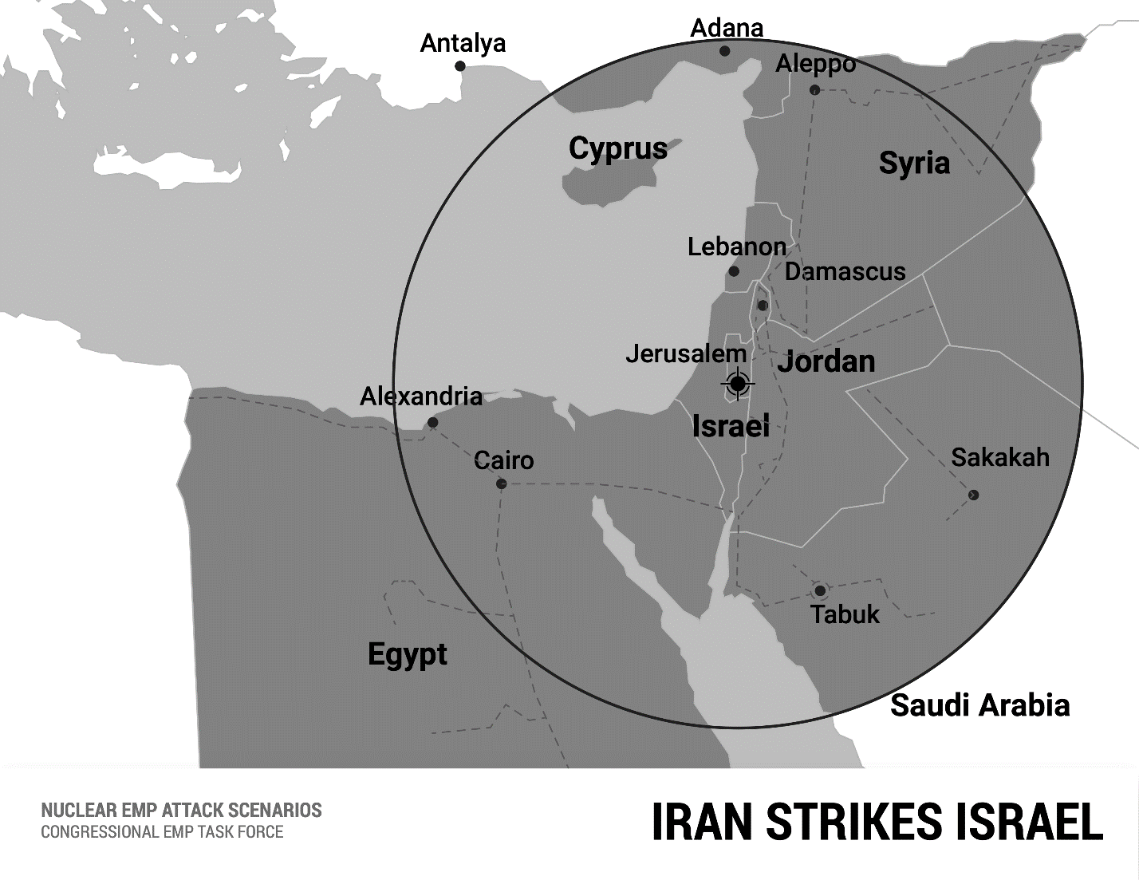

Although Lebanon and Syria would be blacked-out by the HEMP attack, Hamas, Hezbollah, other terror groups, and Syrian government forces of dictator Hafez Al Assad, could participate in the conquest of Israel as their military capabilities are much lower-tech and less vulnerable to EMP than the Israel Defense Forces.
Nonetheless, in this scenario Iran regards diminishment of terrorist and Syrian government military capabilities by the HEMP attack as a bonus, as these allies are also Sunni and secular rivals to Shiite Iran's bold gambit to dominate the Middle East. HEMP induced blackout of Egypt, Jordan, and partly Saudi Arabia, and paralysis of their military forces, are bigger bonuses. These Sunni enemies of Iran, and allies of the United States, are the most likely and best positioned Arab states that might try rescuing Israel.

Iran Strikes Egypt and Israel
In this alternative scenario, Iran centers a HEMP attack over Cairo, to knockout Egypt and Israel, and to avoid diminishing militarily or alienating politically Iran's terrorist and government allies in Syria and Lebanon. Egypt is the most populous and militarily the strongest of the Arab nations: Iran's most serious rival to leadership of the Middle East. Egypt is also Sunni, with a secular anti-Islamist government, an ally of the United States, and friendly to Israel—which makes Egypt almost as hated as Israel by Iran.
A nuclear weapon is detonated at 30 kilometers HOB southwest of Cairo, putting the peak HEMP field over Cairo, Egypt's political-military center, and over many of its most important air, army, and naval bases. Radius of the HEMP extends to a distance of 600 kilometers. Examples of some of Egypt's military assets covered in the HEMP field are Navy HQ and the nation's main naval base in Alexandria, and the major air force bases such as Cairo West AFB, Abu Suwayer AFB, and Bir Gifgafa AFB. Cascading failures in the grid would blackout all of Egypt.
All of Israel is covered by the HEMP field. Half of Jordan is covered by the HEMP field. Cascading failures would probably blackout the whole of Jordan, which is on a single grid. Northeast Saudi Arabia is in the HEMP field, but this would likely cause only localized blackouts as the region is not connected to the Saudi national grid.
None of Lebanon or Syria is covered by the HEMP field. Thus, the HEMP attack paralyzes Iran's enemies and spares its most important allies.
Egypt is so unstable that a HEMP attack that paralyzes the government, communications, transportation, and cuts the supply of food and water might well trigger a protracted revolution or civil war, effectively destroying the state of Egypt and creating a zone of permanent chaos, as in Libya, Gaza, Lebanon, and Syria.

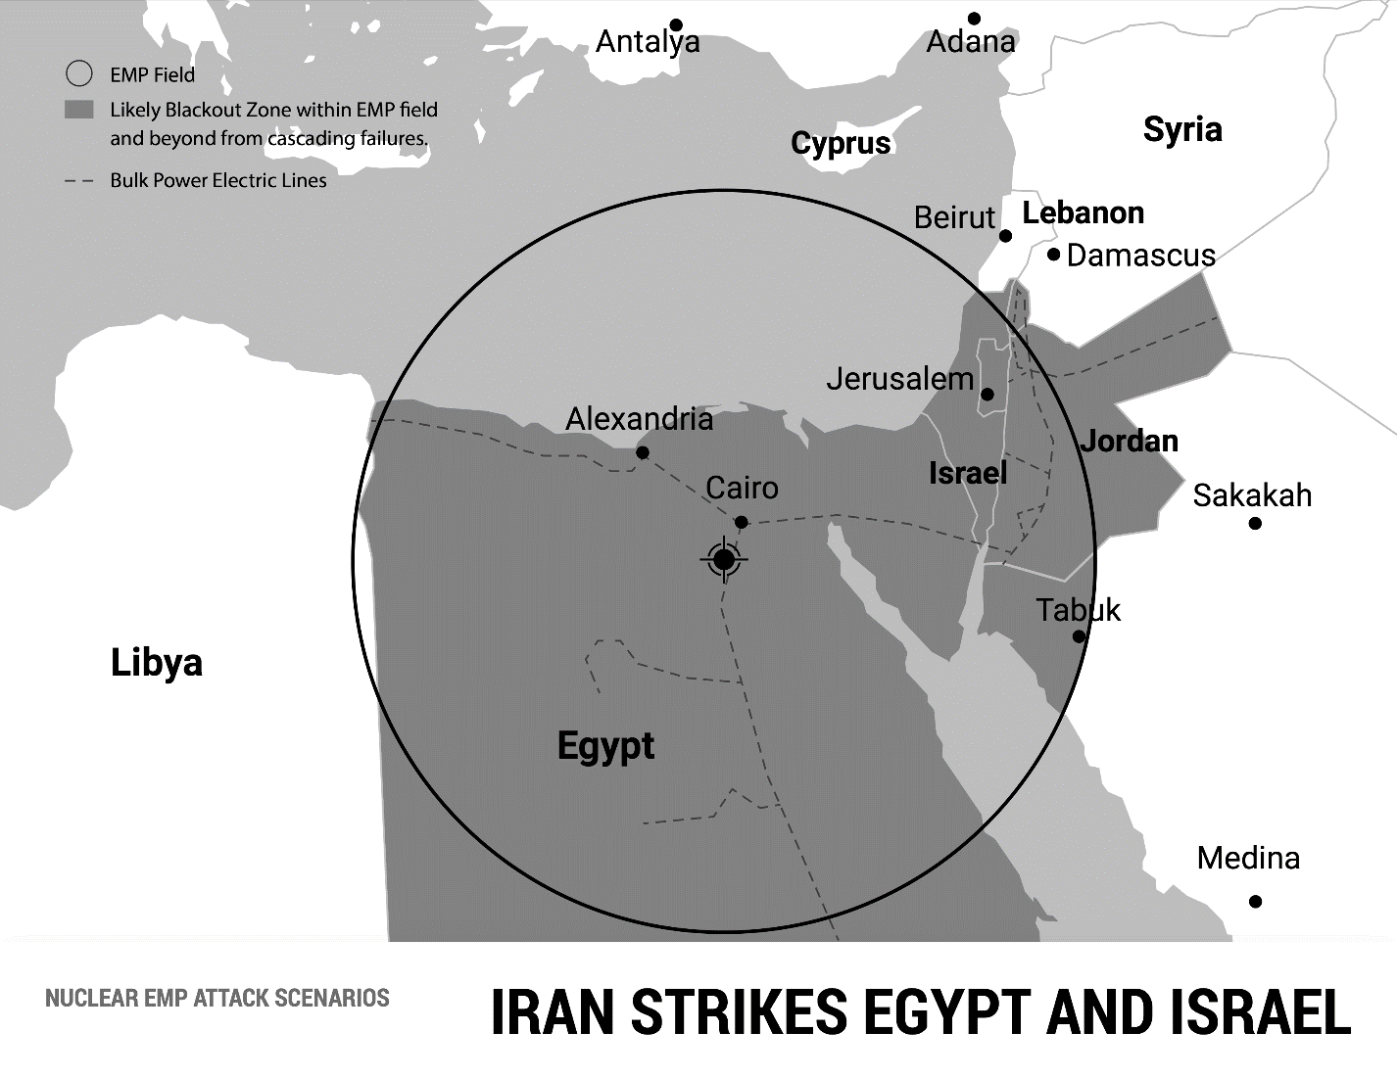

Iran Strikes Saudi Arabia and the Gulf States
In this scenario, Iran centers a HEMP attack over Riyadh, the capital of Saudi Arabia, to destroy its main ideological rival for leadership of the Muslim world in the struggle between Shiites and Sunnis. Sunni Saudi Arabia, protector of the holy cities of Mecca and Medina, has long claimed spiritual leadership of Islam, a claim legitimated to many Muslims by the blessing of Saudi oil wealth. Oil rich Saudi Arabia and its oil wealthy allies Kuwait, Bahrain, Qatar, and the United Arab Emirates, all Sunni, have used their wealth and influence with the West to lead Arab opposition to the rise of Shiite Iran.
Saudi Arabia and its Persian Gulf allies have small populations, and small militaries, that rely heavily on western jet fighters and other high-tech equipment to compensate for their lack of manpower with modern firepower. A HEMP attack that neutralizes their military capabilities would be a red carpet for invasion and takeover of their oil wealth by Iran.
Iran knows that the world economy is heavily dependent upon Persian Gulf oil, and for that reason has frequently attempted to coerce the West by threatening to cutoff the supply of oil by closing the Strait of Hormuz with Iran's Navy. However, the presence of the U.S. Navy in the Persian Gulf to protect the strait makes this a hollow threat. A HEMP attack that destroys Saudi Arabia and the Persian Gulf states, and better yet enables Iran to capture their oil wealth, would eliminate Iran's main Muslim ideological rival and put its foot on the throat of the world economy.
A nuclear weapon is detonated 30 kilometers HOB over Riyadh, the Saudi capital. Radius of the HEMP field extends from Riyadh to a distance of 600 kilometers. The HEMP field covers most of Saudi Arabia's most important military bases, including for example Riyadh Air Force Base, King Khalid AFB, Hail AFB, Al Kharj AFB, Al Kharj East AFB, Prince Sultan AFB, and Sulayel AFB. The HEMP field covers all of Saudi Arabia's major oil fields and pipelines, including Jubail, Ras Tannurah, Dhahran, Dammam, and Abqaiq.
The HEMP attack would probably also cause protracted blackout of all Saudi Arabia's Persian Gulf allies. The HEMP field covers all of Kuwait, all of Qatar, all of Bahrain, and part of the United Arab Emirates. The HEMP would most likely trigger cascading failures through the electric grid that would blackout all of the UAE.
While accomplishing the above, the HEMP field would not paralyze Iran's allies in Iraq and Yemen. Although the HEMP field covers part of southern Iraq, the national electric grid is not in this region, the Al Muthanna, which is inhabited by Sunnis hostile to Iran. Iraq's Shia regions are spared.
100,000 Iranian Revolutionary Guards now in Iraq could spearhead an invasion of Kuwait, Saudi Arabia and the Persian Gulf states, while the Houthis attack from Yemen.
The attack described would avoid placing a HEMP field over the holy cities of Mecca and Medina, that might be an important consideration for ideological and propaganda reasons.

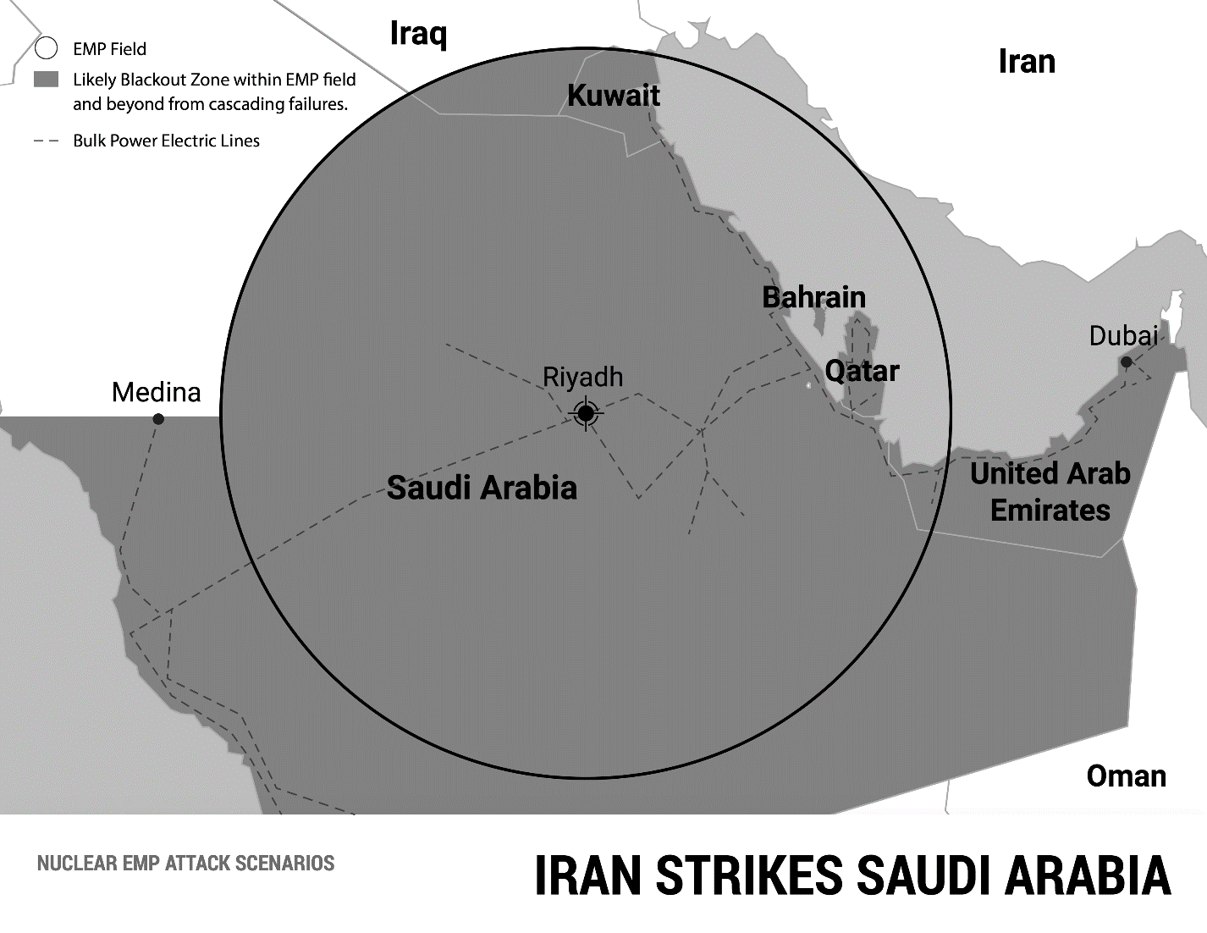

The IRGC Strikes Italy
Ideologically, an attack on the Holy See fits in with apocalyptic worldviews of Iran’s Mullahs and the terrorist Islamic Revolutionary Guard Corps (IRGC) that runs Iran’s nuclear missile program. The IRGC is the world’s most powerful terrorist organization. The Biden Administration’s effort to revive the Iran nuclear deal—including by offering to remove IRGC from the U.S. list of terrorists—testifies to the coercive power of Iran’s nuclear blackmail.

The IRGC claims to be the champion of Islam come to destroy the world's false religions, Catholicism being chief among them, in a final confrontation between the "true religion" and its enemies, during these final days of the world's end time. The IRGC’s progress developing nuclear, missile, and space capabilities are often advertised as a symbolic harbinger of the coming Apocalypse and triumph of Islam over the Infidels.

The IRGC has access to all of Iran’s weapons and is so fanatical that a scenario cannot be ruled out where the IRGC acts independently of the political government of Iran and its spiritual leaders. The IRGC armed with a simple Scud SRBM with a nuclear warhead could be a fatal HEMP threat to much of Europe.
Scuds are engineered to be robust missiles that can take a lot of punishment and are easy to use, literally "designed by geniuses to be used by idiots." Houthi rebels and terrorists in the rough desert country of Yemen have successfully operated and used Scuds. In June 2016, the Houthis launched a Scud strike on King Khalid Air Force Base in Saudi Arabia, killing Lt. General Ahmed al-Shaalan, Chief of the Saudi Arabian Air Force. Reportedly, "South Korean intelligence officials said...20 Scud missiles fired at Saudi Arabia from Yemen by Houthi rebels and their allies originated in North Korea."
Anything the Houthis can do, the IRGC can do, and probably better. But even if the IRGC had a Shahab-III MRBM, the missile does not, from Iran, have the range to reach Rome.
However, as the richest, largest, and most sophisticated terrorist organization in the world, the IRGC might be able to engineer a spectacular act of destruction that finally eclipses rival Al Qaeda's 9/11 attacks on New York City and Washington, D.C. If New York and Washington are the economic and political capitals of the United States, Rome is the spiritual capital of Western Civilization and one of the biggest religious rivals to Islam.
In this scenario, the IRGC buys a freighter with a nuclear-armed Scud missile in its hold from North Korea, which is strapped for cash and furious over UN economic sanctions. North Korea has threatened to sell nuclear weapons to terrorists, according to an intelligence report to Congress.
The IRGC makes a ship-launched HEMP attack, detonating the Scud at HOB 30 kilometers over Vatican City.
The HEMP field extends to a radius of 600 kilometers around Rome, covering all of Italy, including Sicily and Sardinia, and all Switzerland. The HEMP field reaches across the Adriatic Sea and covers the Balkan states, Serbia, Albania, Bosnia-Herzegovina, Croatia, and Slovenia. The IRGC would surely see this as divine justice for the "ethnic cleansing" of Muslims during the Yugoslav Wars of 1991-2001, and as punishment for Muslim "traitors" now living in peace with their Christian neighbors.
The HEMP field covers most of Austria to Vienna, and significant parts of the electric grids in France, Germany, and Hungary. Across the Mediterranean in North Africa, the HEMP field covers part of Tunisia including the capital, Tunis. All of these nations would probably go into protracted blackout from cascading failures that cause massive damage to their electric grids nationwide.
The stage is now set for terror cells in Europe to arise, for terrorist fighters in Libya to cross into blacked-out Italy, and everywhere make bloody chaos. It would be like the Mumbai and Paris massacres on an international scale.
Iran’s Shiite Islamic Revolutionary Guard Corps would finally eclipse the Sunni holy warriors of Al Qaeda in everything.

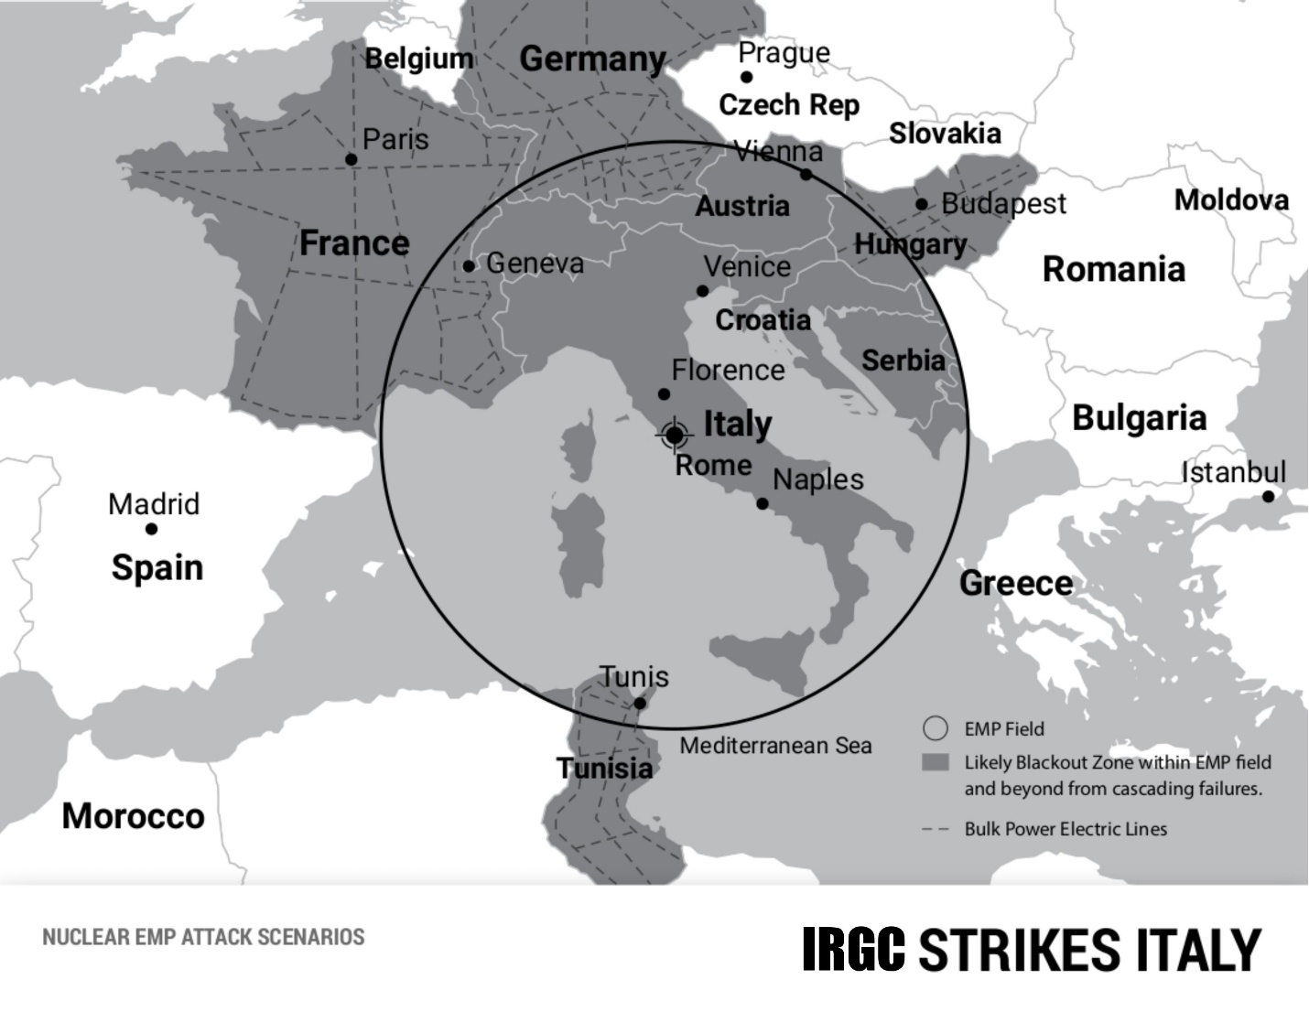

Strategic Implications of EMP Threat from Iran

The Congressional EMP Commission estimates that, given U.S. current unpreparedness, within one year of an EMP attack that causes a nationwide blackout, two-thirds or more, up to 90 percent, of the U.S. population could perish from starvation, disease, and societal collapse.

Therefore, HEMP attack capabilities—even NNEMP attack capabilities—will confer upon Iran against the United States the threat of Assured Destruction. The geopolitical consequences of this development are so extremely grave that U.S. and global security would, in effect, go over the "strategic cliff" into free-fall. Where we would land, into what kind of future, is as yet unknown.

Nevertheless, some very bad developments are foreseeable. Iran will certainly be inspired by North Korea's example to persist in the development of its own nuclear weapon and ICBM programs to pose a mortal threat to the United States. North Korea will continue to help Iran.

Iran and North Korea are both client states of Russia and China, owe their growing missile and nuclear capabilities to technology transfers from Russia and China, and serve the geostrategic interests of the Sino-Russian Axis in the New Cold War against the West.

Yet HEMP capabilities also make Iran and North Korea increasingly independent superpowers, capable of toppling the technological pillars of global electronic civilization, for motives as alien to the West as the megalomania of Kim Jong-un or the apocalyptic tenets of radical Shiite Islam.

If Iran and North Korea both acquire the capability to threaten America and the world with EMP genocide, this will destroy the foundations of the existing world order based on the U.S. acting as a superpower, which has since 1945 halted the cycle of world wars and sustained the global advancement of freedom. Iran and North Korea being armed with Assured Destruction capability changes the whole strategic calculus of risk for the United States in upholding its superpower role, and will erode the confidence of U.S. allies—perhaps to the point where they need to develop their own nuclear weapons.

Most alarming, we are fast moving to a place where, for the first time in history, failed little states like Iran and North Korea, will have power in their hands to blackmail or destroy the largest and most successful societies on Earth. Iran and North Korea perceive themselves to be at war with the United States, and are desperate, highly unpredictable characters. When the mob is at the gates of their dictators, will they want to take America with them, down into darkness?

Iran and North Korea are two of the best reasons for the United States and the world to become prepared to survive and recover from an EMP catastrophe.

“EXPERTS: Iran Now A Nuclear-Ready State, Missiles Capable of Hitting U.S.” Newsmax (February 1, 2015). “Underestimating Nuclear Missile Threats from North Korea and Iran” National Review (February 12, 2016). Israeli experts: Joshua Davidovich, “Iran Already Has A Nuclear Bomb” Times of Israel (September 27, 2013). Author interviews with Israeli national security officials, who also stated Israel does not want to contradict U.S. State Department and CIA assessments and risk alienating these institutions and the White House.
“Underestimating Nuclear Missile Threats from North Korea and Iran” National Review (February 12, 2016).
“Iran Probably Already Has The Bomb” National Review (March 19, 2021).
Institute for Science and International Security, Anatomy of Iran’s Nuclear Deception and How Iran Benefitted (March 6, 2019); Breaking-up and Reorienting Iran’s Nuclear Weapons Program (March 6, 2019); Addressing the Military Dimensions of Iran’s Nuclear Program (November 4, 2015).
“Gen. Paul Vallely: Iran Already Has Nukes, Making Deal ‘Moot’” Newsmax (August 27, 2015).
Defense Science Board (DSB), Assessment of Nuclear Monitoring and Verification Technology (Department of Defense: January 2014).
The author saw sample photos of nuclear weapons-related equipment and tried to help Kahlili procure additional photos. See also: Reza Kahlili, “Revealed! Evidence Iran Crossed the Nuclear ‘Red Line’” and “Obama’s Failure To Act Invites Frightening Consequences” World Net Daily (March 22, 2013) banned from the internet but in “Reza Kahlili Archives” highfrontier.org/category/reza-kahlili. See also: Reza Kahlili, A Time To Betray (Simon and Schuster: 2010).
“Trump Administration Recertifies Iran Compliance with JCPOA Notwithstanding Increasing Concern with Iranian Behavior” Cambridge University Press (February 13, 2018). Fred Fleitz, “Five Myths About President Trump’s Withdrawal from the Nuclear Deal” Center for Security Policy (May 14, 2019).
Majid Rafizedeh, “Why Is The Biden Administration Determined To Help Terrorist Iran Get A Bomb? Gatestone (April 23, 2022). “Fmr. Iran MP: From the very beginning we wanted to build a nuclear bomb” Jerusalem Post (April 25, 2022).
UN International Atomic Energy Agency (IAEA), Implementation of the NPT Safeguards Agreement and Relevant Provisions of Security Council Resolutions in the Islamic Republic of Iran (2011). Dr. Peter Vincent Pry, Iran—The Worst Deal (2015) and “We assess…Iran probably already has nuclear weapons” (Mackenzie Institute: September 25, 2019). Dr. Alejo Vidal Quadras, Ambassador Bob Joseph, Ambassador John Bolton et al., Examining 10 Warning Signs of Iran Nuclear Weapon Development (ISJ: November 20, 2014).
Defense Intelligence Agency (DIA), Iran Military Power (November 19, 2019).
“Iran Probably Already Has The Bomb” National Review (March 19, 2021).
IAEA, Implementation of the NPT Safeguards Agreement and Relevant Provisions of Security Council Resolutions in the Islamic Republic of Iran (2011).
Dr. William R. Graham, Threat Posed by Electromagnetic Pulse Attack, Hearing before the House Armed Services Committee (July 10, 2008).
Ibid.
Ibid.
Ibid. See also Committee Hearing on Commission to Assess the Threat to the United States from Electromagnetic Pulse Attack, House Armed Services Committee (July 22, 2004). EMP Commission, Foreign Views of Electromagnetic Pulse Attack (July 2017). All the unclassified EMP Commission reports are at www.firstempcommission.org.
Dr. Lowell Wood, Testimony before the Senate Committee on the Judiciary, Subcommittee on Terrorism, Technology and Homeland Security (March 8, 2005) p. 11. Source: “Missile Threat: CSIS Missile Defense Project” https://missilethreat.csis.org/country/iran.
“Pentagon Downplays Iran Military Satellite As ‘Tumbling Webcam’” AFP (April 27, 2020). “IRGC Puts Iran’s First Military Satellite Into Orbit” Tehran Times (April 22, 2020).
“Noor-1 Satellite” theiranproject.com (May 28, 2020). “Noor (satellite)” en.wikipedia.org.
Ibid. “IRGC’s Noor-1 Satellite: A New Chapter in Iran’s Defense Power” globalsecurity.org (April 24, 2020).
Samuel Hickey, “Iran’s Military Satellite Launch” armscontrolcenter.org. Potkin Azarmehr, “The Real Threats Behind Iran’s Military Satellite Launch” www.investigativeproject.org (May 1, 2020).
“Iranian Space Agency” en.wikipedia.org. Zhanna Malekos Smith, “Iran’s Space Program and the Wall Between ‘Peaceful Purposes’” csis.org (October 1, 2020).
Ambassador Henry Cooper, former Director of the Strategic Defense Initiative and the West’s foremost space weapons expert, has warned for years Iran’s satellite program poses a HEMP threat to the United States. See for example: “August 20, 2019—Iran’s Pending Satellite Launch” High Frontier (August 19, 2019) and “February 23, 2016—Another Satellite Launch By Iran—Hmmm!” High Frontier (February 23, 2016).
“IRGC Aerospace Force Commander: We Are Now A Superpower” www.Memri/TV (April 28, 2020).
Ibid.
“Sputnik-1” en.wikipedia.org.
William Graham, “Iran Carries Out Military Launch With Qased Rocket and Noor-2” nasaspaceflight.com (March 8, 2022).
EMP Commission, Chairman’s Report (July 2017).
Yeganeh Torbati and Roger Atwood, “Iran, North Korea Agree to Cooperate in Science, Technology” Reuters (September 1, 2012).
EMP Commission, Chairman’s Report (July 2017).
Ambassador Henry Cooper, “September 20, 2016—Whistling Past the Graveyard” High Frontier (September 19, 2016) www.highfrontier.org. F. Michael Maloof, “Star Wars Chief: Iran Could Launch Satellite With Nukes” World Net Daily (July 28, 2015) www.wnd.org.
See for example: Stewart Stogel, "Source: Iran Scientists Present at N. Korea Nuclear Test" Newsmax (October 9, 2006). Yaakov Lappin and Benjamin Weinthal, "Former German Official: Iran Tested Bomb in North Korea" Jerusalem Post (March 5, 2012). Tzvi Ben Gedalyahu, "'Hundreds' of North Korean Nuke Scientists in Iran" Arutz Sheva: Israel National News (December 19, 2011). Lee Tae-hoon, "NK Nuclear Experts Work in Iran" Korea Times (November 13, 2011). Donald Kirk, "Nuclear Deal? New North Korea and Iran Pact Raises International Concern" Christian Science Monitor (September 20, 2012). Bill Powell, "North Korea's Syria Connection" Time (April 25, 2008). Robin Wright, "N. Koreans Taped at Syrian Reactor" Washington Post (April 24, 2008). Yossi Melman, "North Korea Supplying Syria, Iran with Prohibited Technology, Report Says" Haaretz (January 6, 2013).
Reza Kahlili, "Iran Preparing for the 'Last Six Months'" WND (April 24, 2012). Reza Kahlili, "Iran Already Has Nuclear Weapons" Washington Times (October 27, 2011).
"Russian General Confirms Iran Has Nuclear Weapons!" STRATFOR Intelligence (June 4, 2002) http://www.cuttingedge.org/na/na260.htm. Google "Iran's Full Ticket?-Edward Jay Epstein"; Also quoted in Wikipedia entry on General Yuri Baluyevsky.
INOBIS, Institute of Defense Studies, Conceptual Provisions of a Strategy for Countering the Main External Threats to Russian Federation National Security (Moscow: October 1995)
Tzvi Ben Gedalyahu, "Israeli EMP Attack Could Throw Iran 'Back to the Stone Age'" Arutz Sheva (September 9, 2012). Bill Gertz, "Report: Possible EMP Strike on Iran?" Washington Free Beacon (August 29, 2012).
“Iran Builds EMP Filter For 1st Time” MEHR News Agency (June 13, 2015).
Ibid.
Army of the Islamic Republic of Iran, Passive Defense: Approach to the Threat Center (Tehran: Martyr Lt. General Sayad Shirazi Center for Education and Research, Spring 2010).
Ibid.
Ibid, Iran’s military textbook salutes Russian General Slipchenko for his groundbreaking work No Contact Wars that describes using EMP and other means to blackout electric grids and achieve decisive victory.
The author was present at this meeting.
Ibid.
Ibid.
Ibid.
https://mackenzieinstitute.com/2019/09/we-assess-iran-probably-already-has-nuclear-weapons/
Carlo Kopp, The Electromagnetic Bomb – A Weapon of Electrical Mass Destruction (February 8, 2003). Though dated, Kopp is still among the best for background.
Rebecca Smith, “U.S. Risks National Blackout From Small-Scale Attack” Wall Street Journal (March 12, 2014).
Emphasis original in Dr. Carlo Kopp, “E-Bombs vs. Pervasive Infrastructure Vulnerability” Briefing, Pacific Theater Air, Sea, Land Battle Concept: IO/EW/Cyber Operations International Conference (Monash University/Air Power Australia) carlo.kopp@monash.edu.
Ibid, emphasis original.
Applied Physics Electronics, “High-Power RF Suitcase EMP Pulse Generator” www.apelc.com/rf-suitcase.
U.S. FERC Interagency Report, Wiliam Radasky and Edward Savage, Intentional Electromagnetic Interference (IEMI) and Its Impact on the U.S. Power Grid (Meta-R-323) Metatech Corporation (January 2010) p. 2-5.
Global Research Institute Northeastern University, Mobilizing a National Response to the Vulnerability of Critical Infrastructure to Non-nuclear Electromagnetic Pulse/Electromagnetic Interference Attacks (April 2020) p. 4.
Ibid.
“Range of Russian EMP Weapons Increased to 10 km” Russia Today Military News TASS (July 5, 2020).
“Boeing: CHAMP – Lights Out” www.boeing.com.
Ron Kessler, “USAF Deploys New CHAMP Missile” (May 17, 2019) www.neogaf.com/threats/usaf-deploys-new-champ-missile. Dave Majumdar, “CHAMP: America’s EMP Missile that Might Be Able to Fry North Korea’s Nukes” The National Interest (December 11, 2017).
“Arms Seized by U.S., Missiles Used to Attack Saudi Arabia ‘of Iranian Origin’” Reuters and New York Times (June 11, 2020).
“China Reveals Chilling New ‘Sharp Sword’ Stealth Drone” www.mirror.co.uk (19 January 2017). “Losing World War III Inside America’s Borders” Washington Times (8 September 2020). “When Will DC Awaken To Putin’s Nuclear Aim For US?” Newsmax (21 August 2019). “Russia’s Top Long-Range Attack Drones” airforce-technology.com (27 November 2020). “Drone Attacks Cripple Production At Giant Saudi Oil Plants” www.abc.net.au (14 September 2019). “2019 Abqaiq-Khurais Attack” en.wikipedia.org.
Ibid.
Loren Thompson, “Critical U.S. Military Sites Can’t Cope With A Prolonged Power Outage” Forbes (18 May 2018). Peter Huessy, “Electronic Doomsday for the U.S.?” Gatestone (13 January 2016).
Zawahiri quoted in: Rolf Mowatt-Larssen, Al Qaeda's Religious Justification of Nuclear Terrorism (Belfer Center for Science and International Affairs, Harvard Kennedy School) pp. 9, 12 http://belfercenter.ksg.harvard.edu/files/aq-religious-justification.pdf. See also Raymond Ibrahim, "Native Son: Alyman al-Zawahiri and Morsi's Egypt" RSL: Rivka Shpak Lissak (December 20, 2012). "Al-Qaeda: Declarations and Acts of War" Heritage Foundation (Washington, D.C.: undated).
"U.S. Officials: Up To 100,000 Iran-Backed Fighters Now In Iraq" Fox News, August 16, 2016.
VICE News, July 29, 2015.
"N. Korea Would Sell Nukes To Terrorists" Washington Times, February 5, 2008.
Dr. William R. Graham, Ambassador R. James Woolsey, Dr. Peter Vincent Pry, “Prepare For The Worst” Real Clear Defense (October 21, 2019) summarizes the findings of the Congressional EMP Commission on societal catastrophe. See also: EMP Commission, Assessing the Threat from Electromagnetic Pulse (July 2017) and the Chairman’s Report (July 2017) at www.firstempcommission.org.

